Supporting Data
Title of the Manuscript:
Biomarkers and heterogeneous fibroblast phenotype associated with incisional hernia
Authors:
Finosh G Thankam, PhD^{1,2}, Nicholas K Larsen BS², Ann Varghese, BS², Thao-Nguyen Bui, BS², Matthew Reilly, BS², Robert J Fitzgibbons, MD² and Devendra K. Agrawal, PhD^{1,2}*

¹Department of Translational Research, Western University of Health Sciences, Pomona, CA 91766, USA, and ²Departments of Clinical & Translational Science and Surgery, Creighton University School of Medicine, Omaha, NE 68178, USA

Control PT – Raw data for MFI, No of cells and MFI/100
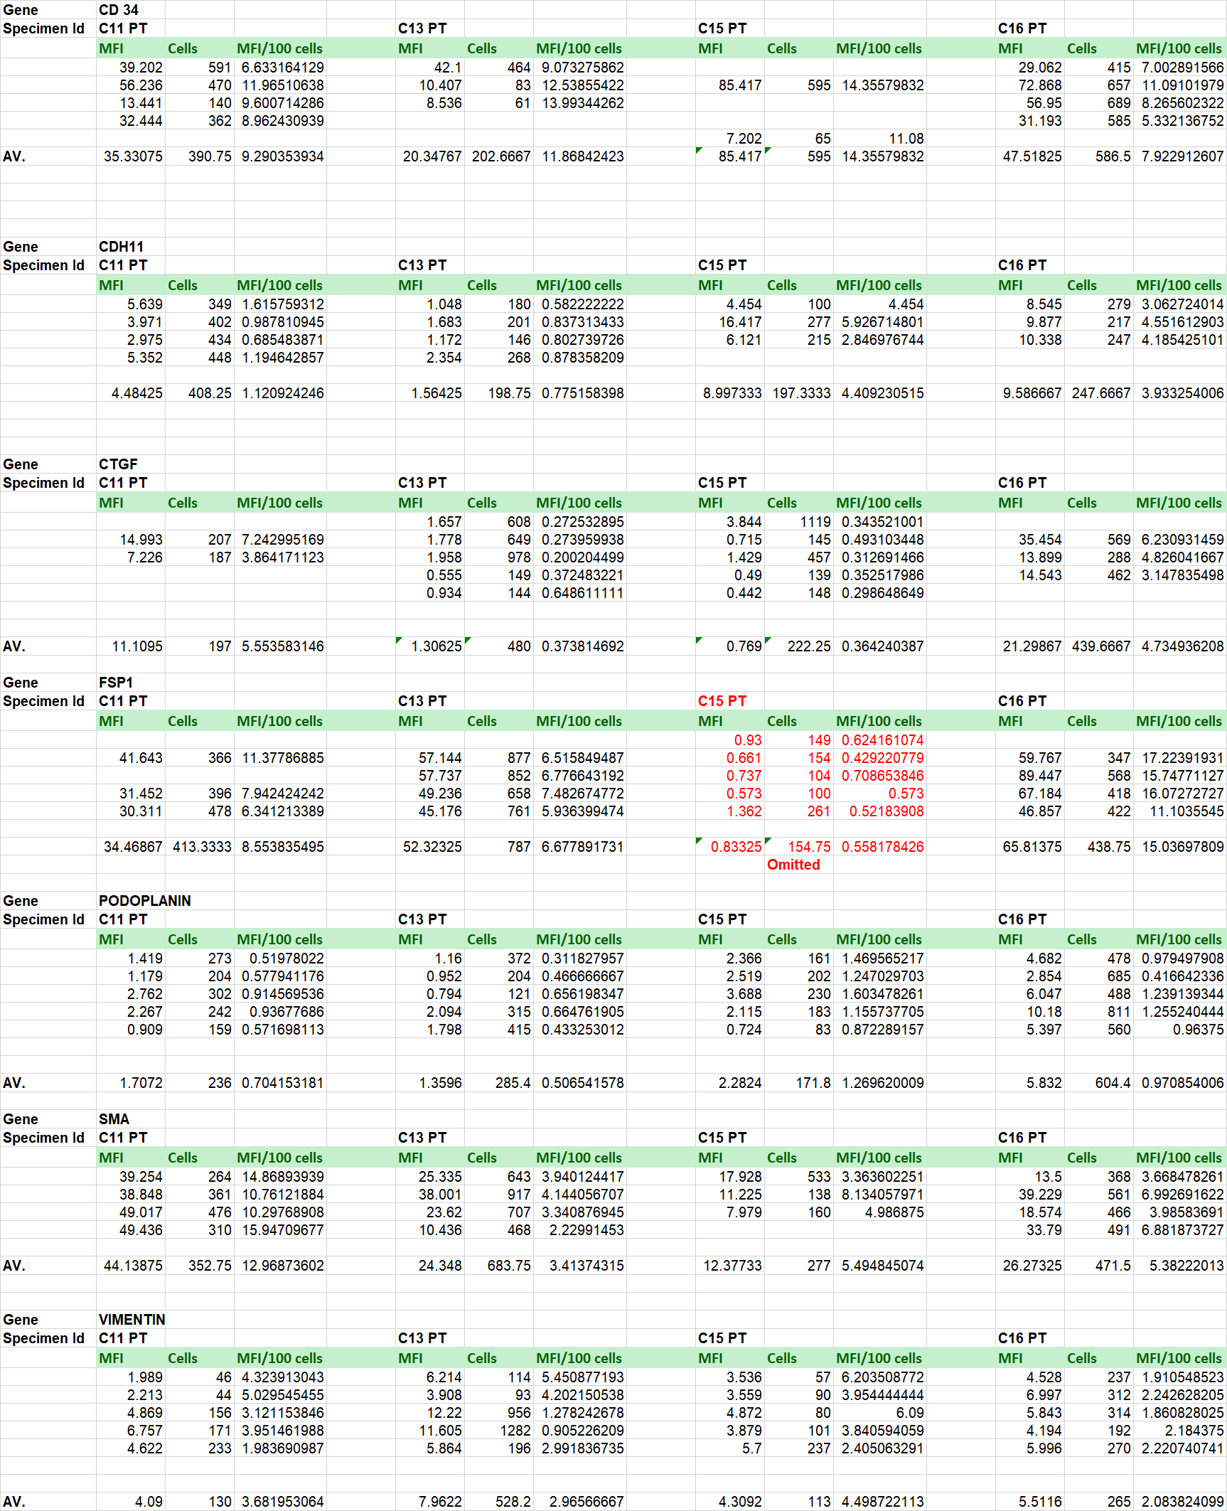
Control FT – Raw data for MFI, No of cells and MFI/100
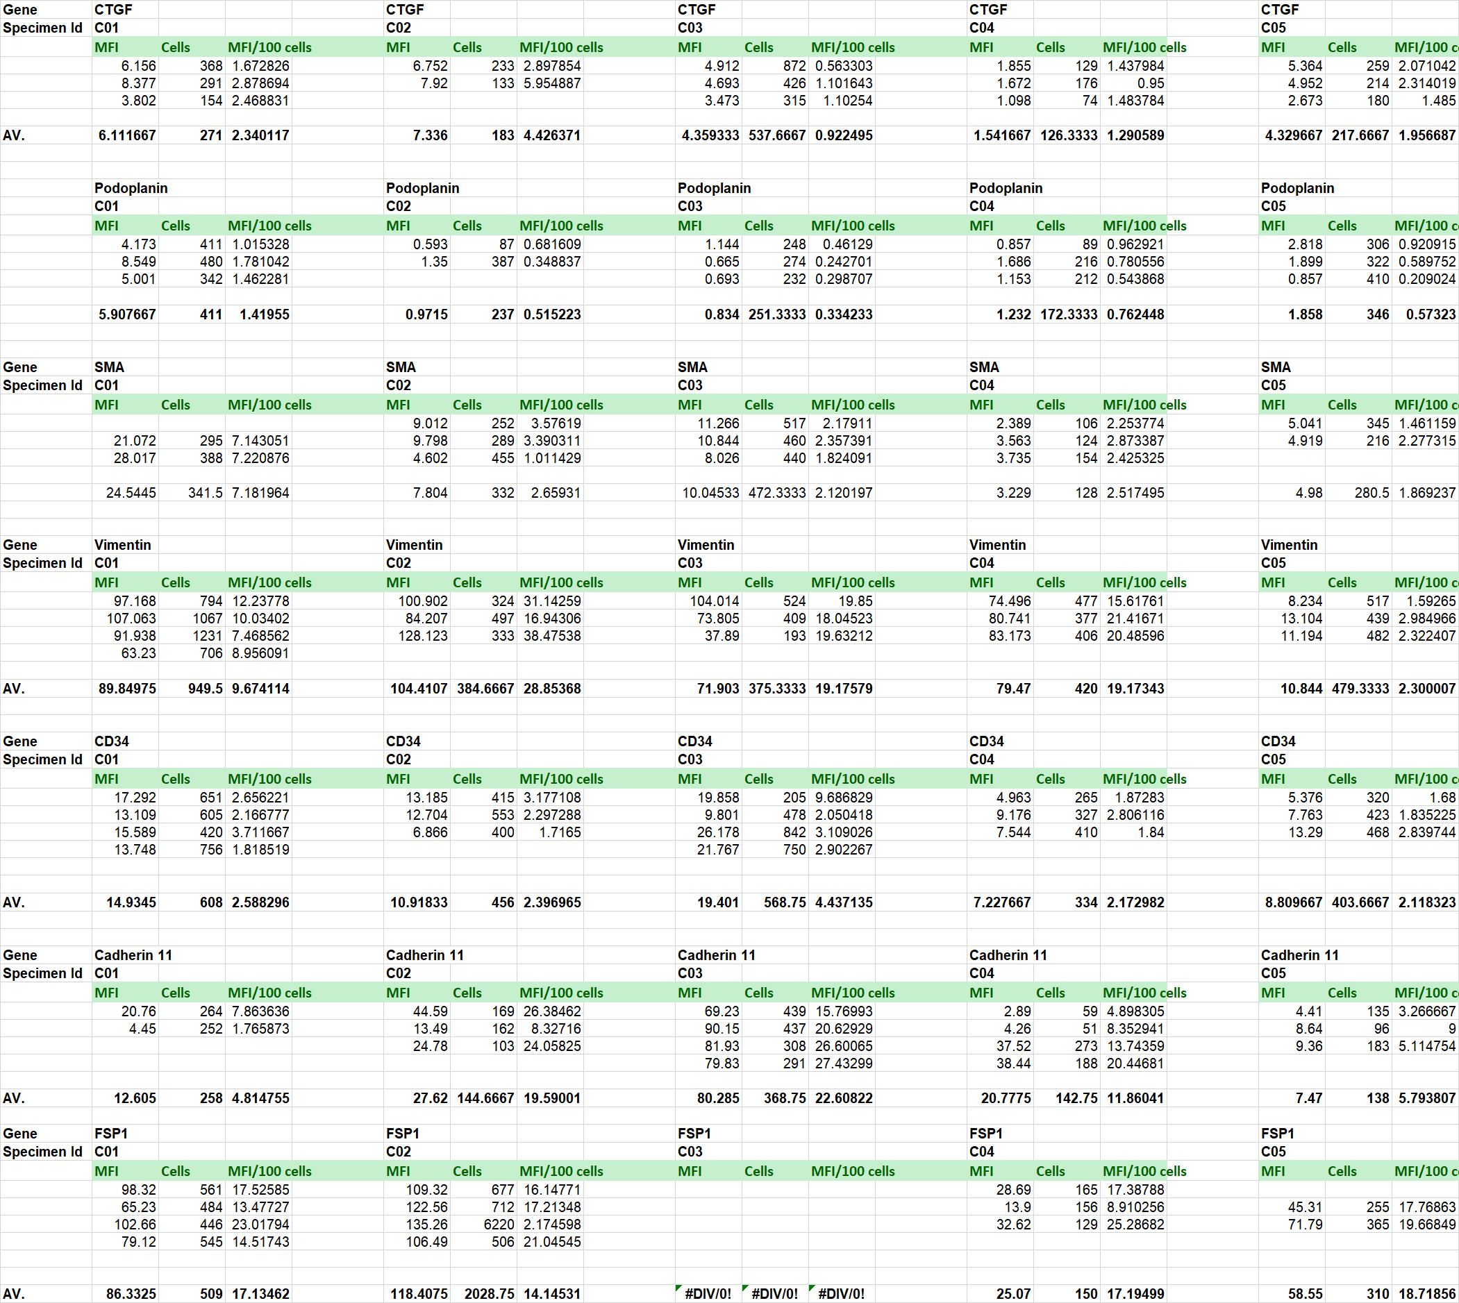
HST – Raw data for MFI, No of cells and MFI/100
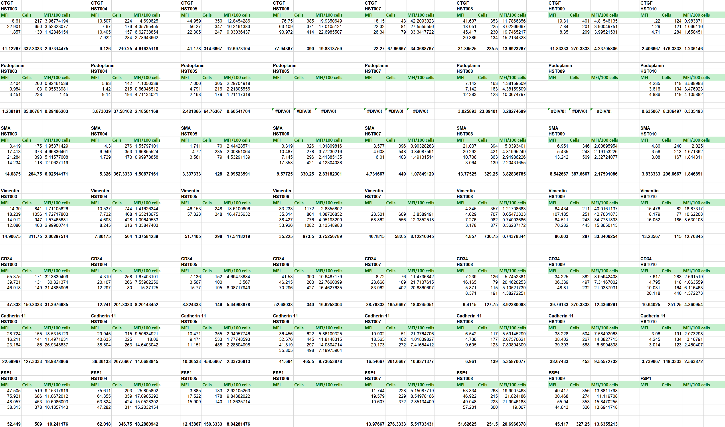

HRT – Raw data for MFI, No of cells and MFI/100
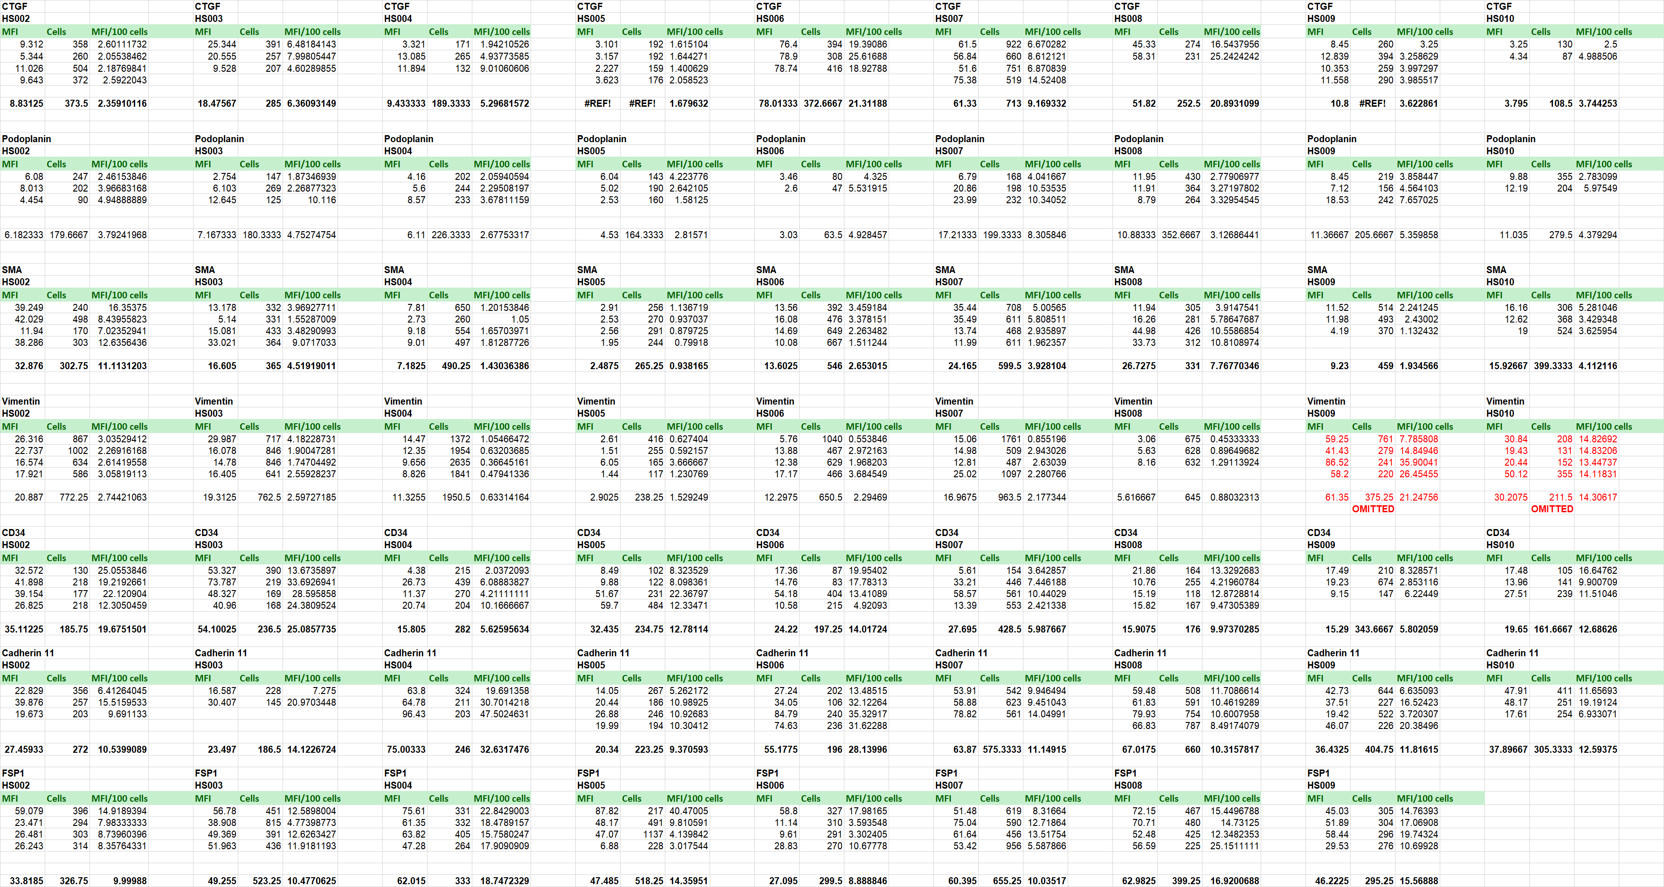

Calculation of fold change expression in HST and HRT with respect to the respective controls
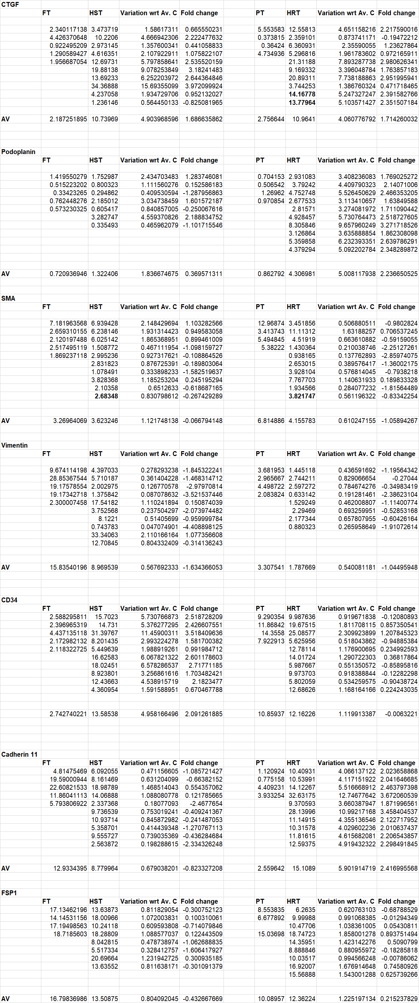

Statistics and graphs
