Extended Data

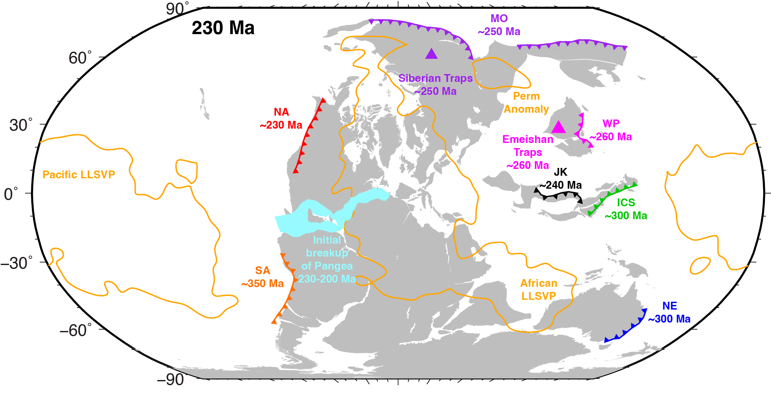

Extended Data Figure 1. Pangea at 230 Ma. The gray areas represent reconstructed continents⁴³, while the subduction zones are based on reconstructed continental arcs⁶. The triangles represent approximate locations of Large Igneous Provinces (LIPs) in the early Triassic, and the age beside each feature represents its initiation time. The orange contours outline the LLSVPs at the core-mantle boundary (CMB), and the cyan pattern indicates the initial rifting between North America and Africa⁴³. Abbreviations of continental arcs: ICS, Indochina–Sumatra; JK, Jiangda–Hoh Xil Shan–Karakorum; MO, Mongol–Okhotsk; NA, North American Cordillera; NE, New England; SA, South American Cordillera; WP, West Pacific.
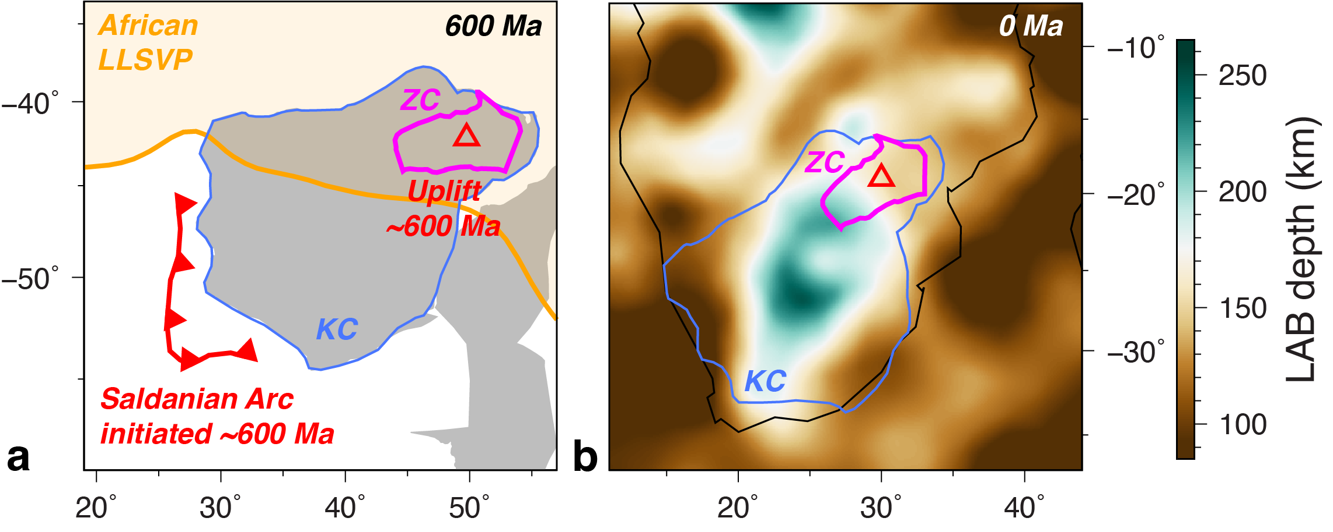

Extended Data Figure 2. Geological and geophysical evidence for SI and delamination in the Zimbabwe Craton. (a) The configuration of Kalahari Craton at 600 Ma⁷³, with the subduction zone (red line) based on the reconstructed magmatic arc⁶. The red triangle represents an unroofing event in the Zimbabwe Craton ~600 Ma⁵². The orange region represents the African LLSVP at the CMB. (b) Present-day LAB depth beneath southern Africa⁵¹. In both panels, the blue and magenta contours outline the Kalahari Craton and Zimbabwe Craton, respectively. KC, Kalahari Craton; ZC, Zimbabwe Craton.
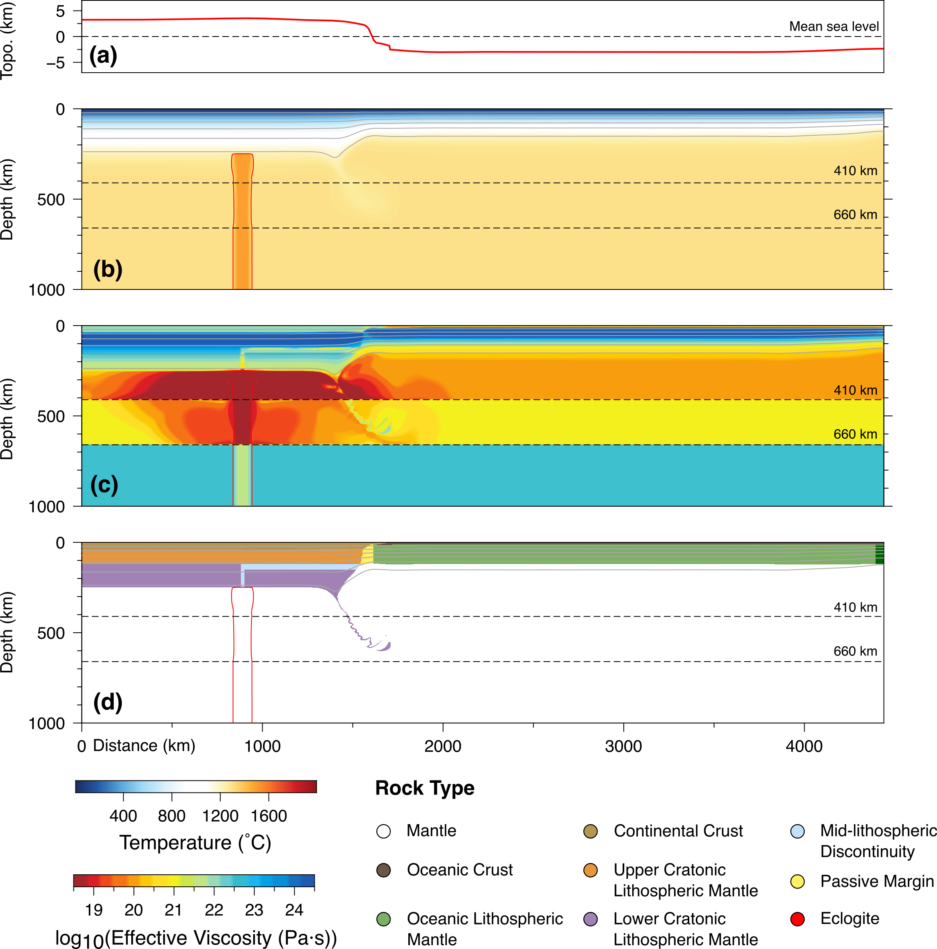

Extended Data Figure 3. Initial conditions of the numerical model. (a) Predicted initial topography. (b) Temperature field. (c) Effective viscosity field. (d) Composition field. In (b)-(d), the dark gray lines are temperature contours at every 200˚C, and the red contour outlines the initial plume conduit (at 20˚C warmer than the ambient mantle).
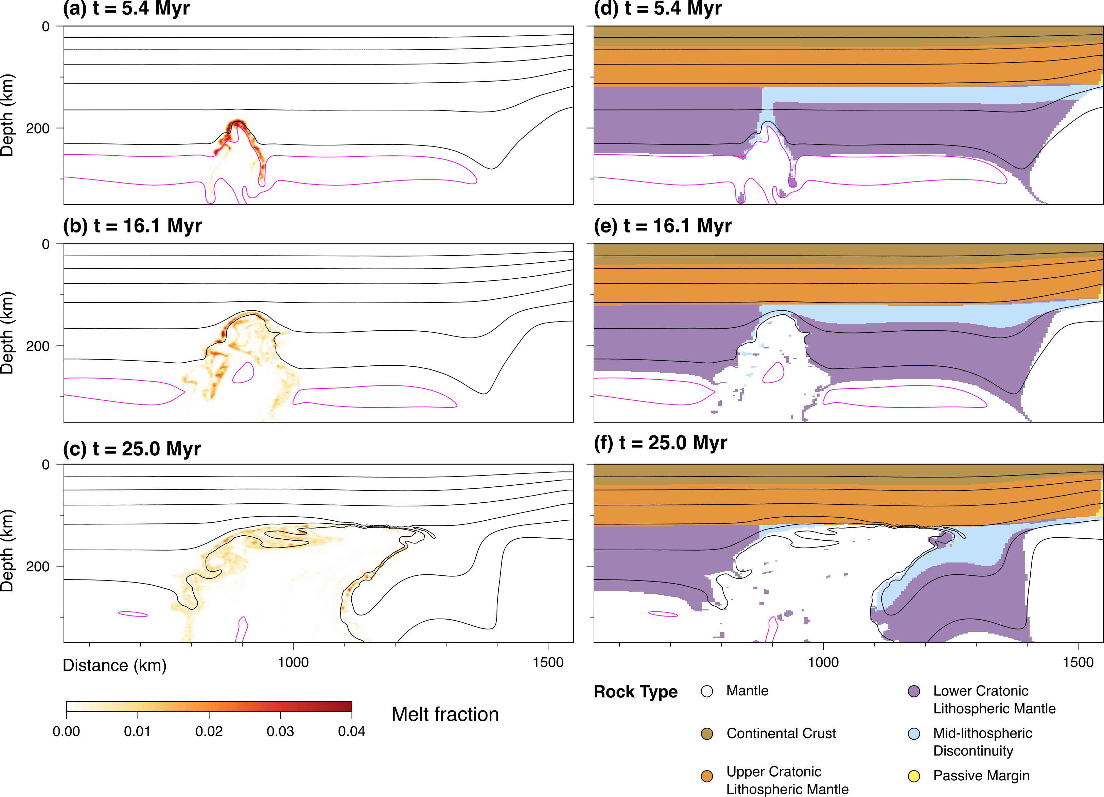

Extended Data Figure 4. Evolution of melt fraction and composition field during the delamination of the lower CLM. (a) – (c) show melt fraction at different times during this process. (d) – (f) show the corresponding composition field. The impinging plume heats up the MLD material, which has a low solidus, leading to its melting.

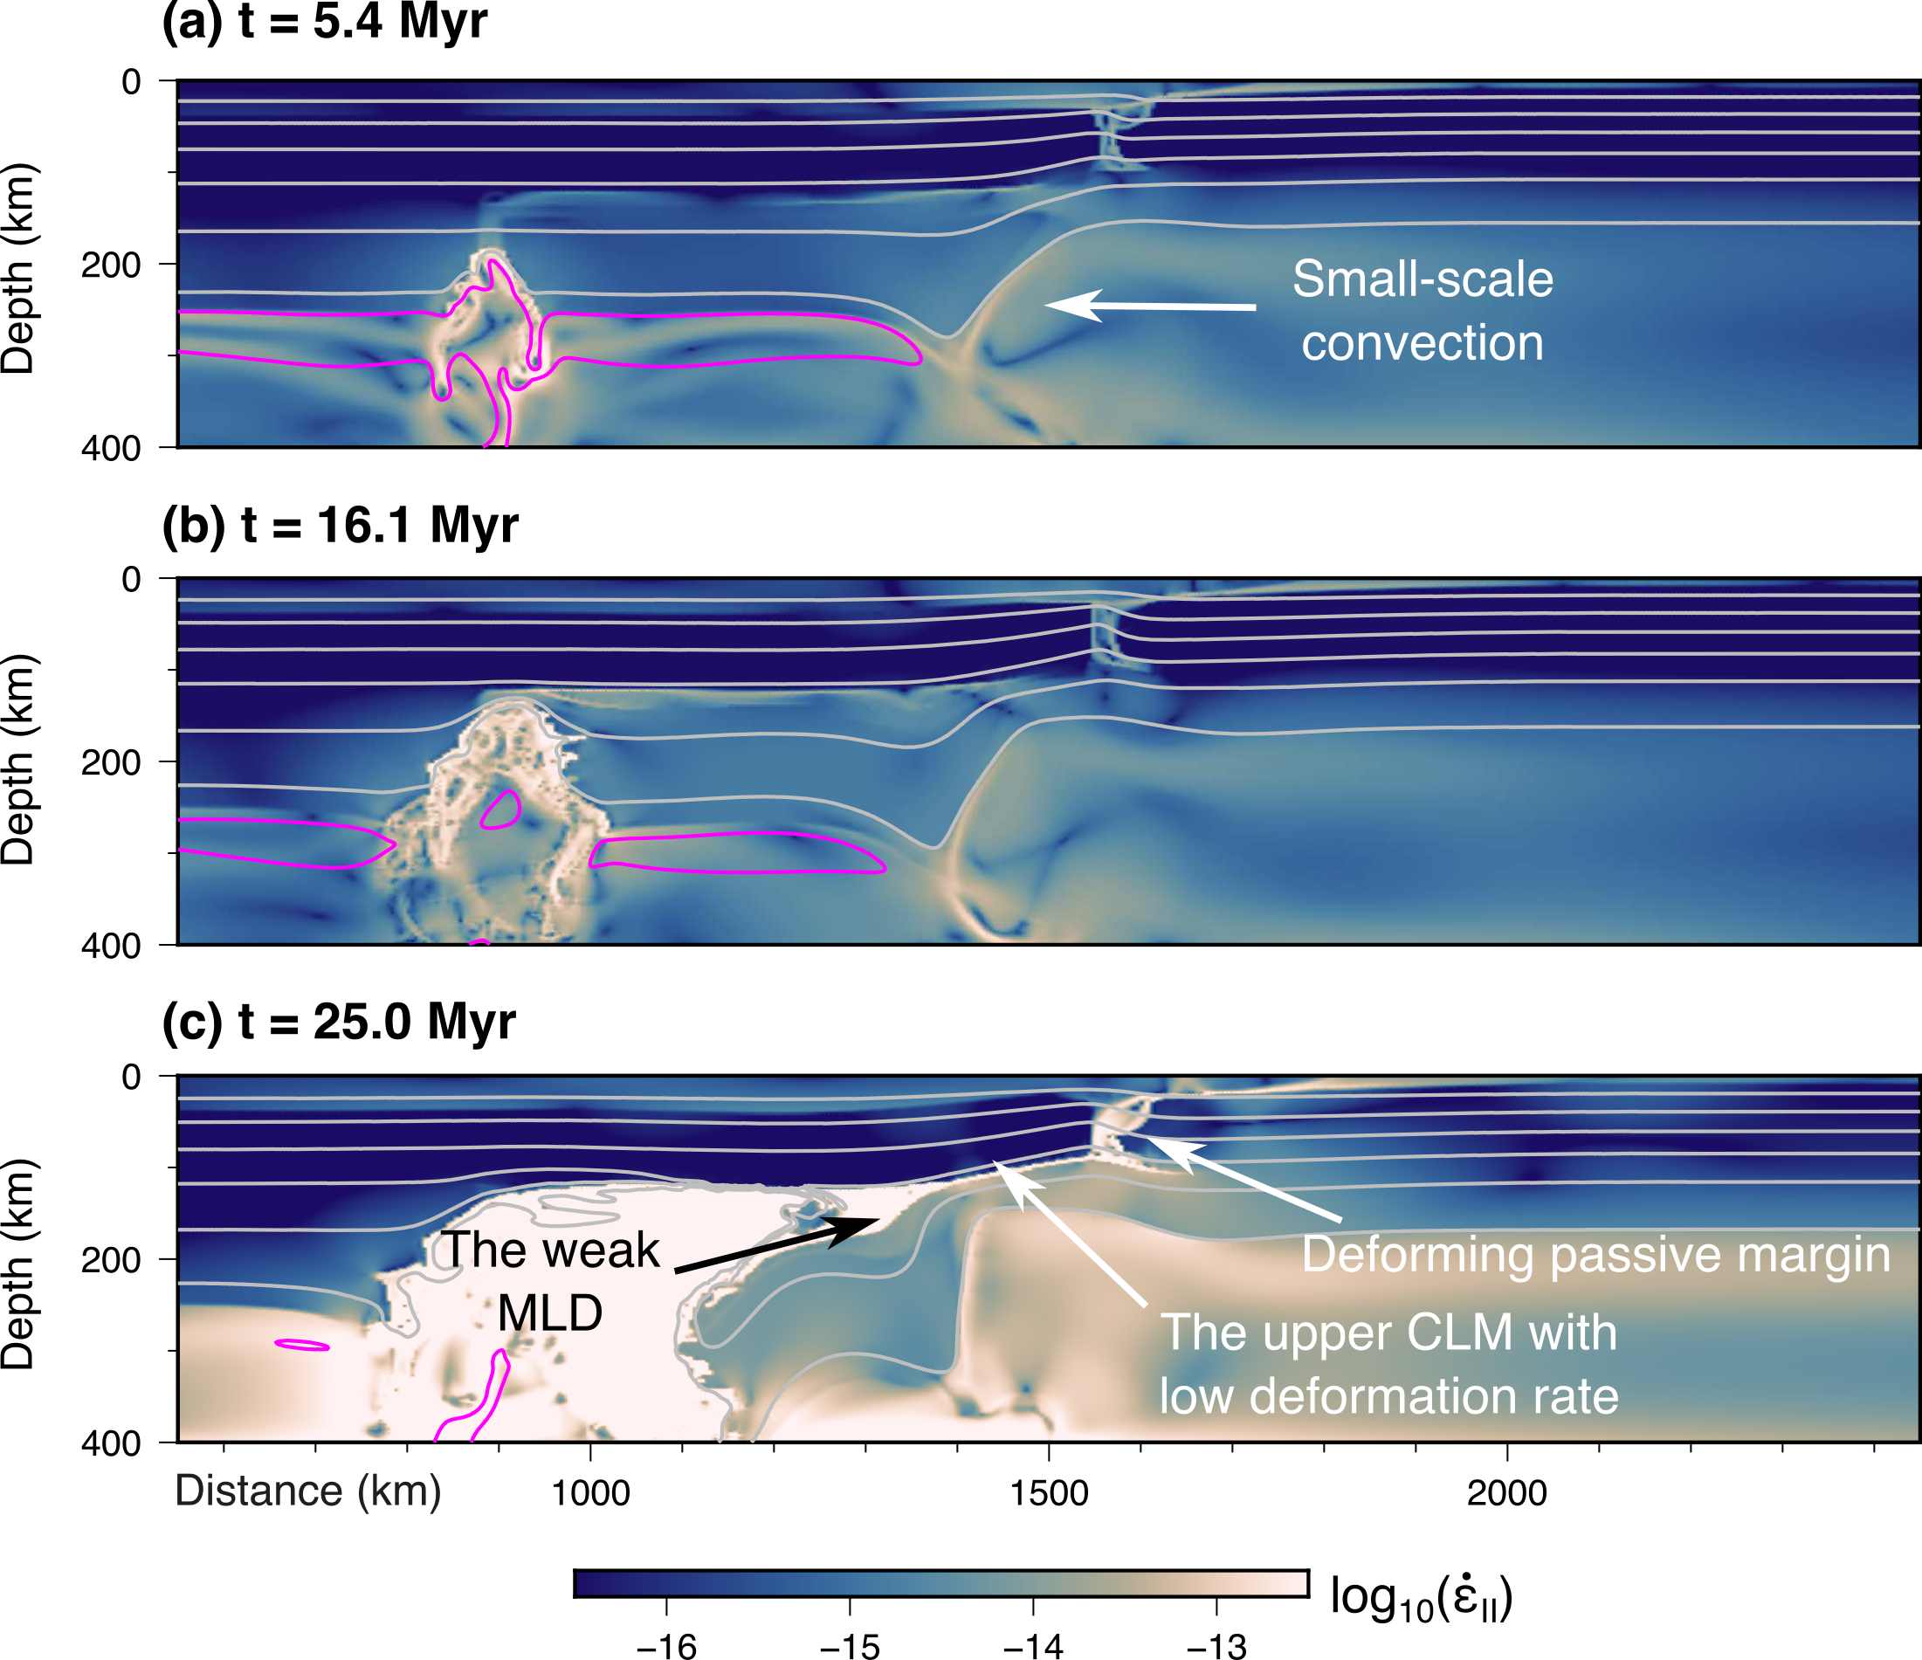

Extended Data Figure 5. Deformation during the delamination of the lower CLM. (a) - (c) Deformation rate (the second invariant of strain rate tensor) at different times. During the delamination, the upper CLM experiences low deformation rate since the weak MLD acts as a lubrication layer, decoupling the upper and lower CLM and protecting the upper CLM and continental crust from extensive deformation.
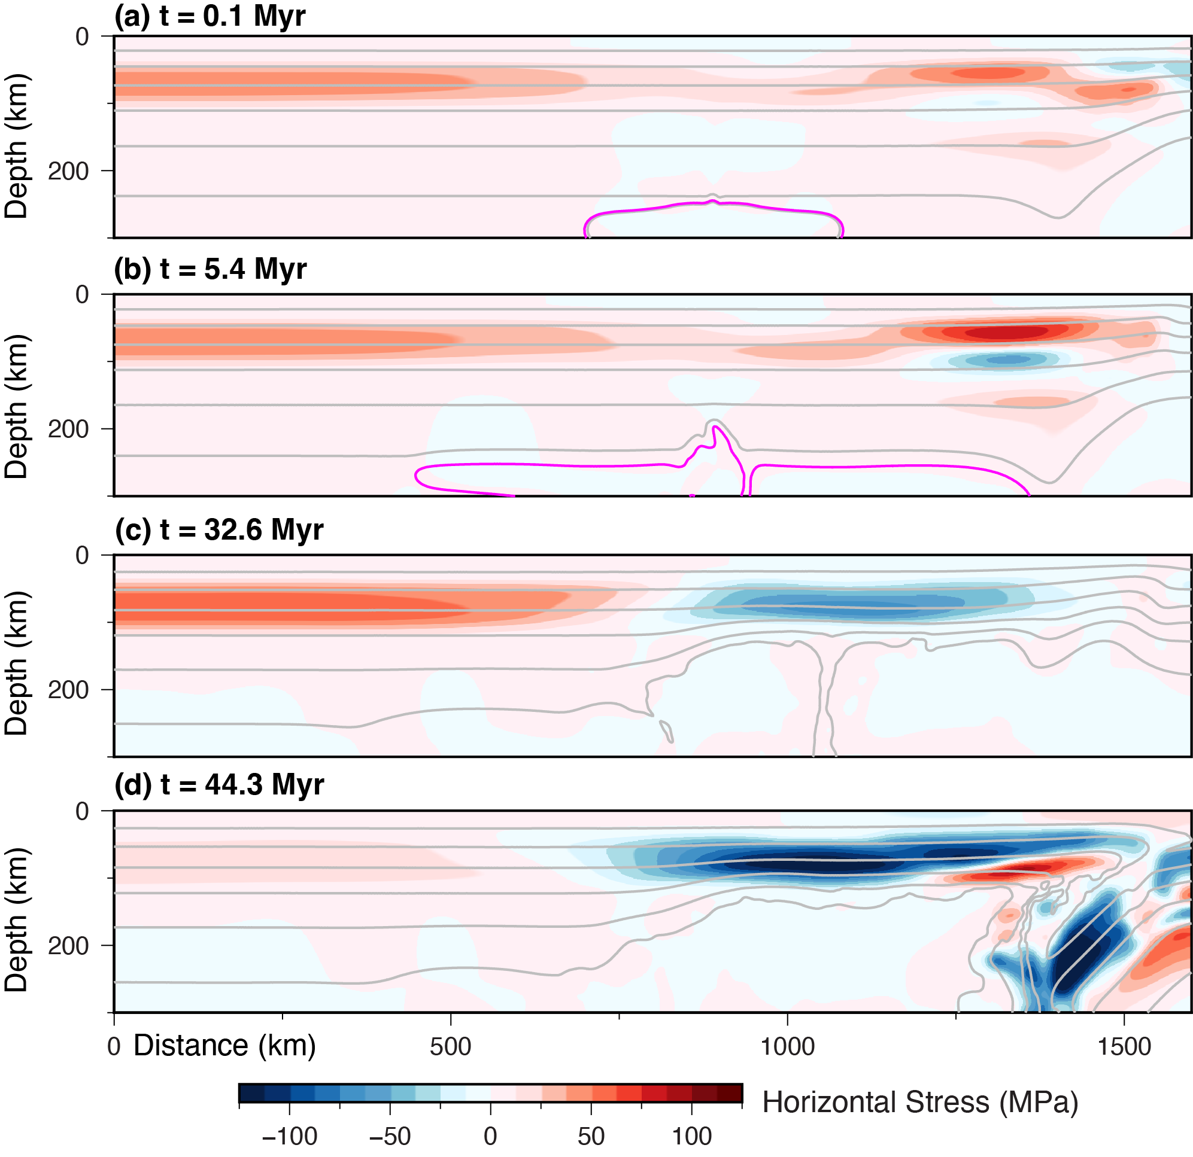

Extended Data Figure 6. Evolution of continental stress state. (a) - (d) Horizontal stress field at different times. The dark gray lines are temperature contours at every 200°C.
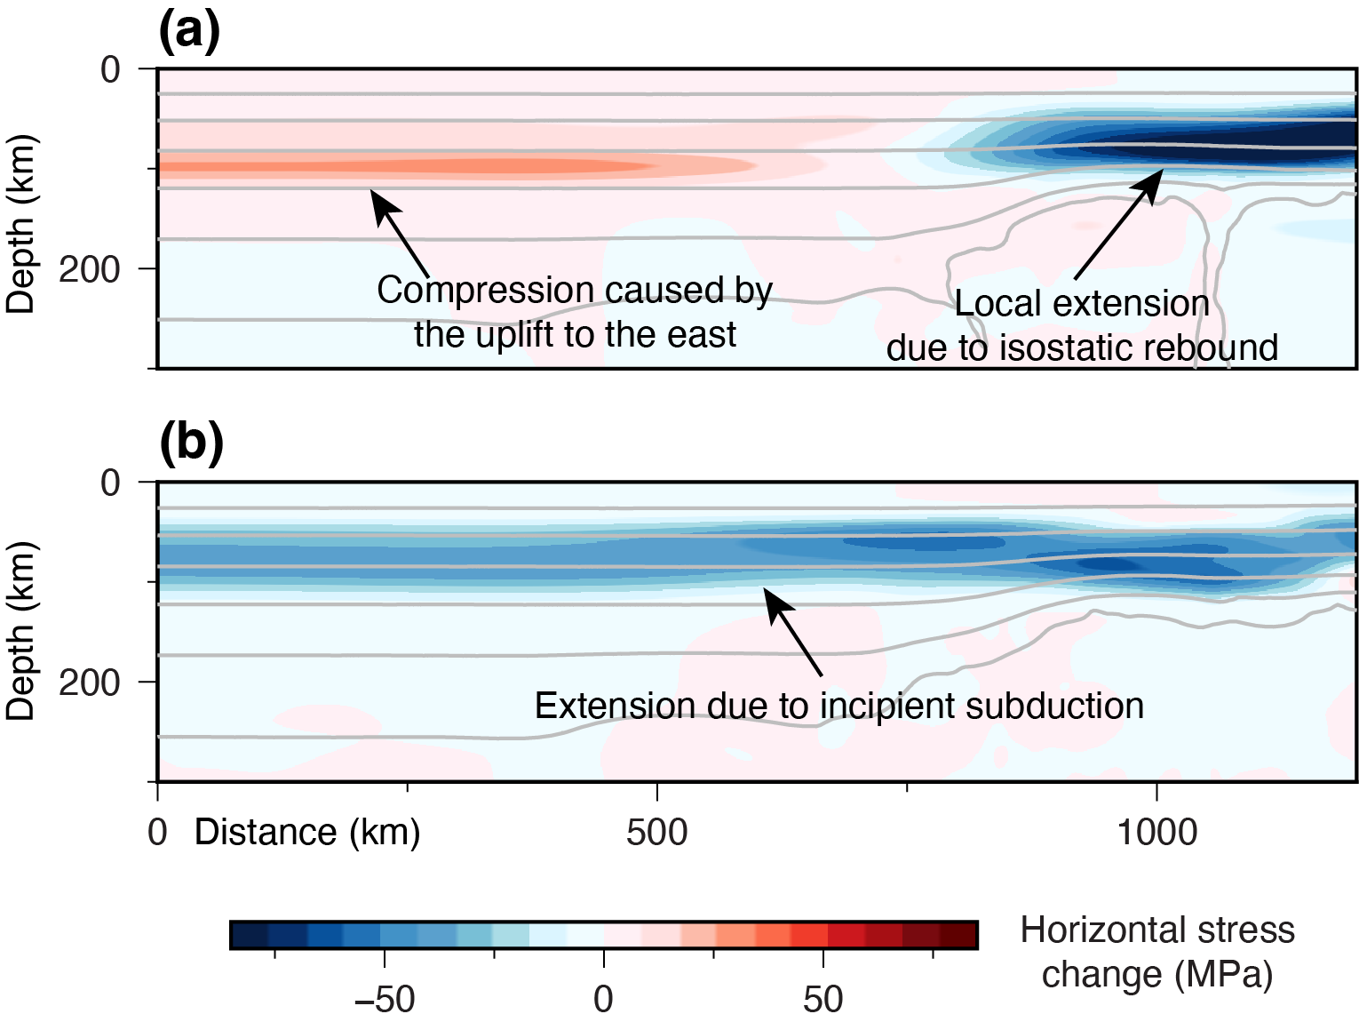

Extended Data Figure 7. Changes in continental stress state. Horizontal stress changes due to (a) the delamination of the dense lower CLM (difference between t = 32.6 and 0.1 Myr), and (b) the incipient subduction (difference between t = 44.3 and 32.6 Myr). The figures show horizontal stress changes in regions away from the evolving passive margin and the subduction zone. The dark gray lines are temperature contours at every 200˚C, at 32.6 Myr in (a) and 44.3 Myr in (b).
Parameters | Symbol | Dimensional value | Units
Earth radius | R₀ | 6371.0 | km
Reference density | ρ₀ | 3340.0 | kg·m⁻³
Thermal expansivity | α | 3.0e-5 | -
Thermal diffusivity | κ | 1.0e-6 | m²·s⁻¹
Gravitational acceleration | g | 9.81 | m·s⁻²
Reference viscosity | η₀ | 1.0e+21 | Pa·s
Temperature drop across mantle | ΔT | 2000.0 | ˚C
Mantle temperature | T_{m} | 1300.0 | ˚C
Maximum viscosity cutoff | η_{max} | 1.0e+25 | Pa·s
Minimum viscosity cutoff | η_{min} | 1.0e+18 | Pa·s

Extended Data Table 1. Physical parameters used in the numerical simulations.
Material | Density (kg/m³) | Compositional viscosity multiplier | Initial coefficient of friction | Min. coefficient of friction | Initial cohesion (MPa) | Min. cohesion (MPa) | Critical plastic strain
Mantle | 3340.0 | 1.0 | 0.1 | 0.01 | 40 | 10 | 0.2
CC | 2850.0 | 1.0e-3 | - | - | 40 | 40 | -
Upper CLM | variable | 10.0 | 0.1 | 0.01 | 40 | 10 | 0.2
Lower CLM | variable | 10.0 | 0.1 | 0.01 | 40 | 10 | 0.2
MLD | variable | 1.0 | - | - | 25 | 25 | -
OC | 3000.0 | 1.0e-5 | - | - | 10 | 10 | -
OLM | 3340.0 | 1.0 | 0.1 | 0.01 | 40 | 10 | 0.2
PM | 3340.0 | 1.0 | - | - | variable | variable | variable
Weak OLM | 3340.0 | 1.0 | - | - | 50 | 50 | -
Eclogite | 3440.0 | 1.0e-5 | - | - | 10 | 10 | -
Molten rock | 2900.0 | 1.0e-5 | - | - | - | - | -

Extended Data Table 2. Material properties used in the numerical simulations. CC: continental crust; CLM: cratonic lithospheric mantle; MLD: mid-lithospheric discontinuity; OC: oceanic crust; OLM: oceanic lithospheric mantle; PM: passive margin.

