Supplementary information
for
Alice Rhelly V. Carvalho^{a,b,†}, José Diogo E. Reis^{a,c,†}, Paulo Wender P. Gomes^{d,e,†,*}, Ariane Coelho Ferraz^{f}, Horrana A. Mardegan^{a,,g}, Marília Bueno da Silva Menegatto^{f}, Rafaela Lameira Souza Lima^{f}, Maria Rosilda V. de Sarges^{a,,g}, Sônia das G. S. R. Pamplona^{a,c}, Karen Sartori Jeunon Gontijo^{j}, José Carlos de Magalhães^{j}, Milton N. da Silva^{a,c}, Cintia Lopes de Brito Magalhães^{f,i} and Consuelo Yumiko Yoshioka e Silva^{a,b,g**}
ª Laboratory of Liquid Chromatography, Institute of Exact and Natural Sciences, Federal University of Pará, Belém 66075-110, Brazil
^{b} Faculty of Pharmacy, Institute of Health Sciences, Federal University of Pará, Belem, PA, Brazil
^{c} Chemistry Post-Graduation Program, Institute of Exact and Natural Sciences, Federal University of Pará, Belém 66075-110, Brazil
^{d} Collaborative Mass Spectrometry Innovation Center, University of California San Diego, La Jolla, CA 92093, USA
^{e} Skaggs School of Pharmacy and Pharmaceutical Sciences, University of California San Diego, La Jolla CA 92093, USA
^{f} Programa de Pós-Graduação em Ciências Biológicas, Núcleo de Pesquisas em Ciências Biológicas, Universidade Federal de Ouro Preto, Ouro Preto, Minas Gerais, Brazil
^{g} Pharmaceutical Sciences Post-Graduation Program, Institute of Health Sciences, Federal University of Pará, Belem, PA, Brazil
^{h} Instituto de Ciências da Saúde, Programa de Pós-Graduação em Ciências Farmacêuticas, Universidade Federal do Pará, Belém, Pará, Brazil
^{i} Programa de Pós-Graduação em Biotecnologia, Núcleo de Pesquisas em Ciências Biológicas, Universidade Federal de Ouro Preto, Ouro Preto, Minas Gerais, Brazil
^{j} Programa de Pós-Graduação em Biotecnologia, Universidade Federal de São João del-Rei, Minas Gerais, Brazil

† These authors contributed equally to this work.
*Corresponding author: Paulo Wender P. Gomes, Skaggs School of Pharmacy and Pharmaceutical Sciences, University of California San Diego, La Jolla CA 92093, USA. E-mail: wendergomes@health.ucsd.edu
**Corresponding author: Consuelo Y. Y. e Silva, Institute of Health Sciences, Federal University of Pará, Cidade Universitária José Silveira Neto, Belém, Pará, 66075-110, Brazil. E-mail: yumikoyoshioka@yahoo.com.br
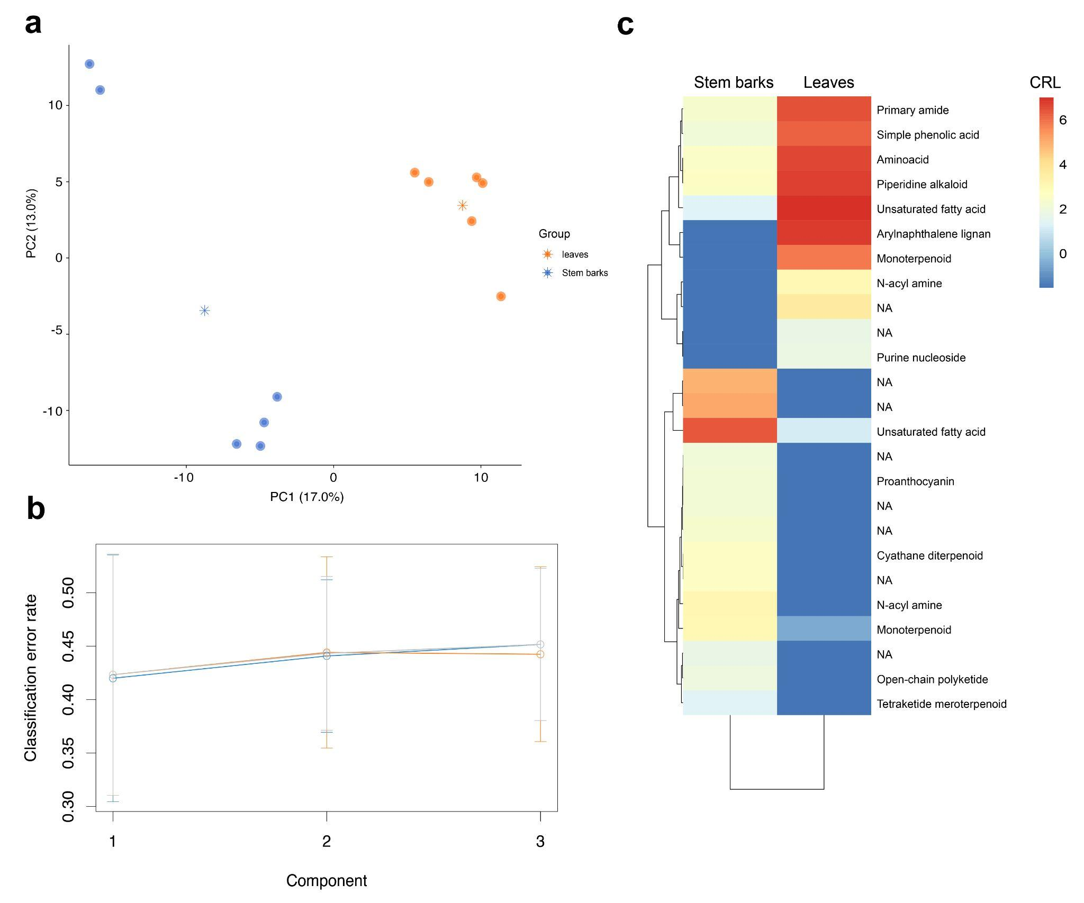
Figure S1. PLS-DA and main metabolites extracted from the PLS-DA model based on variable importance. a) PLS-DA chart between Stem barks and leaves samples. b) Performances of the PLS-DA CRL model. c) Heatmap containing the top 25 features with VIP scores > 1.5 extracted from pairwise PLS-DA models. CANOPUS was used for the chemical ontology classification. The asterisks in the PLS-DA plot represent group centroids. NA: No assignment

Table S1. PLS-DA VIP score list. 25 features with variable importance projection (VIP) scores > 1.5 were extracted from the pairwise PLS-DA model between leaves and stem barks samples.
Feature ID_m/z | VIP score | Group contributing | CANOPUS class | Annotation
116_413.2670 | 2.43357458 | Stem barks | Monoterpenoid | NA
269_543.1499 | 2.36668362 | Leaves | NA | 5- O-β-d-Glucopyranosyljusticidin B
98_381.0971 | 2.34222885 | Stem barks | ArylnaphtHELene lignan | Justicidin H
285_617.5226 | 2.081211 | Leaves | NA | NA
278_571.3145 | 2.06259951 | Leaves | Cyathane diterpenoid | NA
181_663.4544 | 2.03890256 | Stem barks | Unsaturated fatty acid | NA
264_513.1369 | 1.97779902 | Leaves | NA | Tuberculatin
328_439.3569 | 1.97754509 | Stem barks | NA | Olean-12-en-28-oic acid
167_579.2936 | 1.75659538 | Stem barks | Simple phenolic acid | NA
20_245.2276 | 1.71377054 | Stem barks | Primary amide | NA
43_279.2322 | 1.71114048 | Stem barks | N-acyl amine | NA
12_226.2177 | 1.67220003 | Stem barks | Piperidine alkaloid | Suspect to 9-Octadecenamide – 56.06 Da (C₄H₈)
191_803.5443 | 1.66232349 | Stem barks | Aminoacid | NA
232_298.2750 | 1.66034559 | Leaves | Proanthocyanin | NA
345_614.4787 | 1.64606556 | Stem barks | Purine nucleoside | NA
170_609.2725 | 1.64519475 | Leaves | Alkaloid | 10-Hidroxyphaeophorbide
309_315.1558 | 1.63869185 | Stem barks | NA | NA
376_287.0561 | 1.63580907 | Leaves | NA | NA
407_381.0966 | 1.6351311 | Leaves | N-acyl amine | NA
444_727.2062 | 1.6316755 | Leaves | NA | Suspect to Kaempferol 3-O-rutinoside – 132.04 Da (C₅H₈O₄)
411_469.3271 | 1.62561635 | Leaves | Tetraketide meroterpenoid | NA
410_453.1205 | 1.61807806 | Leaves | Open-chain polyketide | NA
463_278.2189 | 1.61161249 | Leaves | NA | NA
455_163.0757 | 1.60852632 | Leaves | NA | NA
7_219.1748 | 1.6000289 | Leaves | Monoterpenoid | NA
NA: No assignment

Data availability
1. Molecular network job (accessed on: 04/04/2023)
https://gnps.ucsd.edu/ProteoSAFe/status.jsp?task=259e8db6fb8f40eb9bcfe534323dac58
2. MolNetEnhancer job (accessed on: 04/04/2023)
https://gnps.ucsd.edu/ProteoSAFe/status.jsp?task=e3c4c4c1f3e646188fba8371df917e0b

