Supplementary Information
Many parts of the world are already outside the safe and just ESB for surface water and groundwater (Fig. S1). Over 4 billion people live in catchments where annual discharge is outside the safe and just ESB for surface water (Table S1). This is particularly acute in densely populated arid, and agricultural regions. For example, substantial areas of flow alteration are predominantly seen in the Western industrialized nations as well as most of Central and Southeast Asia and Australia (Fig. S1a) affecting approximately half of the population in those regions (Table S1). In addition to exceeding the ESB for surface water, almost half of the world’s population live in catchments that are outside the ESB for groundwater (Table S1), evident where drawdown is exceeding recharge over the longer term, leading to declining GW storage (Fig. S1b). The combination of exceeding the ESBs for surface and groundwater affects approximately 2 billion people (~25%) that tend to be centred around dry regions and the large population centres of the globe, including parts of the Middle East and East Asia. Relatively small proportions of the populations of Africa and the Americas live under these conditions (Table S1). In addition to these current levels of surface water alteration that exceed the ESB, there are also substantial challenges to providing even the minimum access levels of water.

Table S1. Populations living in catchments where we are currently outside the safe and just ESBs for blue water. Population numbers are in millions and numbers in parentheses show the proportion of the global continental populations as at 2020.
 | Global | Africa | Asia | Australia | Europe | North America | South America
Surface water | 4,203  (0.52) | 605  (0.44) | 2,750  (0.58) | 0.2  (0.01) | 357  (0.5) | 301  (0.48) | 185  (0.42)
Groundwater | 3,787  (0.48) | 142  (0.10) | 2,811  (0.59) | 13  (0.62) | 559  (0.77) | 120  (0.19) | 141  (0.32)
Surface and groundwater | 1,844  (0.23) | 7  (0.002) | 1,419  (0.30) | 0.006  (<0.001) | 306  (0.42) | 70  (0.11) | 40  (0.09)

Table S2. The proportion of catchments in each continent where the different access needs cannot be met from surface water alone.
 | Global | Africa | Asia | Australia | Europe | North America | South America
Domestic access Level 1 | 0.032 | 0.122 | 0.045 | 0.045 | 0.001 | 0.003 | 0.031
Domestic access Level 2 | 0.037 | 0.138 | 0.05 | 0.046 | 0.003 | 0.004 | 0.038
All needs access Level 1 | 0.048 | 0.178 | 0.066 | 0.051 | 0.017 | 0.006 | 0.046
All needs access Level 2 | 0.053 | 0.193 | 0.07 | 0.053 | 0.023 | 0.008 | 0.054

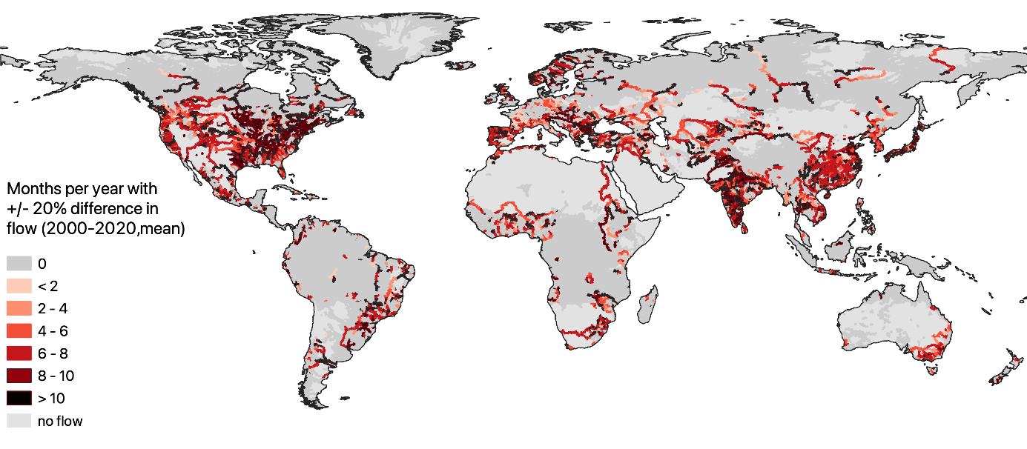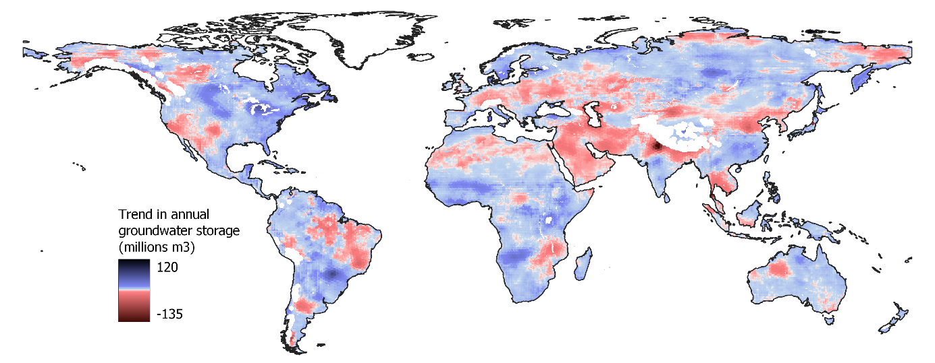
Fig. S1. a) The average number of months of the year that surface water flows are outside the safe and just ESB; and b) the long-term annual trend in groundwater storage, showing regions where groundwater is already in decline indicating they are currently outside the safe and just ESB.

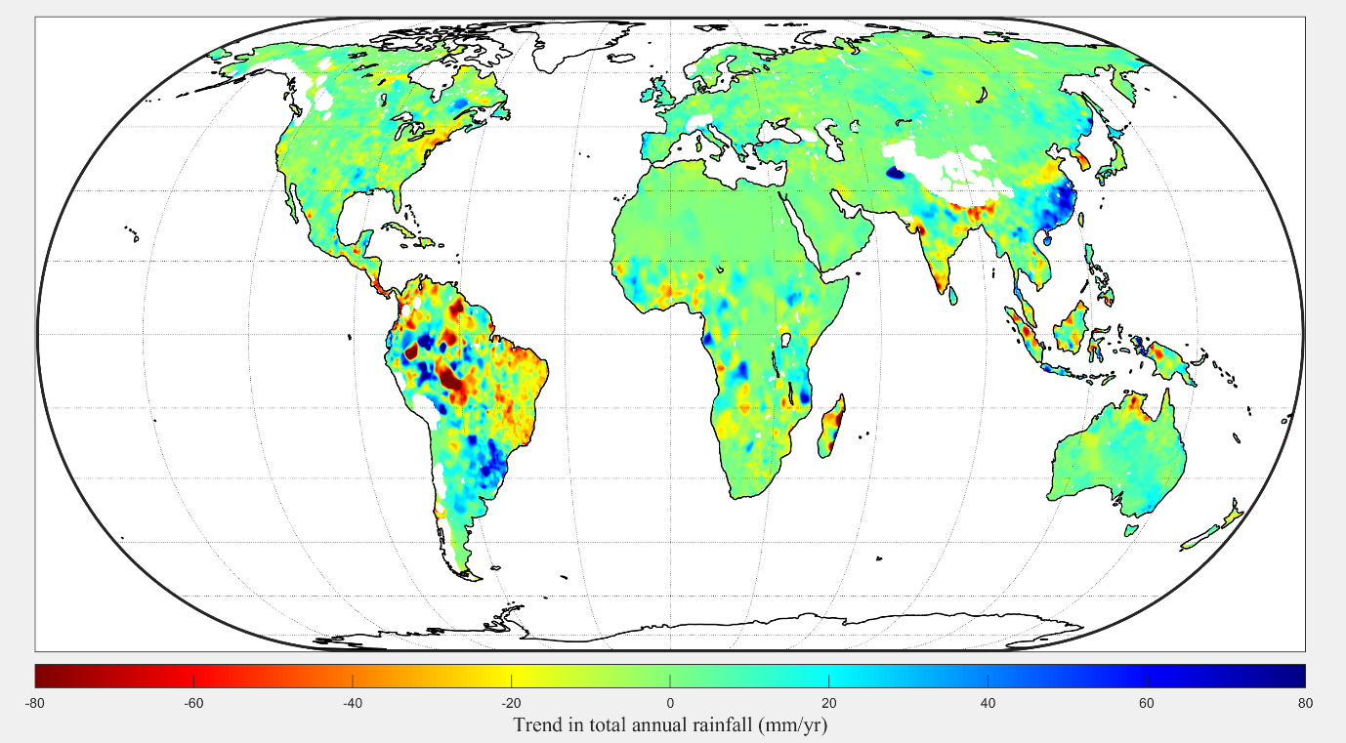
Fig. S2. Trend in annual rainfall between 2003-2016

