SUPPLEMENTARY INFORMATION

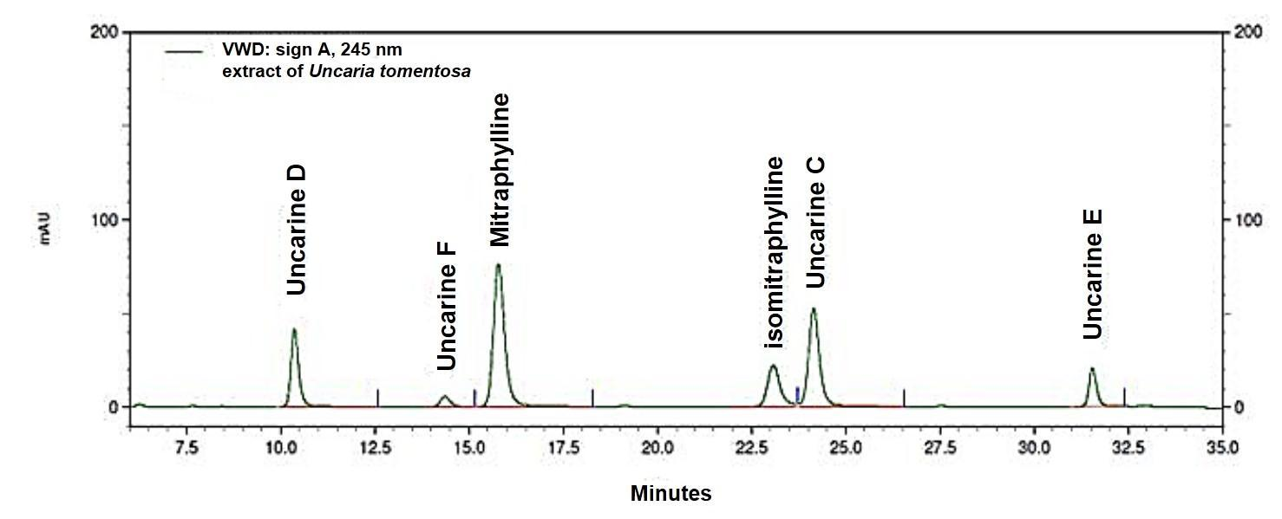
SI 1: Chromatogram of Uncaria tomentosa crude extract used in the experiments, showing most of the alkaloids such as uncarine D, uncarine F, isomitraphylline, uncarine C, uncarine E, as well as mitraphylline (5.97%), which is a major component of the oxindole alkaloids. The crude extract compounds presented until one hundred milli-Absorbance Units (mAU), for thirty-five minutes, measured by high-performance liquid chromatography (HPLC).

