Supplementary information
Populations targeted by conservation
Mammals had the highest number of populations in the LPD subject to conservation management, albeit across a relatively low number of species (nspp (number of species) = 244, npops (number of populations) = 2,200), followed by fish (nspp = 548, npops = 1,994), birds (nspp = 305, npops = 756), reptiles (nspp = 58, npops = 220), and amphibians (nspp = 52, npops = 73) (See Fig. S2 for taxonomic breakdown of the groups, Fig. S4 for distribution of managed vs unmanaged populations, Fig. S5 for the length of the population time series, and Fig. S6 for first recorded year of each population).
Taxonomic classes categorized into groups
We categorized Actinopteri, Coelacanthi, Dipneusti, Elasmobranchii, Holocephali, Myxini and Petromyzonti together as ‘fish’, Aves as ‘birds’, Mammalia as ‘mammals’, Reptilia as ‘reptiles’ and Amphibia as ‘amphibians’.
Caveats
The management actions used in this analysis are recorded from information in the LPD and, in few instances, from external sources online. SJ and MH have made every effort to correctly code the actions based on information available in the LPD, original sources and additional online material. However, some errors may remain as management actions have not been coded according to consistent categories. This means that management actions may be in place for some populations but are missing from the LPD (omission error). Also, management actions may be documented in place, but are relatively trivial / inconsequential to the population (commission error) – our analysis treats all actions as equal importance. Furthermore, management information may be documented, but may not reflect all actions in place for that population. Additionally, conservation actions apply only to the population during that time-series time-period.
Validating the link between conservation actions and reasons for population increase
For the selected subsample used to estimate the impact of conservation on the global index, we validated the link between conservation actions and population increases. A potential concern was whether the reasons for population increases listed in the original sources and the conservation actions that we categorized matched. A mismatch between the selected populations’ reasons for population increase and the targeted conservation actions would either mean that (i) the recorded conservation actions did not cause the population increase or (ii), that conservation actions were missing from the original sources or not categorized accordingly. We verified whether the targeted conservation actions and reasons for increase aligned, effectively meaning that conservation likely caused the population increase, by comparing the frequency at which conservation actions and different reasons for population increase were recorded for populations (Fig. S7). If population increases were caused by conservation actions, we would expect a higher frequency at which specific reason for increase logically caused by a certain conservation action and that specific conservation action occurred. For example, we would expect increasing populations targeted by effective legislation to have legal protection listed as the reason for increase. For each population, unique combinations of the selected reasons for population increase and primary conservation type were expanded into separate rows, each row representing a unique combination of a single reason listed as the cause of population increase and a single recorded conservation action. The frequency of unique combinations was then summarized into a frequency table which we used to visualize the frequency at which each of the primary conservation actions occurred relative to each of the selected reasons for increases.

Supplementary tables and figures
Table S1
Variable | Description | Reason for inclusion | Liberal | Benchmark | Stringent
Species | Taxonomic information according to the latest authority for that class | Populations from the same species are likely to respond similarly to external effects of climate, land-use changes etc. | x | X | X
Genus | Taxonomic information according to the latest authority for that class | Populations from the same genus are likely to respond similar to external effects of climate, land-use changes etc. | X
Country | The country (or countries) that the population occurs in from the list. Marine data are allocated a country if it is within its EEZ (see map), or as International Waters. Multiple countries are selected in order of proportion of the population it represents starting with the greatest. | Populations within the same country are more likely to be influenced by country-specific norms, rules and legislation | x | X | X
Region | The political region a country is assigned to. | Populations within the same region are more likely to be influenced by country-specific norms, rules and legislation | X | x | x
First year of observation | The first recorded year with an abundance estimate for a given populaiton | Ensures that populations which start in proximate years are matched | X | X | X
Last year of observation | The last recorded year with an abundance estimate for a given populaiton | Ensures that populations which end in proximate years are matched | X | X | X
Number of observation | The number of annual abundance estimates for a given population | Ensures that populations with similar level of information are matched | X | X | X

Table S2 Types of population abundance data that meets the data standards for tracking trends in the abundance of species populations (Accepted) and that does not meet the data standards (Not accepted)

Table S3 Table of the information extracted from the LPD on the variables used for categorizing conservation actions and analysis.
Variable | Description
Species | Taxonomic information according to the latest authority for that species
Genus | Taxonomic information according to the latest authority for that genus
Class | Taxonomic information according to the latest authority for that class. Coding: 'Actinopteri', 'Coelacanthi', 'Dipneusti', 'Elasmobranchii', 'Holocephali', 'Myxini', 'Petromyzonti', 'Amphibia', 'Aves', 'Mammalia', 'Reptilia'.
Country | The country (or countries) that the population occurs in from the list. Marine data are allocated a country if it is within its EEZ, or as International Waters. Multiple countries are selected in order of proportion of the population it represents starting with the greatest.
Region | The political region a country is assigned to. Coding: 'Africa', 'Antarctic', 'Asia', 'Europe', 'International Waters', 'Latin America and Caribbean', 'North America', 'Oceania'
First year of observation | The first recorded year with an abundance estimate for a given population
Time series length | The number of years from first to last population abundance estimate
Managed | A population that receives targeted management (e.g. supplementary feeding, reintroduction). This is usually to promote recovery in a population or can incentivise its use for conservation. It can include measures to stem ‘unsustainable’ population growth. This is based on information in the data source. Coding: ‘Yes’, ‘No’, ‘Unknown’
Utilised | A population that is intentionally regularly or systematically utilised, either individuals or eggs. This may be sustainable or unsustainable, and the population does not necessarily have to be threatened by use or be overexploited. This refers to consumptive use whereby individuals or parts of individuals are removed from the wild. This is based on information in the data source. Coding: ‘Yes’, ‘No’, ‘Unknown’
Reason for population increase | Indicates the reasons given by the data source for any increase in the population. Coding: 'Introduction', 'Recolonisation', 'Recruitment', 'Removal of threat', 'Rural to urban migration', 'Reintroduction', 'Range shift', 'Legal protection', 'Management', 'Other', 'Unknown'.

Table S4 Parameter estimates for the seven primary types of conservation actions, research, utilization status and time series length.
Estimate Std. Error t value
Utilised -0.0091880 0.0112007 -0.820
Ts length 0.0014400 0.0006965 2.067
Land water protection 0.2253907 0.1165584 1.934
Land water management 0.2003847 0.0306416 6.540
Species management 0.1153678 0.0254073 4.541
Education awareness -0.0118926 0.1442860 -0.082
Law policy 0.0209303 0.0383110 0.546
Incentives 0.0094938 0.1945584 0.049
External capacity 0.4269375 0.4397941 0.971
Research -0.2371960 0.0762102 -3.112

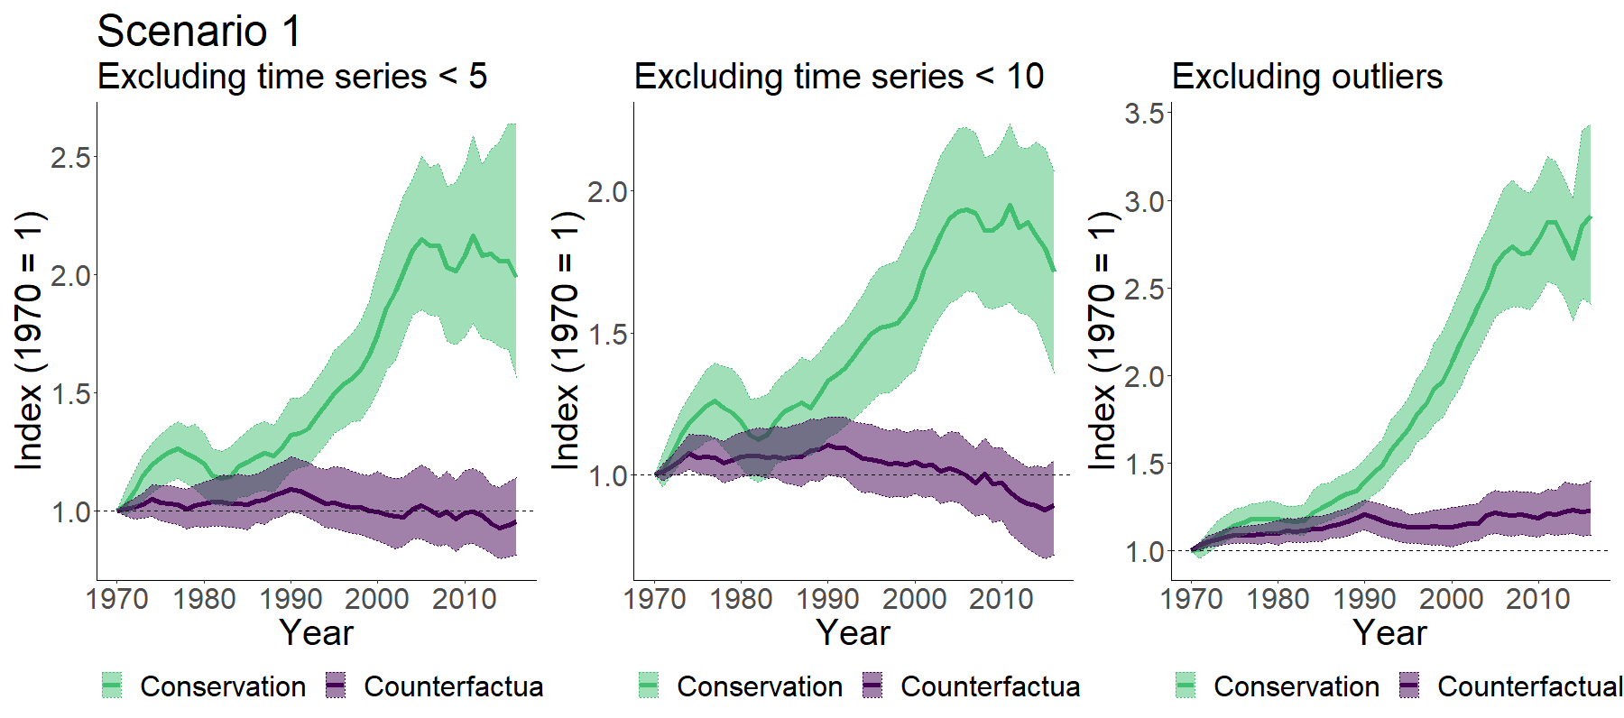
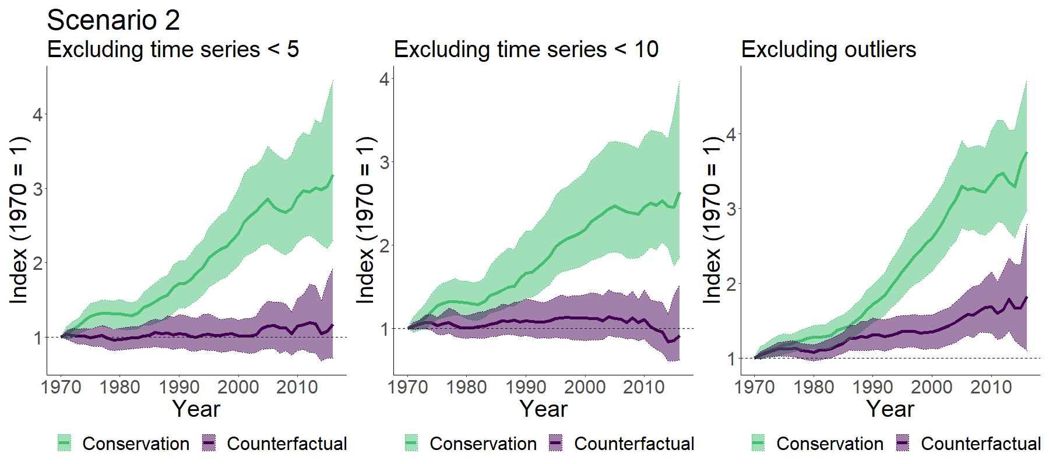

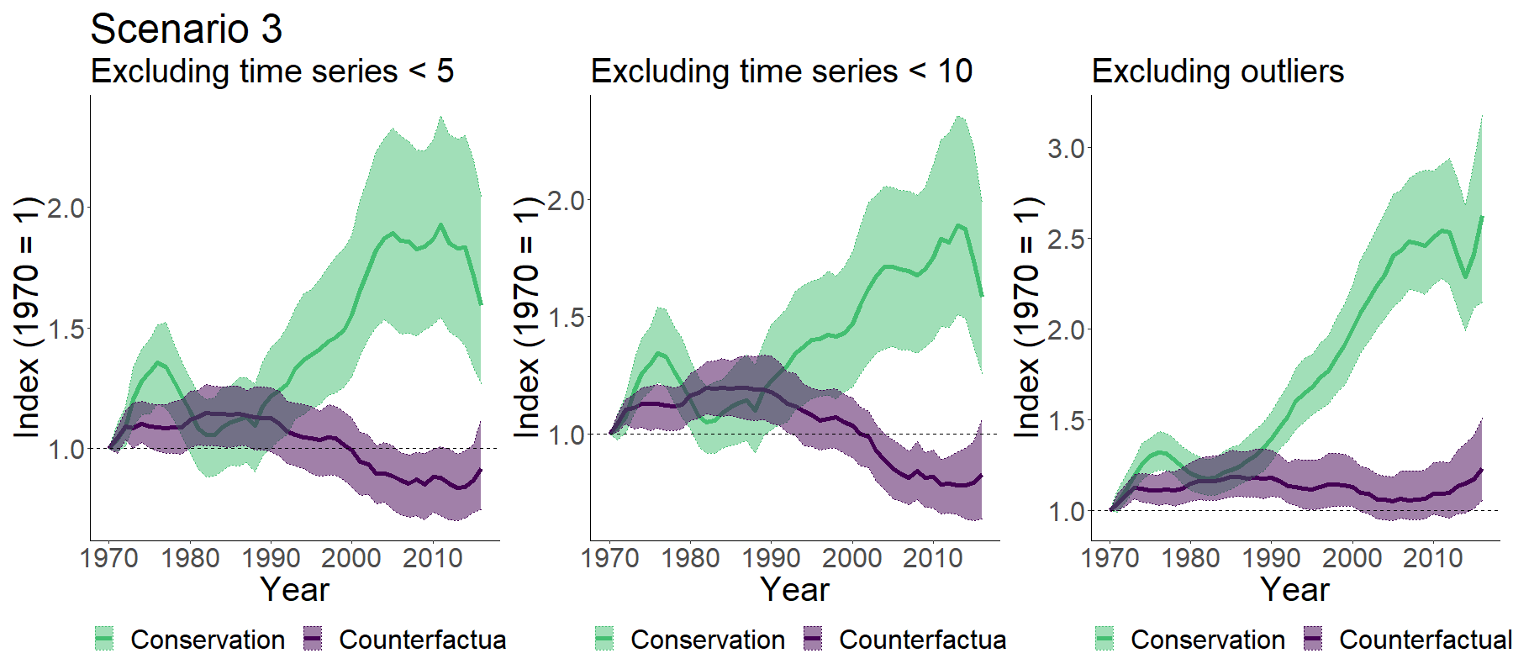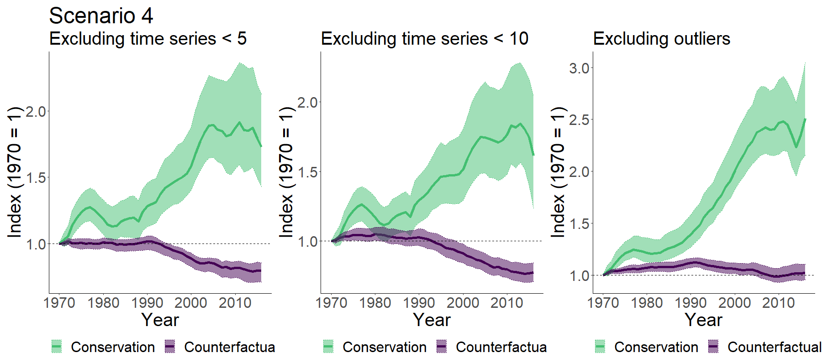
Figure S1 Sensitivity test for the four scenarios. Trends were calculated excluding populations covering less than five and ten years and excluding species with populations in the top and bottom 1% annual population change quantiles.

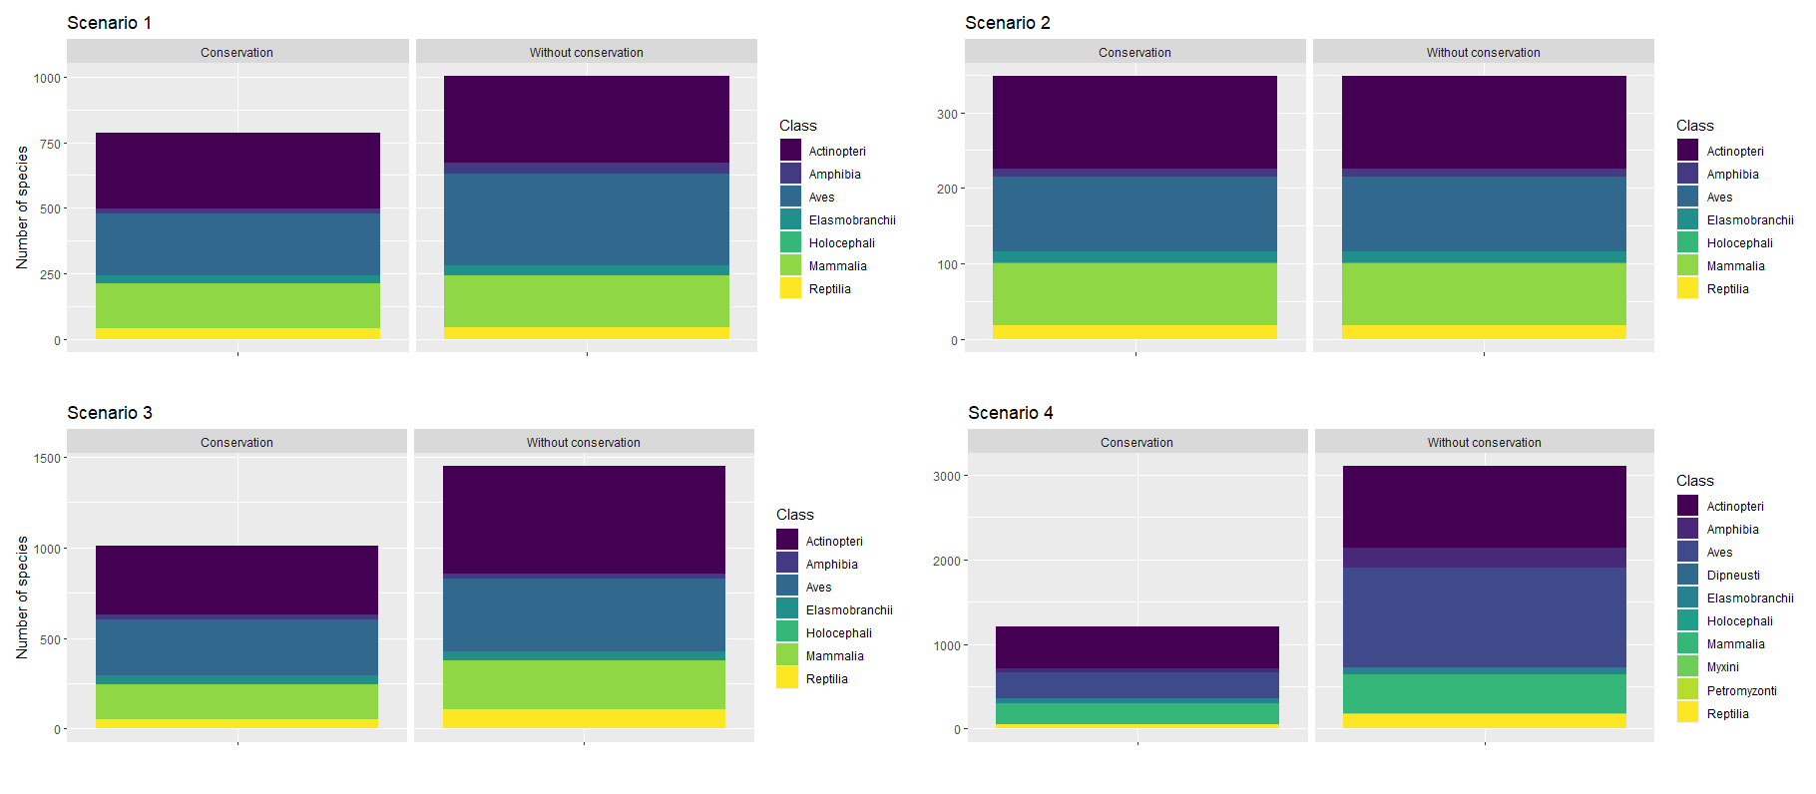
Figure S2 Number of species within each taxonomical class for each scenario.

Figure S3. Number of targeted populations and the relative percentage of detailed conservation actions for taxonomic classes. For each of the taxonomic classes with targeted conservation actions, the x-axis shows the percentage of populations targeted by the detailed conservation actions and research (Salafsky et al. 2008). The number of targeted populations is shown for each bar.
Figure S4. Locations of managed (n = 5,243) and unmanaged populations (n = 9,086).

Figure S5. Length (in years) of each managed population.

Figure S6. Starting year of each managed population.

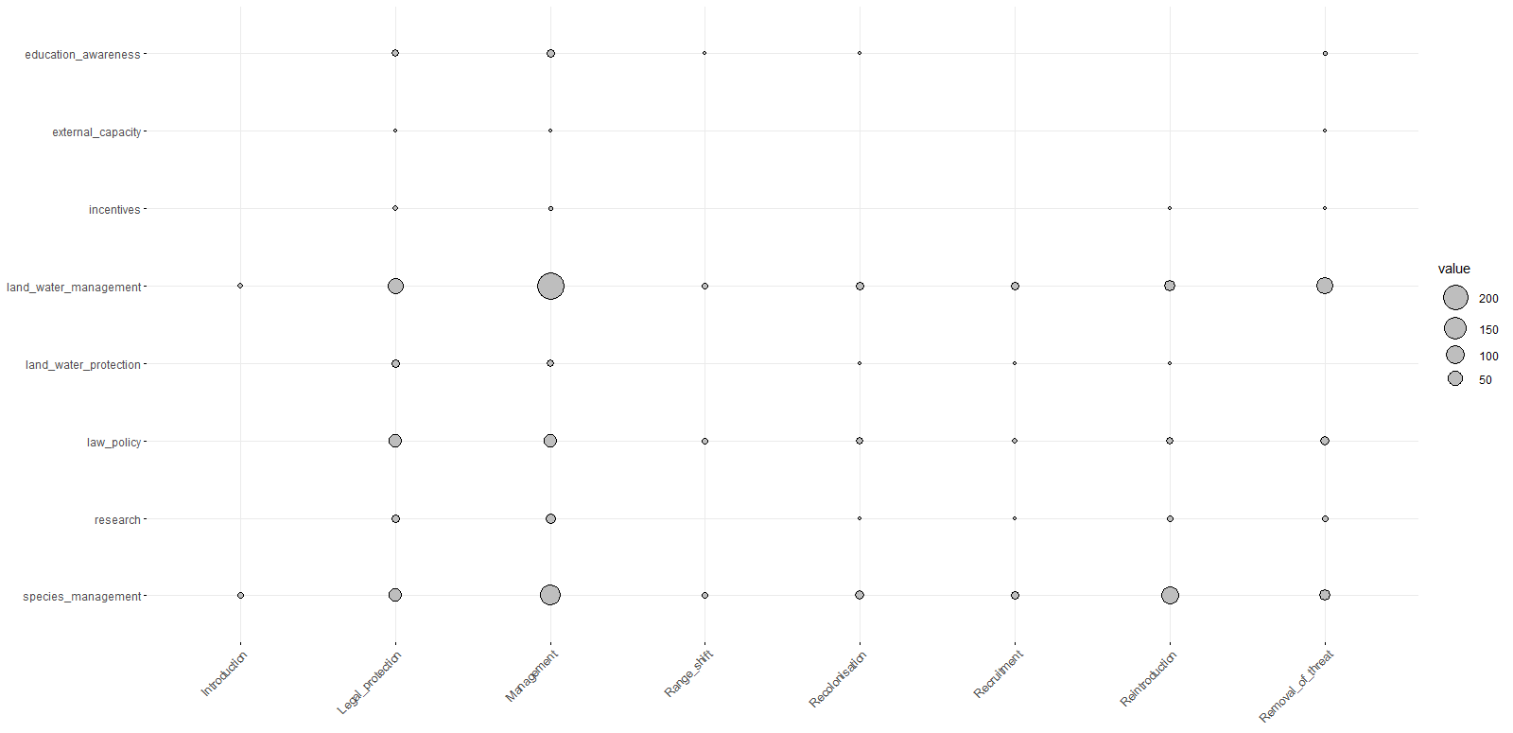
Figure S6 Combination frequencies for conservation actions (y-axis) and reasons for increase listed in the LPD (x-axis).

