Supplementary materials
A sex-specific trade-off between pesticide resistance and thermal tolerance in Tetranychus urticae

Table of contents

Table S1 Number of replicates analysed in each experiment performed …………………………….. 2
Table S2 Survival and oviposition of adult females exposed to different temperatures .……………... 4
Table S3 Description of the statistical models used to analyse the effect of high developmental temperatures on life-history traits ..……………………………………………………………………. 5
Table S4 Description of the statistical models used to analyse the interaction between pesticide resistance and the response to high developmental temperature ...……………………………………. 6
Fig. S1 Detailed backcross procedure used to create the Wi.RR population replicates ………………. 7

Table S1 Number of replicates analysed in each experiment performed. a) the effect of high developmental temperatures on life-history traits; b) the effect of the interaction between pesticide resistance and high developmental temperature on life-history traits. “Resistance status”: the individuals tested could be from a population resistant or susceptible to the pesticide etoxazole; “Treatment”: developmental temperatures (25, 33, 35, 36 or 37°C in a), and 25 or 36°C in b)) of the offspring (in variables “Developmental time (♀) and (♂)” and “Number of surviving juveniles”) or of the female and male crossed (in variables “Daily fecundity”, “Offspring number” and “Offspring sex ratio”). In all response variables, replicates with damaged (i.e., hurt during manipulation) mothers (in variables “Developmental time (♀) and (♂)” and “Number of surviving juveniles”) or damaged individuals forming the mating pairs (in variables “Daily fecundity”, “Offspring number” and “Offspring sex ratio”) were excluded from the analyses; in all response variables except “Daily fecundity”, females that did not lay eggs were excluded from the analyses. ª Due to the low number of replicates (see Table S2), 37°C was not considered in the statistical analyses. ^{b} Due to logistic constraints, temperatures were not tested simultaneously; instead, three assays were performed, always including the control temperature, and testing 33 and 37 together, 35 alone or 36°C alone; as such, three values are provided, each corresponding to a different assay following the previously stated order. ^{c} The values of offspring number and sex ratio were taken from the same patches

a)
Response Variable | Resistance status | Treatment | No. of replicates
Developmental time (♀) ª | Susceptible | 25 | 31/32/31 ^{b}
Developmental time (♀) ª | Susceptible | 33 | 21
Developmental time (♀) ª | Susceptible | 35 | 23
Developmental time (♀) ª | Susceptible | 36 | 23
Developmental time (♂) ª | Susceptible | 25 | 29/31/30 ^{b}
Developmental time (♂) ª | Susceptible | 33 | 20
Developmental time (♂) ª | Susceptible | 35 | 23
Developmental time (♂) ª | Susceptible | 36 | 22
Number of surviving juveniles ª | Susceptible | 25 | 31/32/31 ^{b}
Number of surviving juveniles ª | Susceptible | 33 | 22
Number of surviving juveniles ª | Susceptible | 35 | 30
Number of surviving juveniles ª | Susceptible | 36 | 30
Daily fecundity | Susceptible | ♀25 x ♂25 | 37/36/36 ^{b}
Daily fecundity | Susceptible | ♀33 x ♂25 | 33
Daily fecundity | Susceptible | ♀35 x ♂25 | 34
Daily fecundity | Susceptible | ♀36 x ♂25 | 34
Daily fecundity | Susceptible | ♀37 x ♂25 | 39
Offspring number | Susceptible | ♀25 x ♂25 | 37/36/33 ^{b}
Offspring number | Susceptible | ♀33 x ♂25 | 33
Offspring number | Susceptible | ♀35 x ♂25 | 28
Offspring number | Susceptible | ♀36 x ♂25 | 31
Offspring number | Susceptible | ♀37 x ♂25 | 25

b)
Response Variable | Resistance status | Treatment | No. of replicates
Developmental time (♀) | Susceptible | 25 | 28
Developmental time (♀) | Susceptible | 36 | 20
Developmental time (♀) | Resistant | 25 | 28
Developmental time (♀) | Resistant | 36 | 21
Developmental time (♂) | Susceptible | 25 | 26
Developmental time (♂) | Susceptible | 36 | 20
Developmental time (♂) | Resistant | 25 | 27
Developmental time (♂) | Resistant | 36 | 22
Number of surviving juveniles | Susceptible | 25 | 28
Number of surviving juveniles | Susceptible | 36 | 28
Number of surviving juveniles | Resistant | 25 | 29
Number of surviving juveniles | Resistant | 36 | 29
Offspring number and  Offspring sex ratio ^{c} | Susceptible | ♀25 x ♂25 | 38
Offspring number and  Offspring sex ratio ^{c} | Susceptible | ♀25 x ♂36 | 40
Offspring number and  Offspring sex ratio ^{c} | Susceptible | ♀36 x ♂25 | 24
Offspring number and  Offspring sex ratio ^{c} | Susceptible | ♀36 x ♂36 | 21
Offspring number and  Offspring sex ratio ^{c} | Resistant | ♀25 x ♂25 | 39
Offspring number and  Offspring sex ratio ^{c} | Resistant | ♀25 x ♂36 | 40
Offspring number and  Offspring sex ratio ^{c} | Resistant | ♀36 x ♂25 | 13
Offspring number and  Offspring sex ratio ^{c} | Resistant | ♀36 x ♂36 | 18

Table S2 Survival and oviposition of adult females exposed to different temperatures. Females developed at 25°C in cohorts were maintained at 25°C or were transferred to one of the four high temperatures (33, 35, 36 or 37°C) for 3 days, after which they were isolated to oviposit for 24 hours at the same temperature. A minimum of 60 and a maximum of 200 females were transferred to high temperature for 3 days. “No. alive ♀ at the time of isolation”: a maximum of 32 alive adult females (i.e., maximum number of replicates created) were isolated on a patch after 3 days at high temperature. “No. ovipositing ♀ (% ovipositing ♀)”: number and proportion of females that laid at least one egg during the oviposition period. At 37°C, the survival and probability of ovipositing of adult females was very low, which led to the exclusion of the data obtained at this temperature from the experiment. ª Due to logistic constraints, temperatures were not tested simultaneously; instead, three assays were performed, always including the control temperature. 33 and 37°C were tested together, and 35 and 36°C were tested alone. As such, three values are provided, each corresponding to a different assay following the previously stated order.

Temperature | No. alive ♀ at the time of isolation | No. ovipositing ♀  (% ovipositing ♀)
25°C | 32/32/32 ª | 31/32/31 ª (96.9/100/96.9%)
33°C | 26 | 22 (84.6%)
35°C | 32 | 30 (93.8%)
36°C | 32 | 32 (100%)
37°C | 6 | 3 (50%)

Table S3 Description of the statistical models used to analyse the effect of high developmental temperatures on life-history traits. “Sample size”: total number of replicates included in each analysis. “Maximal model”: complete set of explanatory variables included in the model. “Minimal model”: model containing only the variables that were statistically significant; round brackets indicate that the variable was included as a random factor. Within R subroutine, “lm”: linear model, “lmer”: linear mixed-effects model. Square brackets indicate the error structure (“g”: gaussian). “Developmental temperature”: temperature at which eggs were exposed until adulthood; “Fecundity”: the difference between the number of eggs laid at a high temperature and the mean number of eggs laid at control temperature (25°C); “Temperature of pair”: developmental temperature of both females and males paired to mate and oviposit (offspring developed at 25°C). “$\overline{x}$”: mean trait value. ª only includes replicates in which fecundity was above zero. ^{b} due to the low number of replicates (see Table S2), 37°C was not considered in the statistical analyses. Replicates with damaged mothers or individuals forming the mating pairs were excluded in all analyses

Var. of interest | Response variable | Sample size | Maximal model | Minimal model | R subroutine [err struct.]
Developmental time (♀) | Day of 1st adult ♀ at high developmental temperature - $\overline{x}$(day of 1st adult ♀ at 25°C) | 161 ^{a, b} | Developmental temperature | Developmental temperature | lm [g]
Developmental time (♂) | Day of 1st adult ♂ at high developmental temperature - $\overline{x}$(day of 1st adult ♂ at 25°C) | 155 ^{a, b} | Developmental temperature | Developmental temperature | lm [g]
Number of surviving juveniles | Adult offspring at high developmental temperature - $\overline{x}$(adult offspring at 25°C) | 176 ^{a, b} | Developmental temperature + (Fecundity) | Developmental temperature + (Fecundity) | lmer [g]
Daily fecundity | Daily fecundity from ♀ developed at high temperature - $\overline{x}$(daily fecundity from ♀ developed at 25°C) | 249 | Temperature of pair | Temperature of pair | lm [g]
Offspring number | Adult offspring from ♀ developed at high temperature - $\overline{x}$(adult offspring from ♀ developed at 25°C) | 223 ª | Temperature of pair | Temperature of pair | lm [g]

Table S4 Description of the statistical models used to analyse the interaction between pesticide resistance and the response to high developmental temperature. “Sample size”: total number of replicates included in each analysis. “Maximal model”: complete set of explanatory variables included in the model. “Minimal model”: model containing only the variables that were statistically significant. Round brackets indicate that the variable was included as a random factor. Within R subroutine, “glm”: general linear model, “glmer” and “glmmTMB”: general mixed-effects models. Square brackets indicate the error structure used (“p”: Poisson; “qp”: quasi-Poisson; “bbI”: beta-binomial, accounting for zero inflation). “Developmental temperature”: temperature at which eggs were exposed until adulthood; “Resistance status”: resistance or susceptibility to etoxazole; “Fecundity”: number of eggs laid for four days; “♂”: number of sons; “♀”: number of daughters. “♀ temperature”: developmental temperature of the females paired with males to mate and oviposit (offspring developed at 25°C); “♂ temperature”: developmental temperature of the males paired with females to mate and oviposit (offspring developed at 25°C); “Age of male”: Age at which each male was paired; “Age of female”: Age at which each female was paired. All analyses include only replicates in which fecundity was above zero. Replicates with damaged mothers or individuals forming the mating pairs were excluded all analyses

Var. of interest | Response variable | Sample size | Maximal model | Minimal model | R subroutine [err struct.]
Developmental time (♀) | Day of first adult female | 97 | Developmental temperature *  Resistance status | Developmental temperature | glm [p]
Developmental time (♂) | Day of first adult male | 95 | Developmental temperature *  Resistance status | Developmental temperature | glm [p]
Number of surviving juveniles | Number of adult offspring | 114 | Developmental temperature *  Resistance status + (Fecundity) | Developmental temperature + (Fecundity) | glmer [p]
Offspring number | Number of adult offspring | 233 | ♀ temperature * ♂ temperature * Resistance status + (Age of male) + (Age of female) | ♀ temperature + ♂ temperature * Resistance status | glmmTMB [qp]
Offspring sex ratio | cbind (♀, ♂) | 233 | ♀ temperature * ♂ temperature * Resistance status + (Age of male) + (Age of female) | ♀ temperature + ♂ temperature * Resistance status | glmmTMB [bbI]

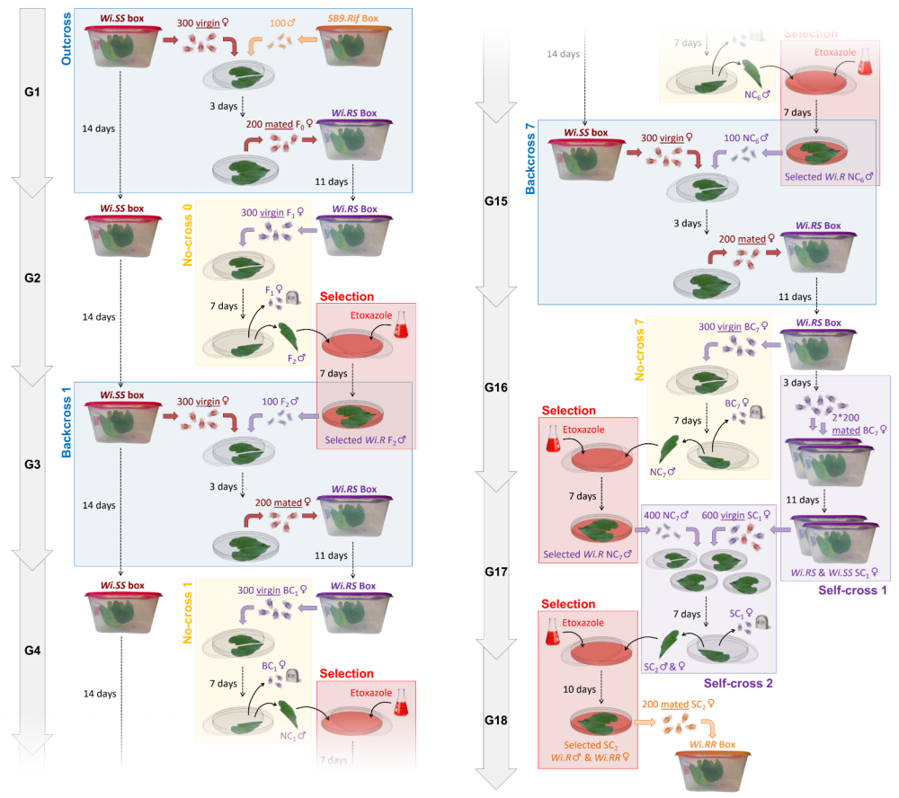
Fig. S1 Detailed backcross procedure used to create the Wi.RR population replicates. For each population replicate, F0 crosses (left panel) were performed by mixing 300 quiescent females (i.e., female nymphs undergoing their last moulting stage) from each Wi.SS population box with 100 males from the SB9.rif donor strain, into a petri dish containing a bean leaf placed on water-saturated cotton. Females emerged as adult virgins and could mate for 3 days, after which 200 of them were transferred to an experimental box (14 × 14 × 20 cm) containing two 17-day-old bean plants whose stem was imbibed in wet cotton. Eleven days later, 300 quiescent females were collected from each experimental box for a first ‘no-cross’ (NC) step. These females were placed without males (to remain virgin when emerging as adult) into a petri dish containing a bean leaf placed on water-saturated cotton and could lay eggs for 7 days (T. urticae is haplodiploid so virgin females produce male offspring). Selection was then applied to the offspring (all males) by transferring the bean leaf into a new petri dish containing cotton soaked with a 0.5g/L lethal concentration of etoxazole (trade name Borneo) (cf. van Leeuwen et al. 2012). Seven days later, 100 adult males (all resistant) were collected from this petri dish and back-crossed (BC) with 300 quiescent females collected from each Wi.SS population box (following the same procedure than for F0 crosses). The sequence ‘no-cross, selection, backcross’ was then repeated for six additional generations. At the seventh generation of backcross (right panel), all remaining BC₇ females (not isolated as virgin to produce NC₇ males) were kept in the experimental box for 3 more days to emerge as adult and mate with BC₇ males, i.e., ‘self-cross’ (SC). Then, 400 of these females were transferred into two new experimental boxes (200 females per box, each with two fresh bean plants). Eleven days later, 600 quiescent SC₁ females were collected from these two boxes and equally distributed across 4 petri dishes with 400 selected NC₇ males. These females emerged as adult, mated and laid SC₂ eggs for 7 days. The bean leaves carrying this SC₂ progeny were then transferred into new petri dishes with an etoxazole solution (as described above) to select resistant individuals (Wi.RR females and Wi.R males). Ten days later, 200 adult mated females were collected from these petri dishes and transferred into a new experimental box without pesticide to found a Wi.RR replicate. This entire procedure was repeated independently for the 5 Wi.SS population replicate to create the 5 Wi.RR population replicates

