The effects of bleaching strategies on the teeth metabolome

Supplementary Information

Paulo Wender P. Gomes^{1,2}, Simone Zuffa^{1,2}, Anelize Baumeister³, Andrés Mauricio Caraballo-Rodríguez^{1,2}, Haoqi Nina Zhao^{1,2}, Helena Mannochio-Russo^{1,2}, Cajetan Dogo-isonagie⁴, Om Patel⁴, Paloma Pimenta⁴, Jennifer Gronlund⁴, Stacey Lavender⁴, Shira Pilch⁴, Venda Maloney⁴, Michael North⁴, Pieter C. Dorrestein^{1,2*}

¹Collaborative Mass Spectrometry Innovation Center, Skaggs School of Pharmacy and Pharmaceutical Sciences, University of California, San Diego, La Jolla, CA, USA
²Skaggs School of Pharmacy and Pharmaceutical Sciences, University of California, San Diego, La Jolla, CA, USA
³Institute of Biomedical Sciences, University of São Paulo, 05508-900 São Paulo, Brazil
⁴Colgate-Palmolive, Global Technology Center, Piscataway, NJ, USA

* To whom correspondence should be addressed

E-MAIL pdorrestein@health.ucsd.edu

content
- Supplementary Figure 1: Different tooth bleaching strategies lead to distinct tooth biochemical profiles. Pairwise PLS-DA models constructed on the CLR transformed feature table show close to perfect separation between control and different treatments (a,b,c). Scores plot of control vs. MPS (b) reveals possible misclassification of MPS samples. Model performances were calculated using random 4-fold cross-validation. The asterisk in the scores plots represents group centroids.
- Supplementary Figure 2: Unpaired univariate analyses and annotated metabolites in control samples. a) Volcano plot between control/H₂O₂ and selected metabolite (1) among the VIP metabolites that had matches against the reference MS/MS GNPS library. b) Volcano plot between control/MPS and selected metabolites (2-6) among the VIP metabolites that had matches against the reference MS/MS GNPS library. c) Mirror plot between experimental and reference spectrum of the metabolites that were annotated using GNPS library.
- Supplementary Figure 3: Molecular family of consistent features of amino acid-derived detected in H₂O₂/MPS. a) Annotated amino acid-derived in both bleached samples; b) Each annotated metabolite has a mirror plot comparing a library MS/MS spectrum (top) and the teeth metabolite MS/MS spectrum (bottom) based on cosine similarity. Proposed chemical names and structures were listed when available.

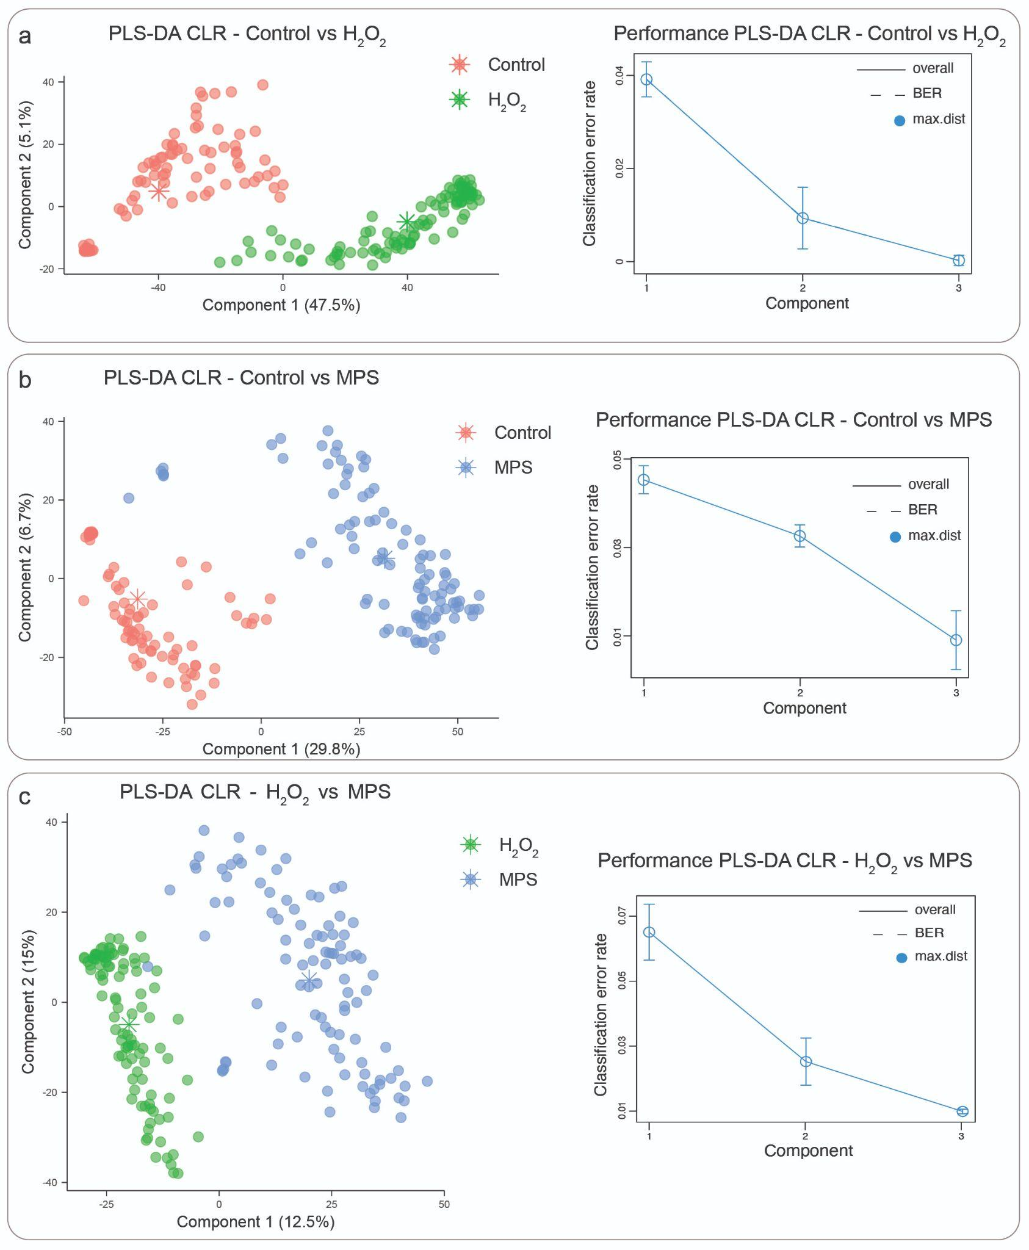
Supplementary Figure 1. Different tooth bleaching strategies lead to distinct tooth biochemical profiles. Pairwise PLS-DA models constructed on the CLR transformed feature table show close to perfect separation between control and different treatments (a,b,c). Scores plot of control vs. MPS (b) reveals possible misclassification of MPS samples. Model performances were calculated using random 4-fold cross-validation. The asterisk in the scores plots represents group centroids.
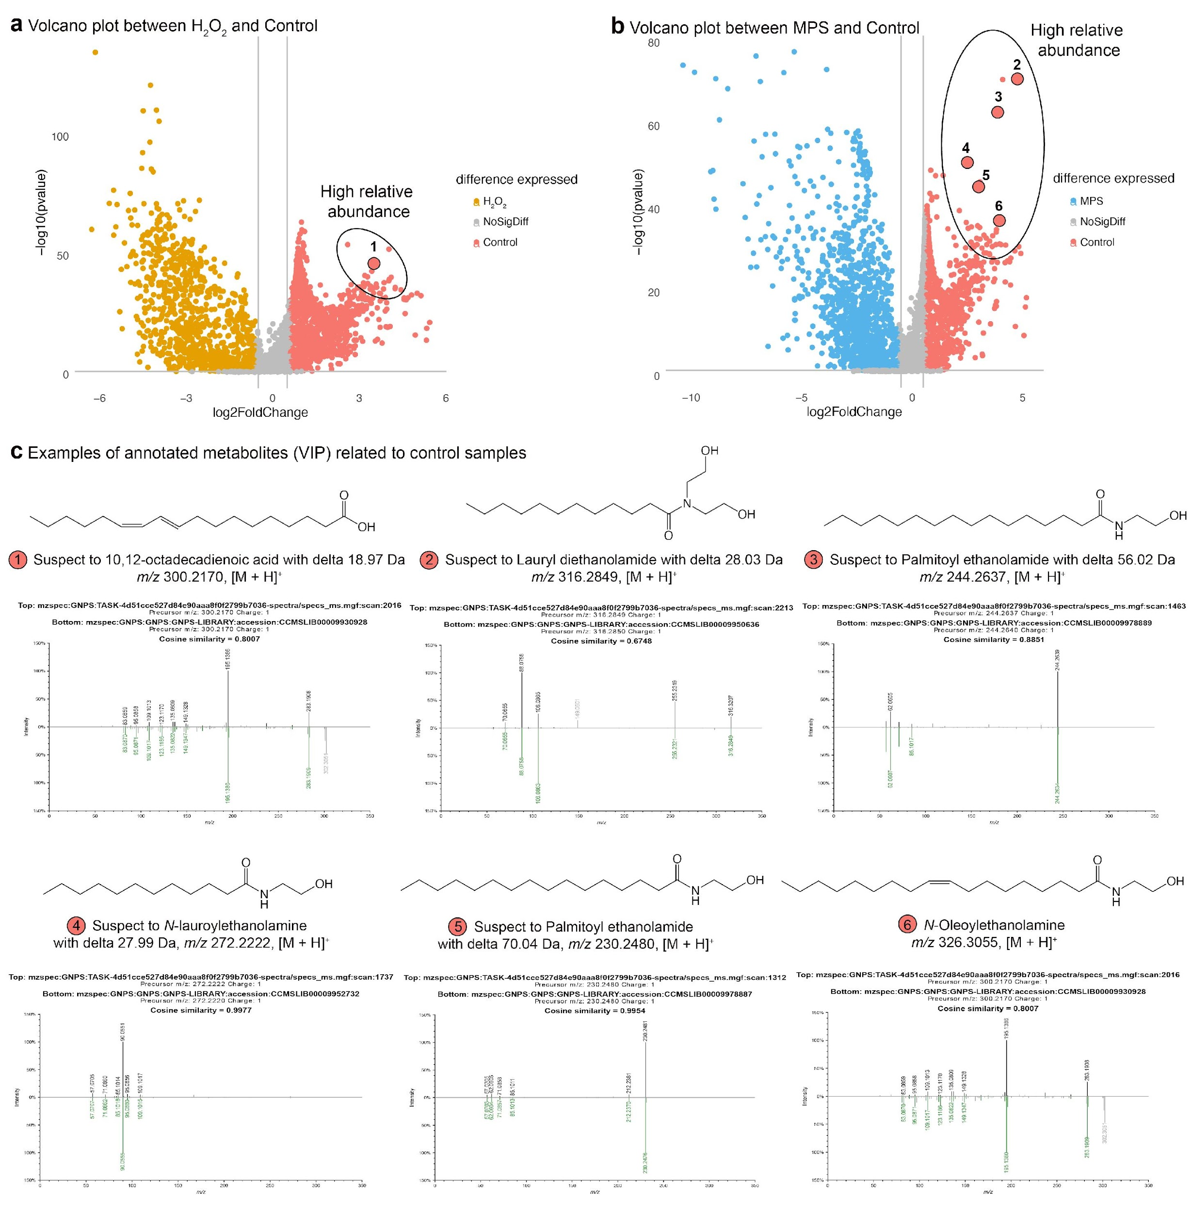
Supplementary Figure 2. Unpaired univariate analyses and annotated metabolites in control samples. a) Volcano plot between control/H₂O₂ and selected metabolite (1) among the VIP metabolites that had matches against the reference MS/MS GNPS library. b) Volcano plot between control/MPS and selected metabolites (2-6) among the VIP metabolites that had matches against the reference MS/MS GNPS library. c) Mirror plot between experimental and reference spectrum of the metabolites that were annotated using GNPS library.
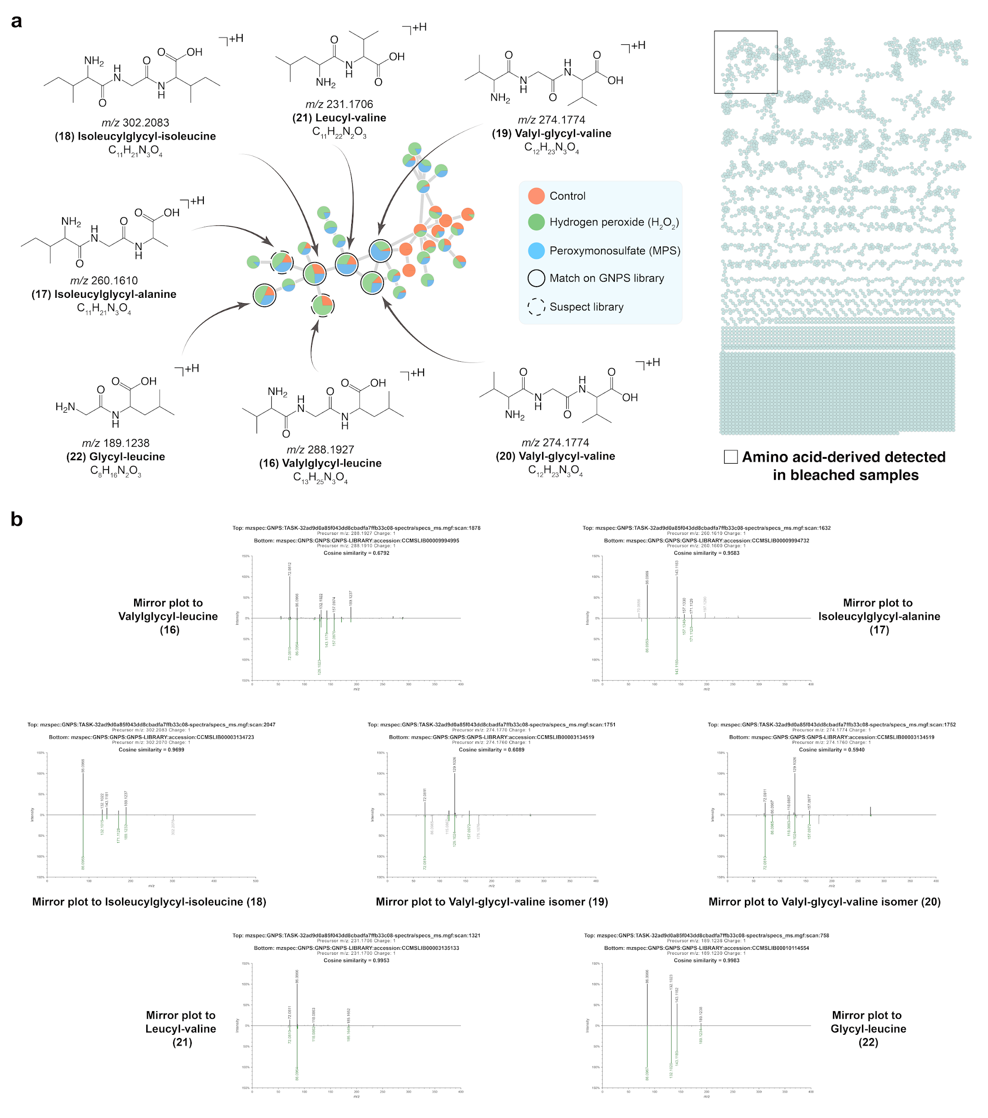
Supplementary Figure 3. Molecular family of consistent features of amino acid-derived detected in H₂O₂/MPS. a) Annotated amino acid-derived in both bleached samples; b) Each annotated metabolite has a mirror plot comparing a library MS/MS spectrum (top) and the teeth metabolite MS/MS spectrum (bottom) based on cosine similarity. Proposed chemical names and structures were listed when available.

