Synthesis, solvatochromism and estimation of ground and excited state dipole moments of silylated benzothiazole dyes

Ingrid Maliszewski Paczkowski, Lidiane Pluczinski and Leandra Franciscato Campo*

Institute of Chemistry, Department of Organic Chemistry, Universidade Federal do Rio Grande do Sul. Avenida Bento Gonçalves, 9500, CEP 91501-970, Porto Alegre, RS, Brazil.
Corresponding author: leandra.campo@ufrgs.br. https://orcid.org/0000-0012-3645-795X

Table of contentes

Fig. S1 ¹H NMR (400 MHz, DMSO-d6) of compound 3a

Fig. S2 APT NMR (75 MHz, DMSO-d6) of compound 3a

Fig. S3 FTIR of compound 3a

Fig. S4 HRMS of compound 3a

Fig. S5 ¹H NMR (400 MHz, DMSO-d6) of compound 3b

Fig. S6 APT NMR (75 MHz, DMSO-d6) of compound 3b

Fig. S7 FTIR of compound 3b

Fig. S8 HRMS of compound 3b

Fig. S9 ¹H NMR (400 MHz, DMSO-d6) of compound 4a

Fig. S10 APT NMR (75 MHz, DMSO-d6) of compound 4a

Fig. S11 FTIR of compound 4a

Fig. S12 HRMS of compound 4a

Fig. S13 ¹H NMR (400 MHz, DMSO-d6) of compound 4b

Fig. S14 APT NMR (100 MHz, DMSO-d6) of compound 4b

Fig. S15 FTIR of compound 4b

Fig. S16 HRMS of compound 4b

Mathematical Equations

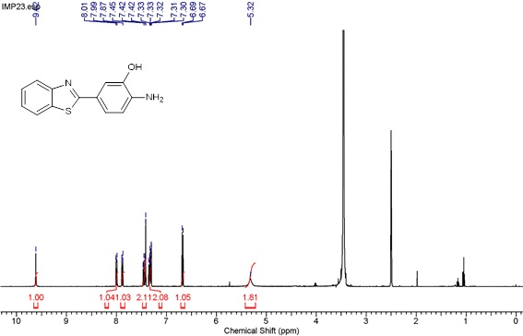
Fig. S1 ¹H NMR (400 MHz, DMSO-d6) of compound 3a

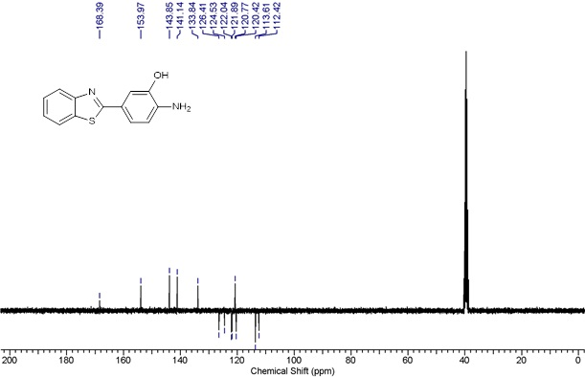
Fig. S2 NMR (75 MHz, DMSO-d6) of compound 3a

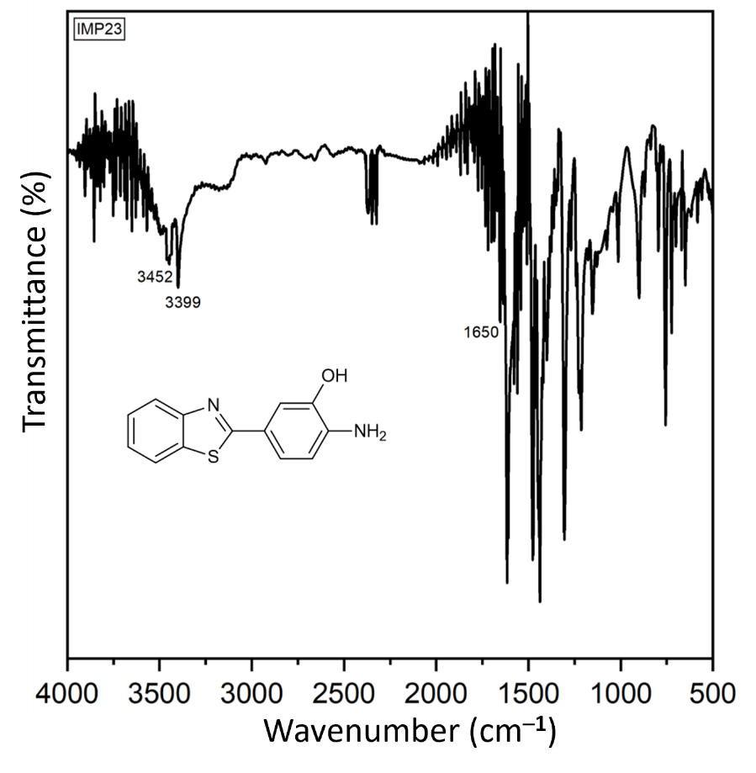
Fig. S3 FTIR of compound 3a

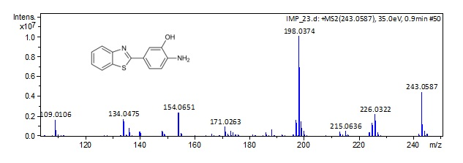
Fig. S4 HRMS of compound 3a

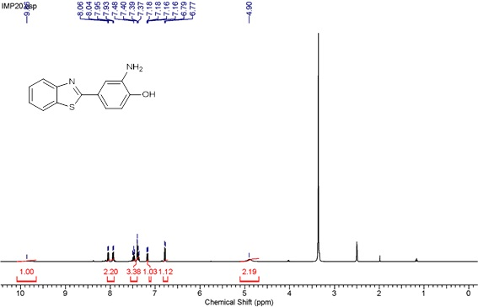
Fig. S5 ¹H NMR (400 MHz, DMSO-d6) of compound 3b

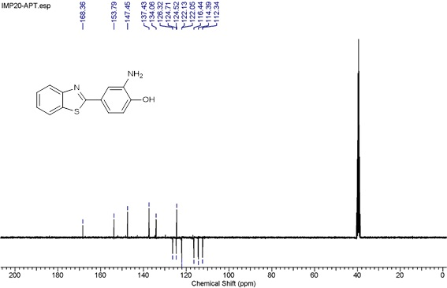
Fig. S6 NMR (75 MHz, DMSO-d6) of compound 3b

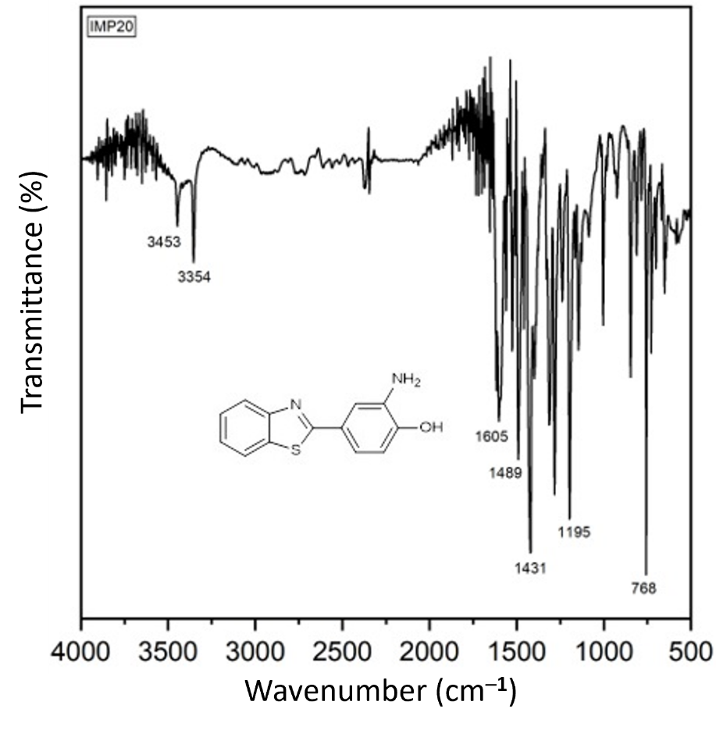
Fig. S7 FTIR of compound 3b

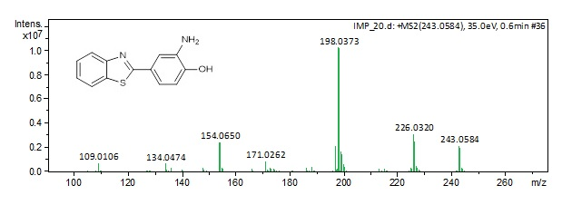
Fig. S8 HRMS of compound 3b

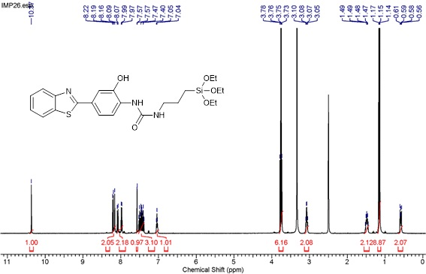
Fig. S9 ¹H NMR (400 MHz, DMSO-d6) of compound 4a

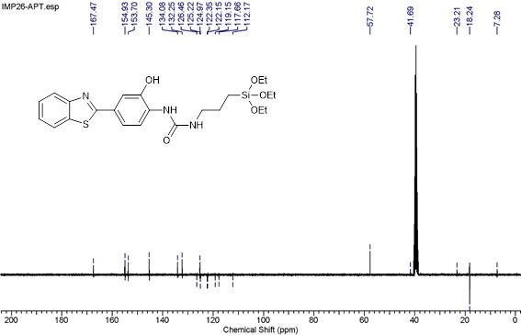
Fig. S10 ^{13a} NMR (75 MHz, DMSO-d6) of compound 4a

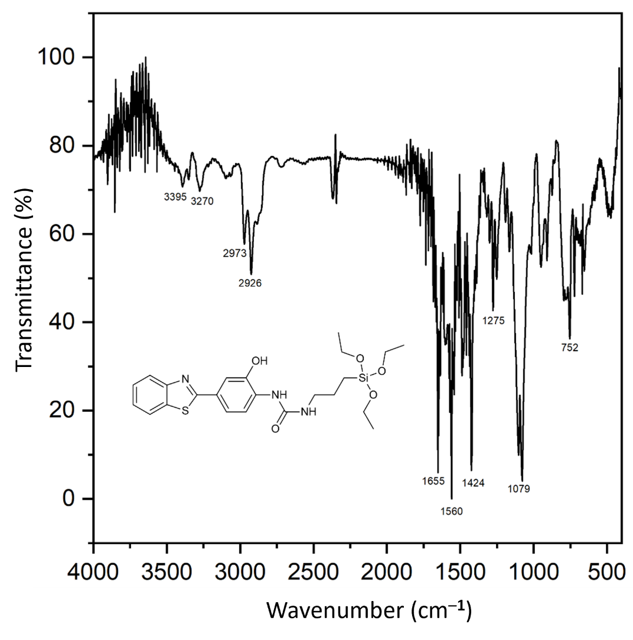
Fig. S11 FTIR of compound 4a

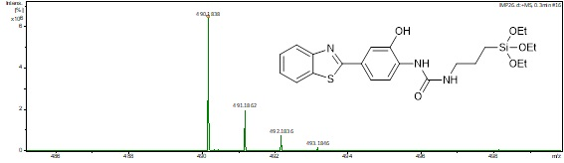
Fig. S12 HRMS of compound 4a

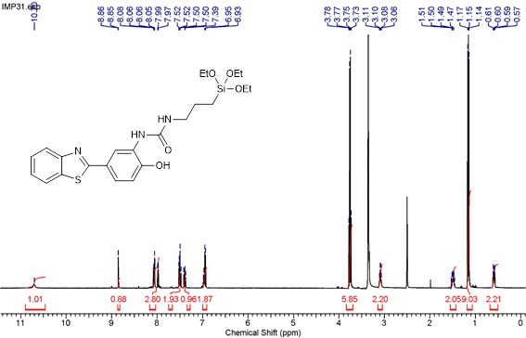
Fig. S13 ¹H NMR (400 MHz, DMSO-d6) of compound 4b

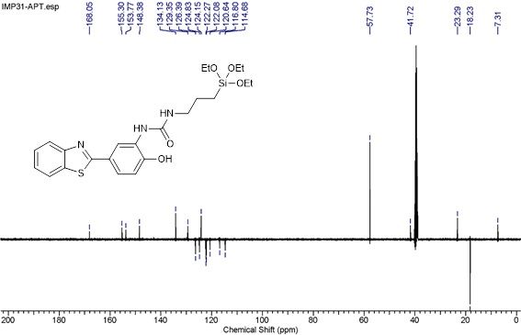
Fig. S14 ^{13a} NMR (100 MHz, DMSO-d6) of compound 4b

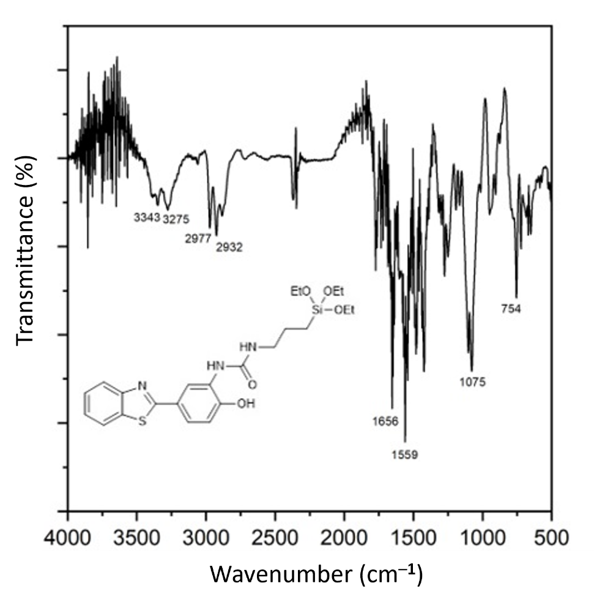
Fig. S15 FTIR of compound 4b

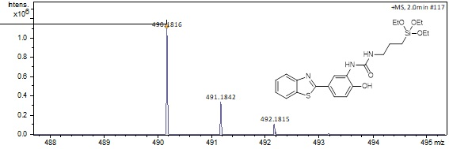
Fig. S16 HRMS of compound 4b

Mathematical Equations

Orientation polarizability (Δf)

The solvent polarity scale known as orientation polarizability (Δf) is defined by the equation given in Eq. 1:

$f=\frac{e -1}{2e +1}-\frac{n^{2}-1}{{2n}^{2}+ 1}$ (1)

where Δf is defined as the solvent orientation polarizability and is a function of the dielectric constant (ε) and the refractive index (n) of a solvent.

Ground and Excited State Dipole Moment

The ratio of excited state (μ_{e}) and ground state (μ_{g}) dipole moments were determined by applying the Bakshiev’s and Kawaski-Chamma-Viallet’s formulations expressed by the following equations:

$\overline{v}a-\overline{v}f=S_{1} f\left(ε,n\right)+k$ (2)
$\overline{v}a+\overline{v}f=-S_{2} \left[f\left(ε,n\right)+2g\left(n\right)\right]+k$ (3)

where $\overline{v}a$ and $\overline{v}f$ are the absorption and fluorescence maxima wavenumbers in cm⁻¹, n and ε are the refractive index and dielectric constant of the solvents. In accordance with these formulations, the polarity function $f\left(ε,n\right)$ can be expressed as:

$f\left(ε,n\right)= \frac{{2n}^{2}+1}{n^{2}+2}\left(\frac{ε-1}{ε+2}- \frac{n^{2}-1}{n^{2}+2}\right)$ (4)

and the expression for g(n) is given by Eq. (5):

$g\left(n\right)=\frac{3}{2}\left(\frac{n^{4}-1}{{(n^{2}+2)}^{2}}\right)$ (5)

The slopes S₁ and S₂ are obtained, the ground state (μ_{g}) and excited state (μ_{e}) dipole moment are given by Eqs. 6 and 7:

$S_{1}=\frac{{2(μ_{e}-μg)}^{2}}{{hca}^{3}}$ (6)
$S_{2}=\frac{2({μe}^{2}-{μg}^{2})}{{hca}^{3}}$ (7)

where h, c and a are the Planck’s constant, the velocity of light and Onsager radius of a molecule respectively. The values of μ_{g} and μ_{e} can be evaluated by means of equations Eqs. 8 and 9.

$μ_{g}= \frac{S_{2}- S_{1}}{2}{\left(\frac{{hca}^{3}}{2S1}\right)}^{1/2}$ (8)
$μ_{e}= \frac{S_{2}+ S_{1}}{2}{\left(\frac{{hca}^{3}}{2S1}\right)}^{1/2}$ (9)

Equations used for determination of Onsager cavity radius (a³)

$V_{VDW}=\frac{4}{3}πa^{3}$

The van der Waals volume ($V_{VDW}$) can be calculated from the following formula^{iii}:

$$V_{VDW}=\sum{(all atom contributions)}-5.92N_{B}-14.7R_{A}-3.8R_{NA}$$

N_{B} = number of bonds
R_{A} = number of aromatic rings
R_{NA} = number of non-aromatic rings

where N_{B} is equal to${: N}_{B}=N-1+R_{A}+R_{NA}$

and¹

V_{vdW} for C = 20.58 Å³
V_{vdW} for H = 7.24 Å³
V_{vdW} for O = 14.71 Å³
V_{vdW} for N = 15.60 Å³
V_{vdW} for S = 24.43 Å³
V_{vdW} for Si = 38.79 Å³

Table S1: Calculated Van Der Waals Volume and Osanger cavity radius.
Dye | Molecular Formula | ∑(all atom contributions) | NB | Vvdw (Å³) | a (Å)
3a | C13H10N2S1O | 410.28 | 29 | 194.5 | 3.594
3b | C13H10N2S1O | 410.28 | 29 | 194.5 | 3.594
4a | C₂₃H₃₂N₃O₅SSi | 888.59 | 67 | 447.8 | 4.746
4b | C₂₃H₃₂N₃O₅SSi | 888.59 | 67 | 447.8 | 4.746

Figure S17. Lippert graphics of a) Stokes displacements and b) maximum wavelength of emission spectra as a function of the polarization of solvent orientation (Δf) defined according to Eq. 1.

Table S2. Slopes (S₁ and S₂) of linear regressions of solvent polarity parameters f(ε,n) and f(ε,n)+2g(n) and the corresponding correlation coefficients (R²).

Benzothiazole | S₁ (cm⁻¹)  Bakshiev (Eq. 2) | R² | S₂ (cm⁻¹)  Kawaski-Chamma-Viallet (Eq. 3) | R²
3a | 2041.1 | 0.819 | 4862.67 | 0.852
3b | 3475.31 | 0.725 | 7764.83 | 0.880
4a | 2816.77 | 0.588 | 4867.49 | 0.695
4b | 1678.24 | 0.692 | 9055.83 | 0.868

. Myśliwa-Kurdziel, B., Solymosi, K., Kruk, J., Böddi, B., Strzałka, K. (2008). Solvent effects on fluorescence properties of protochlorophyll and its derivatives with various porphyrin side chains. European Biophysics Journal, 37, 1185–1193.
. Patil, N. R., Melavanki, R. M., Kapatkar, S. B., Ayachit, N. H., Saravanan, J. (2011). Solvent effect on absorption and fluorescence spectra of three biologically active carboxamides (C1, C2 and C3). Estimation of ground and excited state dipole moment from solvatochromic method using solvent polarity parameters. Journal of Fluorescence, 21, 1213–1222. iii. Yuan H. Zhao, Michael H. Abraham, and Andreas M. Zissimos. Fast Calculation of van der Waals Volume as a Sum of Atomic and Bond Contributions and Its Application to Drug Compounds. J. Org. Chem. 2003, 68, 7368-7373.

