Supplementary Information 4
Contour detection errors in Tomato Analyzer software version 3, using images of a longitudinal section of the apple. a, represents the incorrect delimitation in the proximal and distal part of the fruit. b, represents the manual correction marked in red. c, not recognizing shoulder boundaries in asymmetric fruit sections.

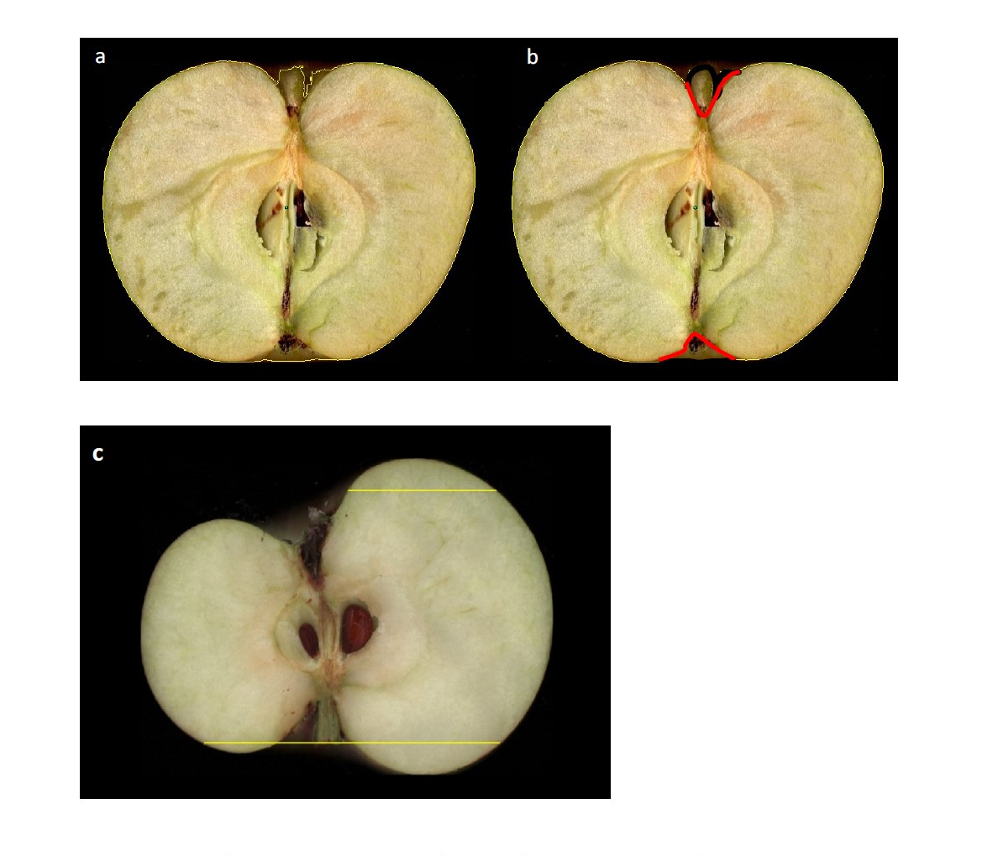

c

