Supplementary Information 3

Material & Methods

Visual models to classify the apple fruit shape with own category (CAT-own).
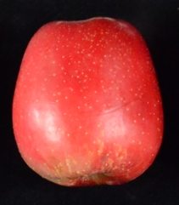
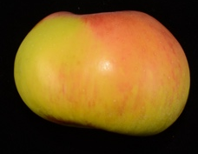
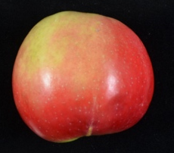

Spheroid Oblong
Spheroid or round
Spheroid oblate or flat

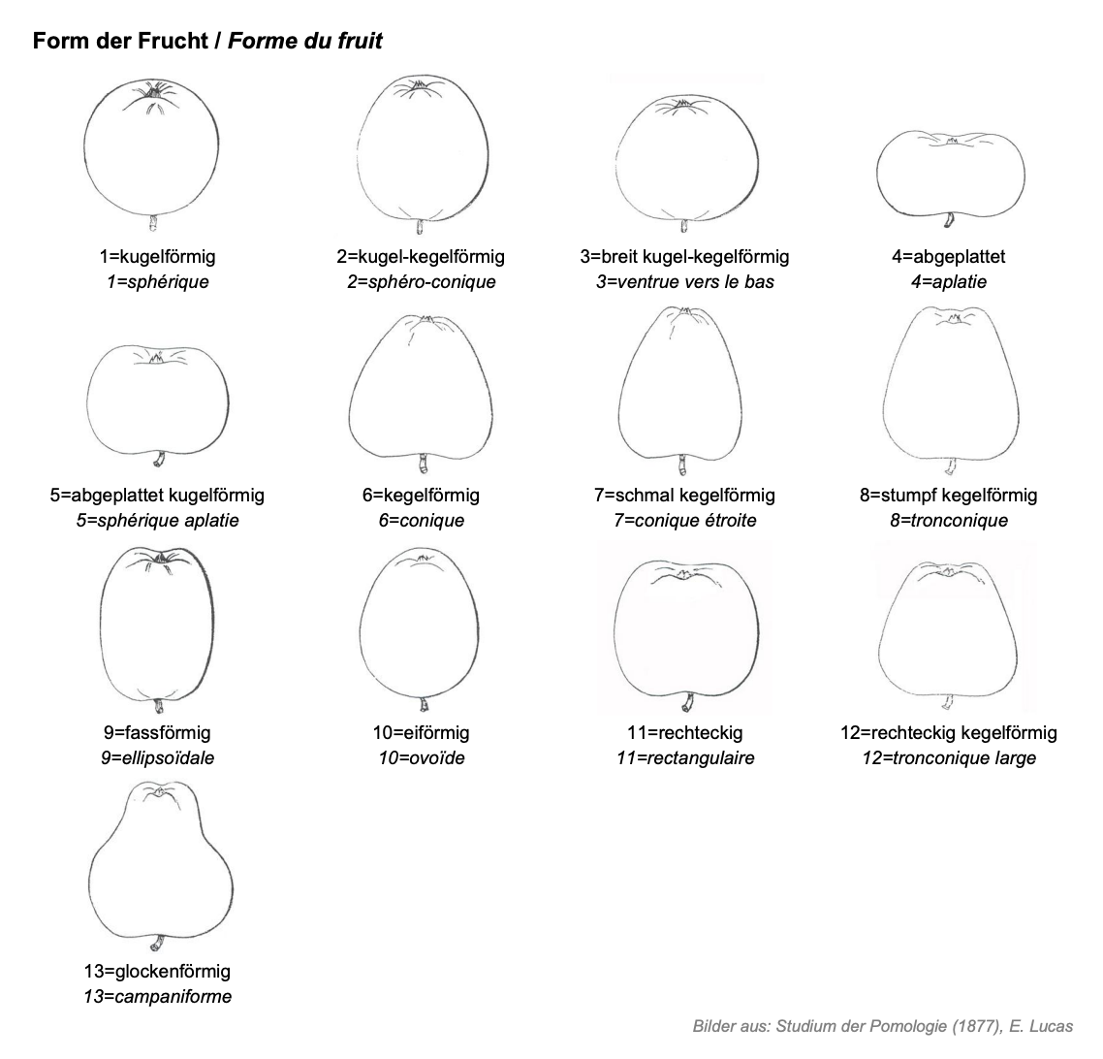
Visual models to classify the apple fruit shape based on Szalatnay 2006.
1= Globose
2= Globose conical
3= Broad-globose-conical
4= Flat
5= Flat globose
6= Conical
7= Narrow conical
8= Truncate conical
9= Ellipsoid
10= Ellipsoid conical
11= Oblong
12= Oblong conical
13= Waisted fruit

