Additional file 1

Development of fluorescence/MR dual-modal manganese-nitrogen-doped carbon nanosheets as an efficient contrast agent for targeted ovarian carcinoma imaging

Cuiping Han^{1,2} †*, Ting Xie ^{1†}, Keying Wang^{3†}, Shang Jin¹, Ke Li¹, Peipei Dou¹, Nana Yu¹, Kai Xu^{2*}
¹ School of Medical Imaging, Xuzhou Medical University, Xuzhou, 221006, China

² Department of Radiology, Affiliated Hospital of Xuzhou Medical University, Xuzhou, 221004, China
³ Department of Medical imaging, Jinshan Hospital Affiliated to Fudan University, Shnghai, 200540, China
†Cuiping Han, Ting Xie and Keying Wang contributed equally to this work.
*Corresponding authors: hancp@xzhmu.edu.cn and xkpaper@163.com

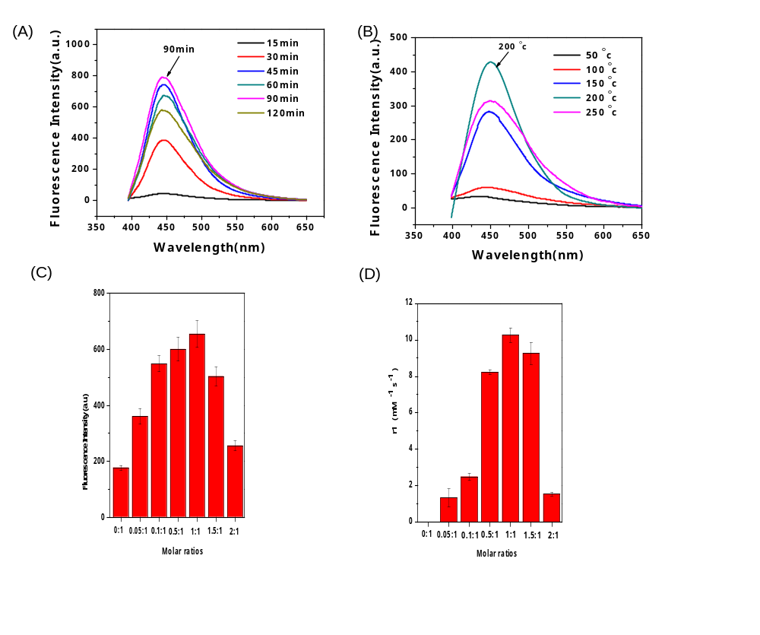
Fig. S1 Optimization of reaction conditions.The reaction time (A) and temperature (B) on the fluorescence spectra of Mn-N-CNSs. The effect of different molar ratios of Mn:DTPA on the fluorescence intensity (C) and MRI relaxation properties of Mn-N-CNSs (D).
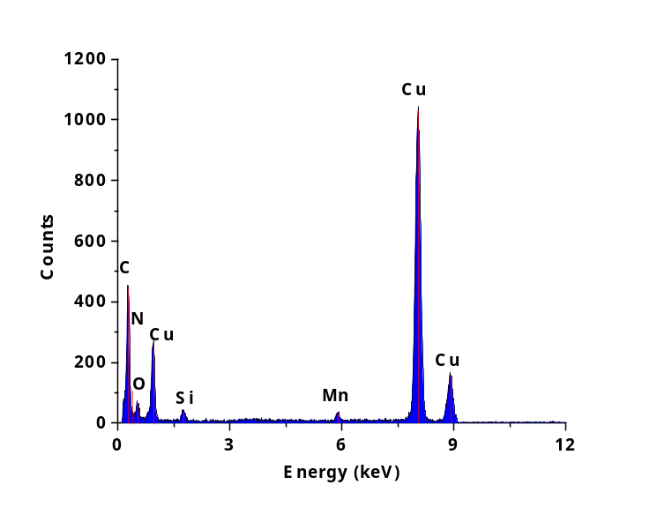
Fig. S2 Typical EDS pattern of Mn-N-CNSs.

Fig. S3 (A) Stability of the Mn-N-CNSs in ID water, PBS, FBS, and RPMI-1640. (B) DLS analysis of the Mn-N-CNSs in ID water, PBS, FBS, and RPMI-1640, respectively. (C) T1-weighted MR images of Mn-N-CNSs in ID water, PBS, FBS, and RPMI-1640, respectively.
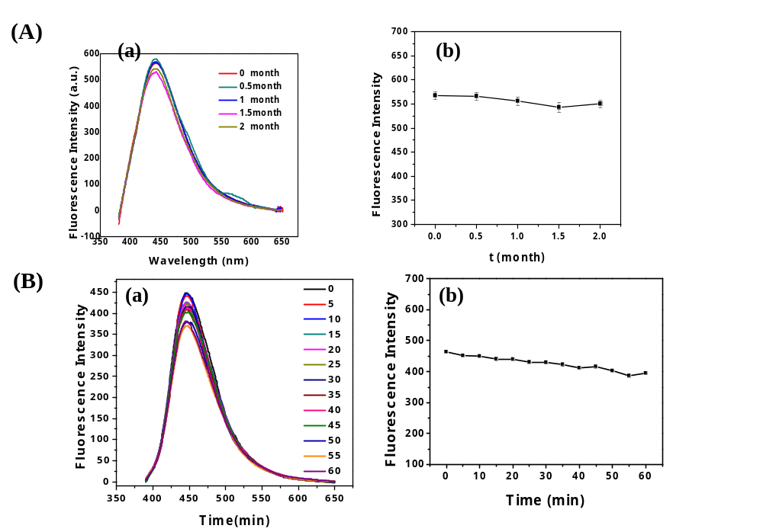
Fig. S4 The fluorescence stability of Mn-N-CNSs. (A) Effect of storage time on fluorescence spectra (a) and fluorescence intensity (b) of Mn-N-CNSs solution. (B) Fluorescence spectra (a) and fluorescence intensity (b) intensity change of Mn-N-CNSs under exposure to the UV light for various time.

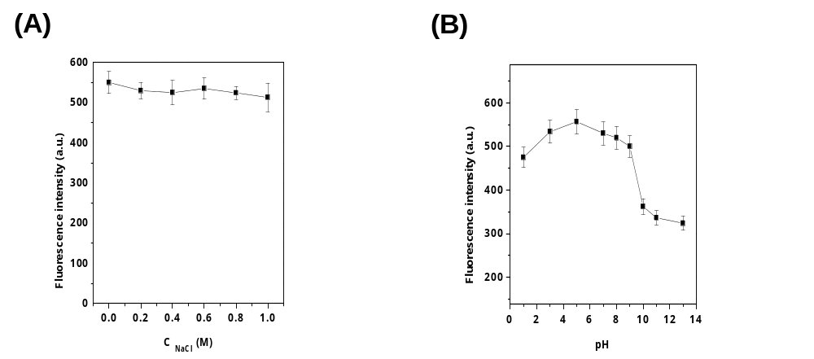
Fig. S5 Effect of pH (A) and ionic strengths (B) on the fluorescence intensity of Mn-N-CNSs. (Ionic strengths were controlled by various concentrations of NaCl).

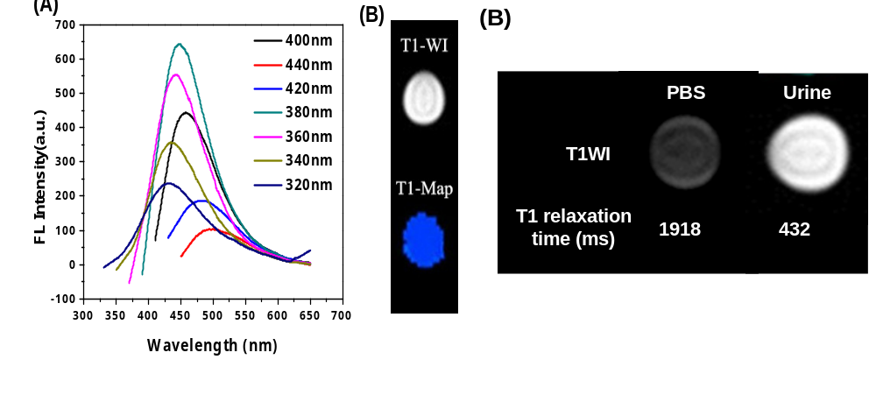
Fig. S6 Fluorescence (A) and T1-weighted images as well as T1 relaxation time (B) of urine samples, taken ~12 h after the injection of Mn-N-CNSs@Anti-HE4. PBS solution used as a control in MR imaging experiments.

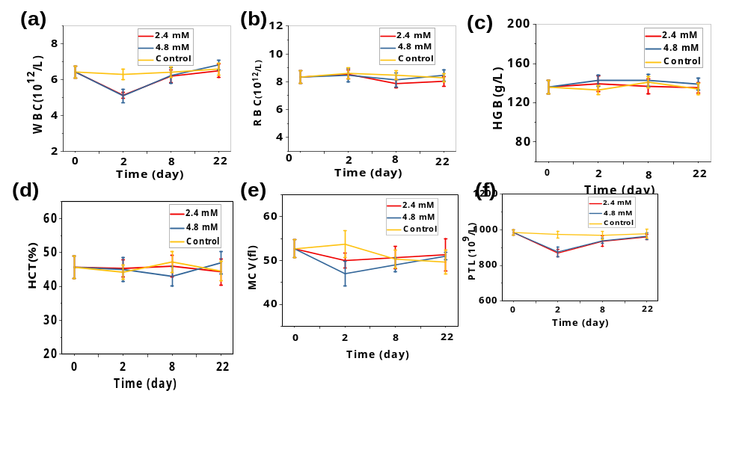
Fig. S7 Complete blood count study of the mice treated by Mn-N-CNSs@Anti-HE4 at various concentraions for 1, 8, 22 days.

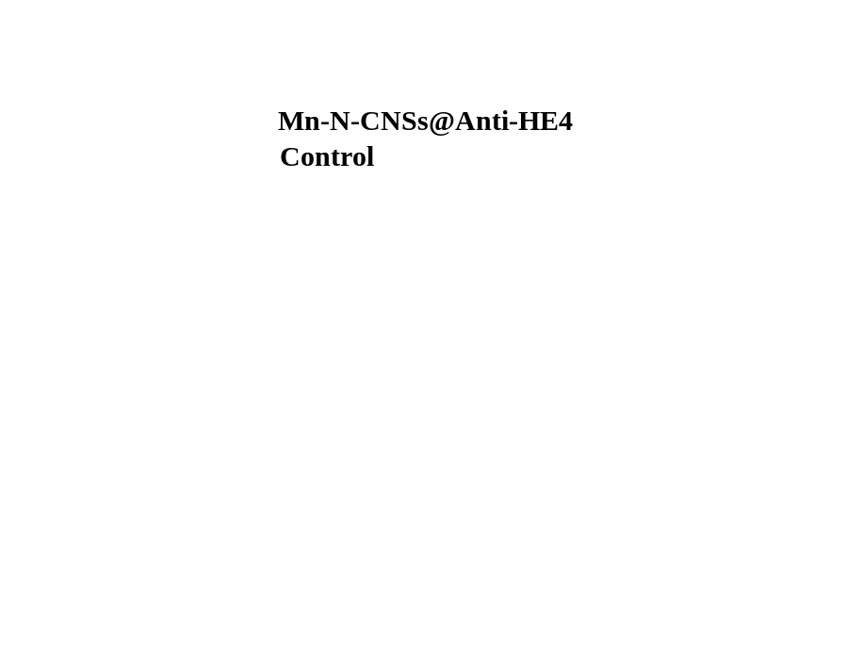
Fig. S8 Body weight changes of the mice after the administration of Mn-N-CNSs@Anti-HE4 and saline for different days.

