Additional file 1

Development of fluorescence/MR dual-modal manganese-nitrogen-doped carbon nanosheets as an efficient contrast agent for targeted ovarian carcinoma imaging

Cuiping Han^{1,2} †*, Ting Xie ^{1†}, Keying Wang^{3†}, Shang Jin¹, Ke Li¹, Peipei Dou¹, Nana Yu¹, Kai Xu^{1,2*}
¹ School of Medical Imaging, Xuzhou Medical University, Xuzhou, 221006, China

² Department of Radiology, Affiliated Hospital of Xuzhou Medical University, Xuzhou, 221004, China
³ Department of Medical imaging, Jinshan Hospital Affiliated to Fudan University, Shnghai, 200540, China
†Cuiping Han, Ting Xie and Keying Wang contributed equally to this work.
*Corresponding authors: hancp@xzhmu.edu.cn and xkpaper@163.com

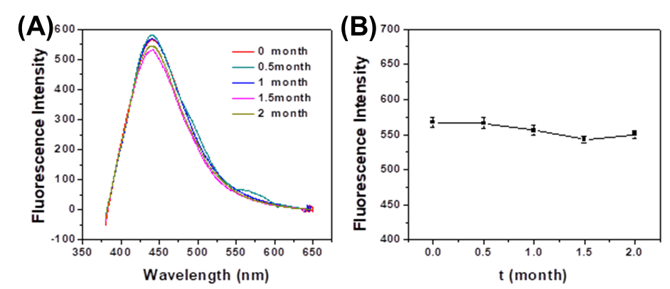
Fig. S1 Fluorescence intensity change of the Mn-N-CNSs after various time intervals.
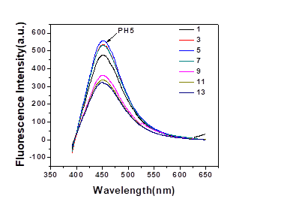
Fig. S2 Fluorescence intensity change of the Mn-N-CNSs at different pH.
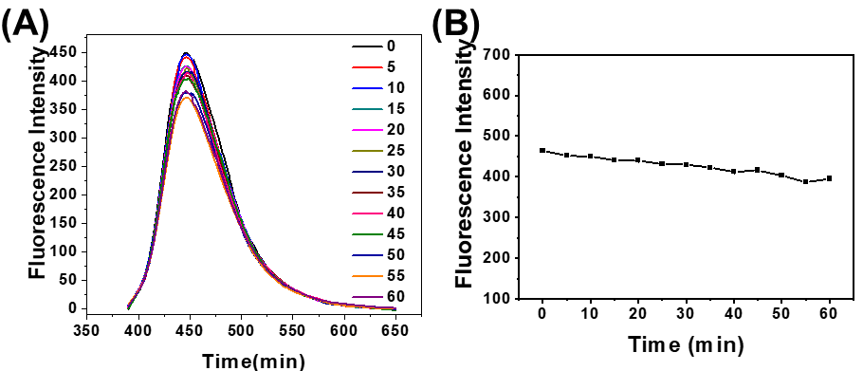
Fig. S3 Fluorescence intensity change of the Mn-N-CNSs under exposure to the UV light for various time.

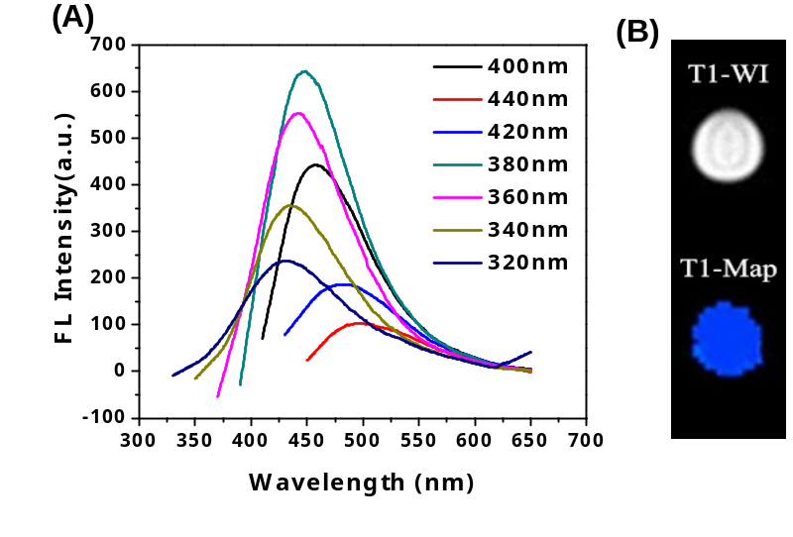
Fig. S4 Fluorescence (A) and T1-weighted images (B) of urine samples, taken ~12 h after the injection of Mn-N-CNSs@Anti-HE4.

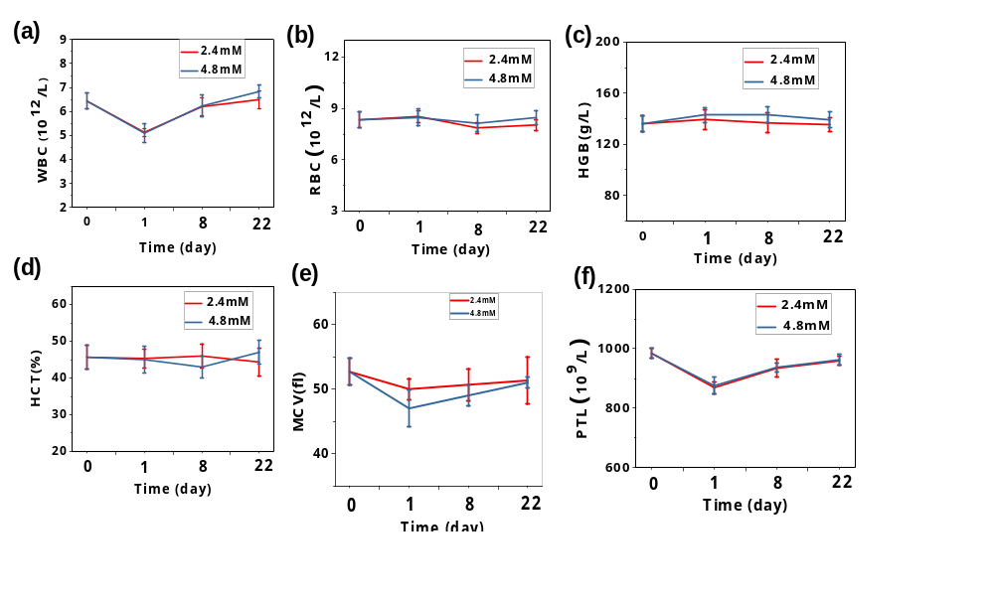
Fig. S5 Complete blood count study of the mice treated by Mn-N-CNSs@Anti-HE4 at various concentraions for 1, 8, 22 days.

Fig. S6 Body weight changes of the mice after the administration of Mn-N-CNSs and saline for different days.

