SUPPLEMENTAL INFORMATION

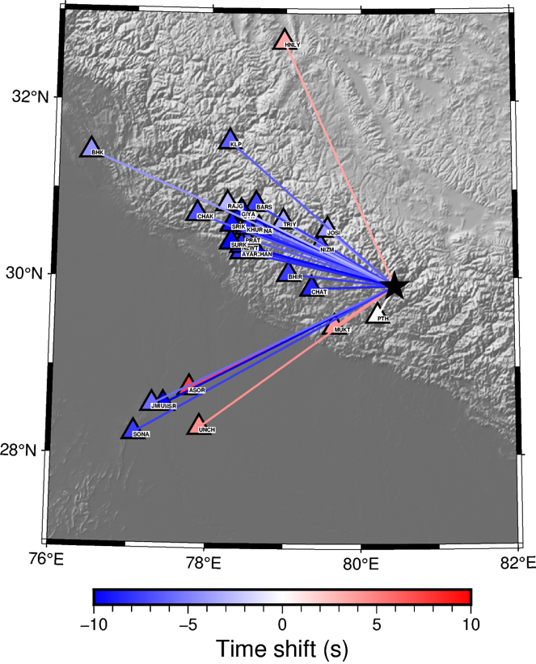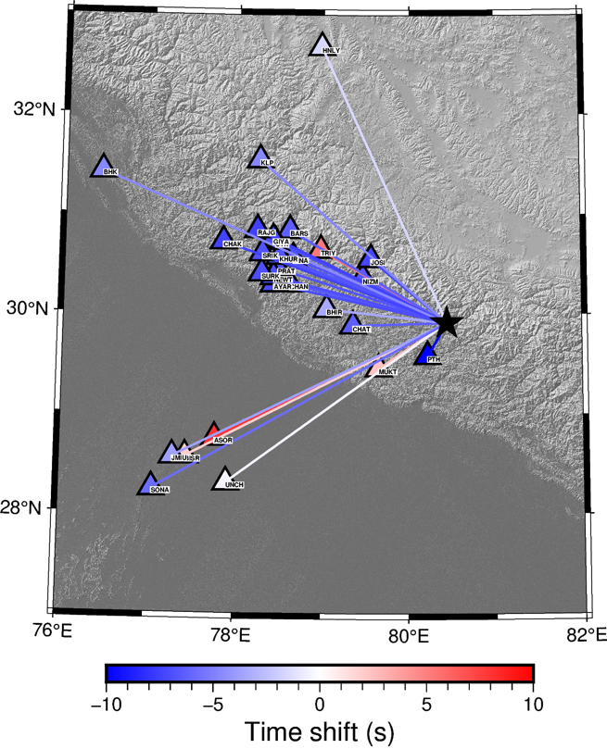
Figure S1. Map of the time shifts between observed data and synthetics for, (a) vertical and radial component of Rayleigh wave and (b) Transverse component of Love wave at each of the stations (inverted triangle).

1945 Nanda Devi Earthquake
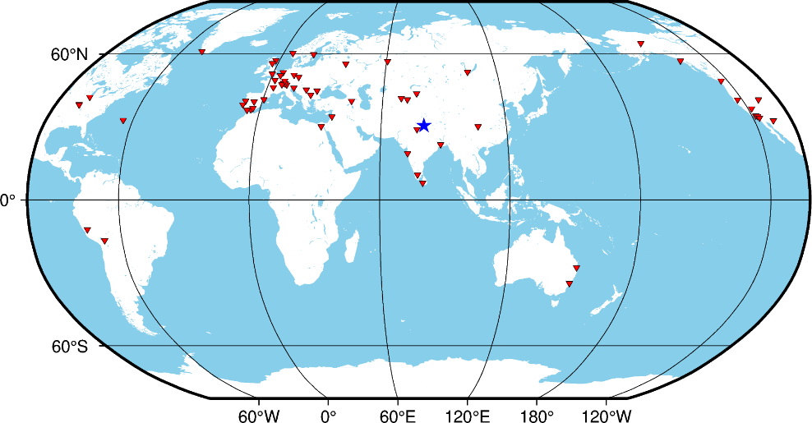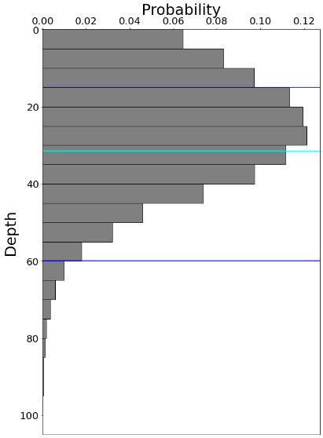

Figure S2: Stations used for location inversion using NonLinLoc of 1945 Nanda Devi event. Also show are the depth distribution of poster samples.

1958 Dharchula earthquake
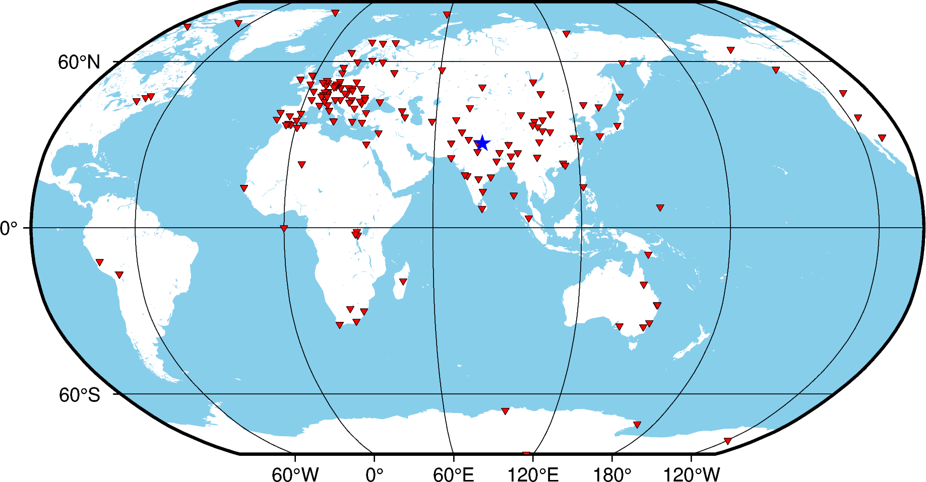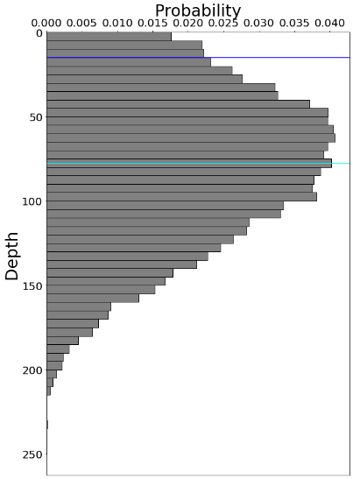
Figure S3: Stations used for location inversion using NonLinLoc of 1958 Dharchula event. Also show are the depth distribution of poster samples.

