Supplementary Material
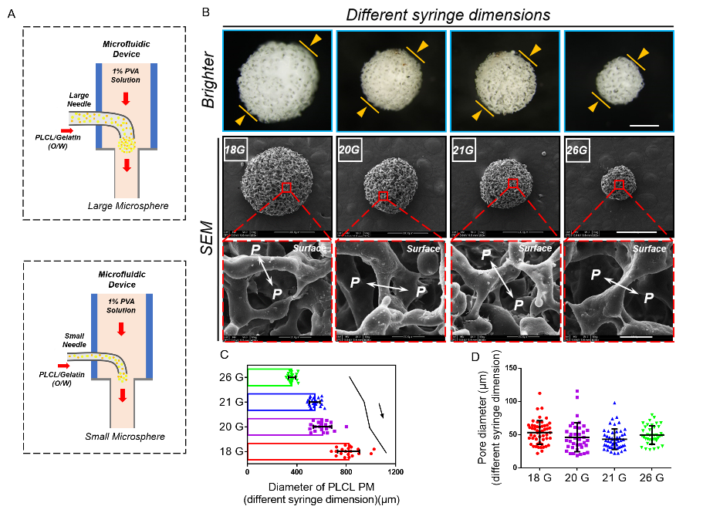
Supplementary Fig. S1 Preparation of porous PLCL microspheres with different needle sizes (18G, 20G, 21G and 26G). A) Schematic diagram of microfluidic device. B) Stereomicroscope and SEM characterization of porous PLCL microspheres. Red box: enlarged partial view; P: pore structure; Scale bars: 250 µm, local magnification bars: 20 µm. C, D) Statistical results of the diameter and pore size of microspheres.

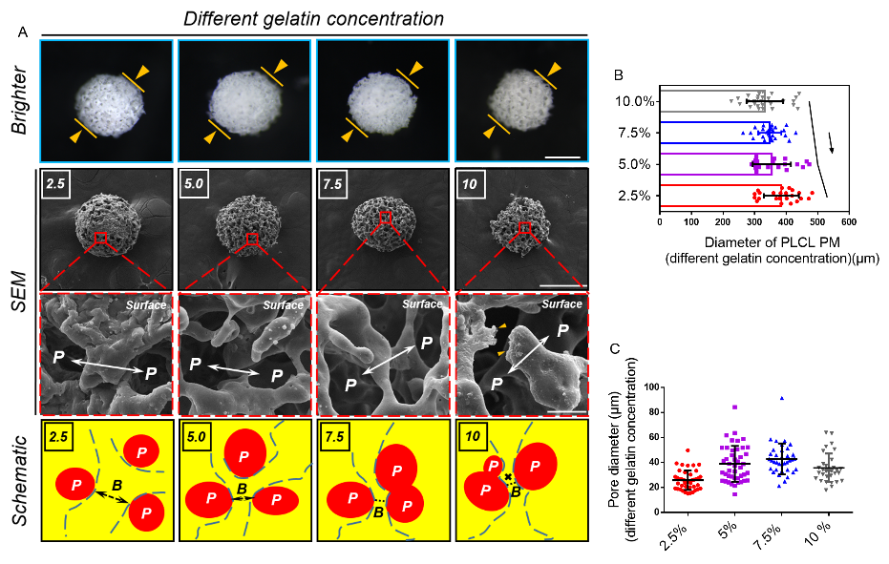
Supplementary Fig. S2 Preparation of porous PLCL microspheres with different gelatin concentrations (2.5%, 5.0%, 7.5% and 10.0%). A) Stereomicroscopy and SEM characterization. The schematic shows the pore distribution. Red box: enlarged partial view; P: pore structure; B: bridge. Scale bars: 250 µm, local magnification bars: 20 µm. B, C) Statistical results of the diameter and pore size of microspheres.

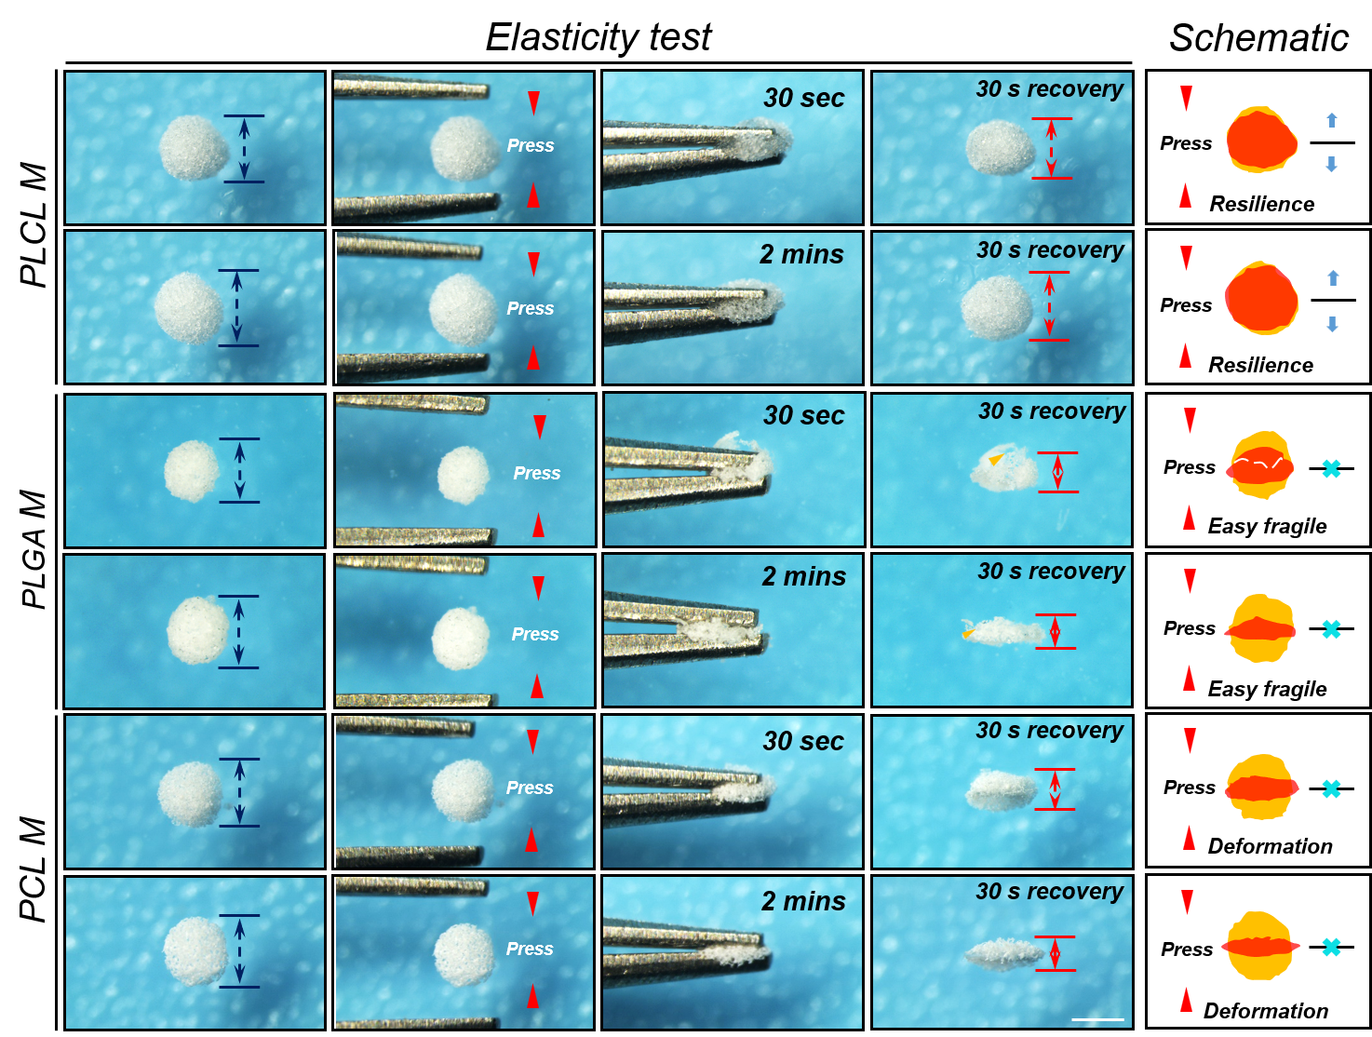
Supplementary Fig. S3 Physical properties characterization of porous PLCL, PLGA and PCL microspheres. A) The morphology of different microspheres after press a single press for 30 s and 2 mins. The schematic shows the morphological recovery of different polymeric microspheres.

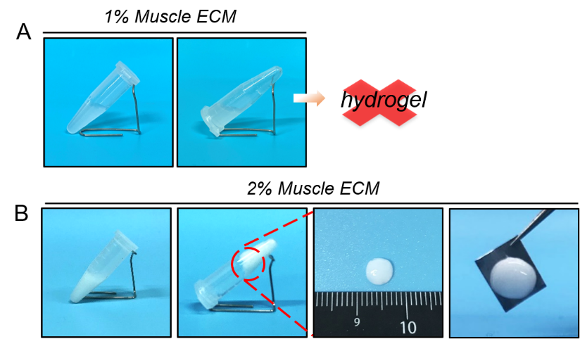
Supplementary Fig. S4 Characteristics of muscle ECM hydrogels with different concentrations (1% and 2%). A, B) One percent muscle ECM was not able to form a hydrogel, and the 2% muscle ECM hydrogel was unstable and could not be clamped.
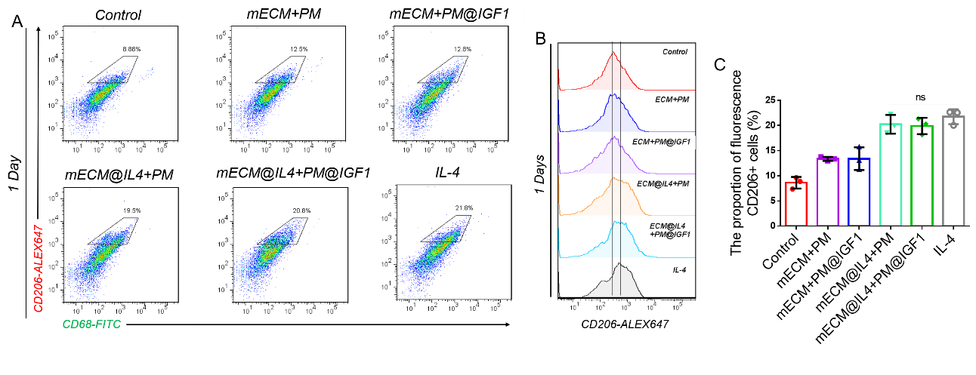
Supplementary Fig. S5 A) Flow cytometric results of primary macrophages treated with different composites for 1 day, mainly observing the expression of CD206⁺ gated cells. B-C) Histogram of CD206 expression after 1 day of treatment and statistical graph of the proportion of CD206⁺ positive cells.

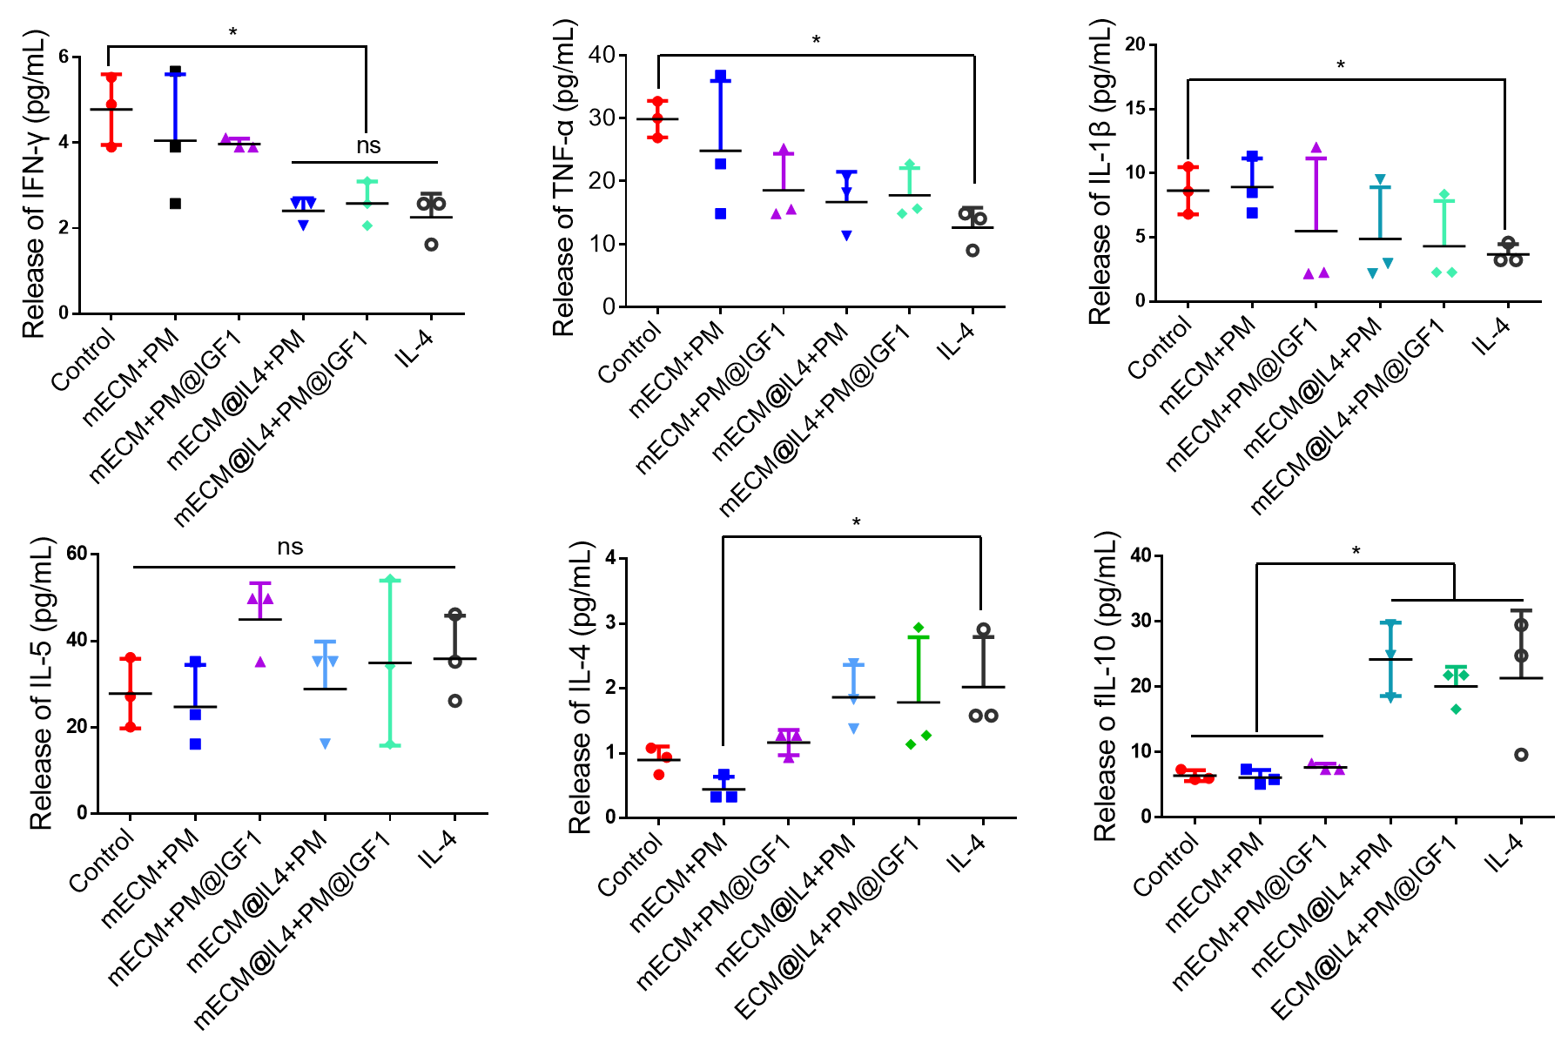
Supplementary Fig. S6 Luminex detected the secretion of inflammation-related factors after treatment of primary macrophages with different composites for 1 day (n=3 per group).

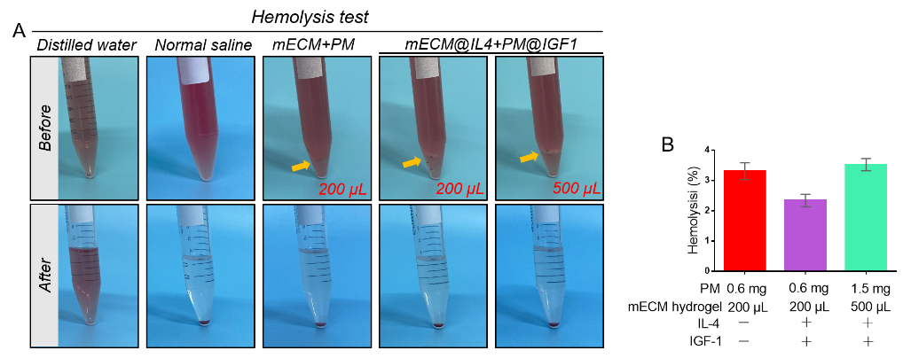
Supplementary Fig. S7 A) Hemocompatibility analysis of different materials. B) The statistical results of the hemolysis rate (n=3 per group).

