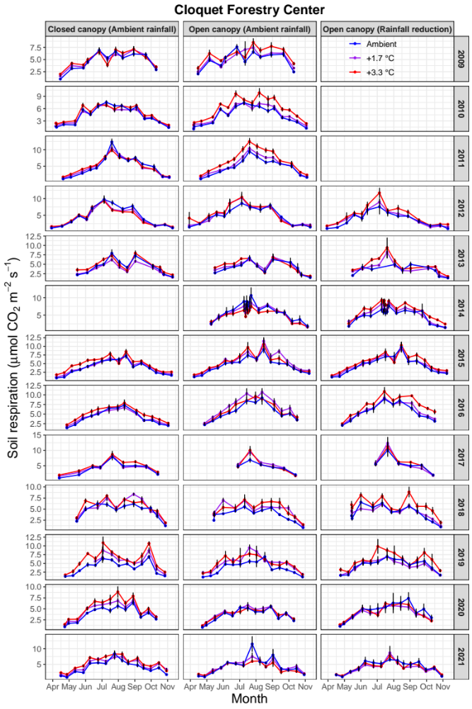

Extended Data Fig. 1. Soil respiration under different treatments at CFC from all campaigns (2009-2021). Panels under “Closed canopy (Ambient rainfall)” and “Open canopy (Ambient rainfall)” show results under different canopy conditions; panels under “Open canopy (Ambient rainfall)” and “Open canopy (Rainfall reduction)” show results under different rainfall amounts. Error bars are standard errors of the mean for each treatment combination.
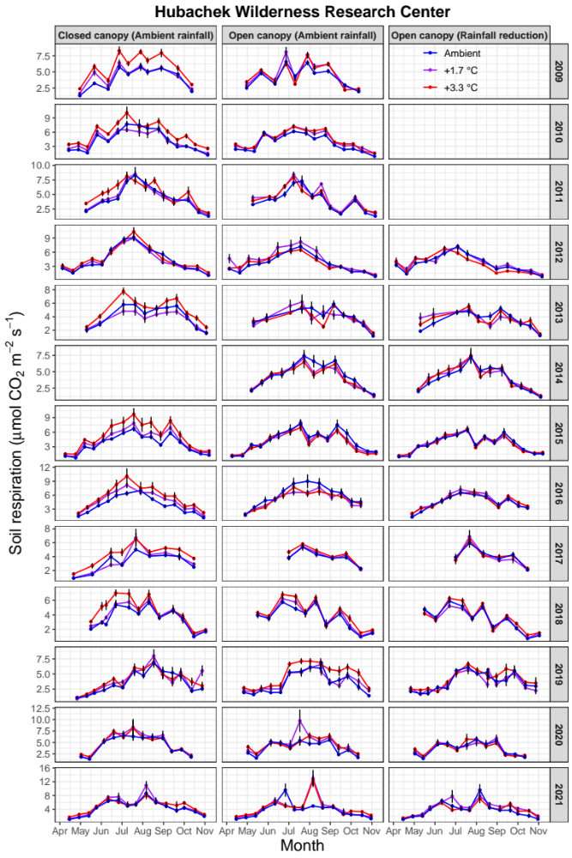

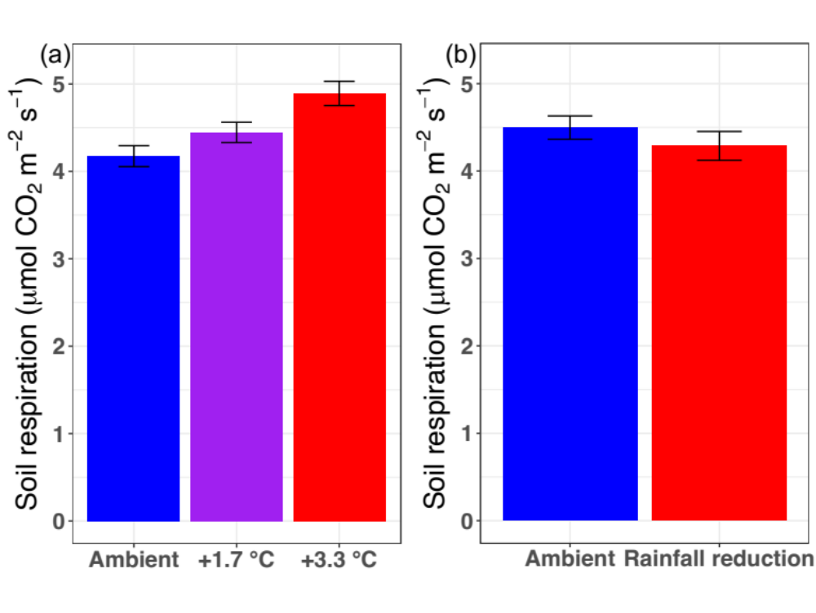
Extended Data Fig. 2. Soil respiration under different treatments at HWRC from all campaigns (2009-2021). Panels under “Closed canopy (Ambient rainfall)” and “Open canopy (Ambient rainfall)” show results under different canopy conditions; panels under “Open canopy (Ambient rainfall)” and “Open canopy (Rainfall reduction)” show results under different rainfall amounts. Error bars are standard errors of the mean for each treatment combination.
Extended Data Fig. 3. Mean soil respiration under different levels of experimental warming (a) and rainfall amount (b). Panel a) shows the result calculated by all measurements of soil respiration from the “warming and canopy condition” experiment (2009-2021), and panel b) shows the result calculated by all measurements of soil respiration from the “warming and rainfall amount” experiment (2012-2021). Error bars are standard errors of the mean. Soil respiration data during years when warming or rainfall reduction was not implemented were not included to calculate the values in this figure.

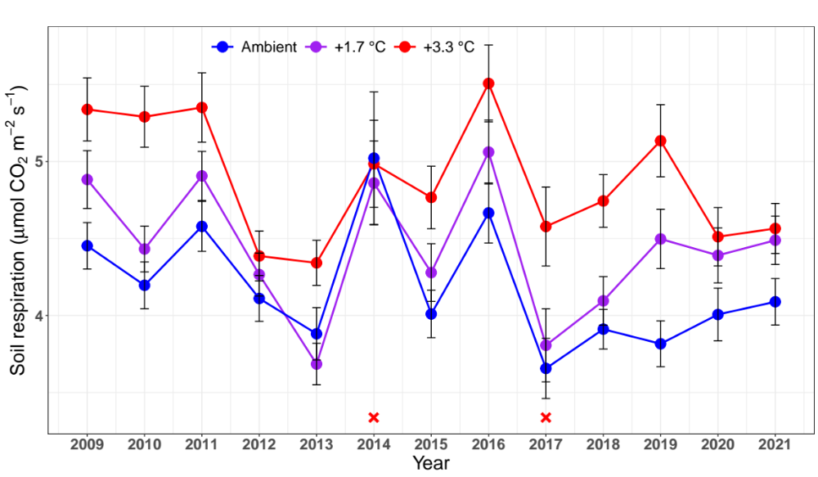
Extended Data Fig. 4. Annual soil respiration under different levels of experimental warming over 13 years. The values were the average of soil respiration across canopy condition and rainfall reduction treatments at both sites. Error bars are standard errors of the mean. The red cross symbols represent that warming was not performed under closed canopy condition in 2014 and under open canopy condition in 2017. Soil respiration data during years when warming was not implemented were not included to calculate the values in this figure.

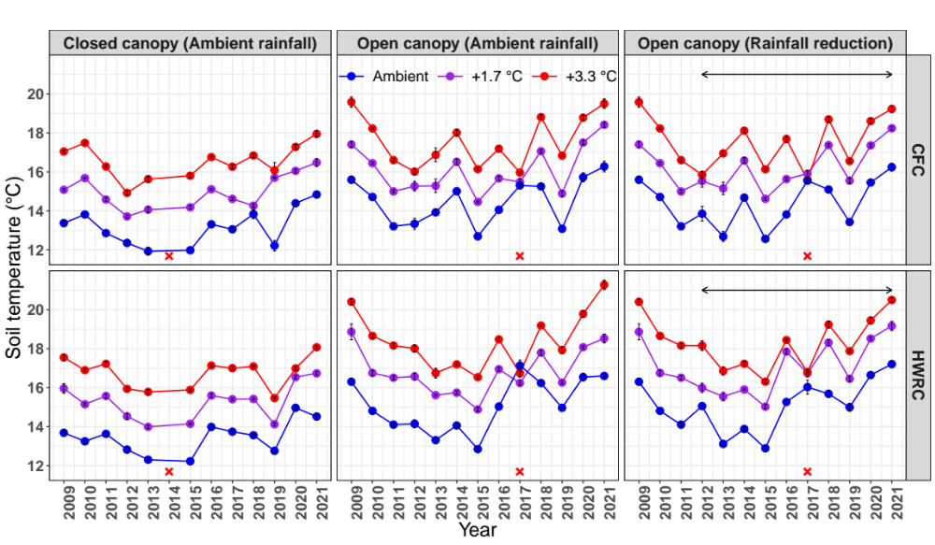
Extended Data Fig. 5. Annual soil temperature under different treatments at two sites (CFC and HWRC) over 13 years. Panels under “Closed canopy (Ambient rainfall)” and “Open canopy (Ambient rainfall)” show results under different canopy conditions; panels under “Open canopy (Ambient rainfall)” and “Open canopy (Rainfall reduction)” show results under different rainfall amounts. Soil temperature data when soil respiration was measured roughly from April to November over 13 years were used. It should be noted that the results are similar if shown for continuous recording at 15-minute intervals of soil temperature. Arrows represent the period that rainfall reduction treatment was applied. The red cross symbols represent the years that warming treatment was not implemented. Error bars are standard errors of the mean for each treatment combination. The results from all plots before the beginning of rainfall treatments (<2012) were used for both “Open canopy (Ambient rainfall)” and “Open canopy (Rainfall reduction)”; therefore, identical results before 2012 were shown for these both treatments.

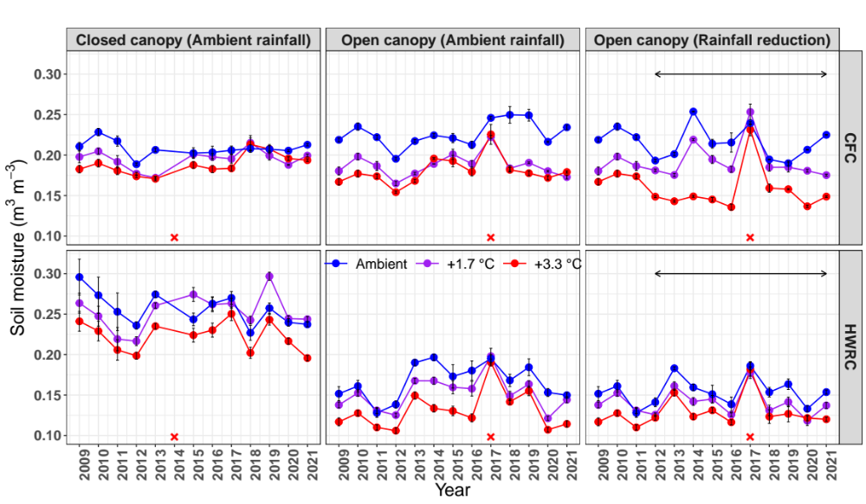
Extended Data Fig. 6. Annual soil moisture under different treatments at two sites (CFC and HWRC) over 13 years. Panels under “Closed canopy (Ambient rainfall)” and “Open canopy (Ambient rainfall)” show results under different canopy conditions; panels under “Open canopy (Ambient rainfall)” and “Open canopy (Rainfall reduction)” show results under different rainfall amounts. Soil moisture data when soil respiration was measured roughly from April to November over 13 years were used. It should be noted that the results are similar if shown for continuous recording at 1-hour intervals of soil moisture. Arrows represent the period that rainfall reduction treatment was applied. The red cross symbols represent the years that warming treatment was not implemented. Error bars are standard errors of the mean for each treatment combination. The results from all plots before the beginning of rainfall treatments (<2012) were used for both “Open canopy (Ambient rainfall)” and “Open canopy (Rainfall reduction)”; therefore, identical results before 2012 were shown for these both treatments.

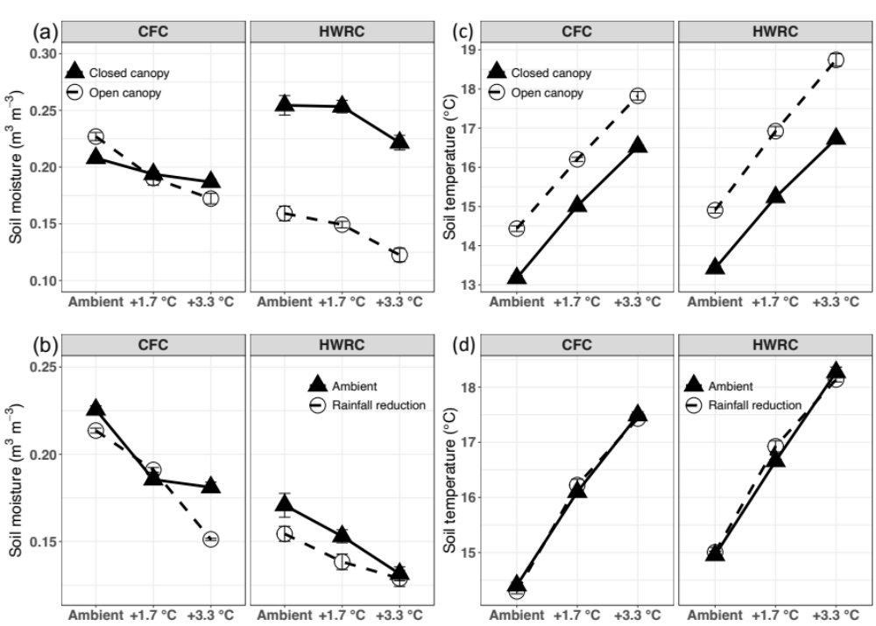
Extended Data Fig. 7. Mean soil moisture and temperature averaged across all measurements at two sites. Panel a) and c) show results of experimental warming effects under different canopy conditions; panel b) and d) show results of experimental warming effects under different rainfall amounts. Error bars are standard errors of the mean for each treatment combination.

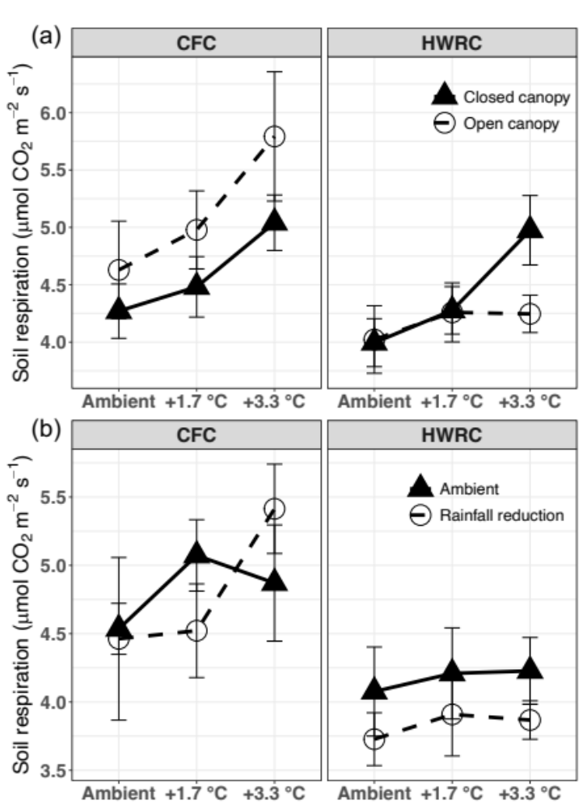

Extended Data Fig. 8. Mean soil respiration averaged across all measurements at two sites. Panel a) shows results of experimental warming effects under different canopy conditions; panel b) shows results of experimental warming effects under different rainfall amounts. Error bars are standard errors of the mean for each treatment combination.

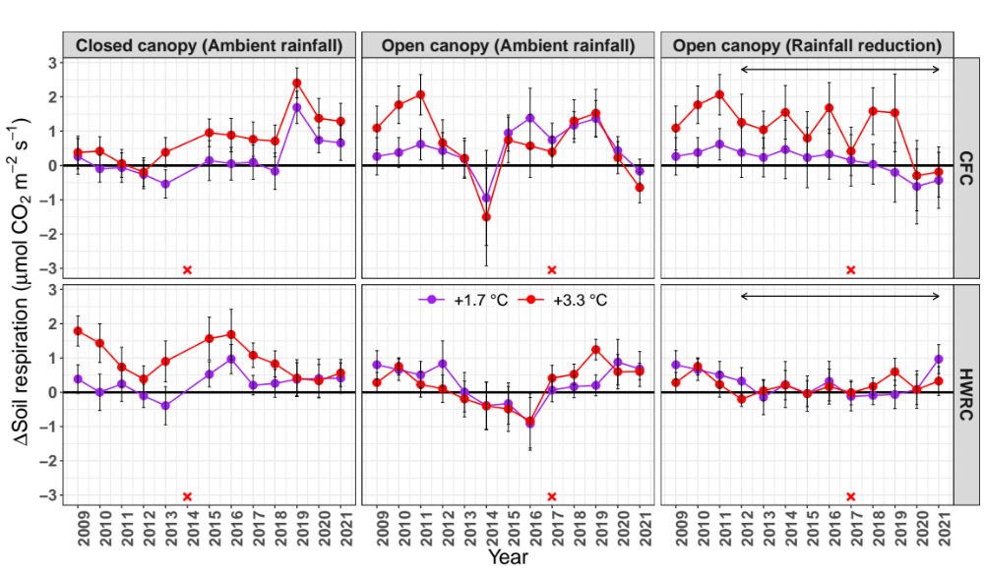
Extended Data Fig. 9. Change in annual soil respiration caused by warming under different treatments at two sites (CFC and HWRC) over 13 years. Panels under “Closed canopy (Ambient rainfall)” and “Open canopy (Ambient rainfall)” show results under different canopy conditions; panels under “Open canopy (Ambient rainfall)” and “Open canopy (Rainfall reduction)” show results under different rainfall amounts. Arrows represent the period that rainfall reduction treatment was applied. The red cross symbols represent the years that warming treatment was not implemented. Error bars are standard errors of the mean for each treatment combination. The results from all plots before the beginning of rainfall treatments (<2012) were used for both “Open canopy (Ambient rainfall)” and “Open canopy (Rainfall reduction)”; therefore, identical results before 2012 were shown for these both treatments.

