Appendix:
Table1. Cluster membership and dendrogram plot of 64 forest landscapes by hierarchical clustering analysis.
No. | Clu8 | Clu7 | Clu6 | Clu5 | Clu4 | Dendrogram Plot
1 | 1 | 1 | 1 | 1 | 1 | 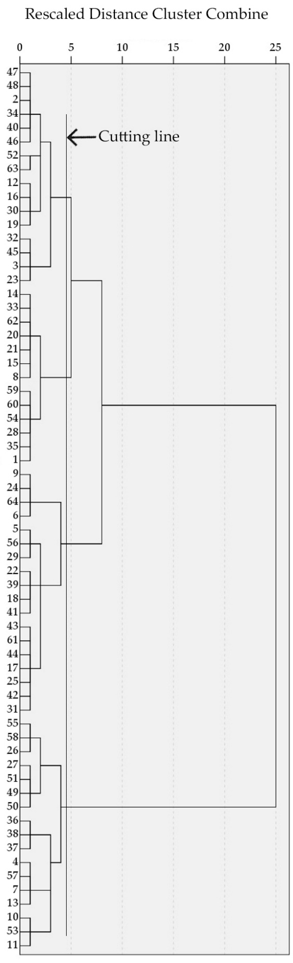
2 | 2 | 2 | 2 | 2 | 2
3 | 2 | 2 | 2 | 2 | 2
4 | 3 | 2 | 2 | 2 | 2
5 | 1 | 1 | 1 | 1 | 1
6 | 4 | 3 | 3 | 3 | 1
7 | 3 | 2 | 2 | 2 | 2
8 | 1 | 1 | 1 | 1 | 1
9 | 5 | 4 | 4 | 4 | 3
10 | 6 | 5 | 5 | 4 | 3
11 | 2 | 2 | 2 | 2 | 2
12 | 7 | 6 | 6 | 5 | 4
13 | 2 | 2 | 2 | 2 | 2
14 | 4 | 3 | 3 | 3 | 1
15 | 4 | 3 | 3 | 3 | 1
16 | 1 | 1 | 1 | 1 | 1
17 | 7 | 6 | 6 | 5 | 4
18 | 6 | 5 | 5 | 4 | 3
19 | 5 | 4 | 4 | 4 | 3
20 | 5 | 4 | 4 | 4 | 3
21 | 7 | 6 | 6 | 5 | 4
22 | 7 | 6 | 6 | 5 | 4
23 | 8 | 7 | 6 | 5 | 4
24 | 4 | 3 | 3 | 3 | 1
25 | 7 | 6 | 6 | 5 | 4
26 | 2 | 2 | 2 | 2 | 2
27 | 2 | 2 | 2 | 2 | 2
28 | 4 | 3 | 3 | 3 | 1
29 | 4 | 3 | 3 | 3 | 1
30 | 5 | 4 | 4 | 4 | 3
31 | 5 | 4 | 4 | 4 | 3
32 | 2 | 2 | 2 | 2 | 2
33 | 4 | 3 | 3 | 3 | 1
34 | 5 | 4 | 4 | 4 | 3
35 | 5 | 4 | 4 | 4 | 3
36 | 6 | 5 | 5 | 4 | 3
37 | 6 | 5 | 5 | 4 | 3
38 | 6 | 5 | 5 | 4 | 3
39 | 5 | 4 | 4 | 4 | 3
40 | 6 | 5 | 5 | 4 | 3
41 | 8 | 7 | 6 | 5 | 4
42 | 7 | 6 | 6 | 5 | 4
43 | 5 | 4 | 4 | 4 | 3
44 | 7 | 6 | 6 | 5 | 4
45 | 8 | 7 | 6 | 5 | 4
46 | 8 | 7 | 6 | 5 | 4
47 | 5 | 4 | 4 | 4 | 3
48 | 1 | 1 | 1 | 1 | 1
49 | 8 | 7 | 6 | 5 | 4
50 | 7 | 6 | 6 | 5 | 4
51 | 2 | 2 | 2 | 2 | 2
52 | 7 | 6 | 6 | 5 | 4
53 | 3 | 2 | 2 | 2 | 2
54 | 1 | 1 | 1 | 1 | 1
55 | 2 | 2 | 2 | 2 | 2
56 | 2 | 2 | 2 | 2 | 2
57 | 3 | 2 | 2 | 2 | 2
58 | 2 | 2 | 2 | 2 | 2
59 | 1 | 1 | 1 | 1 | 1
60 | 1 | 1 | 1 | 1 | 1
61 | 5 | 4 | 4 | 4 | 3
62 | 1 | 1 | 1 | 1 | 1
63 | 7 | 6 | 6 | 5 | 4
64 | 8 | 7 | 6 | 5 | 4
65 | 5 | 4 | 4 | 4 | 3
66 | 2 | 2 | 2 | 2 | 2
67 | 2 | 2 | 2 | 2 | 2
68 | 5 | 4 | 4 | 4 | 3
69 | 3 | 2 | 2 | 2 | 2
70 | 3 | 2 | 2 | 2 | 2
71 | 4 | 3 | 3 | 3 | 1
72 | 4 | 3 | 3 | 3 | 1

