Table 1. Distribution of variables (%)
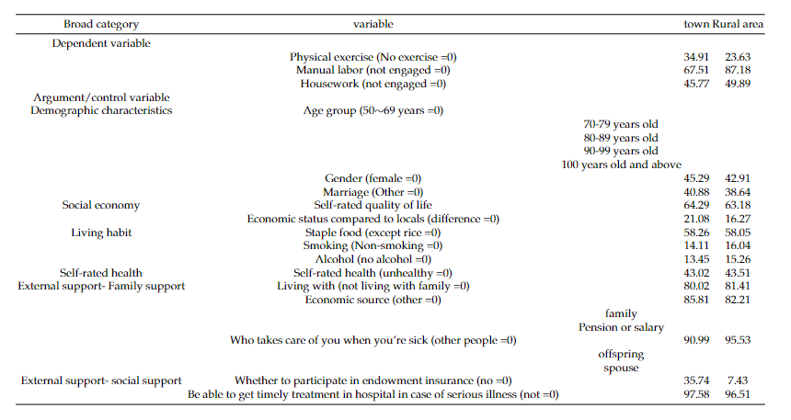
Note:N=12176

Table 2:Physical Activity Status of urban and rural elderly in 2018 (%)
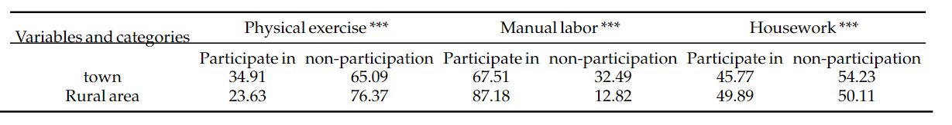
Note:N=12176；*p<0.05，**p<0.01，***p<0.001

Table 3: Logistic Regression of physical exercise difference between urban and rural areas in 2018 (%)
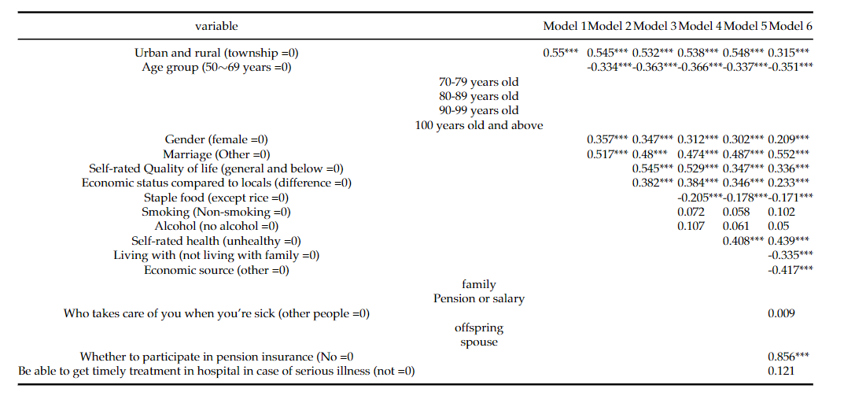
Note：N=12176；*p<0.05，**p<0.01，***p<0.001

Table 4: Logistic Regression of Urban and rural Differences in physical labor in 2018 (%)
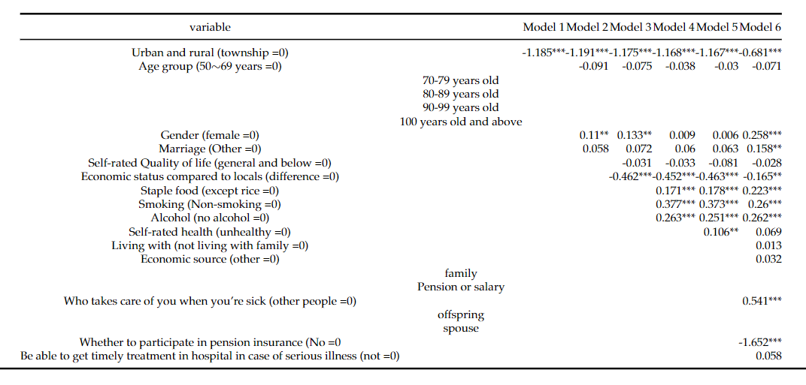
Note：N=12176；*p<0.05，**p<0.01，***p<0.001

Table 5: Logistic Regression of urban-rural difference in housework activities in 2018 (%)
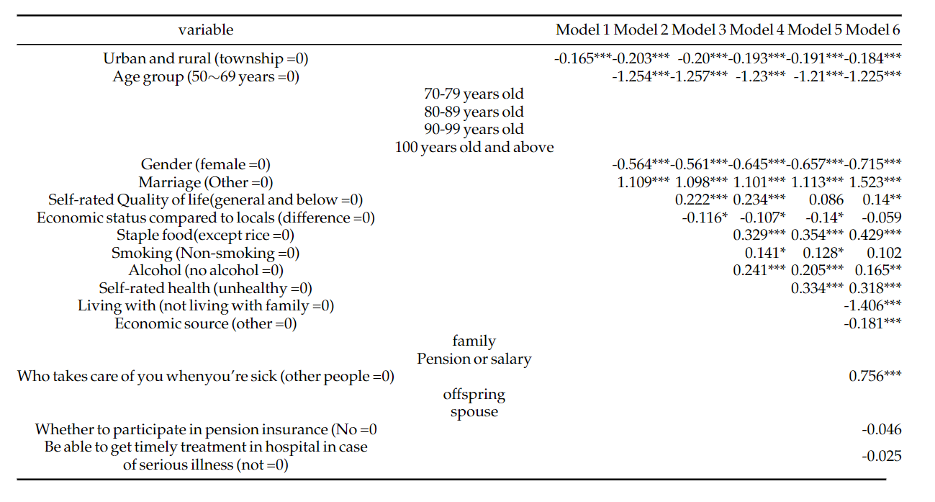
Note：N=12176；*p<0.05，**p<0.01，***p<0.001

