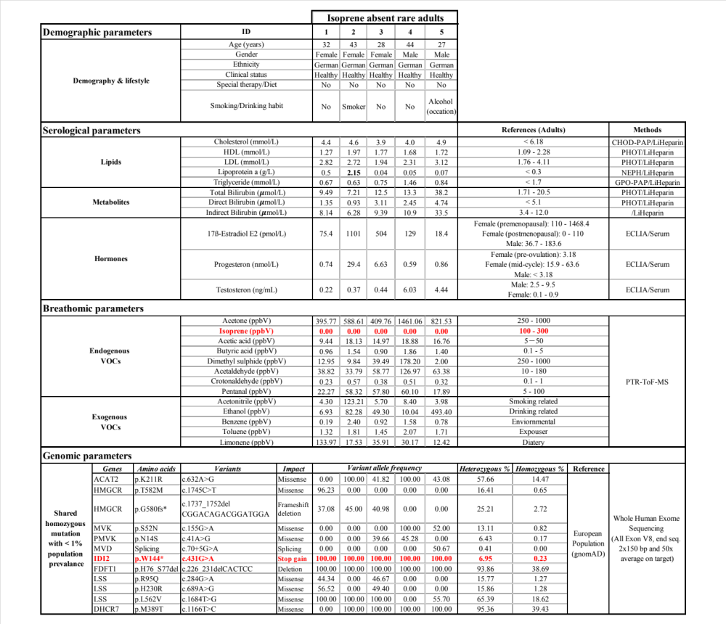

Table. 1. Demographic. serological. breathomic and genomic parameters from rare adults. Demography (age, gender, ethnic origin and health status), lifestyle (smoking, drinking habits and therapy and special diet), relevant serological parameters (plasma lipid profile, bile metabolites and sex hormones) and exhaled concentrations of prime endogenous and exogenous VOCs from the five rare adults are presented. Corresponding reference range and applied methods are also listed. Aberrated parameters are marked in bold red colors.

