Supplementary Information-Plant and Soil

Habitat, plant height, and soil nutrients are important determinants of the Hypericum perforatum microbiome

Renee H. Petipas¹, Steven A. Higgins^{2,3}, Chantal Koechli^{2,4}, Spencer J. Debenport^{2,5}, Chandra N. Jack⁶, Monica A. Geber¹, Daniel H. Buckley²
¹Department of Ecology and Evolutionary Biology, Cornell University, Ithaca, NY, 14853, USA

*Corresponding author. E-mail: renee.petipas@gmail.com

Supplementary Figures
a
b

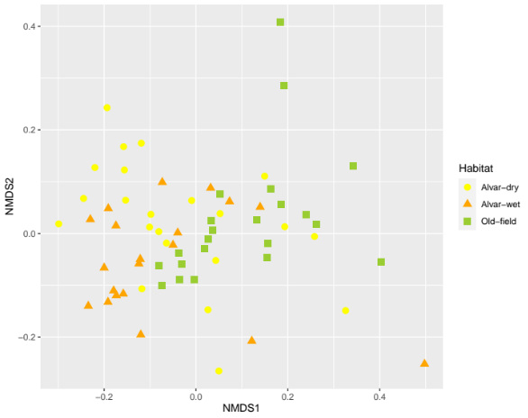
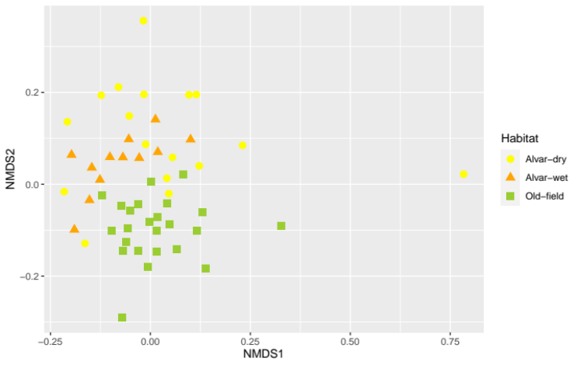

Fig S1: Unconstrained ordinations (nonmetric multidimensional scaling-NMDS plots) showing bacterial (a) and fungal (b) community composition in two types of limestone barrens (dry and wet alvars) compared to old-field habitats.

Supplementary Tables

Table S1: Coordinates for the habitats sampled at three sites in Jefferson County, NY.

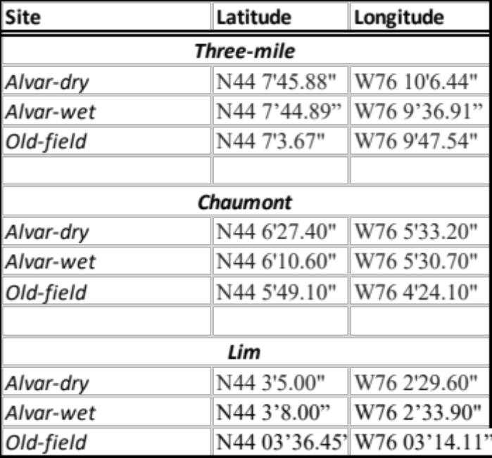

Table. S2: The number of bacterial reads and fungal reads obtained in this study.
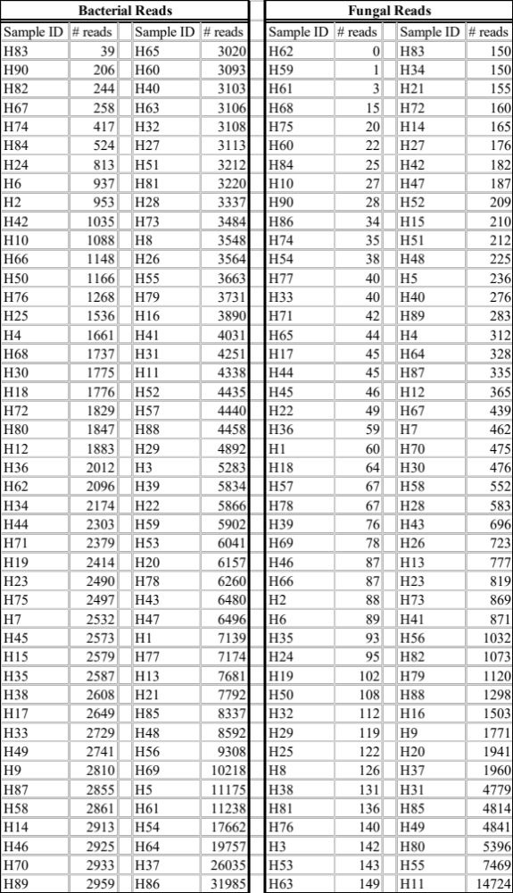

Table S3a-d: Permutational analysis of variance tables describing habitat, soil geochemistry, and plant phenotype effects on bacterial and fungal community composition

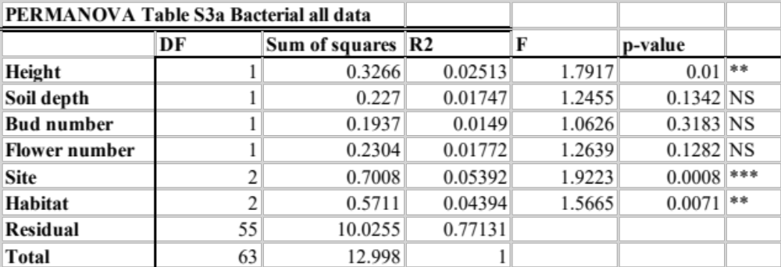

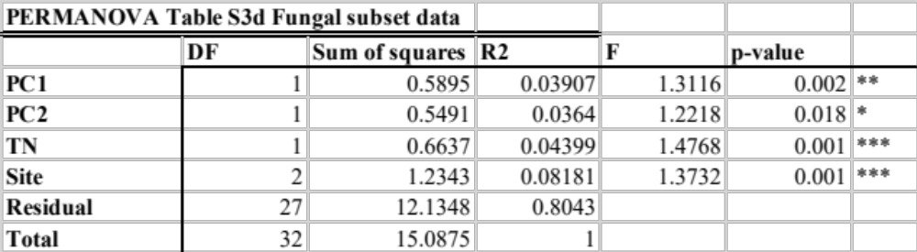
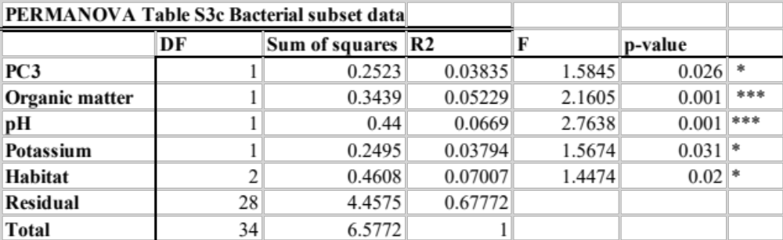
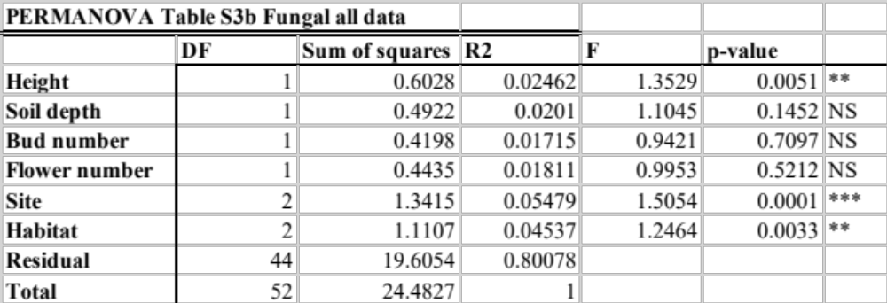

Table S4: The loadings from micronutrient PCA. To control for multicollinearity of soil micronutrient variables we used principal component analysis to distill the micronutrient data into a small set of independent variables (principal components) for use in PERMANOVA models.

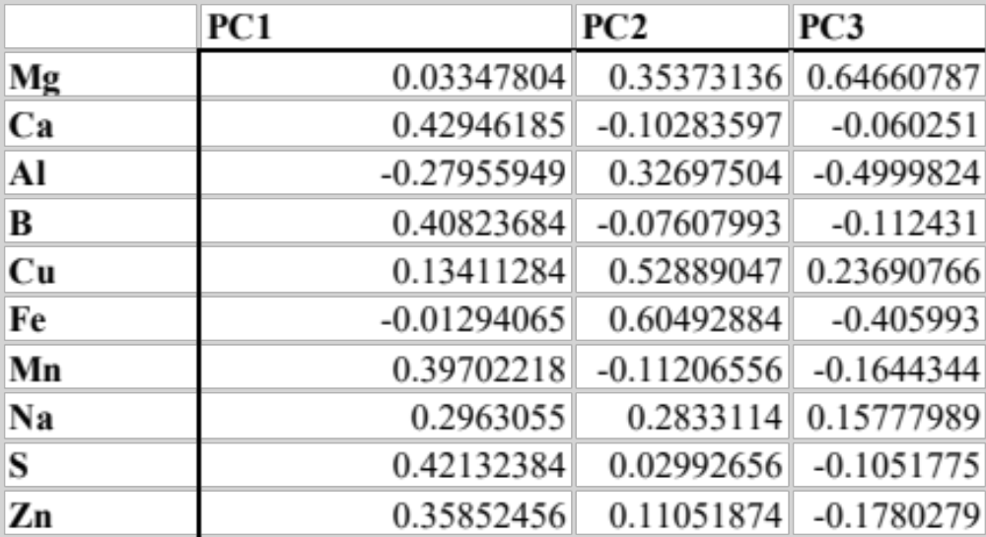

Table S5: Indicator species analysis uses microbial species occurrence and abundance to identify how strongly taxa associate with a particular habitat/environment. We found thirty six bacterial taxa were differentially abundant between the three habitats. Of these six were found on the dry alvars and six were found in the wet alvars. The remaining 24 were unique to old-fields. No taxa were identified to species level.
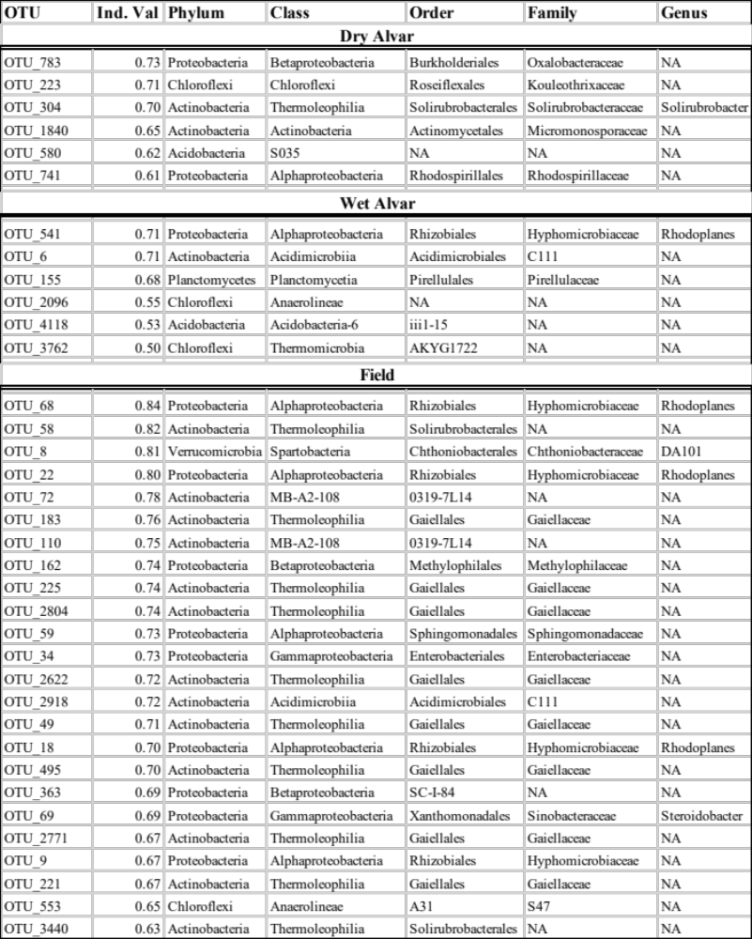

Table S6: List of blastn hits that show significant alignment with query taxa (fungal indicator taxa, OTU 20, 223, 477, and 613). The reference column indicates the taxa found in the NCBI database that show significant alignment with query taxa, the score is measure of how good the alignment is with high values meaning better alignment, and the prcnt (percent) column indicates the percentage of base pairs that are similar between query taxa and reference taxa.

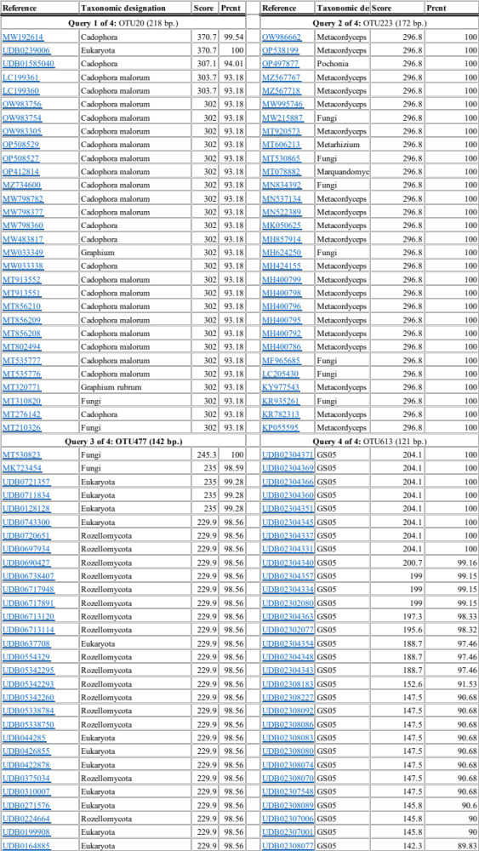
Table S7: Analysis of variance was used to determine if habitat was potentially driving the association between PCA axis scores and plant height. This table confirms that PCA scores and habitat were independently associated with plant height.

