Supplementary information

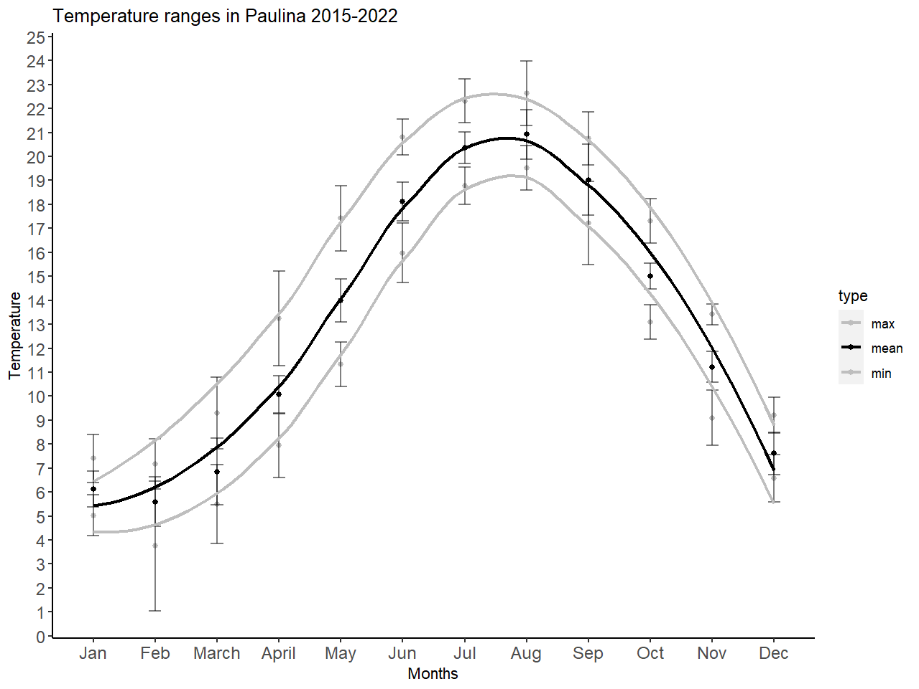
Fig. S1 Average mean, maximum and minimum temperatures in the subtidal area of the polyhaline region of the Westerschelde using data from 2015-2022 (Rijkswateersban).
Table S1 Mean, minimum and maximum temperatures (±SE) over 7 years (2015-2022) in the Paulina mudflat
 | mean | min | max
Jan | 6.05±0.66 | 5.03±0.8 | 7.4±0.93
Feb | 5.61±0.92 | 3.75±2.53 | 7.18±0.98
March | 6.86±1.22 | 5.5±1.53 | 9.29±1.4
April | 10.07±0.69 | 7.94±1.24 | 13.25±1.85
May | 14.01±0.8 | 11.33±0.88 | 17.43±1.28
June | 18.11±0.71 | 15.98±1.15 | 20.81±0.71
July | 20.36±0.58 | 18.78±0.73 | 22.31±0.86
August | 20.81±0.9 | 19.53±0.86 | 22.64±1.24
September | 18.97±1.3 | 17.21±1.62 | 20.74±1.03
October | 15.02±0.48 | 13.1±0.67 | 17.31±0.86
November | 11.11±0.55 | 9.1±1.06 | 13.41±0.4
December | 7.49±0.75 | 6.57±0.92 | 9.2±0.69

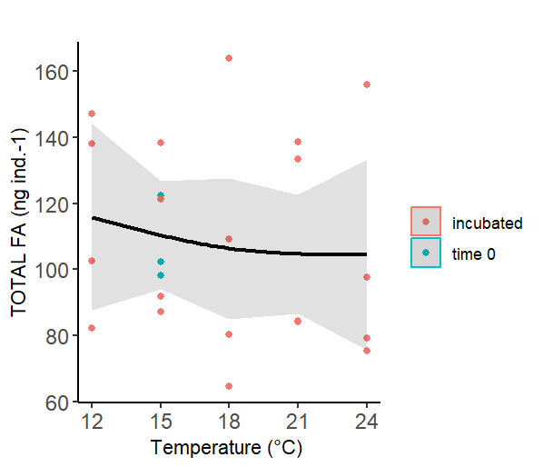
Fig S2. Total FA content across temperatures.
Table S2 Mean and SE of all present FAs (%) in M. littorale for the 5 experimental temperatures and from day 0 of the experiment. FA preceded by (*) indicate significant differences

 | day 0 (15 °C) | 12 °C | 15 °C | 18 °C | 21 °C | 24 °C
i-14:0 | 0.13±0.03 | 0.15±0.02 | 0.14±0.02 | 0.11±0.02 | 0.11±0.04 | 0.08±0
14:00 | 5.53±0.3 | 6.2±0.59 | 5.51±0.32 | 5.54±0.61 | 6±0.26 | 5.56±0.53
i-15:0 | 0.17±0.02 | 0.2±0.01 | 0.17±0.01 | 0.17±0.07 | 0.17±0.02 | 0.12±0.04
ai-15:0 | 0.28±0.06 | 0.28±0.07 | 0.25±0.06 | 0.26±0.08 | 0.2±0.07 | 0.14±0.05
15:00 | 0.74±0.13 | 0.74±0.12 | 0.67±0.11 | 0.88±0.34 | 0.7±0.05 | 0.6±0.04
*16:00 | 18.76±1.49 | 18.11±1.55 | 18.32±1.06 | 20.18±0.99 | 19.6±0.63 | 18.61±0.91
16:1 n-9 | 0.84±0.32 | 0.78±0.33 | 0.77±0.24 | 0.84±0.49 | 0.45±0.16 | 0.32±0.03
*16:1 n-7 | 10.22±3.22 | 9.39±2.13 | 9.45±2.35 | 8.29±2.15 | 8.95±1.5 | 9.13±2.28
16:1 n-5 | 0.33±0.13 | 0.27±0.06 | 0.31±0.05 | 0.28±0.05 | 0.24±0.04 | 0.18±0.02
17:00 | 0.27±0.02 | 0.25±0.01 | 0.28±0.01 | 0.42±0.1 | 0.35±0.03 | 0.29±0.02
16:2 n-4 | 0.99±0.19 | 1.07±0.23 | 1.14±0.26 | 0.9±0.16 | 1.13±0.12 | 0.99±0.1
18:00 | 4.92±0.12 | 5.04±0.32 | 5.5±0.44 | 6.77±1.01 | 8.78±2.28 | 6.39±0.38
*16:3 n-4 | 1.21±0.18 | 1.27±0.28 | 1.11±0.13 | 1.15±0.31 | 1.51±0.25 | 1.31±0.13
16:3 n-3 | 0.05±0.01 | 0.16±0.1 | 0.1±0.05 | 0.22±0.09 | 0.11±0.02 | 0.18±0.04
18:1 n-9 | 1.54±0.52 | 1.42±0.42 | 1.35±0.34 | 1.15±0.17 | 0.84±0.07 | 0.95±0.04
*18:1 n-7 | 2.43±0.06 | 2.4±0.06 | 2.38±0.08 | 2.02±0.14 | 1.67±0.12 | 1.94±0.15
*16:4 n-1 | 1.24±0.47 | 1.61±0.53 | 1.22±0.39 | 1.15±0.07 | 1.11±0.25 | 1.08±0.23
18:2 n-6 | 0.78±0.09 | 0.74±0.07 | 0.69±0 | 0.88±0.09 | 0.78±0.05 | 0.8±0.1
20:00 | 0.14±0 | 0.13±0.01 | 0.14±0.01 | 0.17±0.03 | 0.17±0.06 | 0.12±0
*18:3 n-6 | 1.14±0.37 | 1.09±0.25 | 1.1±0.23 | 1.13±0.04 | 1.07±0.09 | 1.14±0.08
18:3 n-3 | 0.05±0.01 | 0.32±0.24 | 0.17±0.07 | 0.6±0.21 | 0.14±0.04 | 0.3±0.08
18:4 n-3 | 0.62±0.19 | 0.83±0.25 | 0.72±0.2 | 0.64±0.06 | 0.46±0.08 | 0.59±0.11
22:00 | 0.69±0.03 | 0.64±0.05 | 0.67±0.05 | 0.81±0.12 | 0.64±0.05 | 0.74±0.05
*20:4 n-6 | 3.03±1.08 | 2.76±0.72 | 2.78±0.79 | 1.86±0.16 | 2.37±0.26 | 2.15±0.15
*20:5 n-3 | 17.94±3.1 | 18.45±2.47 | 18.31±2.31 | 17.4±0.99 | 17.92±0.51 | 18.72±1.53
24:00:00 | 1.63±0.22 | 1.54±0.18 | 1.65±0.19 | 2.1±0.29 | 1.8±0.19 | 2.1±0.18
*22:5 n-6 | 1.24±0.27 | 1.23±0.21 | 1.26±0.14 | 0.97±0.15 | 0.81±0.1 | 0.93±0.11
22:5 n-3 | 2.15±0.26 | 2.39±0.3 | 2.08±0.16 | 2.45±0.28 | 2.8±0.26 | 2.77±0.24
*22:6 n-3 | 20.94±2.15 | 20.57±1.31 | 21.76±1.48 | 20.66±2.16 | 19.12±1.8 | 21.75±1.92

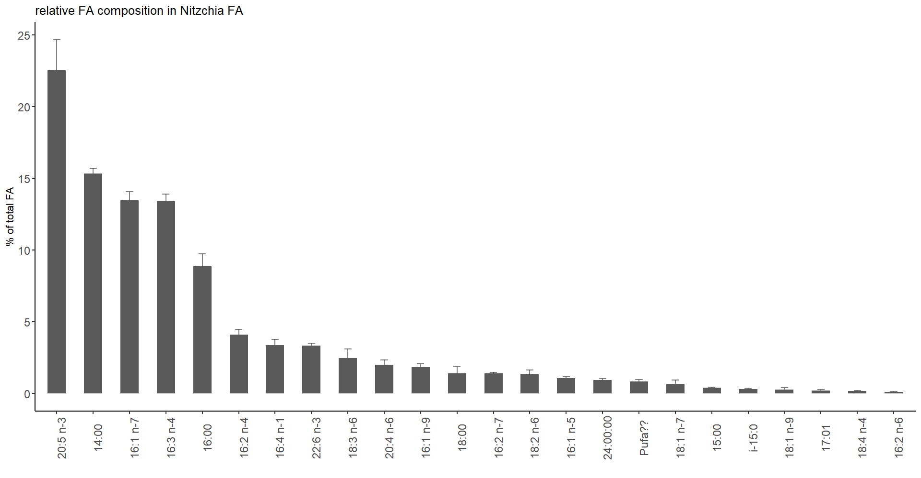
Fig S3. Relative FA composition of Nitzschia sp. in decreasing order.
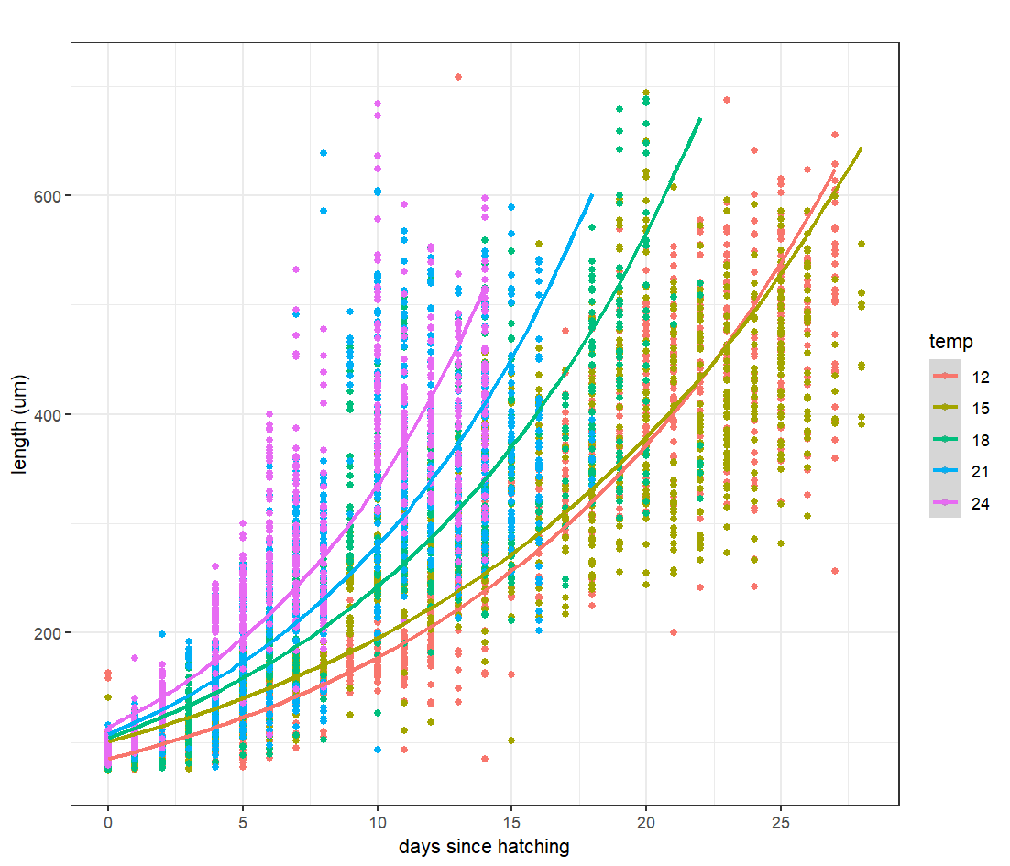
Fig S4. Exponential fit between length vs. days since hatching. Coefficients for the growth rates (r) were extracted from the equation where $L = β_{0}*exp(β_{1}*t)$ where L=length, $β_{0}$ is the length at day 0, t is the temperature and$β_{1}$ is the growth rate as the percentage change in length with time.
Table S3 Max adult size across temperatures and days since hatching until reaching maximum size.
Temp | Max length (um) | Days since hatching
12 | 512.1±45.74 | 25.73
15 | 480.66±49.94 | 25.14
18 | 483.56±40.87 | 20.33
21 | 465.72±55.85 | 15.92
24 | 469.99±53.11 | 14

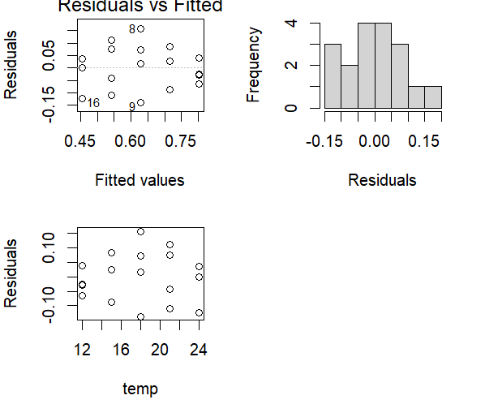
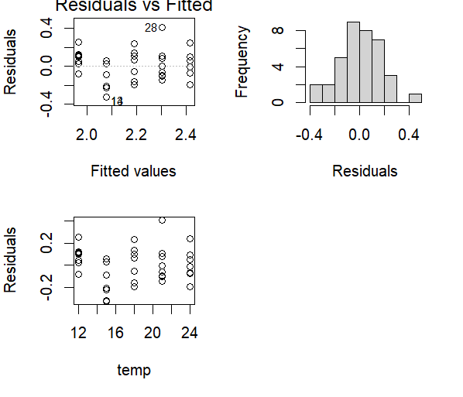
Fig S5 a) Survival model diagnosis graphs. Bartlett test of homogeneity of variances
(Bartlett's K-squared = 2.5566, df = 4, p-value = 0.6345). Shapiro-Wilk normality test
(W = 0.96875, p-value = 0.7739). b) Growth model diagnosis graphs. Bartlett test of homogeneity of variances (Bartlett's K-squared = 2.5623, df = 4, p-value = 0.6335). Shapiro-Wilk normality test (W = 0.98006, p-value = 0.7335).

