- Supplementary materials
  - Material & Methods
    - In Vitro part
      - Dynamic Gastrointestinal and Colonic Fermentation Model description
In this study we used the same protocol described in a previous article from our group [36]. It consists of a computer-assisted model of five interconnected compartments, simulating the physiological conditions of all the gastrointestinal tract, and being able to reproduce the flow of the content from inside the digester. All specifications can be found on the article by Rosés et al., which is divided in the same points that follow below.
      - Faecal Inoculum
Fresh faeces from adult participants were collected and pooled to reproduce a human gut microbiota in the in-vitro digester together with a culture medium. Further details are specified on the article mentioned before.
      - Process Description and Duration
After faecal inoculation, a stabilization period of 12 days (T12) was required to allow bacteria to grow and reach stable levels. The treatment period was conducted for another 14 days (T26) (a total of 26 days of experiment) by feeding the equipment with 40 g of crushed raw Bimi®, with a regular blender, once a day (in culture medium up to 200 ml) and with 200 ml of cultured medium twice a day. The maintenance of the microbial population during the stabilization and treatment period was checked by bacteria plate counts. All further details can be found on the article be Rosés et al. [36].

For the functionality analysis two samples were taken from the in vitro digester at two different stages:
- sample taken at the end of T12, when the microbiota has adapted to the in vitro conditions (Mbasal). This sample is obtained from the mixture of each of the three colonic reactors (“R3” ascending, “R4” transversal and “R5” descending).
- sample taken at the end of T26, after de addition of the 40g of crushed Bimi® on the in vitro digester, and the reaction of the microbiota: Mtt. This sample is obtained from the mixture of each of the three reactors (“R3” ascending, “R4” transversal and “R5” descending).
The samples were diluted ½ with Hank’s Balanced Salt solution (HBSS), selected dilution ½.
      - Short fatty acid analyses
This is fully described in the previous article by Rosés et al. [36].
      - Sample DNA extraction
DNA was extracted with the DNeasy® PowerSoil® Pro Kit (250) (Qiagen. Hilden, Germany) following the manufacturer ́s protocol [37].
    - In Vivo part
      - Participants, anthropometric and biochemical measurements

The individuals participating in this study participated in the BIOTAGUT trial which has been explained in a previous article from our group [38]. This clinical trial has been registered at ClinicalTrials.gov with the reference NCT04799223 and date of registration of March 16th, 2021. The anthropometric and biochemical information of the participants is presented in table 6.
      - Process Description and Duration
During the intervention period (3 weeks long), participants had to include 90 g of Bimi® (either cooked or row) every two days, into their habitual diet.
      - Faecal Sample Collection and DNA extraction
The faecal samples were self-collected by the volunteers, before and after the treatment, using stool preservation tubes (ref. 45660, Norgen Biotek Corp., Thorold, ON, Canada). The DNA extraction from faecal samples was performed with a DNeasy® PowerSoil® Pro Kit (250) (Qiagen, Hilden, Germany), following the manufacturer’s protocol.
    - Metagenomic and bioinformatic DNA analysis of in-vitro and in-vivo samples
This methodology is well explained in a previous article by Rosés et al. [36].
In-vitro samples: the abundance matrix was curated and normalized in R and Bioconductor. A global normalization was performed using the library size as a correction factor. Data was transformed to Log2.
In-vivo samples: the abundance matrix of species, genera, and families was normalized using the centred log-ratio (CLR) transformation using the R packages of zCompositions and compositions [39].
    - Richness and Evenness
Richness was defined as the total of species. Evenness, defined as the alpha diversity index, was calculated using the Shannon index [40] according to the following formula: H = -sum(Pi ln[Pi]).
    - Statistical analysis of the in-vivo samples
Participants’ microbiome composition was analysed using Microbiome Analyst [41, 42] comparing the different anthropometric measures, biochemical markers, and dietary estimation. The population was divided into two groups (high and low levels) according to the median of each variable. Statistical differences in microbiota profiles between groups, were analysed through a Zero-inflated Gaussian approach of Metagenome-Seq using the cumulative sum scaling (CSS) normalization and Student’s t-test through a CLR normalization, followed by FDR correction, were performed.
  - Tables
Table 6. Anthropometric measurements from the subjects, before (Basal) and after (TT) the treatment. No significant (p<0.05) changes were seen. Student t test were performed.
ID | IMC  Basal | IMC  TT | Δ IMC | Weight (kg)  Basal | Weight (kg)  TT | Δ Weight
8004 | 27.35 | 26.89 | -0.463 | 70.9 | 69,7 | -1,2
8011 | 29.65 | 29.58 | -0.068 | 86.7 | 86,5 | -0,2
8022 | 27.18 | 27.92 | 0.735 | 74 | 76 | 2
8023 | 24.80 | 25.10 | 0.297 | 66.7 | 67,5 | 0,8
8029 | 19.69 | 19.87 | 0.184 | 53.6 | 54,1 | 0,5
8032 | 20.59 | 20.62 | 0.032 | 64.5 | 64,6 | 0,1
8034 | 21.16 | 21.19 | 0.037 | 57.6 | 57,7 | 0,1
8039 | 22.93 | 23.24 | 0.313 | 58.7 | 59,5 | 0,8
8043 | 20.34 | 20.56 | 0.216 | 65.9 | 66,6 | 0,7
8047 | 24.42 | 23.88 | -0.543 | 80.9 | 79,1 | -1,8
8061 | 26.30 | 25.75 | -0.551 | 71.6 | 70,1 | -1,5
8062 | 19.85 | 20.12 | 0.267 | 52.1 | 52,8 | 0,7
8069 | 17.55 | 17.36 | -0.189 | 55.6 | 55 | -0,6
Ttest | 0.85 |  |  | 0.92
*ID 8013 and 8048 have been removed from the table due to missing data from the Basal period

Table 7. Serum biochemical parameters analysed before and after the treatment. Paired- t test was performed. Basal columns have the values before the treatment and TT columns, after the treatment.
ID | Glucose  (mg/dl) |  |  | Cholesterol  (mg/dl) |  |  | HDL  (mg/dl) |  |  | Triglycerides  (mg/dl) |  |  | ALT  (U/L) |  |  | AST  (U/L) |  |  |  | Insulin  (µIU/ml)
 | Basal | TT | Basal |  | TT | Basal |  | TT | Basal |  | TT | Basal |  | TT | Basal |  | TT | Basal |  |  | TT
8004 | 94.20 | 95.88 | 198 |  | 196 | 73.14 |  | 77.66 | 58 |  | 60 | 12.2 |  | 13.6 | 20.2 |  | 19.9 | 7.46 |  |  | 10.45
8011 | 99.58 | 105.12 | 228 |  | 232 | 52.38 |  | 49.12 | 106 |  | 104 | 26.5 |  | 35.9 | 23.4 |  | 25.0 | 10.36 |  |  | 11.57
8013 | 84.36 | 95.40 | 175 |  | 190 | 59.44 |  | 61.29 | 84 |  | 62 | 27.9 |  | 29.1 | 24.7 |  | 17.2 | 8.89 |  |  | 11.60
8022 | 127.12 | 148.24 | 237 |  | 283 | 42.69 |  | 52.23 | 179 |  | 184 | 55.3 |  | 48.5 | 26.5 |  | 27.9 | 4.04 |  |  | 6.31
8023 | 90.63 | 89.27 | 176 |  | 183 | 40.81 |  | 42.40 | 47 |  | 90 | 14.1 |  | 16.4 | 14.9 |  | 16.2 | 7.75 |  |  | 10.74
8029 | 81.85 | 80.88 | 135 |  | 117 | 46.96 |  | 43.59 | 50 |  | 44 | 18.1 |  | 9.4 | 23.7 |  | 17.6 | 4.38 |  |  | 11.84
8032 | 89.63 | 87.35 | 179 |  | 168 | 73.97 |  | 75.11 | 37 |  | 35 | 12.6 |  | 13.8 | 14.5 |  | 15.2 | 3.91 |  |  | 7.35
8034 | 95.20 | 95.19 | 218 |  | 227 | 72.2 |  | 74.94 | 47 |  | 48 | 11.6 |  | 11.5 | 16.0 |  | 15.3 | 5.82 |  |  | 7.32
8039 | 74.79 | 73.98 | 216 |  | 226 | 71.47 |  | 66.79 | 84 |  | 81 | 21.2 |  | 31.6 | 21.7 |  | 23.4 | 12.75 |  |  | 8.42
8043 | 93.37 | 85.70 | 175 |  | 197 | 61.87 |  | 68.34 | 59 |  | 51 | 16.4 |  | 15.7 | 21.1 |  | 22.3 | 7.10 |  |  | 6.59
8047 | 93.77 | 97.43 | 209 |  | 218 | 56.20 |  | 63.45 | 93 |  | 64 | 23.3 |  | 23.0 | 27.4 |  | 25.3 | 7.93 |  |  | 7.77
8048 | 101.01 | 114.4 | 198 |  | 213 | 50.63 |  | 50.32 | 70 |  | 103 | 19.7 |  | 22.8 | 16.9 |  | 20.1 | 10.02 |  |  | 14.62
8061 | 121.66 | 134.29 | 220 |  | 222 | 61.73 |  | 60.88 | 159 |  | 129 | 93.0 |  | 102 | 71.5 |  | 83.7 | 10.56 |  |  | 11.6
8062 | 89.40 | 86.99 | 255 |  | 235 | 70.13 |  | 68.50 | 48 |  | 45 | 11.7 |  | 15.9 | 16.5 |  | 18.0 | 2.96 |  |  | 4.02
8069 | 83.33 | 87.70 | 161 |  | 151 | 67.89 |  | 68.50 | 37 |  | 41 | 15.3 |  | 25.1 | 26.4 |  | 33.8 | 6.70 |  |  | 2.07
Average | 94.66 | 98.52 | 198.67 |  | 203.87 | 60.10 |  | 61.54 | 77.20 |  | 76.07 | 25.26 |  | 27.62 | 24.36 |  | 25.39 | 7.38 |  |  | 8.82
SE | 3.59 | 5.17 | 8.23 |  | 10.24 | 2.94 |  | 2.97 | 11.05 |  | 10.49 | 5.61 |  | 5.97 | 3.55 |  | 4.38 | 0.73 |  |  | 0.87
T test | 0.071 |  | 0.249 |  |  | 0.197 |  |  | 0.825 |  |  | 0.129 |  |  | 0.409 |  |  |  | 0.093

Table 8. Bacterial genera presenting significant changes (p < 0.05) or a clear tendency (p < 0.1) after the the in-vivo intervention. Paired t-tests after CLR normalization, followed by FDR correction, were performed.
ID | Alistipes | Anaerostipes | Bifidobacterium | Candidatus Stoquefichus | Eubacterium | Fusicatenibacter | Lachnospira | Lactobacillus
8004-Basal | 3.061 | 5.366 | -1.836 | -2.935 | 5.224 | 1.389 | -2.530 | -0.989
8011-Basal | -1.368 | 4.667 | -2.467 | -4.690 | 3.785 | 0.978 | -1.081 | -1.368
8013-Basal | 0.443 | 6.735 | -3.663 | -3.521 | 4.390 | 3.000 | -2.984 | -3.657
8022-Basal | -0.538 | 6.524 | -3.608 | -0.692 | 3.213 | 2.742 | -3.608 | -3.608
8023-Basal | 3.856 | 4.931 | -2.179 | -4.912 | 3.084 | 0.355 | -0.844 | -2.690
8029-Basal | 3.384 | 5.709 | -4.325 | 0.437 | 3.505 | 2.466 | 2.193 | -3.201
8032-Basal | 3.579 | 3.915 | 1.247 | -3.358 | 3.114 | 0.564 | 0.153 | -5.175
8034-Basal | 4.541 | 6.225 | -0.218 | 1.430 | 4.571 | 2.377 | -2.233 | -2.233
8039-Basal | 3.160 | 4.857 | -0.907 | 1.503 | 3.563 | 0.389 | -3.349 | -5.166
8043-Basal | 4.687 | 6.104 | -2.390 | 0.249 | 4.234 | 2.766 | -2.390 | -3.083
8047-Basal | 1.022 | 5.051 | -0.393 | -4.775 | 2.970 | 1.399 | -1.454 | -3.651
8048-Basal | 2.134 | 6.301 | -1.610 | -2.303 | 3.969 | 2.557 | 1.335 | -1.204
8061-Basal | 3.278 | 5.842 | -2.085 | -0.832 | 3.471 | 2.490 | -4.595 | 1.040
8062-Basal | 3.642 | 5.752 | -0.277 | 0.193 | 3.910 | 2.683 | 0.391 | -1.481
8069-Basal | 3.143 | 6.079 | -1.477 | -3.883 | 3.912 | 2.425 | -3.294 | 0.537
8004-TT | 3.569 | 4.882 | -1.903 | -3.983 | 5.015 | 0.745 | -2.373 | -0.294
8011-TT | -1.235 | 4.689 | -4.662 | -4.662 | 3.829 | 0.413 | -1.235 | -0.899
8013-TT | 0.973 | 6.442 | -1.735 | -3.552 | 4.144 | 2.582 | -1.042 | -3.552
8022-TT | 2.295 | 5.464 | -4.394 | 1.325 | 3.543 | 2.737 | -0.497 | -3.270
8023-TT | 3.892 | 4.497 | -4.771 | -4.771 | 3.335 | 0.342 | -0.315 | -4.771
8029-TT | 3.927 | 5.444 | -3.705 | 0.939 | 3.434 | 1.675 | 1.510 | -0.997
8032-TT | 3.254 | 3.655 | 0.175 | -5.503 | 2.820 | 0.016 | -0.528 | -2.769
8034-TT | 4.362 | 5.361 | -2.742 | 0.896 | 3.313 | 2.008 | -0.216 | 0.349
8039-TT | 2.743 | 5.020 | -1.291 | 0.566 | 3.368 | 1.279 | -0.667 | -3.999
8043-TT | 4.609 | 5.631 | -4.354 | -0.139 | 4.234 | 1.718 | -1.033 | -1.621
8047-TT | 1.671 | 4.708 | 0.382 | -5.033 | 3.363 | 1.262 | -0.412 | -5.033
8048-TT | 3.240 | 4.852 | -4.212 | -4.212 | 3.757 | 1.145 | -1.167 | 0.145
8061-TT | 3.705 | 5.758 | -1.093 | -0.806 | 3.220 | 1.894 | -3.578 | 2.513
8062-TT | 4.064 | 5.142 | -1.551 | -3.055 | 3.235 | 1.865 | -0.111 | -1.264
8069-TT | 3.032 | 5.197 | -2.123 | -4.856 | 2.865 | 1.472 | -1.653 | 2.655
T test | 0.067 | 0.001 | 0.052 | 0.089 | 0.076 | 0.003 | 0.078 | 0.024

Table 9. Bacterial species presenting significant changes (p < 0.05) or a clear tendency (p < 0.1) after the in-vivo intervention. Paired t-tests after a CLR normalization, followed by FDR correction, were performed.
ID | Alistipes putredinis | Bacteroides coprocola | OTU1335 | OTU1479 | OTU1588 | OTU18 | OTU428 | OTU525
8004-Basal | 3.777 | -0.212 | -1.416 | -0.212 | 0.125 | -1.128 | 1.012 | -1.128
8011-Basal | 0.541 | -2.780 | 0.290 | 0.423 | 1.116 | -0.557 | 1.955 | -2.780
8013-Basal | -0.254 | -1.377 | -1.920 | -2.023 | 0.439 | -1.377 | -1.377 | -1.377
8022-Basal | 0.332 | 2.452 | 1.718 | -0.767 | 1.179 | -1.890 | -1.890 | -1.890
8023-Basal | 4.725 | -3.882 | -0.455 | -0.273 | -0.193 | 1.003 | 2.305 | -0.561
8029-Basal | 4.902 | -2.763 | 1.000 | 1.888 | 1.580 | -2.763 | -2.763 | -2.763
8032-Basal | 4.514 | -4.013 | -2.889 | -0.324 | 0.722 | 0.406 | 2.667 | -2.889
8034-Basal | 5.812 | 3.318 | 2.205 | -0.193 | 1.886 | -2.703 | -2.703 | -2.703
8039-Basal | 2.785 | -3.799 | 0.098 | -1.982 | 0.583 | -0.596 | 0.416 | -0.883
8043-Basal | 5.194 | 0.271 | -2.127 | -3.250 | 0.964 | 2.280 | -3.250 | -2.127
8047-Basal | 1.934 | 0.264 | -0.221 | -0.103 | 0.339 | 0.408 | 0.695 | -0.221
8048-Basal | 1.993 | -2.795 | -0.978 | -0.978 | 1.162 | -2.795 | -0.572 | -1.671
8061-Basal | 4.453 | 1.431 | 0.102 | -2.095 | 0.613 | -0.486 | -3.219 | 0.996
8062-Basal | 5.111 | -2.689 | 0.919 | -1.566 | 1.325 | -0.873 | 1.730 | 0.380
8069-Basal | 4.246 | -2.124 | -1.001 | -2.730 | 1.995 | 0.385 | 0.098 | -2.124
8004-TT | 4.387 | 0.672 | -1.840 | -0.166 | 0.152 | -0.374 | 0.932 | -4.063
8011-TT | 0.539 | -2.887 | -2.887 | 0.875 | 1.820 | -0.665 | 1.455 | -2.887
8013-TT | 0.930 | -1.803 | 0.014 | 1.112 | 2.154 | -1.803 | -0.679 | -1.803
8022-TT | 2.058 | 0.335 | 1.904 | 0.805 | 2.222 | -2.398 | -2.398 | -2.398
8023-TT | 4.918 | -3.651 | -2.527 | -0.129 | -0.129 | 0.874 | 2.871 | -1.834
8029-TT | 5.055 | -3.620 | -0.550 | 1.564 | 1.898 | -1.398 | -1.803 | -3.620
8032-TT | 4.456 | -4.098 | -4.098 | -0.083 | 0.394 | 0.117 | 2.837 | -4.098
8034-TT | 5.825 | 2.996 | 0.470 | 0.733 | 1.426 | 2.262 | -1.832 | -2.956
8039-TT | 2.694 | -3.682 | 0.275 | -1.172 | 0.876 | 0.275 | -0.479 | 0.620
8043-TT | 5.000 | -0.328 | -0.616 | -0.328 | 1.377 | 1.812 | 0.232 | -1.714
8047-TT | 2.548 | 0.563 | -1.096 | 0.696 | 0.814 | 1.102 | 1.156 | 0.291
8048-TT | 1.566 | -4.122 | -2.305 | -0.696 | 1.045 | -0.108 | 0.934 | -1.899
8061-TT | 4.627 | 1.391 | 0.418 | 0.224 | 0.986 | -0.470 | -1.722 | 0.149
8062-TT | 5.571 | -3.034 | -0.119 | 0.036 | 1.779 | 2.664 | 1.134 | 0.488
8069-TT | 4.666 | -3.138 | -3.138 | -0.405 | 1.724 | -0.222 | 0.551 | -3.138
T test | 0.043 | 0.064 | 0.052 | 0.001 | 0.048 | 0.077 | 0.078 | 0.088
OTU1335|Oscillibacter valericigenes AB238598|D=95.6 || OTU1479|Anoxystipes fissicatena NR 104800.1|D=92.3
OTU1588|Anoxystipes_fissicatena_NR_104800.1|D=92.2 || OTU18|Ruminococcus_bromii_DQ882649|D=88.1
OTU428|Christensenella_minuta_AB490809|D=84.9 || OTU525|Clostridium_clariflavum_NR_102987.1|D=78.1

Table 10. All bacterial species abundance in the three colonic sections. T12 represents the end of the stabilization period and T26 the end of the treatment period. Values represent relative abundance (%).
Tax | R3T12 | R3T26 | R4T12 | R4T26 | R5T12 | R5T26
Acidaminococcus intestini |  |  | 3.45 | 3.78 | 2.80 | 3.50
Acinetobacter septicus |  |  | 6.23 | 8.65
Akkermansia muciniphila |  |  | 0.00 | 1.11
Alistipes obesi |  |  |  |  | 0.00 | 1.02
Alistipes putredinis |  |  |  |  | 6.14 | 6.58
Anaerofustis stercorihominis |  |  |  |  | 1.32 | 3.50
Anaerotruncus colihominis |  |  | 0.00 | 2.99 | 0.81 | 3.50
Atopobium minutum |  |  | 1.89 | 2.99
Bacteroides cellulosilyticus |  |  | 4.50 | 5.63 | 3.85 | 4.56
Bacteroides coprocola |  |  | 0.00 | 1.73
Bacteroides dorei |  |  | 0.00 | 1.73 | 0.00 | 3.21
Bacteroides eggerthii | 0.00 | 1.65
Bacteroides massiliensis |  |  |  |  | 0.00 | 1.61
Bacteroides salyersiae |  |  | 9.23 | 10.43 | 8.22 | 10.96
Bacteroides uniformis |  |  | 0.00 | 2.99 | 1.70 | 3.74
Bifidobacterium adolescentis | 0.00 | 2.89
Brevundimonas diminuta |  |  | 2.20 | 2.76
Citrobacter werkmanii | 5.38 | 6.54 | 0.00 | 4.29
Clostridium perfringens | 0.00 | 6.63 | 0.00 | 3.78 | 0.00 | 4.21
Dielma fastidiosa |  |  |  |  | 2.00 | 2.03
Eggerthella lenta |  |  | 2.46 | 2.76 | 1.32 | 3.36
Enterobacter ludwigii | 5.12 | 6.99 | 0.00 | 2.76
Eubacterium eligens | 2.96 | 4.18 | 5.47 | 9.55 | 5.47 | 7.89
Eubacterium siraeum |  |  | 0.00 | 1.73
Holdemania massiliensis |  |  | 6.80 | 7.42 | 6.54 | 6.92
Intestinimonas butyriciproducens |  |  | 5.83 | 8.77 | 6.03 | 8.67
OTU1000|Bacteroides vulgatus|D=96.9 |  |  | 5.14 | 7.89 | 5.18 | 8.08
OTU1051|Christensenella minuta|D=87.2 |  |  | 0.00 | 1.11
OTU1168|Anaerorhabdus furcosa|D=82.2 | 0.00 | 1.65
OTU1212|Ruminococcus lactaris|D=87.5 |  |  |  |  | 0.00 | 1.02
OTU1258|Melainabacter A1|D=94.8 |  |  |  |  | 0.00 | 2.03
OTU1262|Catabacter hongkongensis|D=84.1 |  |  |  |  | 0.00 | 2.62
OTU136|Oscillospira capillosus|D=91.2 |  |  |  |  | 9.39 | 9.99
OTU1413|Mesorhizobium loti|D=82.1 | 0.00 | 1.65 | 1.49 | 10.71 | 0.00 | 9.68
OTU1556|Bacteroides thetaiotaomicron|D=95.9 |  |  | 12.26 | 13.14 | 11.69 | 13.29
OTU1560|Oscillibacter valericigenes|D=90.2 |  |  | 0.93 | 2.16 | 0.00 | 1.02
OTU1568|Clostridium sporosphaeroides|D=93.7 |  |  |  |  | 2.25 | 2.35
OTU197|Ruminococcus albus|D=93.7 |  |  | 0.00 | 8.51 | 0.00 | 8.44
OTU20|Bacteroides xylanisolvens|D=96.4 |  |  |  |  | 9.23 | 9.99
OTU253|Geobacillus stearothermophilus|D=75.9 | 0.00 | 12.85 | 0.00 | 3.78 | 0.00 | 1.61
OTU45|Soleaferrea massiliensis|D=88.7 | 0.00 | 2.40
OTU470|Soleaferrea massiliensis|D=87.5 | 0.00 | 2.40 |  |  | 0.00 | 3.94
OTU503|Parabacteroides goldsteinii|D=79.6 |  |  | 0.00 | 1.11 | 1.32 | 2.03
OTU522|Melainabacter A1|D=92.9 |  |  |  |  | 0.00 | 1.02
OTU563|Anoxystipes fissicatena|D=96.2 |  |  |  |  | 0.00 | 1.65
OTU606|Adlercreutzia equolifaciens|D=92.8 |  |  | 0.00 | 3.78 | 0.00 | 3.21
OTU616|Turicibacter sanguinis|D=87.1 | 0.00 | 1.65
OTU62|Clostridium subterminale|D=95 | 0.00 | 3.79
OTU632|Parasutterella excrementihominis|D=96.3 |  |  | 9.37 | 10.38 | 9.48 | 10.27
OTU700|Oscillibacter valericigenes|D=90.8 | 0.00 | 1.65 | 5.76 | 5.91 | 5.63 | 6.02
OTU81|Clostridium lactatifermentans|D=90.2 |  |  | 0.93 | 1.11
OTU82|Clostridium lactatifermentans|D=93.1 |  |  | 0.00 | 4.96 | 0.00 | 3.74
OTU882|Melainabacter A1|D=94.7 | 0.00 | 2.89
Parabacteroides goldsteinii |  |  | 0.93 | 9.01 | 0.00 | 8.70
Parabacteroides merdae | 0.00 | 1.65
Paraprevotella clara |  |  | 0.00 | 2.49 | 0.00 | 1.02
Phascolarctobacterium succinatutens |  |  | 6.82 | 8.36 | 4.30 | 7.18
Ralstonia mannitolilytica |  |  | 3.67 | 4.60
Succinatimonas hippei |  |  | 4.38 | 5.85 | 3.78 | 6.19
Sutterella wadsworthensis |  |  | 5.06 | 6.64 | 4.88 | 6.33
Victivallis vadensis | 0.00 | 2.40 | 4.90 | 10.67 | 8.72 | 10.78
 | Marked species indicate growth in all three reactors

  - Figures
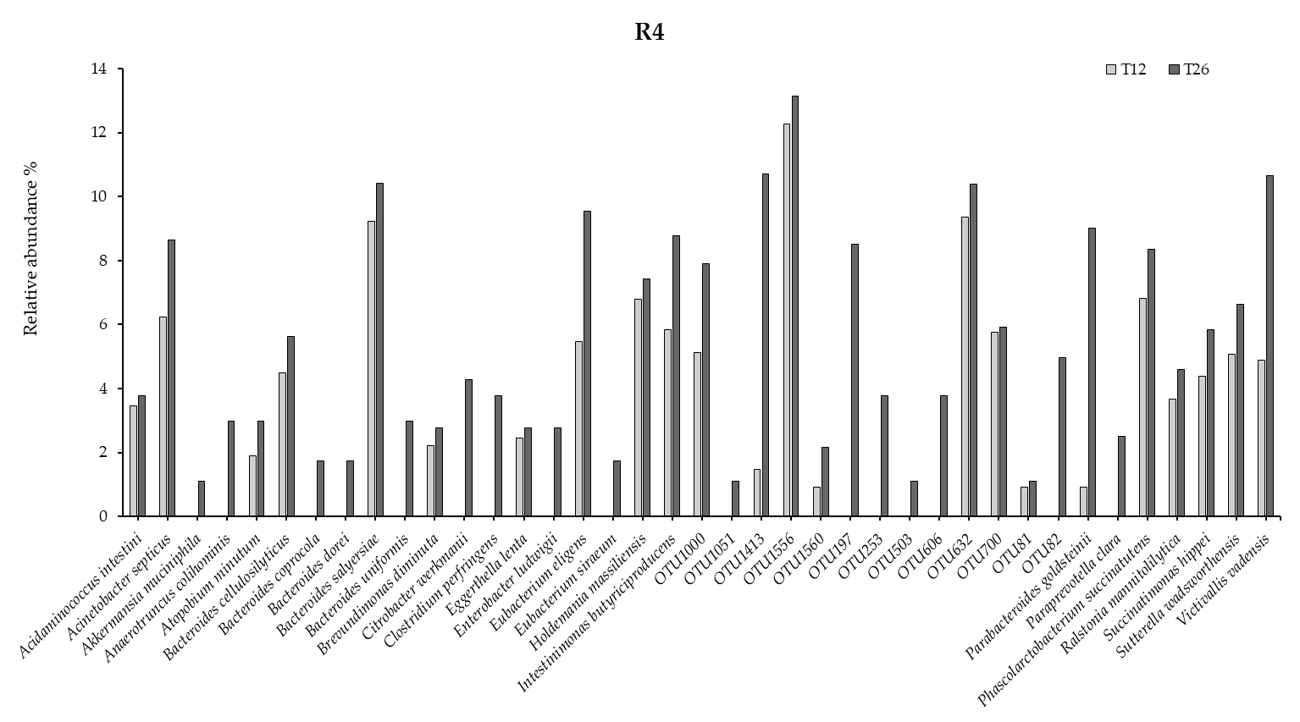
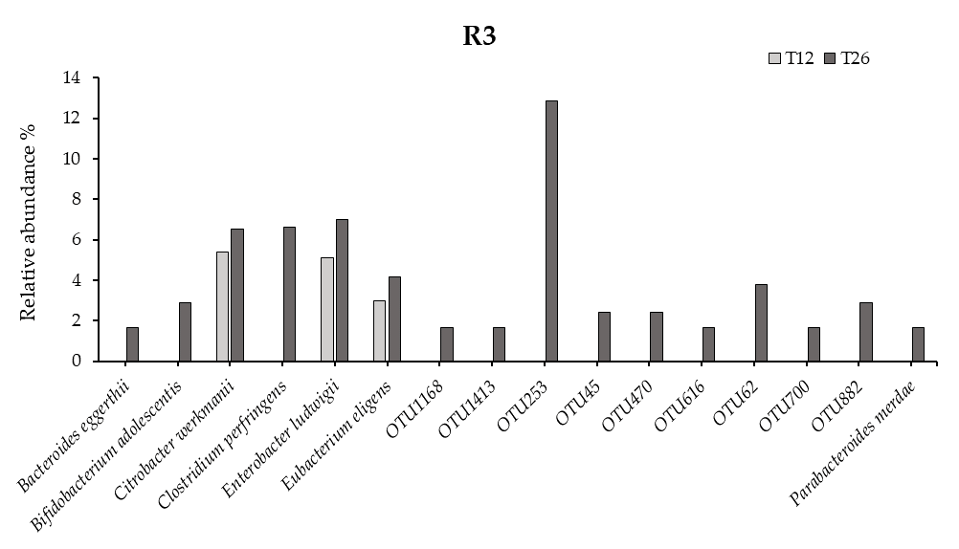
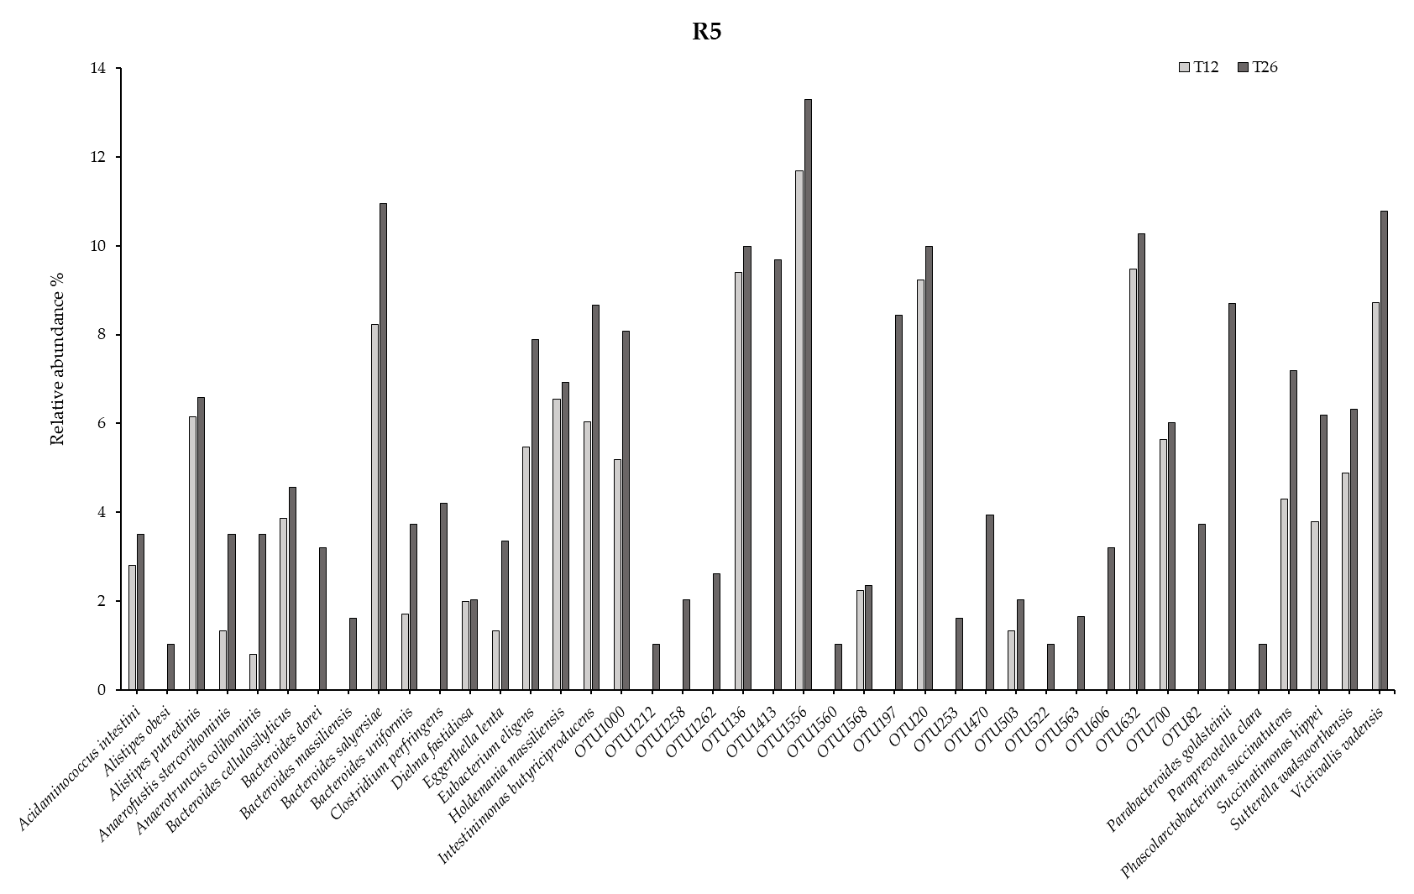
Figure 3. Representation of the relative abundance of bacterial species in the different reactors: (R3) ascending colon, (R4) transversal colon, (R5) descending colon, before (T12) and after the treatment period (T26) with Bimi®.
  - References
36. Rosés C, Nieto JA, Viadel B, et al (2021) An In Vitro Protocol to Study the Modulatory Effects of a Food or Biocompound on Human Gut Microbiome and Metabolome. Foods 10:3020. https://doi.org/10.3390/FOODS10123020
37. Menu E, Mary C, Toga I, et al (2018) Evaluation of two DNA extraction methods for the PCR-based detection of eukaryotic enteric pathogens in fecal samples. BMC Res Notes 11:206. https://doi.org/10.1186/S13104-018-3300-2
38. Villaseñor-Aranguren M, Rosés C, Riezu-Boj JI, et al (2022) Association of the Gut Microbiota with the Host’s Health through an Analysis of Biochemical Markers, Dietary Estimation, and Microbial Composition. Nutrients 14:4966. https://doi.org/10.3390/NU14234966
39. Aitchison J (1983) Principal component analysis of compositional data. Biometrika 70:57–65. https://doi.org/10.1093/BIOMET/70.1.57
40. Spellerberg IF, Fedor PJ (2003) A tribute to Claude Shannon (1916–2001) and a plea for more rigorous use of species richness, species diversity and the ‘Shannon–Wiener’ Index. Global Ecology and Biogeography 12:177–179. https://doi.org/10.1046/J.1466-822X.2003.00015.X
41. Chong J, Liu P, Zhou G, et al Using MicrobiomeAnalyst for comprehensive statistical, functional, and meta-analysis of microbiome data. Nature Protocols 15:799-821. https://doi.org/10.1038/s41596-019-0264-1
42. Dhariwal A, Chong J, Habib S, et al (2017) MicrobiomeAnalyst: a web-based tool for comprehensive statistical, visual and meta-analysis of microbiome data. Nucleic Acids Res 45:W180–W188. https://doi.org/10.1093/NAR/GKX295

