Microplastics and phthalate esters release from teabags into tea drink: Occurrence, human exposure, and health risks
Fatemeh Sadat Kashfi^{1#}, Azam Mohammadi^{1#}, Farzaneh Rostami², Arezou Savari², Gabriel E. De-la-Torre³, Jörg Spitz⁴, Reza Saeedi^{5,6}, Mohammadreza Kalantarhormozi⁷, Akram Farhadi⁷, Sina Dobaradaran^{1,2,8,9*}

¹Systems Environmental Health and Energy Research Center, The Persian Gulf Biomedical Sciences Research Institute, Bushehr University of Medical Sciences, Bushehr, Iran
²Department of Environmental Health Engineering, Faculty of Health and Nutrition, Bushehr University of Medical Sciences, Bushehr, Iran
³Biodiversity, Environment, and Society Research Group, San Ignacio de Loyola University, Lima, Peru
⁴Akademie Für Menschliche Medizin GmbH, Krauskopfallee 27, 65388 Schlangenbad, Germany
⁵Workplace Health Promotion Research Center, Shahid Beheshti University of Medical Sciences, Tehran, Iran.
⁶Department of Health, Safety and Environment, School of Public Health and Safety, Shahid Beheshti University of Medical Sciences, Tehran, Iran.
⁷The Persian Gulf Tropical Medicine Research Center, The Persian Gulf Biomedical Sciences Research Institute, Bushehr University of Medical Sciences, Bushehr, Iran.
⁸Instrumental Analytical Chemistry and Centre for Water and Environmental Research (ZWU), Faculty of Chemistry, University of Duisburg-Essen, Universitätsstr. 5, Essen, Germany
⁹Centre for Water and Environmental Research, University of Duisburg-Essen, Universitätsstr. 5, Essen, 45141, German

*Systems Environmental Health and Energy Research Center, Boostan 19 Alley, Imam Khomeini Street, Bushehr, 7514763448, Iran. E-mail addresses sina_dobaradaran@yahoo.com, s.dobaradaran@bpums.ac.ir

# FK and AM should be considered as joint first authors.

Contents
1. PAEs analysis
Table S1. The summary of characteristics of teabag brands.
Table S2. Abbreviation, limit of detection (LOD), limit of quantification (LOQ), and recovery percent (R%) for each examined PAE.
Table S3. Average number of detected MPs in different brands of the Persian (A₁-A₁₀) and German (B₁-B₅) teabags.
Table S4. Size, shapes, and color distribution of detected MPs in different brands of the Persian (A₁-A₁₀) and German (B₁-B₅) teabags.
Table S5. PAEs concentration in different brands of the Persian (A₁-A₁₀) and German (B₁-B₅) teabags.
Table S6. EDI of 6 PAEs congeners for teabag consumers.
Fig. S1. Shape (a) and color (b) of detected MPs in different brands of the Persian (A₁-A₁₀) and German (B₁-B₅) teabag.
Fig. S2. Some detected MPs in teabag samples.
Fig. S3. Spectra Raman of some polymers identified in MPs of the teabag samples.

1. PAEs analysis
An Agilent gas chromatography (GC) model 7890 equipped with triple quadrupole mass spectrometer (MS) model 5975C was applied for PAEs analysis. Isolation was performed via a capillary column of polydimethylsiloxane (HP-5 MS (5% phenyl) -95%) built of silica with a film thickness of 0.25 µm. Helium with a 99.999% purity was used as carrier gas with a flow rate of 1 mL/min. SIM analysis was used for each of the target species. The samples were injected at 290°C in splitless mode. The temperature of the oven was started from 70°C (maintained for 1 min) and then increased to 300°C at 10°C/min, which was maintained at this temperature for 7 min. The ion source and quadrupole temperatures were 230°C and 150°C, respectively. MSD ChemStation software (version E.02.01.1177) was used for data acquisition.

Table S1. The summary of characteristics of teabag brands.
Tea brand | Place of production | Place of packaging | Tea type
A₁ | India | Iran | Black tea
A₂ | India | Iran | Black tea
A₃ | India | Iran | Black tea
A₄ | Sri Lanka | Iran | Black tea
A₅ | Sri Lanka | Iran | Black tea
A₆ | Iran | Iran | Black tea
A₇ | Iran | Iran | Black tea
A₈ | Iran | Iran | Black tea
A₉ | Iran | Iran | Black tea
A₁₀ | Iran | Iran | Black tea
B₁ | Japan | Germany | Green tea
B₂ | China | China | Green tea
B₃ | China | Germany | Green tea
B₄ | China | Austria | Green tea
B₅ | China | Germany | Green tea

Table S2. Abbreviation, limit of detection (LOD), limit of quantification (LOQ), and recovery percent (R%) for each examined PAE.
PAEs | Abbreviations | LOD (ng/mL) | LOQ (ng/mL) | R² | Recovery  (%) | Precision  (%RSD)
Dimethyl phthalate | DMP | 1.68 | 5.56 | 0.993 | 101.3 | 9.4
Diethyl phthalate | DEP | 0.86 | 2.84 | 0.995 | 103.1 | 6.5
Diisobutyl phthalate | DiBP | 0.06 | 0.21 | 0.999 | 87.8 | 3.4
Dibutyl phthalate | DBP | 0.75 | 2.46 | 0.99 | 101.1 | 2.2
Butyl benzyl phthalate | BBP | 1.67 | 5.50 | 0.992 | 100.2 | 5.2
Diethylhexyl phthalate | BEHP | 0.10 | 0.34 | 0.991 | 104.3 | 1.9
Dioctyl phthalate | DOP | 2.11 | 6.97 | 0.996 | 99.5 | 2.7

Table S3. Average number of detected MPs in different brands of the Persian (A₁-A₁₀) and German (B₁-B₅) teabags.
Country  (n= Sample number) | Brand | Average ± SD  (items/single teabag)
Iran  (n= 30) | A₁ | 164.8
Iran  (n= 30) | A₂ | 123.2
Iran  (n= 30) | A₃ | 1446.8
Iran  (n= 30) | A₄ | 425.6
Iran  (n= 30) | A₅ | 1370.4
Iran  (n= 30) | A₆ | 262
Iran  (n= 30) | A₇ | 109.2
Iran  (n= 30) | A₈ | 73.6
Iran  (n= 30) | A₉ | 74
Iran  (n= 30) | A₁₀ | 73.6
Average ± SD |  | 412.32 ± 22.92
Germany  (n= 15) | B₁ | 202.8
Germany  (n= 15) | B₂ | 59.6
Germany  (n= 15) | B₃ | 55.6
Germany  (n= 15) | B₄ | 95.2
Germany  (n= 15) | B₅ | 323.2
Average ± SD |  | 147.28 ± 7.09
Total average ± SD |  | 323.97 ± 132.52
p-value* |  | 0.04*
*Significant at p-value< 0.05

Table S4. Size, shapes, and color distribution of detected MPs in different brands of the Persian (A₁-A₁₀) and German (B₁-B₅) teabags.
Characteristics | Category | Teabag brand
Characteristics | Category | A₁ | A₂ | A₃ | A₄ | A₅ | A₆ | A₇ | A₈ | A₉ | A₁₀ | B₁ | B₂ | B₃ | B₄ | B₅
Size | 20-100 µm | 31 | 38 | 290 | 37 | 111 | 13 | 8 | 39 | 2 | 4 | 7 | 15 | 0 | 6 | 26
Size | 100-250 µm | 209 | 77 | 1415 | 632 | 1418 | 315 | 97 | 94 | 64 | 51 | 211 | 61 | 17 | 84 | 248
Size | 250-500 µm | 93 | 60 | 857 | 193 | 1112 | 179 | 69 | 25 | 60 | 60 | 150 | 30 | 30 | 64 | 256
Size | 500-1000 µm | 51 | 78 | 854 | 123 | 609 | 119 | 67 | 20 | 40 | 40 | 108 | 34 | 58 | 59 | 244
Size | 1000-5000 µm | 28 | 56 | 201 | 79 | 76 | 29 | 39 | 6 | 19 | 27 | 31 | 9 | 34 | 25 | 34
Shape | Fiber | 412 | 308 | 3615 | 1063 | 3426 | 653 | 273 | 183 | 185 | 184 | 503 | 149 | 139 | 238 | 808
Shape | Film | 0 | 0 | 2 | 1 | 0 | 2 | 0 | 0 | 0 | 0 | 4 | 0 | 0 | 0 | 0
Color | White/Transparent | 404 | 305 | 2773 | 1062 | 3419 | 641 | 265 | 184 | 177 | 175 | 500 | 145 | 126 | 228 | 803
Color | Blue/Purple | 0 | 0 | 0 | 0 | 0 | 2 | 0 | 0 | 0 | 0 | 1 | 0 | 0 | 0 | 0
Color | Red/Pink | 0 | 0 | 1 | 1 | 4 | 6 | 4 | 0 | 4 | 2 | 2 | 1 | 3 | 2 | 0
Color | Black | 8 | 3 | 10 | 1 | 3 | 6 | 3 | 4 | 4 | 7 | 2 | 3 | 5 | 9 | 5
Total |  | 412 | 308 | 3617 | 1064 | 3426 | 655 | 273 | 184 | 185 | 184 | 507 | 149 | 139 | 238 | 808

Table S5. PAEs concentration in different brands of the Persian (A₁-A₁₀) and German (B₁-B₅) teabags.

Country | Brand | DMP |  | DEP |  | DiBP |  | DBP |  | BBP |  | DEHP |  | DOP |  | ∑₇PAEs
(n= Sample number) |  | mg/g | mg/L | mg/g | mg/L | mg/g | mg/L | mg/g | mg/L | mg/g | mg/L | mg/g | mg/L | mg/g | mg/L | mg/g | mg/L
Iran  (n= 30) | A₁ | 0.22 | 0.37 | 0.002 | 0.003 | 0.19 | 0.31 | 0.49 | 0.82 | 0.01 | 0.01 | 4.55 | 7.55 | 0.03 | 0.04 | 5.49 | 9.11
Iran  (n= 30) | A₂ | 0.63 | 1.04 | 0.53 | 0.88 | 0.74 | 1.22 | 0.13 | 0.21 | 0.14 | 0.24 | 0.77 | 1.28 | 0.22 | 1.28 | 3.16 | 5.24
Iran  (n= 30) | A₃ | 0.21 | 0.35 | <LOD¹ | <LOD | 0.84 | 1.4 | 0.01 | 0.02 | <LOD | <LOD | 0.37 | 0.62 | 0.04 | 0.07 | 1.48 | 2.46
Iran  (n= 30) | A₄ | 0.08 | 0.13 | <LOD | <LOD | 0.46 | 0.77 | 0.04 | 0.07 | 0.02 | 0.03 | 1.10 | 1.83 | 0.06 | 0.1 | 1.76 | 2.92
Iran  (n= 30) | A₅ | 0.76 | 1.26 | 0.03 | 0.05 | 0.47 | 0.78 | 0.14 | 0.24 | 0.01 | 0.02 | 1.8 | 2.99 | 0.05 | 0.09 | 3.27 | 5.43
Iran  (n= 30) | A₆ | 0.5 | 0.83 | <LOD | 0.01 | 1.84 | 3.05 | 0.1 | 0.17 | 0.01 | 0.01 | 0.46 | 0.77 | 0.01 | 0.01 | 2.92 | 4.85
Iran  (n= 30) | A₇ | 0.66 | 1.10 | 0.6 | 0.99 | 0.72 | 1.20 | 0.16 | 0.27 | 0.02 | 0.03 | 1.87 | 3.10 | 0.12 | 0.19 | 4.14 | 6.87
Iran  (n= 30) | A₈ | 0.64 | 1.06 | 0.01 | 0.01 | 0.54 | 0.9 | 0.2 | 0.33 | 0.01 | 0.02 | 0.79 | 1.31 | 0.06 | 0.1 | 2.25 | 3.74
Iran  (n= 30) | A₉ | 0.4 | 0.66 | 0.01 | 0.01 | 0.37 | 0.62 | 0.05 | 0.08 | 0.03 | 0.06 | 0.67 | 1.12 | 0.06 | 0.1 | 1.58 | 2.64
Iran  (n= 30) | A₁₀ | 0.72 | 1.20 | 0.05 | 0.08 | 0.42 | 0.7 | 0.11 | 0.18 | 0.12 | 0.20 | 1.15 | 1.91 | 0.03 | 0.06 | 2.60 | 4.31
Average ± SD |  |  |  |  |  |  |  |  |  |  |  |  |  |  |  | 2.87 ± 1.18 | 4.76 ± 1.96
Germany  (n= 15) | B₁ | 0.57 | 0.94 | 0.18 | 0.3 | 0.34 | 0.57 | 0.49 | 0.82 | 0.02 | 0.04 | 2.07 | 3.44 | 0.05 | 0.08 | 3.73 | 6.19
Germany  (n= 15) | B₂ | 0.18 | 0.30 | 0.09 | 0.14 | 0.49 | 0.81 | 0.13 | 0.21 | 0.01 | 0.02 | 1.32 | 2.19 | 0.03 | 0.05 | 2.24 | 3.72
Germany  (n= 15) | B₃ | 0.4 | 0.66 | 0.2 | 0.33 | 0.09 | 0.15 | 0.01 | 0.02 | 0.07 | 0.12 | 0.53 | 0.87 | 0.02 | 0.03 | 1.32 | 2.19
Germany  (n= 15) | B₄ | 0.35 | 0.59 | 0.07 | 0.11 | 0.06 | 0.1 | 0.04 | 0.07 | 0.02 | 0.03 | 0.84 | 1.40 | 0.05 | 0.09 | 1.44 | 2.39
Germany  (n= 15) | B₅ | 0.11 | 0.19 | 0.06 | 0.1 | 0.14 | 0.24 | 0.14 | 0.24 | 0.03 | 0.05 | 2.45 | 4.06 | 0.18 | 0.30 | 3.12 | 5.17
Average ± SD |  |  |  |  |  |  |  |  |  |  |  |  |  |  |  | 2.37 ± 0.94 | 3.93 ± 1.55
Total average ± SD |  |  |  |  |  |  |  |  |  |  |  |  |  |  |  | 4.93 ± 2.27 | 8.18 ± 3.77
p-value* |  |  |  |  |  |  |  |  |  |  |  |  |  |  |  | 0.32 | 0.45
¹Limit of detection
*Significant at p-value< 0.05

Table S6. Estimated daily intakes (EDI) of 6 PAEs congeners (mg/kg-BW/day) for teabag consumers.
PAEs  Age groups | Teabag brand
PAEs  Age groups | A₁ | A₂ | A₃ | A₄ | A₅ | A₆ | A₇ | A₈ | A₉ | A₁₀ | B₁ | B₂ | B₃ | B₄ | B₅
DMP
Child | 0.007 | 0.02 | 0.006 | 0.002 | 0.02 | 0.01 | 0.02 | 0.02 | 0.01 | 0.02 | 0.017 | 0.005 | 0.01 | 0.01 | 0.003
Teens | 0.002 | 0.007 | 0.002 | 0.0008 | 0.008 | 0.005 | 0.007 | 0.007 | 0.004 | 0.008 | 0.006 | 0.002 | 0.004 | 0.00 | 0.001
adults | 0.0006 | 0.002 | 0.0005 | 0.0002 | 0.002 | 0.001 | 0.002 | 0.002 | 0.001 | 0.002 | 0.001 | 0.0005 | 0.001 | 0.0009 | 0.0003
DEP
Child | 6.89E-05 | 0.03 | 0 | 0 | 0.001 | 0.0001 | 0.02 | 0.0002 | 0.0002 | 0.001 | 0.005 | 0.003 | 0.006 | 0.002 | 0.002
Teens | 2.48E-05 | 0.01 | 0 | 0 | 0.0004 | 5.35E-05 | 0.006 | 5.9E-05 | 6.42E-05 | 0.0005 | 0.002 | 0.0009 | 0.002 | 0.0007 | 0.0006
adults | 5.96E-06 | 0.003 | 0 | 0 | 8.47E-05 | 1.29E-05 | 0.002 | 1.42E-05 | 1.54E-05 | 0.0001 | 0.0005 | 0.0002 | 0.0005 | 0.0002 | 0.0002
DiBP
Child | 0.006 | 0.1 | 0.03 | 0.014 | 0.014 | 0.05 | 0.02 | 0.02 | 0.01 | 0.01 | 0.01 | 0.01 | 0.003 | 0.002 | 0.004
Teens | 0.002 | 0.04 | 0.009 | 0.005 | 0.005 | 0.02 | 0.008 | 0.006 | 0.004 | 0.004 | 0.004 | 0.005 | 0.001 | 0.0007 | 0.002
adults | 0.0005 | 0.008 | 0.002 | 0.001 | 0.001 | 0.005 | 0.002 | 0.001 | 0.001 | 0.001 | 0.0009 | 0.001 | 0.0002 | 0.0002 | 0.0004
DBP
Child | 0.02 | 0.004 | 0.0003 | 0.001 | 0.004 | 0.003 | 0.005 | 0.006 | 0.001 | 0.003 | 0.01 | 0.004 | 0.0003 | 0.001 | 0.004
Teens | 0.005 | 0.001 | 0.0001 | 0.0005 | 0.002 | 0.001 | 0.002 | 0.002 | 0.0005 | 0.001 | 0.005 | 0.001 | 0.0001 | 0.0004 | 0.002
adults | 0.001 | 0.0003 | 2.66E-05 | 0.0001 | 0.0004 | 0.0003 | 0.0004 | 0.0005 | 0.0001 | 0.0003 | 0.001 | 0.000326 | 2.66E-05 | 0.0001 | 0.0004
BBP
Child | 0.0002 | 0.004 | 4.61E-05 | 0.0005 | 0.0003 | 0.0003 | 0.0005 | 0.0004 | 0.001 | 0.004 | 0.0007 | 0.0003 | 0.002 | 0.0005 | 0.001
Teens | 7.53E-05 | 0.001 | 1.66E-05 | 0.0002 | 0.0001 | 9.45E-05 | 0.0002 | 0.0001 | 0.0004 | 0.001 | 0.0003 | 0.0001 | 0.0008 | 0.0002 | 0.0003
adults | 1.81E-05 | 0.0004 | 3.99E-06 | 4.07E-05 | 2.83E-05 | 2.27E-05 | 4.47E-05 | 3.25E-05 | 8.56E-05 | 0.0003 | 6.21E-05 | 2.86E-05 | 0.0002 | 4.5E-05 | 8.3E-05
DEHP
Child | 0.14 | 0.41 | 0.01 | 0.03 | 0.05 | 0.01 | 0.06 | 0.02 | 0.26 | 0.03 | 0.06 | 0.04 | 0.02 | 0.03 | 0.07
Teens | 0.05 | 0.15 | 0.004 | 0.01 | 0.02 | 0.005 | 0.02 | 0.008 | 0.09 | 0.01 | 0.02 | 0.01 | 0.006 | 0.009 | 0.03
adults | 0.01 | 0.04 | 0.001 | 0.003 | 0.005 | 0.001 | 0.005 | 0.002 | 0.02 | 0.003 | 0.005 | 0.003 | 0.001 | 0.002 | 0.006
DOP
Child | 0.0008 | 0.27 | 0.001 | 0.002 | 0.002 | 0.0002 | 0.003 | 0.002 | 0.002 | 0.001 | 0.001 | 0.0009 | 0.0006 | 0.002 | 0.005
Teens | 0.0003 | 0.1 | 0.0005 | 0.0007 | 0.0006 | 6.44E-05 | 0.001 | 0.0007 | 0.0006 | 0.0004 | 0.0005 | 0.0003 | 0.0002 | 0.0006 | 0.002
adults | 6.85E-05 | 0.02 | 0.0001 | 0.0002 | 0.0001 | 1.55E-05 | 0.0003 | 0.0002 | 0.0001 | 8.58E-05 | 0.0001 | 7.65E-05 | 5.33E-05 | 0.0001 | 0.0005

a)

b)

Fig. S1. Shape (a) and color (b) of detected MPs in different brands of the Persian (A₁-A₁₀) and German (B₁-B₅) teabags.

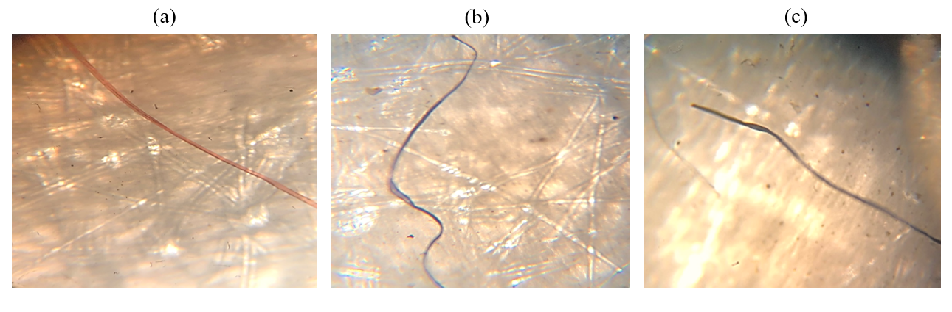
Fig. S2. Some detected MPs in teabag samples.

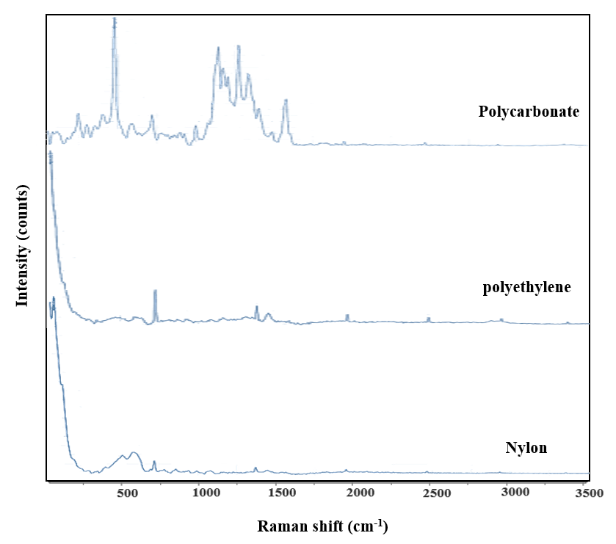
Fig. S3. Spectra Raman of some polymers identified in MPs of the teabag samples.

