Supplementary of
Self-supervised dynamic learning for long-term high-fidelity image transmission through unstabilized diffusive media

Supplementary Movie
Supplementary Movie 1 | Demo of continuous transmission of generalized patterns via unstabilized long MMFs
Supplementary Movie 2 | Demo of continuous transmission of hand-written letters and fashion images via 1km-length MMF
Supplementary Movie 3 | Demo of high-throughput encoded video transmission via unstabilized 1km-length MMF

Supplementary Information Table
Supplementary Figure 1 | Schematic of a multimode fiber based spatial transmission system
Supplementary Figure 2 | Characterization of MMF transmission channel stability
Supplementary Figure 3 | Characterization of abrupt distortion of MMF channel
Supplementary Figure 4 | Comparison of multi-scale memory ensemble and long-term only dynamic learning network
Supplementary Figure 5 | Efficient pixel reassignment of the transmitted spatial patterns
Supplementary Figure 6 | Transmission of incompressive encoded video via MMFs
Supplementary Figure 7 | Comparison of MMDN and state-of-art approaches for spatial decoding in MMFs

Supplementary Figure 1
Schematic of a multimode fiber based spatial transmission system. The experimental setup of the amplitude-to-amplitude multimode fiber (MMF) spatial transmission system is illustrated. ND: neutral density filter, OD=1; L1, L2: aspherical lens, f=10mm, 100mm; L3, L4: objectives, Nikon, 20X, 0.25NA; SLM: spatial Light Modulator, V-7001.

Supplementary Figure 2
Characterization of MMF transmission channel stability. We summarized the stability of seven representative MMF channels of varying configurations including core diameters of 50$μ$m and 200$μ$m, fiber lengths of 100m and 1km, fiber type of step-index (SI) and gradient-index (GI), and spatial resolution of 16x16-pixels and 32x32-pixels. We experimented for 100 seconds and calculated the metrics including SSIM and Hellinger distance between each output speckle image and the first one, as well as pixel-wise accuracy of the recovered input pattern using RVITM algorithm. The system instability rapidly grows as the fiber length increases or the core diameter reduces (from top to bottom).

Supplementary Figure 3
Characterization of abrupt distortion of MMF channel. We repeatly inserted a fixed reference pattern at 5s-interval into a sequence of random test patterns for continuous spatial transmission through a 1km-long MMF. The reference pattern was used to evaluate the short-term stability and the test pattern sequence was used to calculate transmission accuracy. (a) Output speckle images of the reference pattern at five timepoints within the 115-135s were displayed. The intensity errors of timepoints 2~5 compared to timepoint 1 were presented, indicating an intense transmission model turbulence within the timepoint 2~4. (b) plots the accuracy during the whole transmission process, where up to 30% accuracy degradation was observed at the moment when abrupt distortion occurred. The SSIM analysis was further performed on the speckle images of reference pattern at timepoints 1-5.

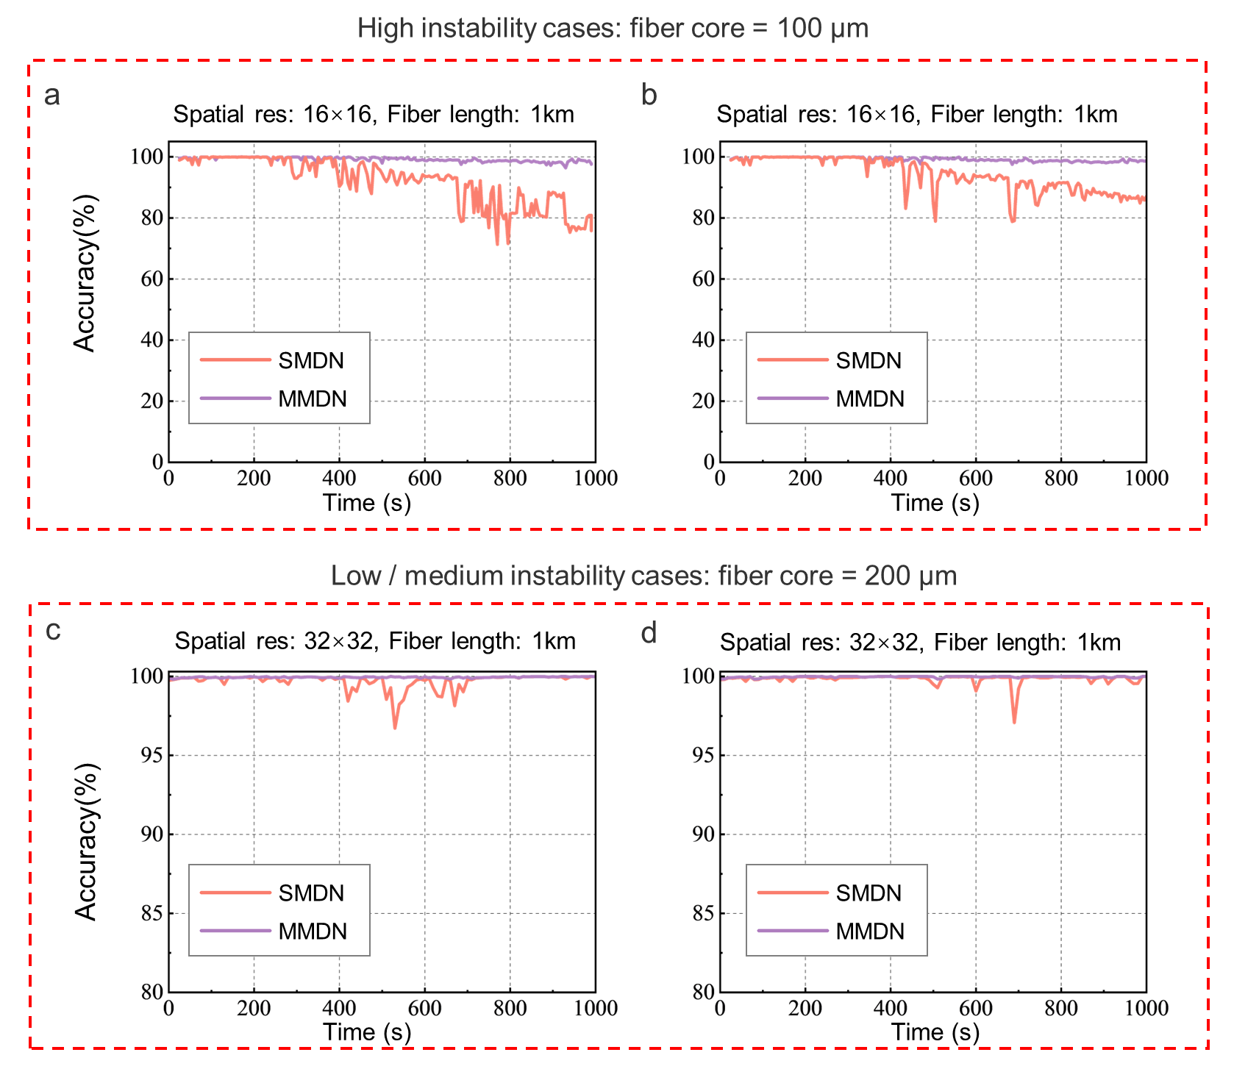
Supplementary Figure 4
Comparison of multi-scale memory ensemble and long-term only dynamic learning network. To evaluate the improvement in robustness brought by the Multi-scale Memory ensembling scheme of the proposed MMDN, we developed the Single-scale Memory Dynamic learning Network (SMDN) and compared their performance for spatial transmission in highly and mediumly unstable MMF channels. (a)(b) High unstability case of 16x16-pixel patterns transmission through 1km-length SI MMF with 100$μ$m core diameter. (c)(d) Medium unstability case of 32x32-pixel transmission through 1km-length SI MMF with 200$μ$m core diameter. In the highly unstable medium, traditional SMDN cannot adapt to the rapid changes in transmission characteristics, and the accumulated prediction error leads to an accuracy decrease after 200-300s duration. While the proposed MMDN can quickly adapt to system changes and hence shows superior transmission accuracy compared to SMDN. In medium stable transmission medium, we obverse a sharp accuracy decrease due to the abrupt periodic oscillation of the medium’s transmission characteristics, while MMDN can adapt to these changes and significantly reduce the accuracy fluctuation. Comparative experiments indicate that compared to SMDN, multi-scale memory integration endows MMDN with higher robustness to support transmitting spatial information over a long period and with high precision through multimode fibers.

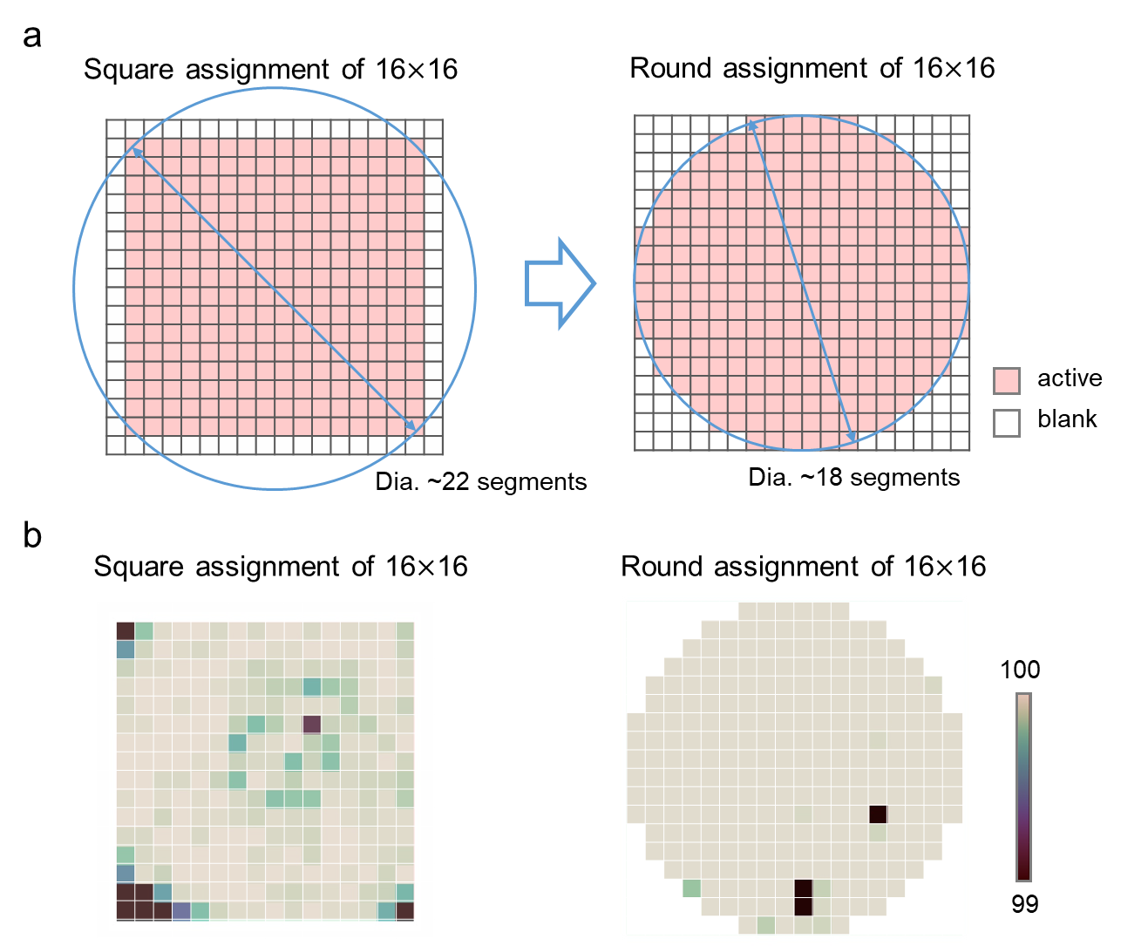

Supplementary Figure 5
Efficient pixel reassignment of the transmitted spatial patterns. (a) Concept of round distributed pixel assignment strategy. In previous works regarding 2D information transmission over MMF, the spatial information was multiplexed using a square assignment. However, we observed a significant decrease in transmission accuracy at the edges and corners of the 2D pattern in experimental tests. To make the transmitted 2D information better fit the shape of the fiber, we proposed a round assignment scheme for 2D patterns. (b) Experimental comparison of two coding formats. We tested the spatial transmission of 16x16-pixel patterns within a 1km MMF, and the spatial distribution of average both pixel assignment schemes was compared. We can see that the transmission accuracy of the round assignment scheme is significantly enhanced, especially at the corners.

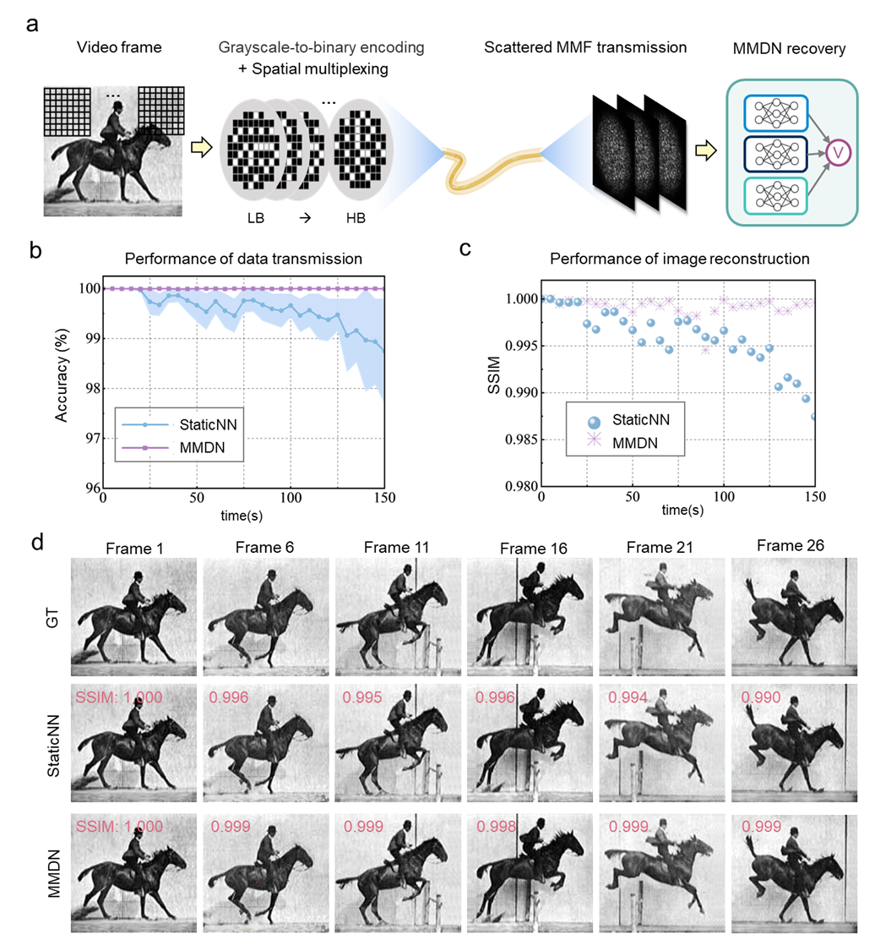
Supplementary Figure 6
Transmission of incompressive encoded video via MMFs. (a) Pipeline of incompressive encoded video transmission through spatial-multiplexed MMF channel and decoding with MMDN. To transmit the video frame of 8-bit precision and RGB format, we convert each pixel into a binary sequence of 24-bit length, and sequentially assemble the bit sequences into a set of spatial-multiplexed patterns. (b) Transmission accuracy of encoded signals. (c) SSIM of decoded video frames. (d) Example video frames recovered with StaticNN and MMDN. For the incompressive encoded video transmission scheme, the recovered image quality is much less vulnerable to the transmission accuracy decrease compared to the compressive scheme, yet the transmission throughput is lower (it takes about 150s to transmit the 31-frame video).

Supplementary Figure 7
Comparison of MMDN and state-of-art approaches for spatial decoding in MMFs. (a) Comparison of transmission distance, reconstruction accuracy, transmission duration, spatial resolution, and image category using approaches described in [1-5] and proposed MMDN. (b) Specific performance parameters.

Supplementary References：
- Borhani, Navid, et al. "Learning to see through multimode fibers." Optica 5.8 (2018): 960-966.
- Rahmani, Babak, et al. "Multimode optical fiber transmission with a deep learning network." Light: science & applications 7.1 (2018): 69.
- Caramazza, Piergiorgio, et al. "Transmission of natural scene images through a multimode fibre." Nature communications 10.1 (2019): 2029.
- Fan, Pengfei, et al. "Learning enabled continuous transmission of spatially distributed information through multimode fibers." Laser & Photonics Reviews 15.4 (2021): 2000348.
- Zhu, Changyan, et al. "Image reconstruction through a multimode fiber with a simple neural network architecture." Scientific reports 11.1 (2021): 1-10.

