Figure S1. BlastKOALA functional annotation of AK164 strain. The colored represent the number of genes assigned to each functional pathway.

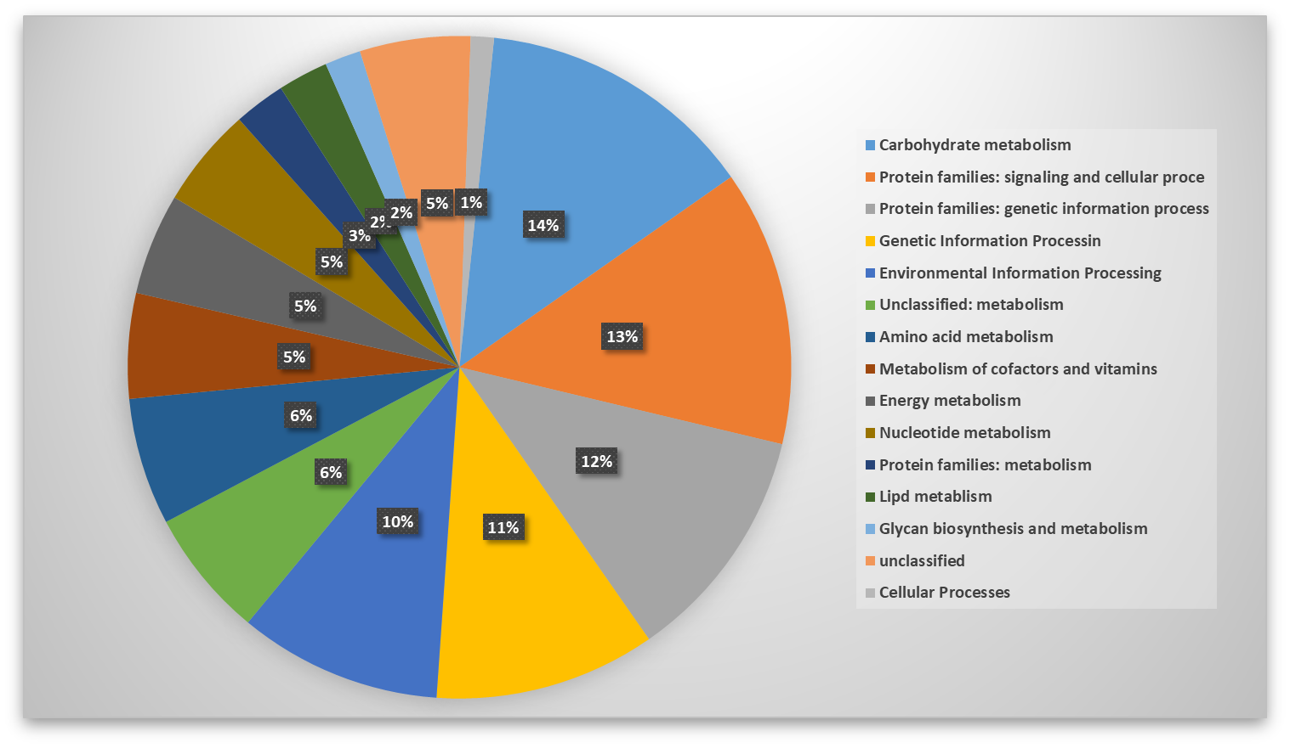

Figure S2. KEGG functional annotation of AK164 strain. The colored bars represent the number of genes assigned to each functional pathway.

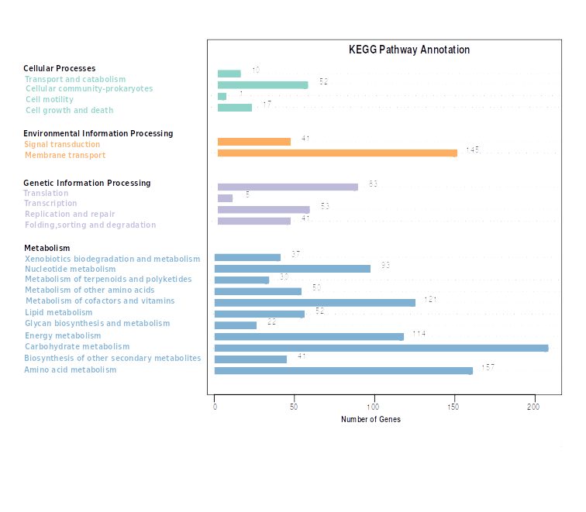

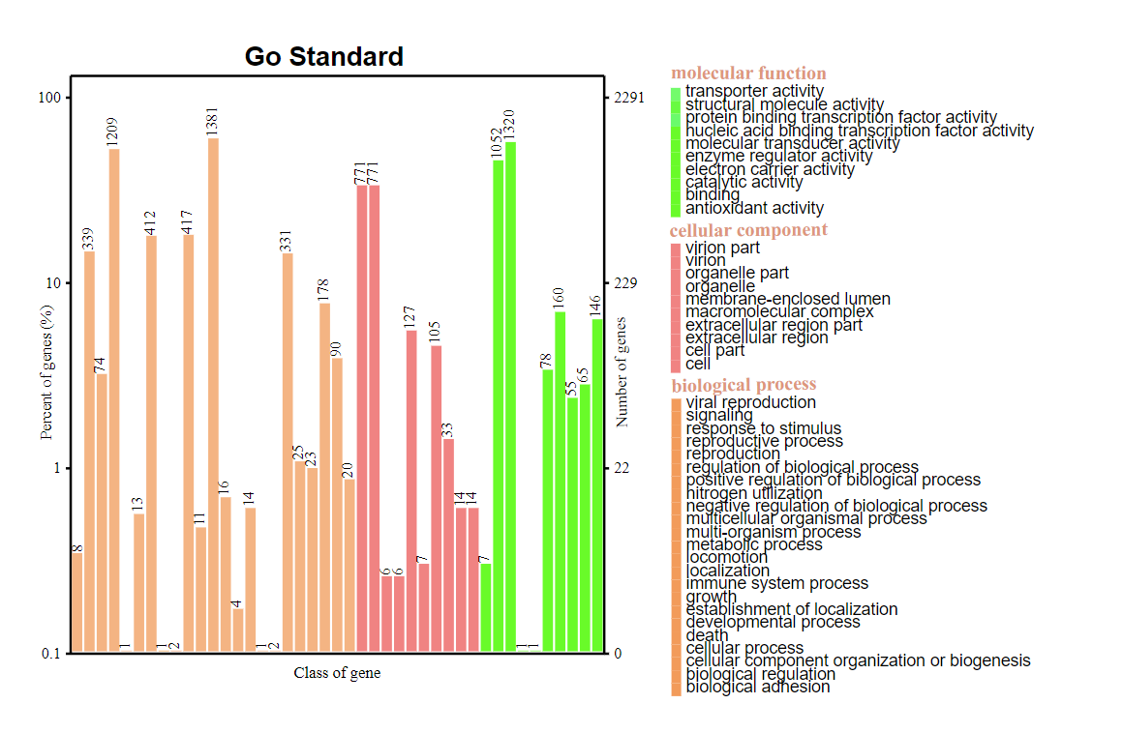
Figure S3. GO functional annotation of AK164 strain. Colored bars represents the Percent and Number of genes assigned to each GO category.

