Table 3. The interaction plot and type of bonding of the reference ligands bound with the CVA16 RdRp are listed with their PDB IDs.
Interaction Plot | PDB ID | Ligands | Hydrogen Bonds | Hydrophobic Bonds
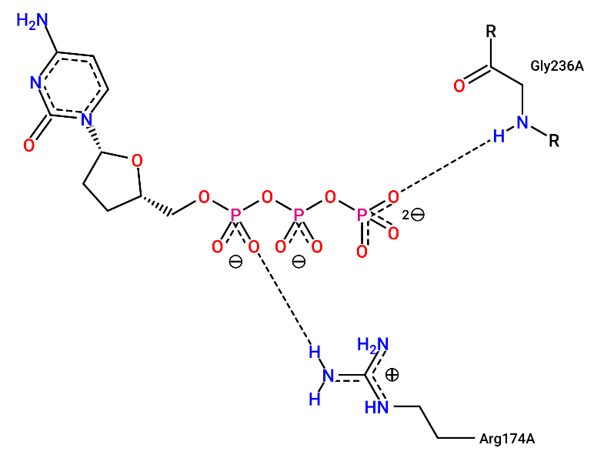 | 6KWR | DCT | Arg¹⁷⁴, Gly²³⁶ | Nil
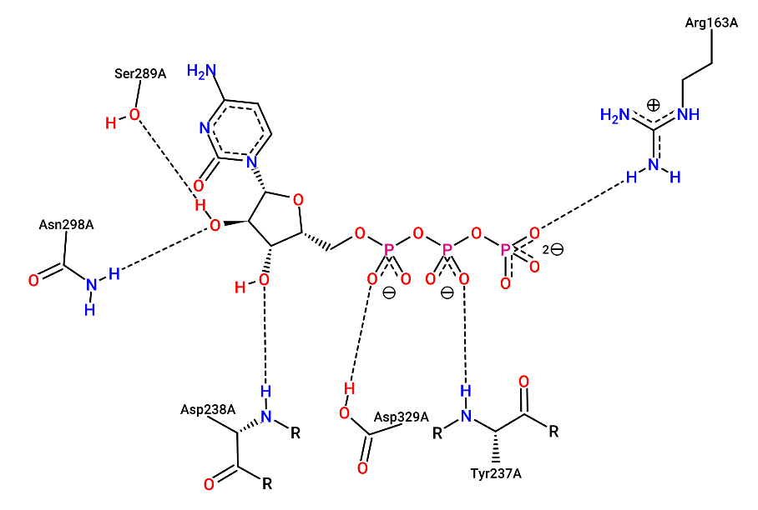 | 5F8I | CTP | Arg¹⁶³, Tyr²³⁷, Asp²³⁸, Ser²⁸⁹, Asn²⁹⁸, Asp³²⁹ | Nil
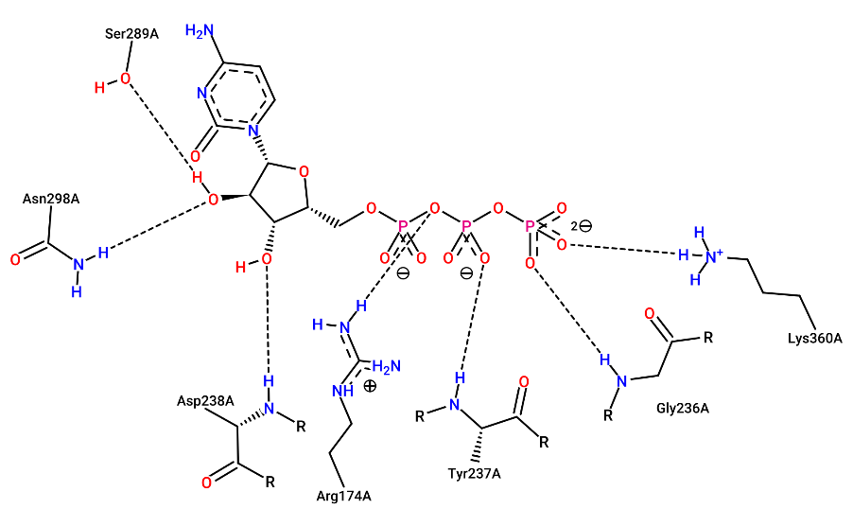 | 7W9S | CTP | Arg¹⁷⁴, Gly²³⁶, Tyr²³⁷, Asp²³⁸, Ser²⁸⁹, Asn²⁹⁸, Lys³⁶⁰ | Nil
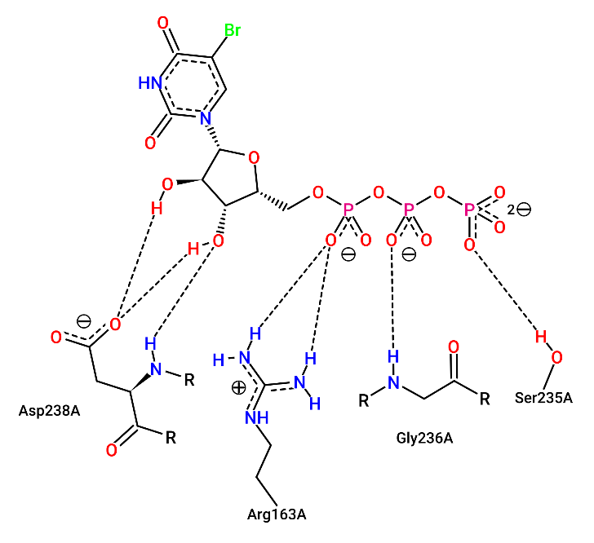 | 3N6N | BUP | Arg¹⁶³, Ser²³⁵, Gly²³⁶, Asp²³⁸ | Nil
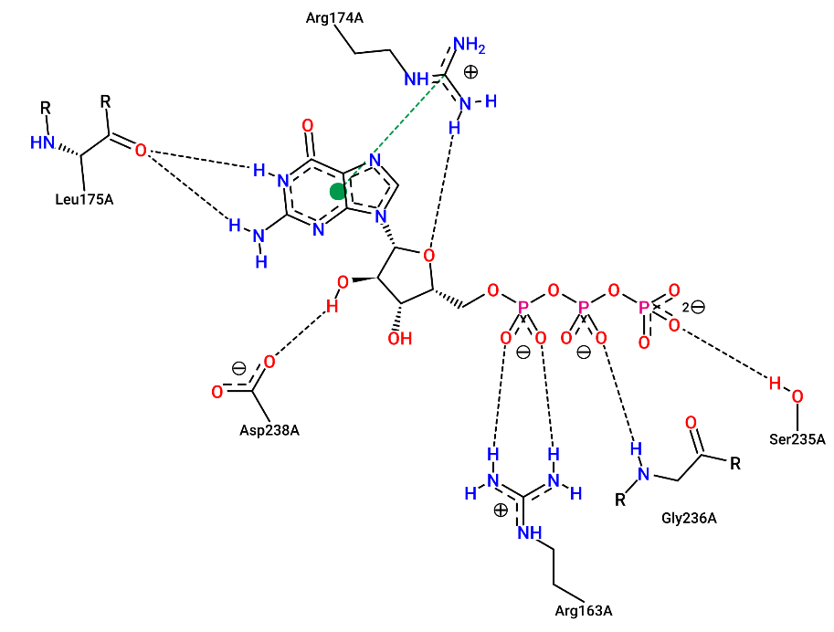 | 3N6M | GTP | Arg¹⁷⁴, Leu¹⁷⁵, Arg¹⁶³, Ser²³⁵, Gly²³⁶, Asp²³⁸ | Nil

