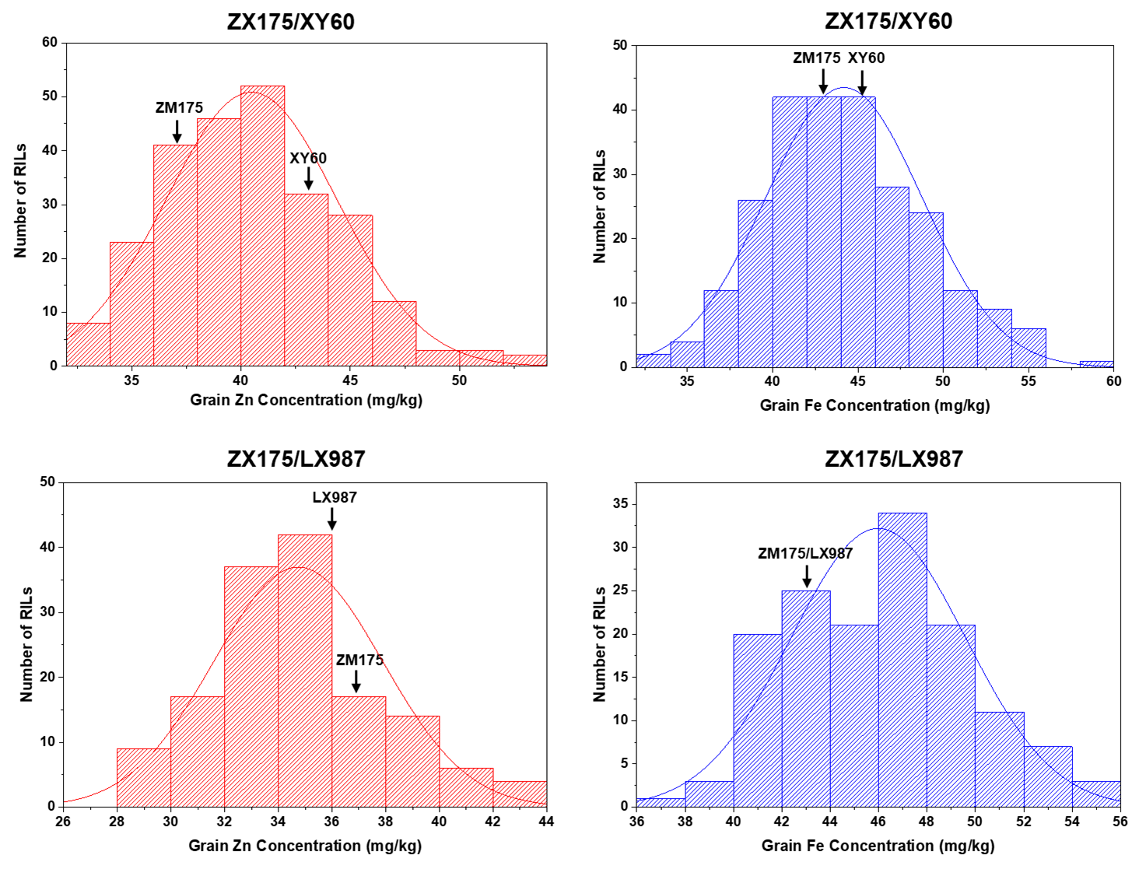
Fig. S1 Frequency distributions of grain Zn and Fe concentrations for the ZM175/XY60 and ZM175/LX987 RIL populations based on best linear unbiased estimations (BLUE). Black arrows show the mean grain Zn and Fe concentrations of the parents
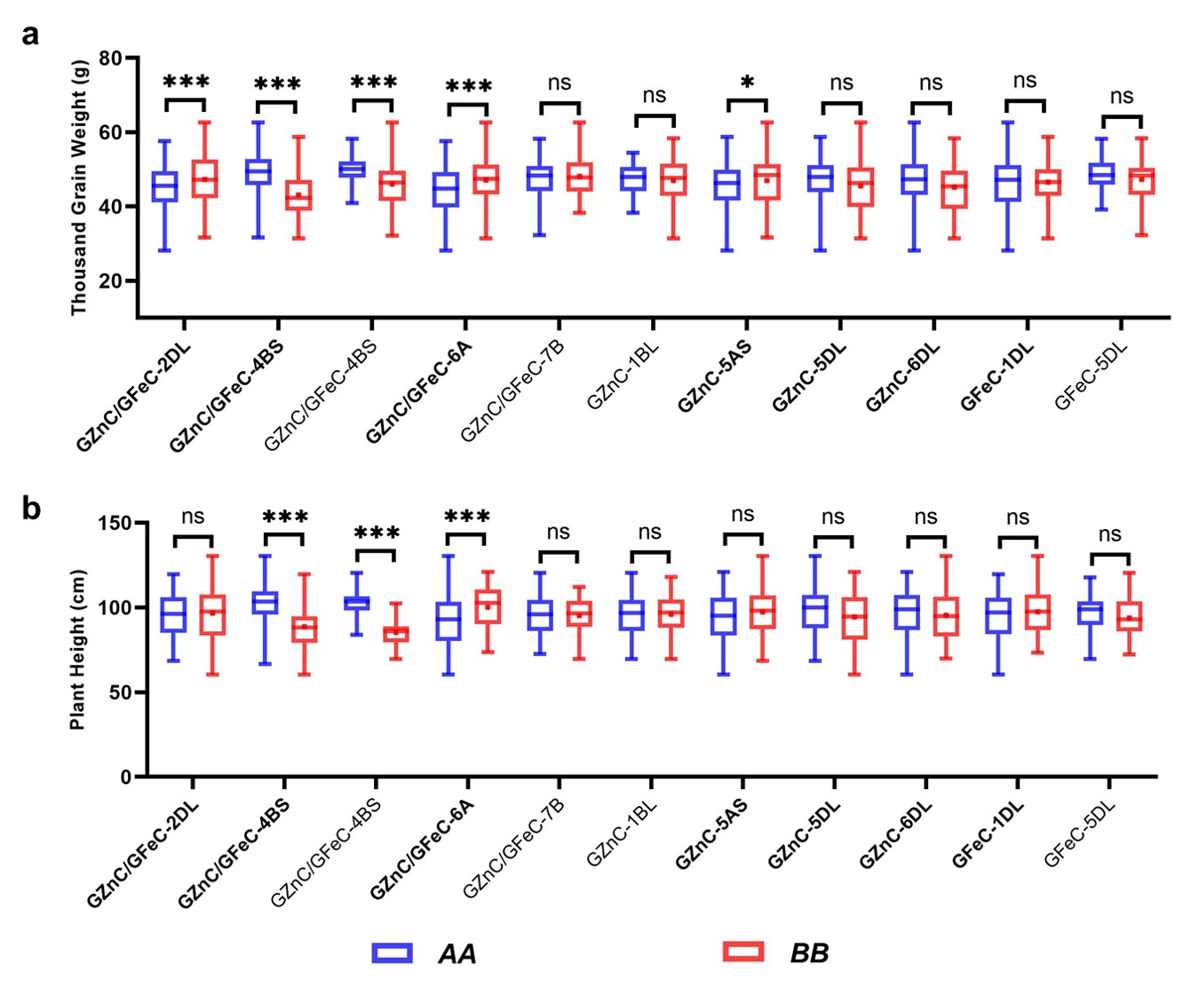
Fig. S2 Boxplots showing thousand grain weight and plant height of different alleles of markers closely linked to the QTL for grain Zn and Fe concentrations. a QTL effects on thousand grain weight. b QTL effects on plant height. Bold font, QTL detected in the ZM175/XY60 RIL population. Normal font, QTL detected in the ZM175/LX987 RIL population. AA, allele from ZM175. BB, allele from XY60 or LX987. ns, not significant. *, P <0.05. **, P <0.01. ***, P <0.001
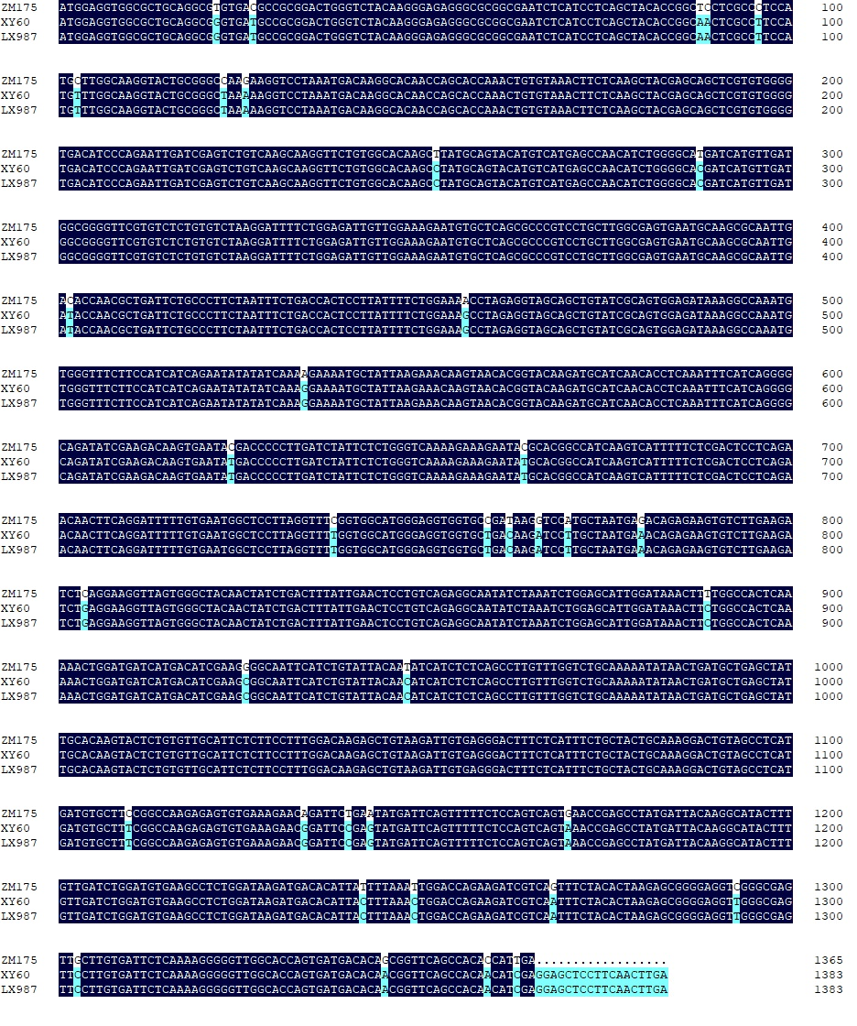
Fig. S3 Sequence alignment of TraesCS2D02G612600LC (TaIPK1-2D) among ZM175, XY60 and LX987
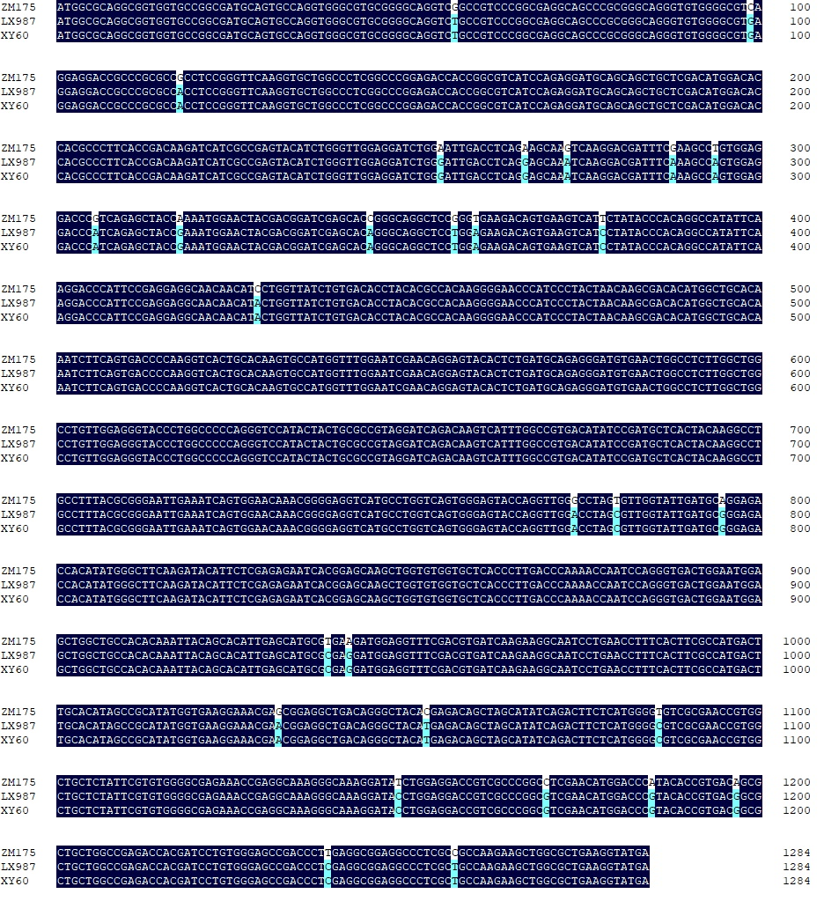
Fig. S4 Sequence alignment of TraesCS2D02G500600 (TaGS2-2D) among ZM175, XY60 and LX987
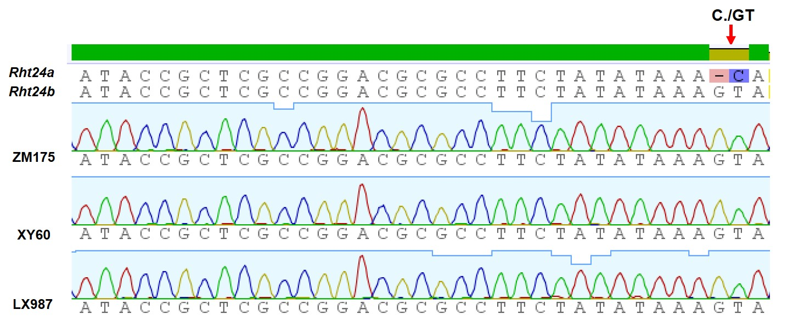
Fig. S5 Haplotype analysis of Rht24 in ZM175, XY60 and LX987
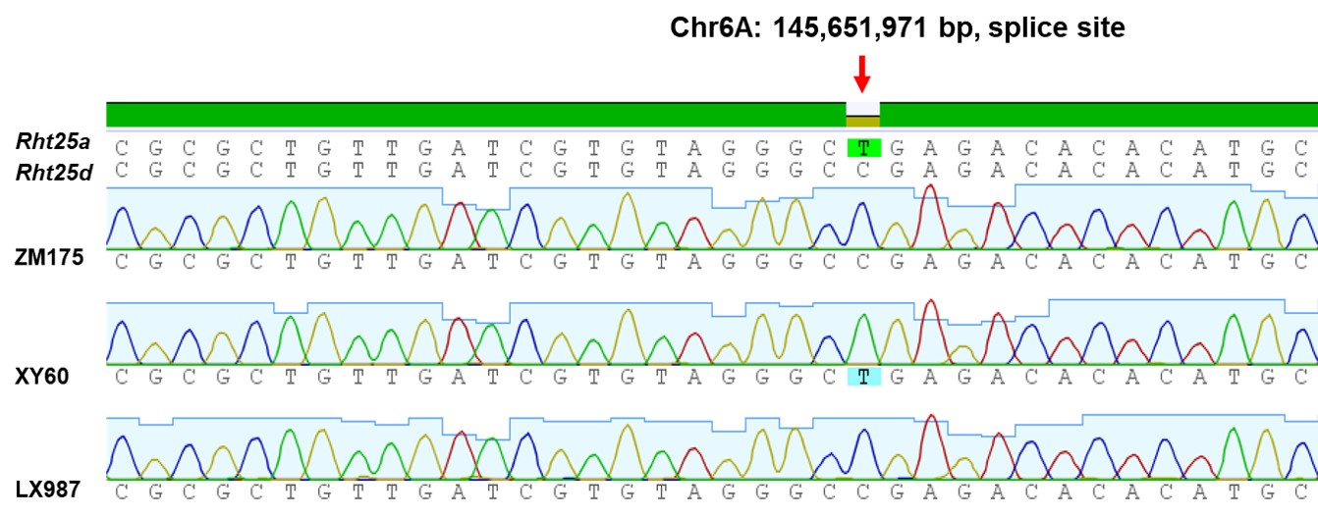
Fig. S6 Haplotype analysis of Rht25 in ZM175, XY60 and LX987

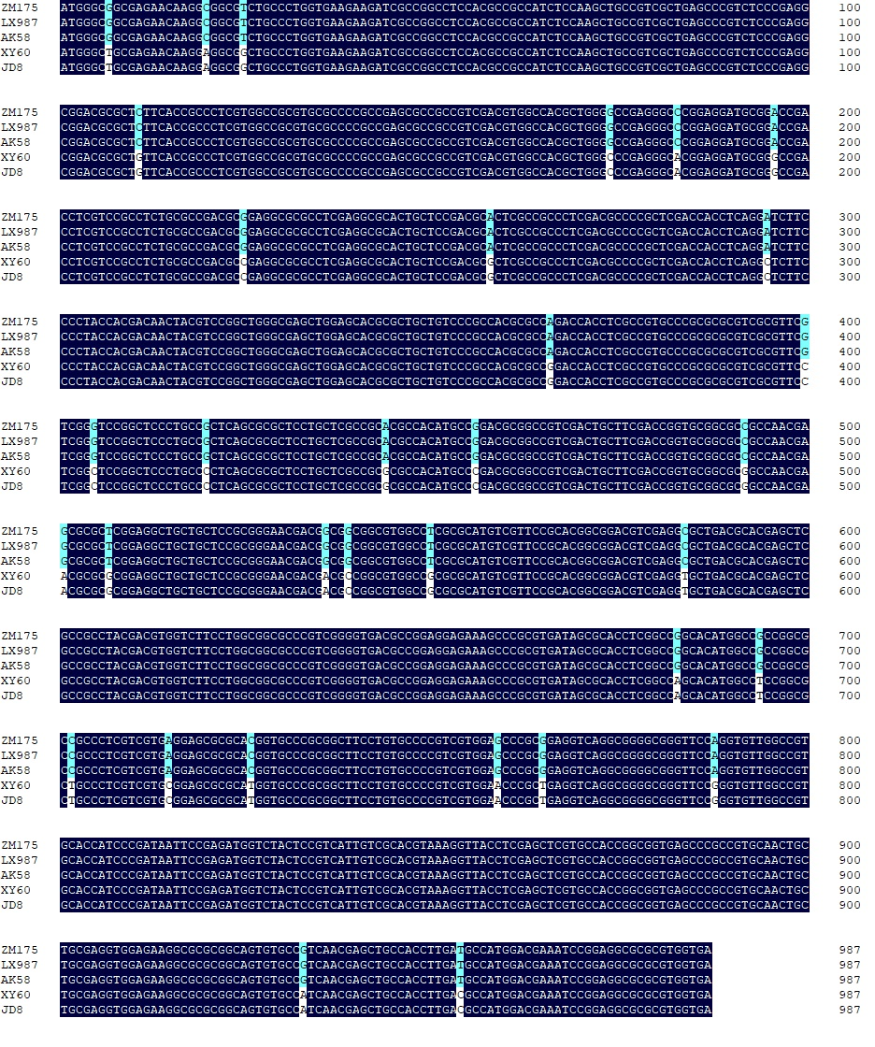
Fig. S7 Sequence alignment of TraesCS6D02G382900 (TaNAS10-6D) among ZM175, XY60, LX987, JD8 and AK58
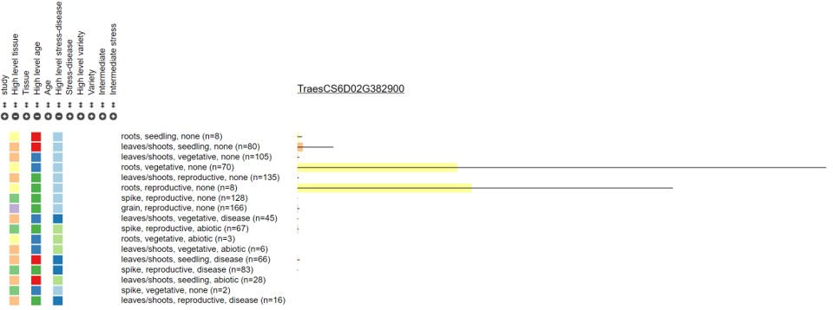
Figure S8 Expression pattern of TraesCS6D02G382900 (TaNAS10-6D) in different tissues according to the Wheat Expression Browser (http://wheat-expression.com/)

