Supplementary Material

1 SUPPLEMENTARY TABLES AND FIGURES

1.1 Supplementary Tables

Table S1. The BCL2 family members included in the custom NanoString panel

Group | Gene Symbol | Protein Symbol | Description
 | BAX | BAX | BCL2 Associated X, Apoptosis Regulator
 | BAK | BAK | BCL2 Antagonist/Killer 1
Pro-apoptotic | BOK | BOK | BCL2 Family Apoptosis Regulator BOK
Pro-apoptotic | BCL2L13 | BCL-Rambo | BCL2-Like 13 (Apoptosis Facilitator)
 | BCL2L15 | BFK | Bcl-2-Like Protein 15
 | SPIKE | SPIKE | Apoptosis regulator, interaction with BAP31 and BCL-xL
 | BCL2 | BCL2 | B-Cell Lymphoma 2, Apoptosis Regulator
 | BCL2L1 | BCL-xL | BCL2 Like 1
Anti-apoptotic | BCL2L2 | BCL-w | BCL2 Like 2
Anti-apoptotic | MCL1 | MCL-1 | BCL2 Family Apoptosis Regulator
 | BCL2A1 | BFL-1 | BCL2 Related Protein A1
 | BNIP2 | BNIP2 | BCL2 Interacting Protein 2
 | BAD | BAD | BCL2 Associated Agonist Of Cell Death
 | PMAIP1 | NOXA | Phorbol-12-Myristate-13-Acetate-Induced Protein 1
 | BCL2L11 | BIM | BCL2 Like 11
 | BBC3 | PUMA | BCL2 Binding Component 3
Pro-apoptotic(BH3-only) BID |  | BID | BH3 Interacting Domain Death Agonist
 | BMF | BMF | Bcl2 Modifying Factor
 | HRK | HRK | Harakiri, BCL2 Interacting Protein
 | BIK | BIK | BCL2 Interacting Killer
 | BCL2L14 | BCL-G | Apoptosis Facilitator Bcl-2-Like Protein 14
 | BCAP31 | BAP31 | B cell receptor–associated protein 31, integral ER membrane protein
Other | MNT | MNT | MAX Network Transcriptional Repressor
 | BECN1 | BECLIN1 | Coiled-Coil Myosin-Like BCL2-Interacting Protein, Autophage related

Table S2. Table S2. Comparison of BCL2 family member expression distributions between samples and the independent dataset (GSE87371)

 | Samples | GSE87371 | p
 | (n = 157) | (n = 223)
BAX (median [IQR]) | -0.04 [-0.52, 0.64] | -0.03 [-0.73, 0.66] | 0.827
BAK (median [IQR]) | -0.23 [-0.66, 0.34] | -0.08 [-0.66, 0.57] | 0.453
BOK (median [IQR]) | -0.11 [-0.79, 0.61] | -0.13 [-0.60, 0.43] | 0.895
BCL2L15 (median [IQR]) | -0.11 [-0.82, 0.68] | -0.12 [-0.57, 0.44] | 0.815
BCL2L13 (median [IQR]) | -0.18 [-0.74, 0.39] | -0.11 [-0.60, 0.64] | 0.38
BCL2 (median [IQR]) | -0.14 [-0.68, 0.63] | 0.04 [-0.64, 0.67] | 0.602
BCL2L1 (median [IQR]) | 0.08 [-0.62, 0.55] | -0.17 [-0.75, 0.60] | 0.361
BCL2L2 (median [IQR]) | -0.09 [-0.58, 0.46] | 0.03 [-0.60, 0.72] | 0.389
MCL1 (median [IQR]) | 0.21 [-0.63, 0.72] | -0.07 [-0.66, 0.64] | 0.336
BCL2A1 (median [IQR]) | 0.04 [-0.67, 0.76] | 0.17 [-0.51, 0.74] | 0.595
BNIP2 (median [IQR]) | 0.03 [-0.52, 0.64] | 0.06 [-0.42, 0.61] | 0.479
BAD (median [IQR]) | -0.21 [-0.60, 0.48] | -0.11 [-0.68, 0.63] | 0.791
PMAIP1 (median [IQR]) | -0.12 [-0.59, 0.58] | -0.11 [-0.69, 0.69] | 0.976
BCL2L11 (median [IQR]) | -0.09 [-0.70, 0.72] | -0.02 [-0.82, 0.71] | 0.997
IQR, interquartile range

2.2 Supplementary Figures

Figure S1. The expression pattern of BCL2 family members in DLBCL according to their functional groups.
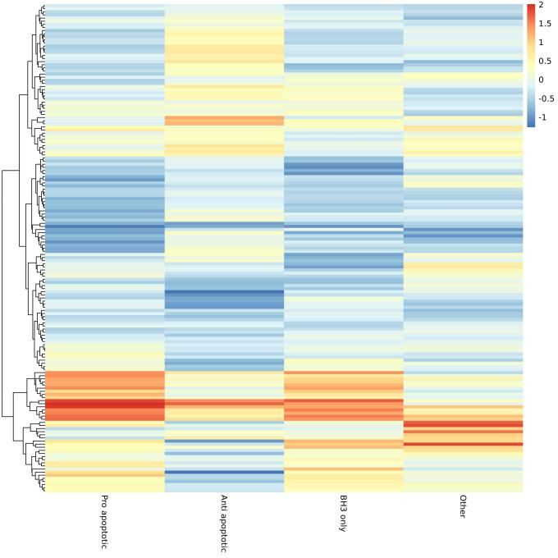
Figure S2. The expression pattern of BCL2 family members in an independent DLBCL dataset.
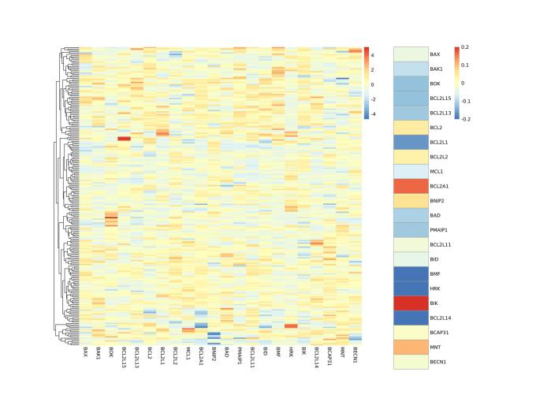
Figure S3. Comparison of BCL2 family member gene expression according to IPI groups.
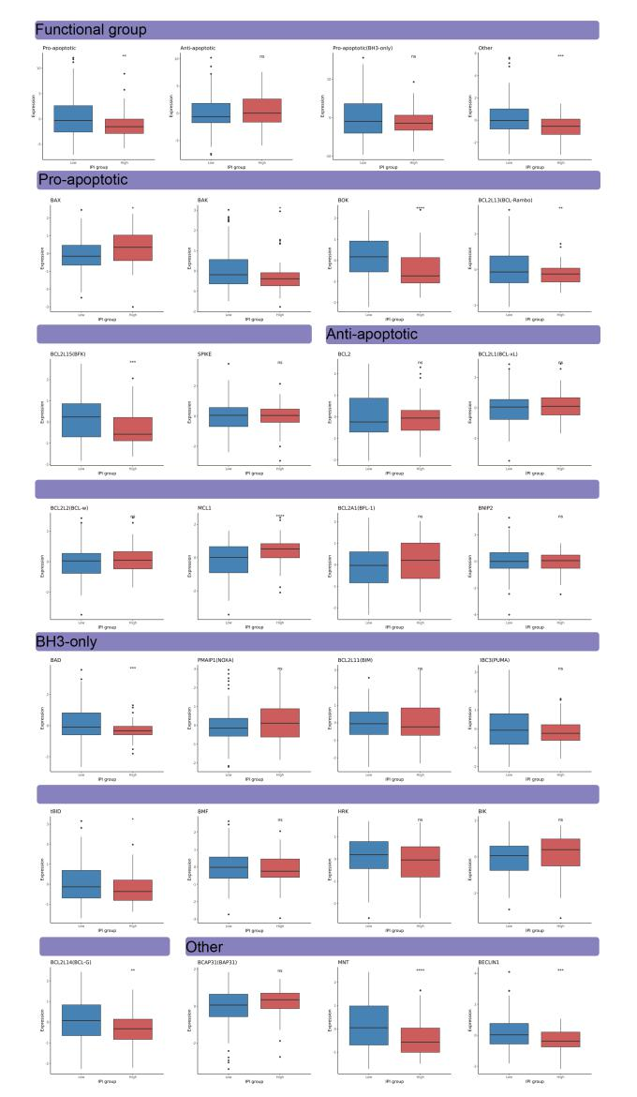
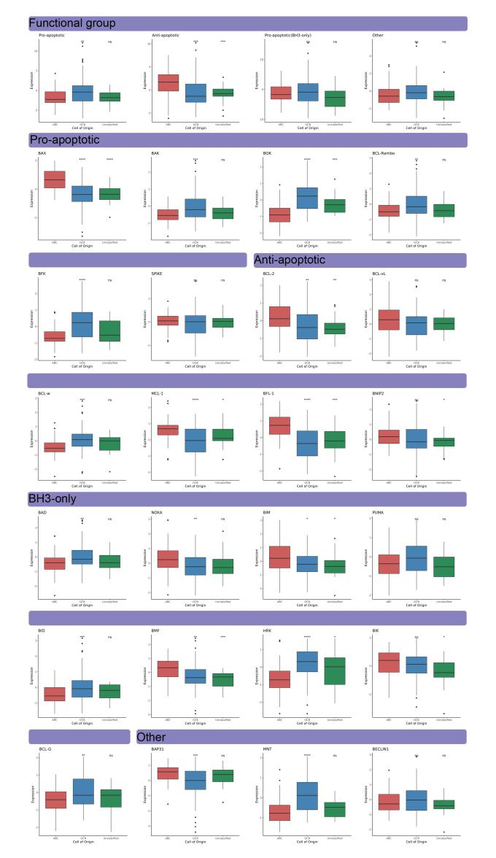
Figure S4. Comparison of BCL2 family member gene expression according to COO.

Figure S5. Survival curves according to the 7 clusters.
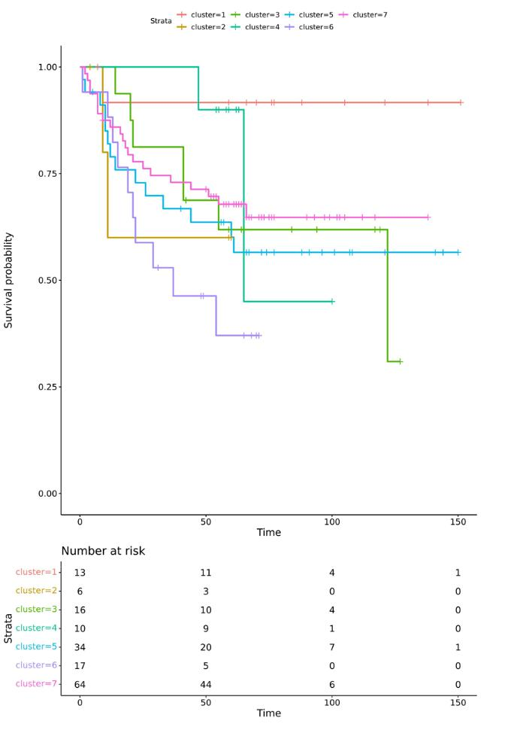
Figure S6. Comparison of BCL2 family member gene expression according to the clusters.
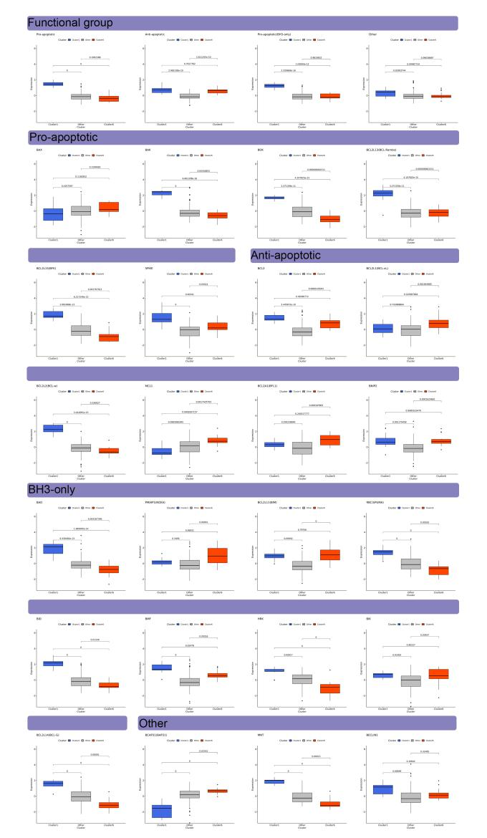
Figure S7. Survival curves according to BCL2 signature score.
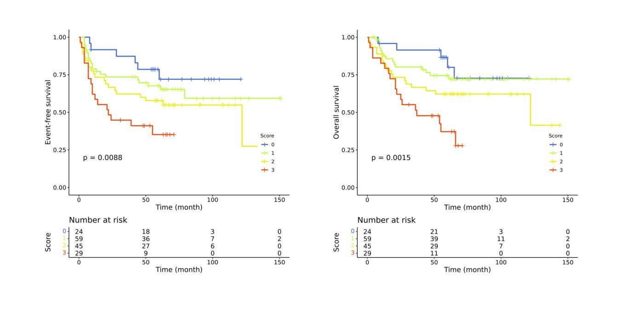
Figure S8. Correlation plot between genes constitute BCL2 signature score.

