Comparison of data-driven methods for linking extreme precipitation events to local and large-scale meteorological variables – Supplementary Material
Author list: Nafsika Antoniadou^{1,2}, Hjalte J. D. Sørup¹, Jonas W. Pedersen^{1,2}, Ida Bülow Gregersen³ , Torben Schmith² and Karsten Arnbjerg-Nielsen¹
¹Technical University of Denmark, Department of Environmental and Resource Engineering, Climate and Monitoring, Lyngby, Denmark
² Danish Meteorological Institute, National Center for Climate Research, Copenhagen, Denmark
³ Rambøll Denmark A/S, Department of Climate Adaptation and Green Infrastructure, Copenhagen, Denmark

1. Observed Surface air temperature (SAT)
From 1979, the daily minimum temperature was recorded at 06z and the maximum at 18z. From the 1990s and onwards, both maximum and minimum temperature was observed twice a day at 06z and 18z. At the beginning of the period, the temperature was measured by a mercury thermometer, but it has been common practice for the past several years to use electronic temperature sensors. It has not been possible to obtain information about the exact time when this automation was implemented at this particular gauge.

2. Atmospheric vertical stability measures
Convectional available potential energy (CAPE) is the energy an air parcel would gain when rising through the atmosphere and is given by
$CAPE = g \int_{ }^{ }{\left(T_{v}-T_{v0}\right)dz}$( S1 )
where $T_{v}$ is the virtual temperature of the air parcel, $T_{v0}$ is the virtual temperature of the surrounding atmosphere, and $z$is height. The virtual temperature is the temperature the air would reach if all water in the air was adiabatically condensed. It is given by
${{ T}_{v}=T + L_{v}}/{ c_{p}× r ≈T + 2.5×{10}^{3}K× r}$ ( S2 )
where $r$is the mixing ratio of water vapor, $L_{v}$ is the latent heat of evaporation and $c_{p}$ is the specific heat of air. Since $r$is in the order of 10⁻³, the contribution to changes in $T_{e}$ from changes in the temperature and from humidity are of comparable magnitude.
Total column water (TCW) is the vertical integral throughout the troposphere of water vapor, cloud water, and cloud ice added (but precipitation excluded). It is thus a measure of the amount of water available for precipitation.
CAPE and TCW are both 2D horizontal fields given on a latitude-longitude grid. We use the daily averaged value interpolated to the location of Copenhagen with bilinear interpolation.

K-Means
This analysis aims to group similar data points and discover underlying patterns. We explore the relationship of each cluster with extreme precipitation events, and we use the clusters as input to the logistic regression model with one hot encoding. All days are assigned to a cluster depending on their Euclidean distance to cluster centroids. The climatological frequencies are calculated as the ratio $p= \frac{n_{i}}{N}$ $,$where $n_{i}$ is the number of days assigned to cluster i, and N is the total number of days. The 95% confidence intervals of the climatological frequencies of the clusters are computed by using a normal approximation to the binomial distribution:
$p ±1.96 \sqrt{\frac{p(1-p)}{N'} }$( S3 )
where $N'$ is the effective sample size (Wilks, 2011)
${ N}^{'}=N\frac{1-ρ_{1}}{1+ρ_{1}}$( S4 )
and $ρ_{1}$ is the 1-day persistence probability for each cluster (Lee et al., 2019) estimated from the transition matrix. Initial exploratory analysis showed that a small number of clusters could not demonstrate a strong relationship between each cluster and extreme precipitation occurrences, and a high number of clusters can contribute to overfitting in the final model. Therefore, we performed k-means explanatory analysis to quantify the connection of each cluster to extreme precipitation occurrences for four up to 10 clusters. Figure 1 presents the composites of the 4-classes k-means clustering, based on Z500 fields, which are defined by averaging the anomalies at each grid for each cluster. The composites exhibit noticeable differences in the spatial extent or shape of Z500. When more clusters are considered, the spatial pattern of the resulting composites does not change significantly. This suggests that the clusters show similarities amongst different samples.
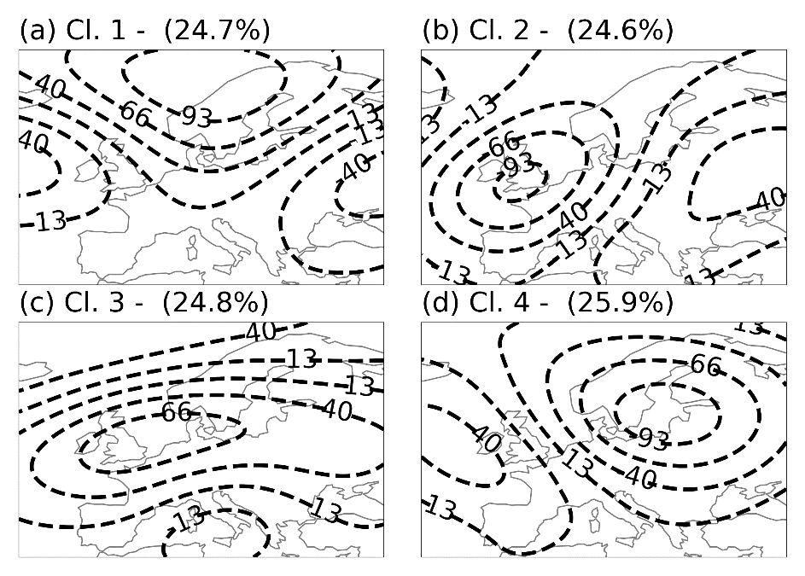
Figure 1: Composites of clusters derived with K-means clustering on the retained PCs based on Z500 fields for k=4. The percentages in each subplot indicate the climatological frequency of each cluster. Cluster (b) was found to have a statistically significant relationship with extreme precipitation events.
Statistically, significant connections between clusters and extreme precipitation events are assessed with a two-tailed binomial test with alpha = 0.05. To follow a conservative approach, the hypothesized probability of the binomial test is the upper value of the 95th confidence interval of the relevant climatological frequency (Mastrantonas et al., 2021). Moreover, to quantify the relationship between extreme precipitation occurrences and different clusters, we calculate the conditional probability of an extreme event to occur for each cluster for all performed k-mean analyses (k = 4, …,10). For each k, we select the maximum conditional probability (MCP) over all clusters and compute the percentage of extremes that occurred in the MCP cluster (Mastrantonas et al., 2021).
Figure 2a shows the cluster with the MCP for all k-means analyses, and Figure 2b presents the extreme event percentages associated with that cluster for all k. From Figure 2a, we see that, i.e., for k = 4, 15.25% of the total days in the MPC cluster are expected to be extreme days. MCP increases with the number of clusters since the relationship between the clusters and the extremes becomes stronger. On the other hand, because each MCP cluster has fewer days and hence fewer extreme occurrences, the percentage of occurring extremes decreases. In figure 2b, we see that, i.e., for k = 4, 42% of the total extremes occurred in the MPC cluster. The results from the binomial test indicate that the MCP cluster in all scenarios has a positive, statistically significant relationship with the extremes. The percentage of extremes is almost stable from 4 to 5 clusters. This justifies using 4 clusters to find connections between extreme precipitation events and large-scale patterns.
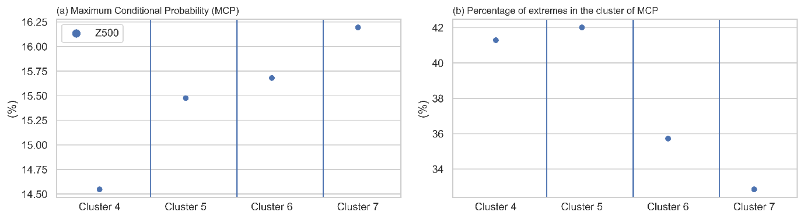

Figure 2: (a) Maximum Conditional Probability (MCP) for Z500 and the number of clusters. (b) Percentage of extremes associated with the MCP cluster.
Figure 3 shows the box plots of the goodness of fit as measured by ROC AUC and PR AUC estimated with 10-fold cross-validation. It is clear that including Clusters instead of the retained PCs does not increase the model's performance for extreme event prediction. Mean ROC AUC values ranged from 0.856 to 0.863 (highest for the model that includes the retained PCs and no SST), and mean PR AUC values ranged from 0.497 to 0.591 (lowest for the model that includes the retained PCs and no SAT). Therefore for all the analysis hereafter, we simply used the retained PCs.

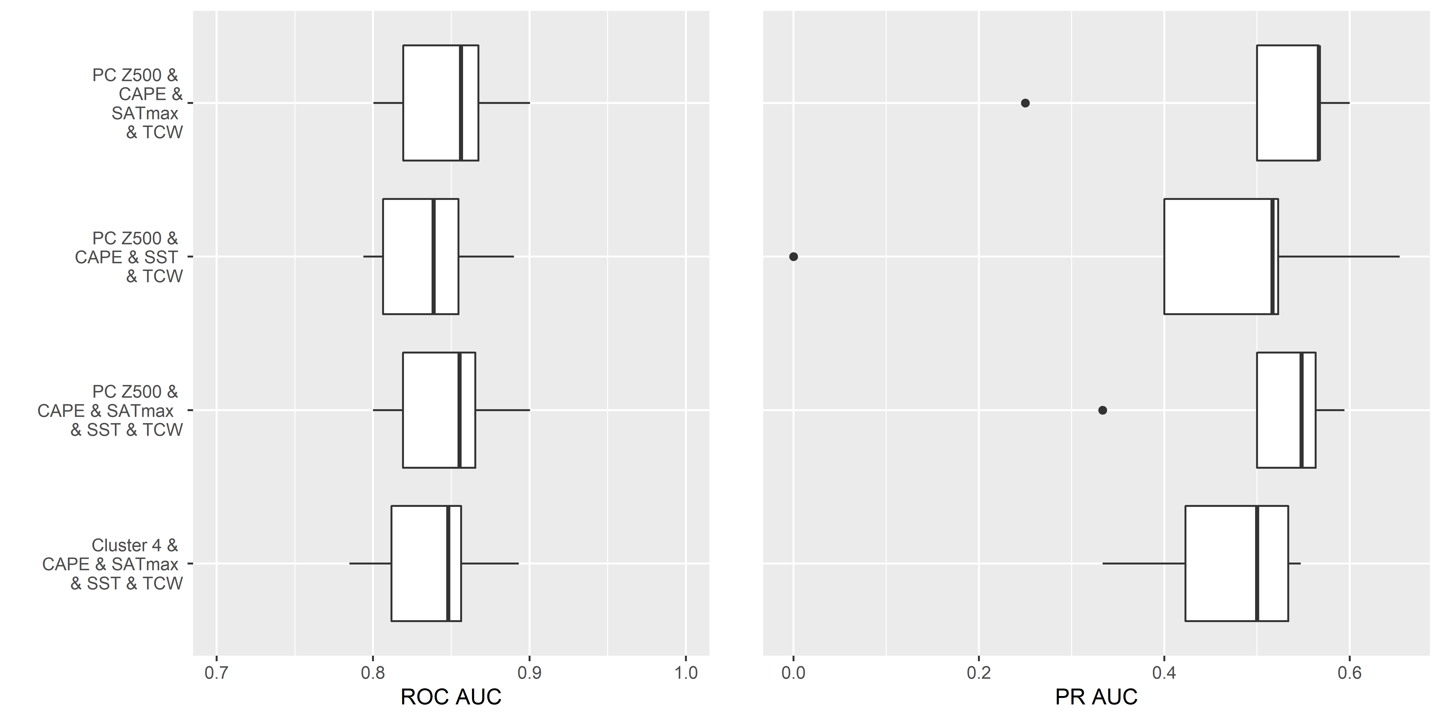
Figure 3: Box plots of the goodness of fit measured by ROC (left) and PR AUC (right) values estimated with 10-fold cross-validation.

Autocorrelation
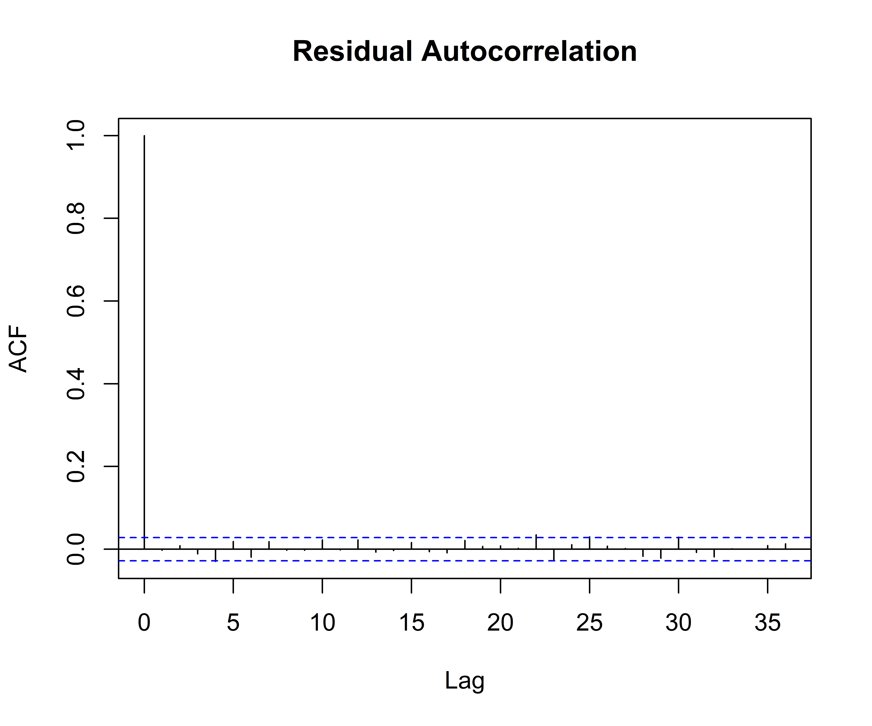
Figure 4: ACF of the residuals. The dashed blue line indicates the significance threshold.
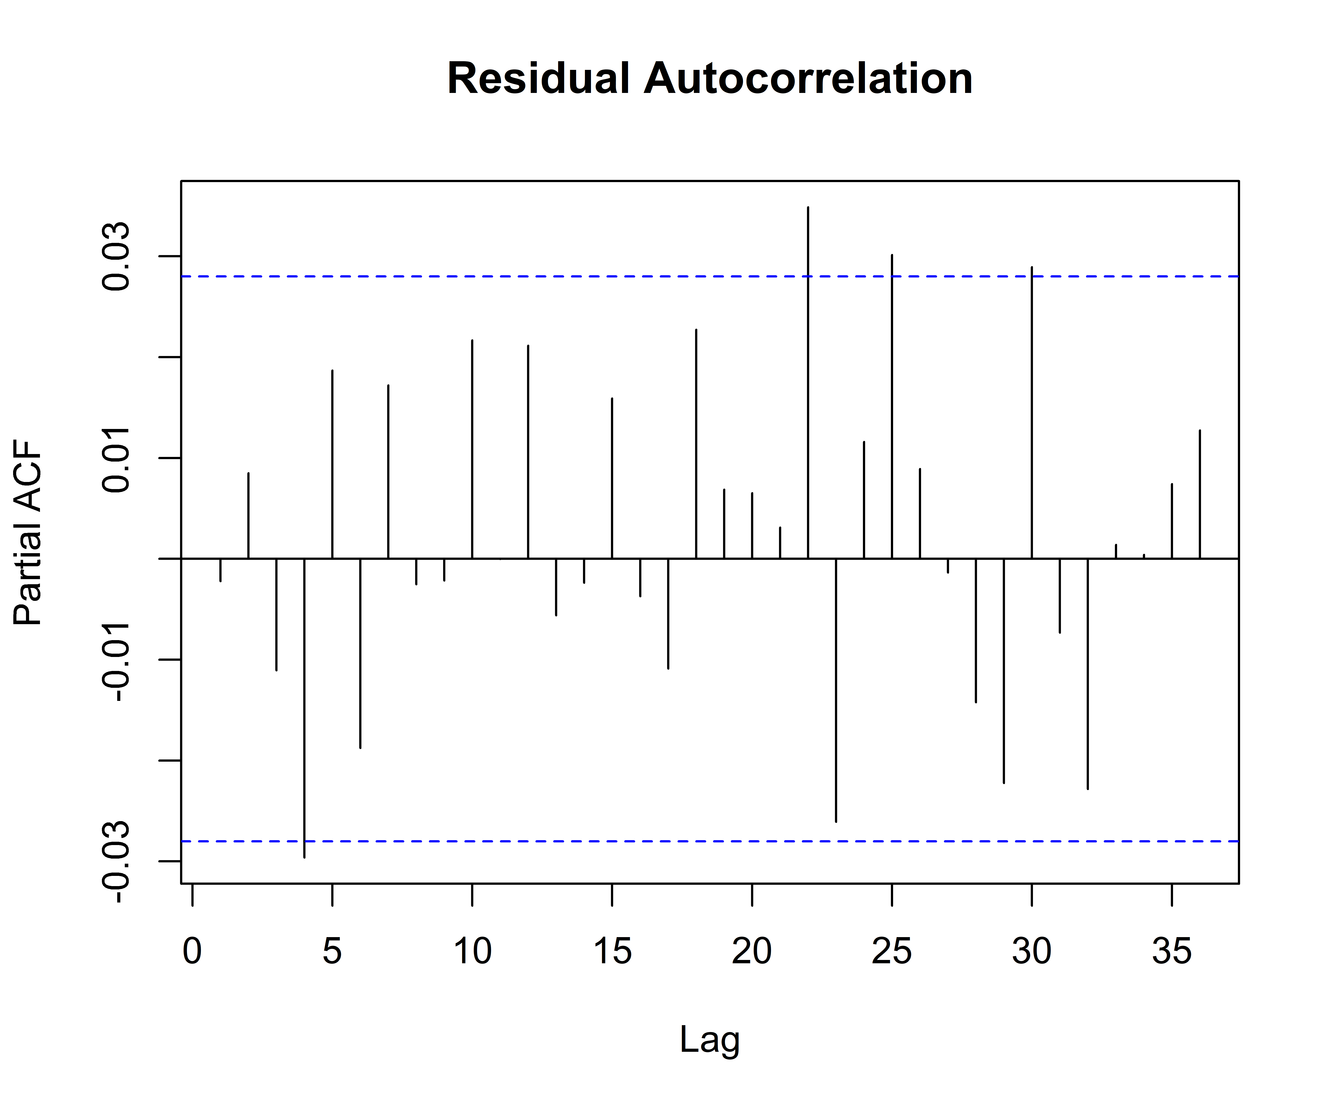
Figure 5: PACF of the residuals. The dashed blue line indicates the significance threshold.

Imbalance Corrections
Methods to correct class imbalance are receiving increasing interest in developing classification models since they can prevent incorrect high classification accuracy. To examine the consequences of imbalance corrections to LR, we examined random undersampling, random oversampling, and SMOTE (Synthetic Minority Oversampling Technique) (Haibo He and Garcia, 2009) using Monte Carlo simulations on artificial data.
We generate artificial data from a logistic model with known model parameters. Predictor variables were drawn from a uniform distribution with zero correlation between predictors. The simulated data include 20,000 events, with a class ratio of about 80:20. Then we pre-process the dataset using random undersampling (RUS), random oversampling (ROS), and SMOTE (Synthetic Minority Oversampling Technique), resulting in three different datasets on which models were fitted.
We performed 1000 Monte Carlo simulations, where a newly simulated training dataset was used in each run, and a logistic regression model was fitted. For quantifying the impact of unbalanced data on the accuracy of the estimated parameters, we calculated the bias of each parameter.
$B\left(b\right)= β-E\left(b\right)$(S5 )
where β is the true parameter value, and E(b) is the expected value of the estimated parameter calculated as the average of the values obtained by the Monte Carlo simulations. The predictive performance of each model is assessed using the ROC AUC.
All the parameter coefficients estimated on imbalance-corrected datasets are biased (Figure 6). Regarding the prediction capabilities of the model, we observe from Figure 7 that there is no significant change in the ROC AUC value after applying imbalance correction methods. Our controlled experiments agree with studies that did similar experiments with LR models (Oommen et al., 2011; Salas-Eljatib et al., 2018). Therefore, we decided not to apply any imbalance corrections in this study.

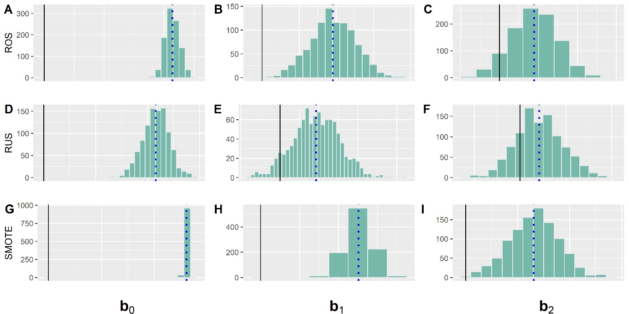
Figure 6: Empirical distribution of estimated parameters for the samples with the different class ratios. The solid and dashed lines represent the true parameter and the average value from the Monte Carlo simulations.

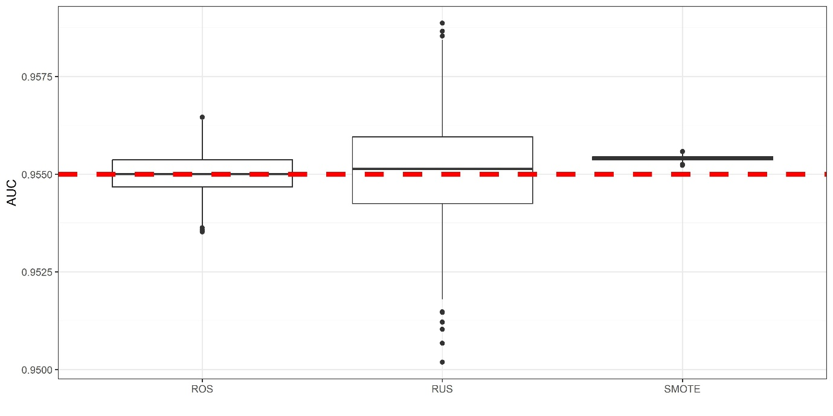
Figure 7: Box plots of ROC AUC of the model fitted to the datasets pre-processed with imbalance corrections. The dashed red line represents the AUC of the unadjusted model.

Hyperparameter Tuning of ML algorithms
Table 1: Hyperparameter values for final model building
Models | Hyperparameters | Hyper-parameters definition | Optimal Value
RF | Mtry | Number of variables randomly sampled as candidates | 2
RF | Min.node.size | Value of minimal node size used | 5
NNET | Size | Number of units in the hidden layer | 2
NNET | Decay | Parameter for weight decay | 0.5
SVM | Cost | Cost of constraints violation | 32
SVM | Sigma | Bandwidth of kernel function | 0.0577
7. Restricted cubic splines
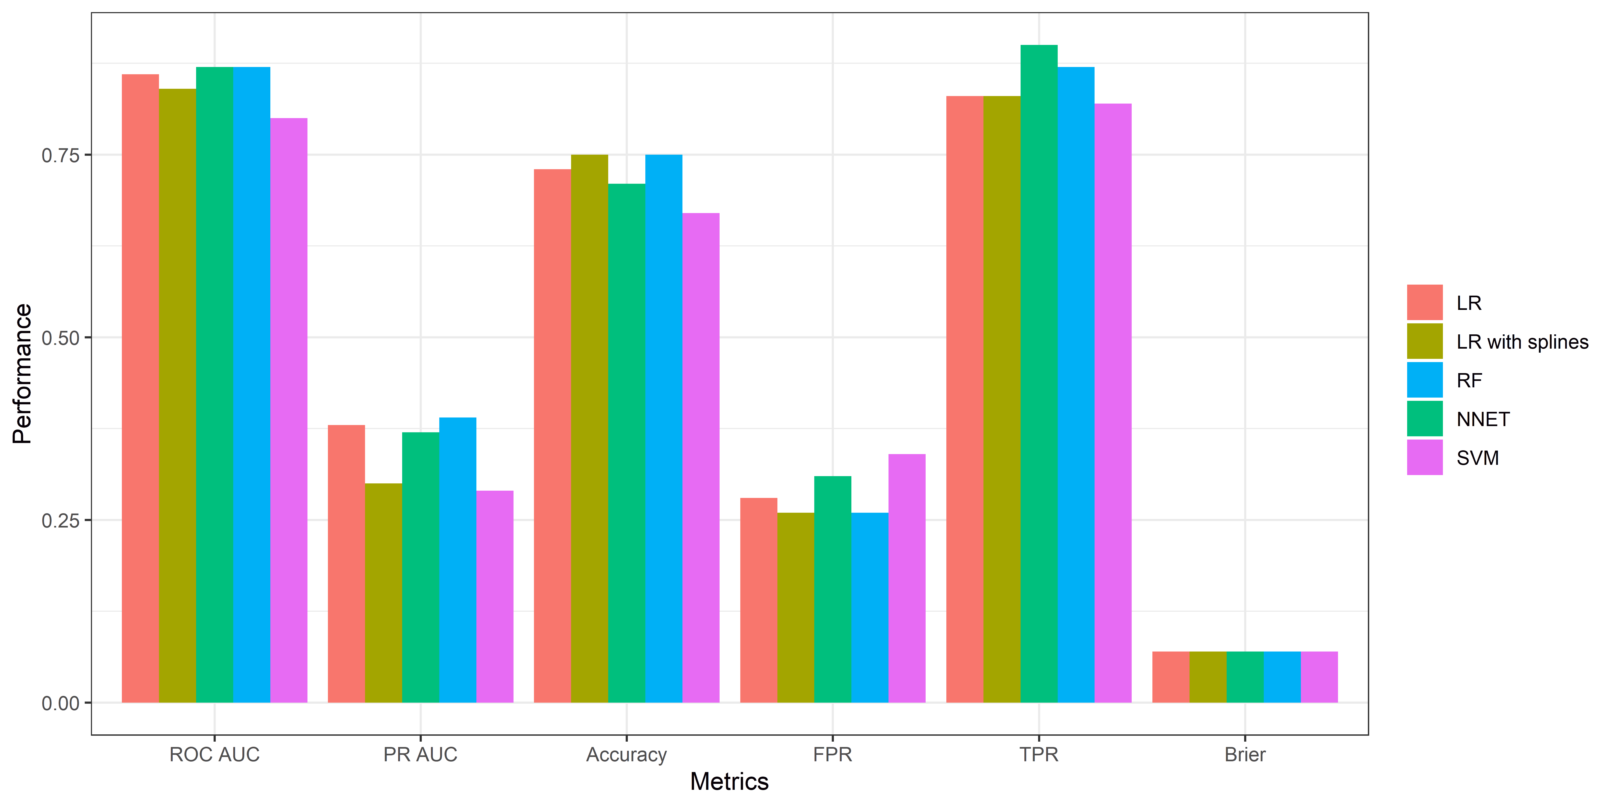Figure 8: Performance metrics of four models predicting the outcomes of extreme precipitation events.
Table 2: ROC AUC [95% CI] performance comparison of the two models applied to the training and test sets. 95% CI is computed with 2000 stratified bootstrap replicates.
Model | Training | Test
LR without splines | 0.86 (0.85 - 0.88) | 0.86 (0.83 - 0.89)
LR with splines | 0.87 (0.86 - 0.89) | 0.84 (0.80 - 0.88)

8. References
Haibo He, Garcia, E.A., 2009. Learning from Imbalanced Data. IEEE Trans. Knowl. Data Eng. 21, 1263–1284. https://doi.org/10.1109/TKDE.2008.239
Lee, S.H., Furtado, J.C., Charlton‐Perez, A.J., 2019. Wintertime North American Weather Regimes and the Arctic Stratospheric Polar Vortex. Geophys. Res. Lett. 46, 14892–14900. https://doi.org/10.1029/2019GL085592
Mastrantonas, N., Herrera‐Lormendez, P., Magnusson, L., Pappenberger, F., Matschullat, J., 2021. Extreme precipitation events in the Mediterranean: Spatiotemporal characteristics and connection to large‐scale atmospheric flow patterns. Int J Climatol 41, 2710–2728. https://doi.org/10.1002/joc.6985
Oommen, T., Baise, L.G., Vogel, R.M., 2011. Sampling Bias and Class Imbalance in Maximum-likelihood Logistic Regression. Math Geosci 43, 99–120. https://doi.org/10.1007/s11004-010-9311-8
Salas-Eljatib, C., Fuentes-Ramirez, A., Gregoire, T.G., Altamirano, A., Yaitul, V., 2018. A study on the effects of unbalanced data when fitting logistic regression models in ecology. Ecological Indicators 85, 502–508. https://doi.org/10.1016/j.ecolind.2017.10.030
Wilks, D.S., 2011. Statistical methods in the atmospheric sciences, 3rd ed. ed, International geophysics series. Academic Press, Oxford Waltham, MA.

