Questionnaire on surgical case order preference
Background:
If an experienced senior surgeon will perform the same four surgeries the next day and the surgical case orders are as follows: (1) the first case starts at 8 a.m.; (2) the second case starts at 10 a.m.; (3) the third case starts at 1 p.m.; (4) the fourth case starts at 3 p.m.
As one of the patients, which is your preferred case order and why?

Questions:
- Your gender is .
- Male.
- Female.

- How old are you?
years.

- Which is your preferred surgical case order?
- The first one.
- The second one.
- The third one.
- The fourth one.
- I don’t care.

- The reason for your choice.
.

- Do you think whether the surgical case order is associated with complications and clinical outcomes or not?
- Yes, it is.
- No, it isn’t.

Results.
- A total of 102 respondents participated in the questionnaire, including 40 men and 62 women.

- The average age was 44.8 ± 11.8 years, ranging from 23 to 75. Median: 45.0.
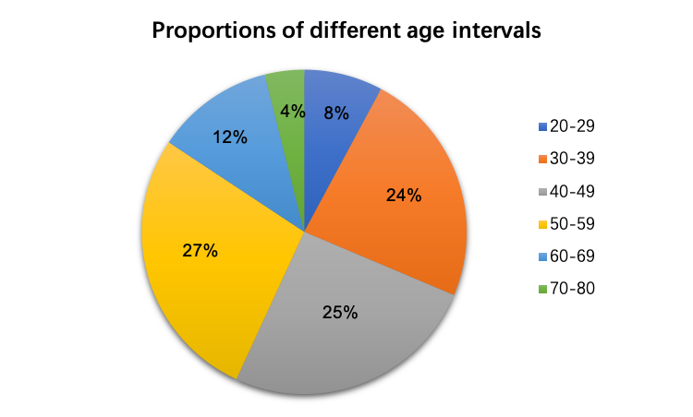

- “A. The first one.” accounts for 50.98%;
“B. The second one.” accounts for 13.72%;
“C. The third one.” accounts for 0.98%;
“D. The fourth one.” accounts for 0.98%;
“E. I don’t care.” accounts for 33.33%.
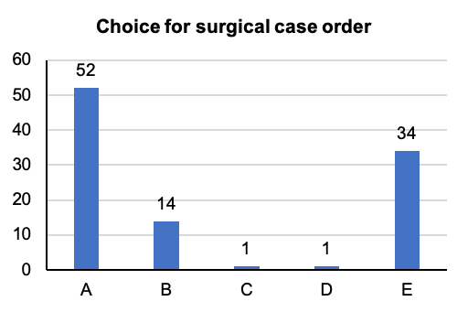

- The reasons for respondents’ choices are summarized as follows:
- Fifty-six answers are related to the surgeon’s physical and mental conditions, such as degree of fatigue;
- Twenty-one answers are related to surgeon’s operative proficiency, such as available warm-up;
- Eighteen answers are related to the patient’s physical and mental conditions, such as tolerance to preoperative fasting;
- Twenty-four answers are related to other factors, such as possible intraoperative complications, cleanliness of the operating room, or even Fengshui theory.

- Fifty-six respondents (54.90%) thought that the surgical case order was associated with complications and clinical outcomes; Forty-six respondents (45.10%) thought that the surgical case order is not associated with complications and clinical outcomes.

