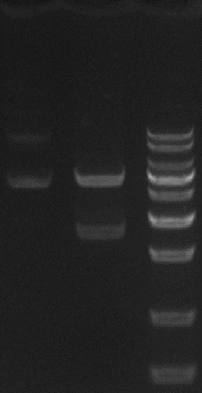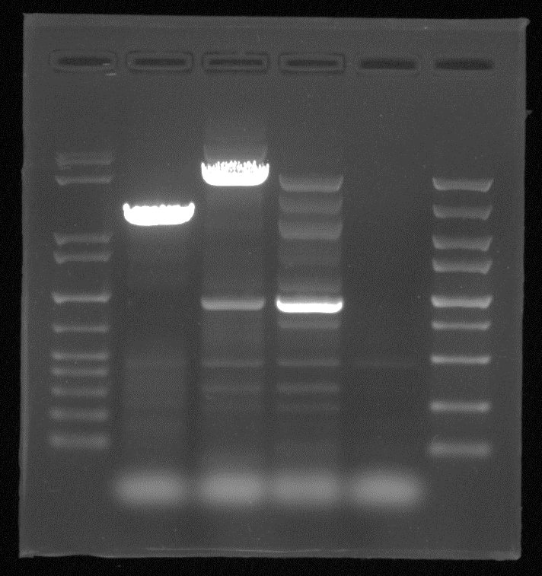
A
B
Supplementary Figure 1: (A) Uncropped Double digest of the recombinant vector pFastBac dual-71cA-mCherry. (B) PCR identification of recombinant bacmid-71cA-mCherry was not cropped. The red box represents the cropped part in the figure
B
A
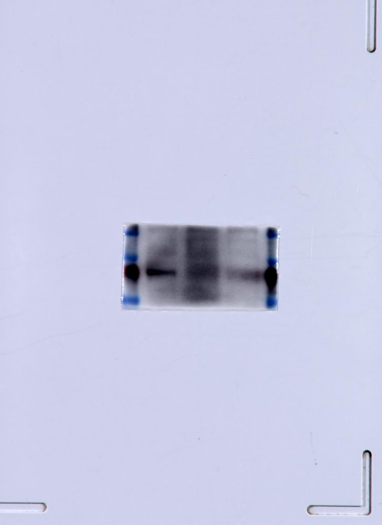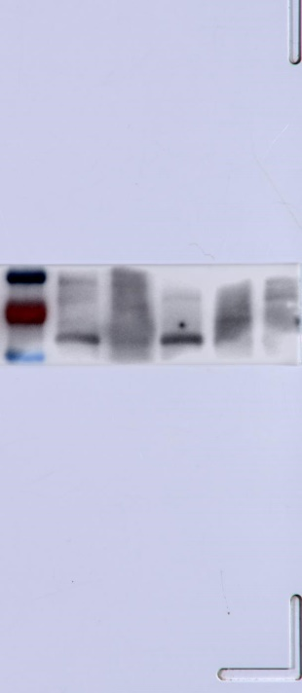
Supplementary Figure 2: Uncropped image Western blot identification of recombinant baculovirus surface-display particles. (A) Western blot identification of rvAc-71cA (63.5 kDa). (B) Western blot identification of rvAc-MTB39A (50.5 kDa). The red box represents the cropped part in the figure.

