A Non-Flammable Flexible Aluminum-Lithium Dual-Ion Battery with a Wide Temperature Range Based on Ionic Liquid Electrolytes
Zeyu Yuan^{1,2}, Lianjia Zhao^{1,2}, Ruoyu Chen¹, Dongdong Li¹, Wei Han², Lili Wang¹
¹ State Key Laboratory for Superlattices and Microstructures, Institute of Semiconductors, Chinese Academy of Sciences & Center of Materials Science and Optoelectronic Engineering, University of Chinese Academy of Sciences, Beijing 100083, PR China
^{2.} College of Physics, the State Key Laboratory of Inorganic Synthesis and Preparative Chemistry, International Center of Future Science, Jilin university, Changchun 130012, P.R. China

Correspondence and requests for materials should be addressed to W. Han (whan@jlu.edu.cn) and L. L. Wang (liliwang@semi.ac.cn).
Supplementary Figure 1 | Photos of aluminum electrode sheet before (left) and after (right) lithium ion deposition

Supplementary Figure 2 | SEM images of a bare Al surface and b Al surface after pre-lithiumation.

Supplementary Figure 3 | a The HRTEM image of AlLi alloy after pre-lithiumation. b The cross-sectional image of AlLi alloy anode. The red part is AlLi Allloy film and the green part is pure Al metal.

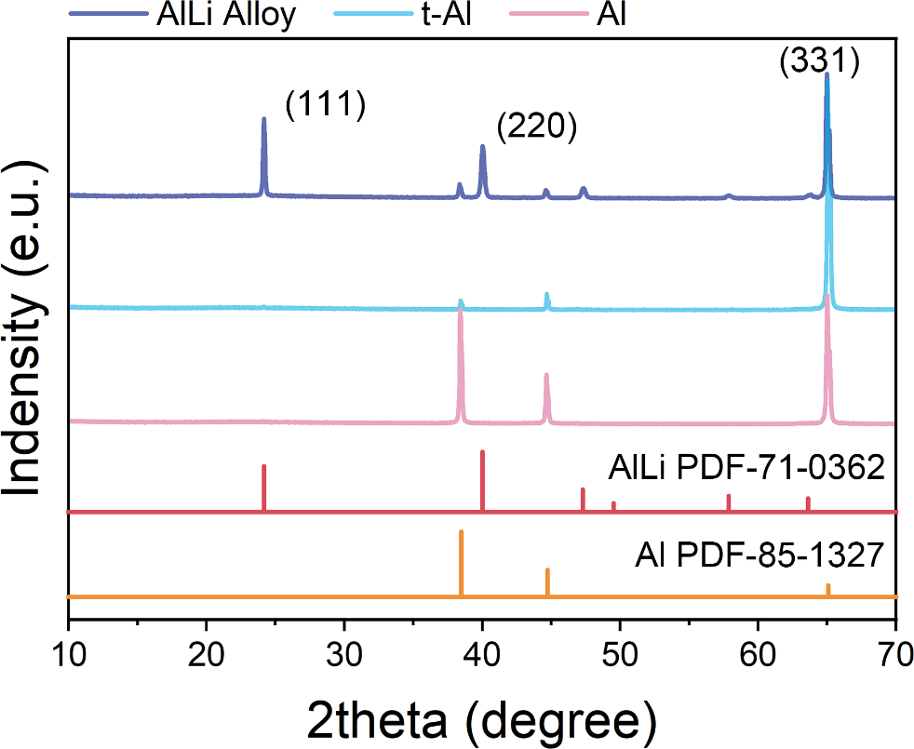
Supplementary Figure 4 | XRD patterns of AlLi alloy, polished Al and original Al.

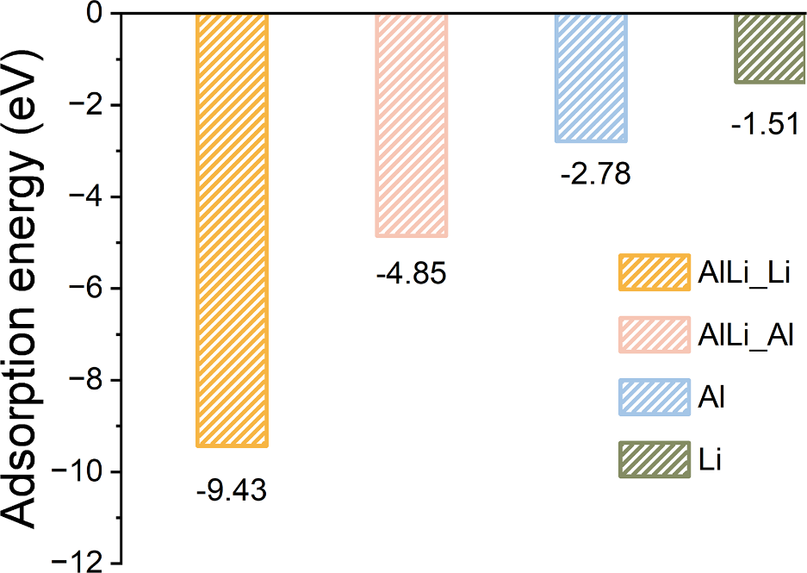
Supplementary Figure 5 | The Li adsorption energy of AlLi alloy (111) with exposed Al or Li atom layer, Al (200) and Li (002).

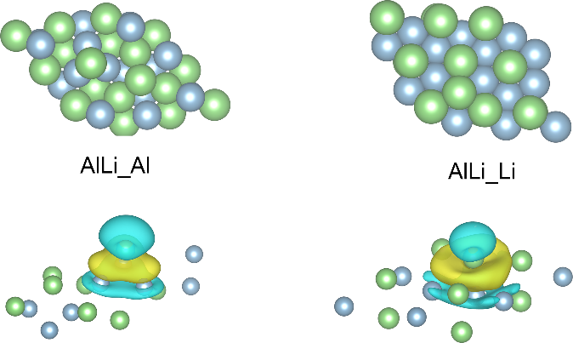
Supplementary Figure 6 | The deposition model of Li on AlLi alloy (111) with exposed Al or Li atom layer.

Supplementary Figure 7 | The deposition model of Li on a Al (200) and b Li (002)

Supplementary Figure 8 | symmetric battery charge/discharge cycle test using aluminum-lithium alloy and pure lithium ion at current density 0.5 mA cm⁻².

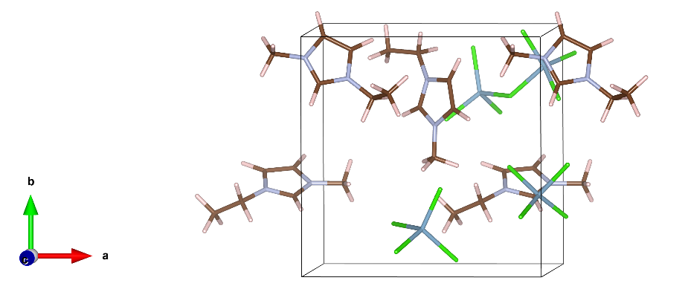
Supplementary Figure 9 | Typical snapshots from the AIMD trajectories of EMIC and AlCl₃.

Supplementary Figure 10 | Cyclic performance of Al//EMIC-AlCl₃//NVP without LiCl additive at current density of 0.1 A g⁻¹.

Supplementary Figure 11 | The GITT results of AlLi//EMIC-AlCl₃-LiCl//NVP with a 0.25, b 0.5, c 1, d 2 M LiCl additive.

Supplementary Figure 12 | a (113), b (006) and c (300) crystal planes in the NVP structure.

Supplementary Figure 13 | XPS spectra of Na 2p for NVP cathode at different potentials.

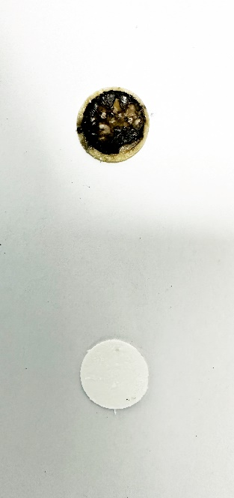
Supplementary Figure 14 | The diaphragm after cycles and before cycles in AlLi//EMIC-AlCl₃-LiCl//NVP.

Supplementary Figure 15 | Galvanostatic charge-discharge curves of Al//EMIC-AlCl₃ //NVP.

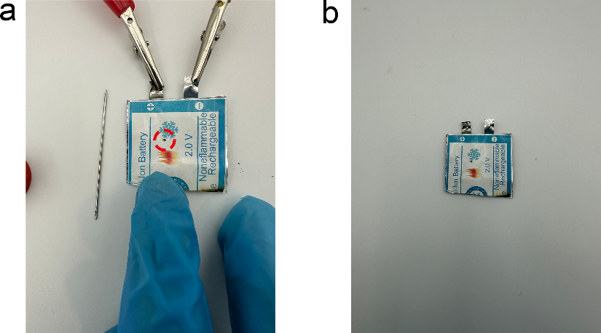
Supplementary Figure 16 | The images of pouch cell after a puncturing and b shearing.

Supplementary Note 1
Figure S1 a,b shows the photos of aluminum electrode sheet before and after lithium ion deposition, and it can be seen that the surface of aluminum sheet after lithium ion deposition has an obvious silver gray metal layer. In order to observe the lithium ion deposition on the surface of the aluminum more clearly, we also took corresponding scanning electron microscope pictures before and after the lithium ion deposition on the aluminum. Figure S2a shows the aluminum anode without any treatment, and it can be seen that its surface is smooth and flat, while figure S2b shows many long cracks on the surface of the aluminum anode after lithium deposition. Upon further magnification we can see that the aluminum-lithium alloy anode surface exhibits a nanoporous morphology, which provides considerable lithium ion deposition sites. The cross-section of the aluminum-lithium negative electrode that the part of this aluminum-lithium negative electrode in contact with the electrolyte forms an aluminum-lithium alloy layer while the aluminum metal layer at its bottom remains undeposited lithium ions (Figure S3b). We further scraped off the surface of the Al-Li alloy for high-resolution transmission microscopy and found that in addition to the signal of the Al-Li alloy (220) crystal surface on its surface there is also a wide stripe with a spacing of about 1.26 nm (Figure S3a). We consider that this wide stripe may be a microscopic Al-Li alloy morphology formed during the rapid deposition of lithium ions. This wide stripe is theoretically very favorable for the storage of lithium and aluminum ions. To further demonstrate the formation of aluminum-lithium alloy on the surface of the aluminum, XRD tests were conducted (Figure S4). It can be seen that the signal intensity of the (111) crystal surface of aluminum becomes significantly lower after grinding to remove the surface oxide layer. And a peak position matching the aluminum lithium PDF-71-0362 appeared after lithium ion deposition was performed. This also proves once again the existence of an aluminum-lithium alloy layer on the surface of aluminum metal.

Supplementary Note 2
$$D_{Na^{+}}=\frac{4}{πt}{\left(\frac{m_{B}V_{M}}{M_{B}S}\right)}^{2}{(\frac{∆E_{s}}{∆E_{t}})}^{2}$$
where s denotes the constant current pulse time; m_{B}, M_{B}, and V_{M} are the mass, molar weight, and molar volume of the active materials, respectively; S is the total contact area between the electrolyte and the electrode; and ΔEs and ΔEt are the changes in the steady-state voltage after subtracting the IR drop and the total transient change in the cell voltage during a single titration.

upplementary Note 3
$$D=\frac{R^{2}T^{2}}{{2A}^{2}n^{4}F^{4}C^{2}σ^{2}}$$

$Z^{'}=R_{s}+R_{p}+{σω}^{-1/2}$
To estimate the diffusion coefficient of ions, the low frequency region of the spectra is used.where R is the gas constant (8.314 J/molK), T stands for the absolute temperature (K), A is the contacting area of electrode with electrolyte (cm²), n is the number of transferred electrons, F is thr Faraday constant (96500 C mol⁻¹), C is the concentration of ion in cathode,σis the Warburg factor which can be calculated from Z‘.

Supplementary Movie 1| AIMD video shows lithium ions move between multiple AlCl₄⁻ chloride atoms in EAL electrolyte. This indicates that the lithium ions in EMIC-AlCl₃-LiCl electrolyte are very easy to diffuse, which is conducive to the improvement of the battery rate performance.

Supplementary Movie 2| The video shows the use of an alcohol lamp that failed to ignite a diaphragm dipped in EAl electrolyte.

Supplementary Movie 3| The video shows the use of an alcohol lamp to instantly ignite a diaphragm dipped in LiPF₆ electrolyte.

Supplementary Movie 4| In this video two aluminum lithium cells in series were used to successfully light up 5 yellow LEDs. In one of the aluminum lithium battery bending, shear and baking experiments LED bulb can maintain a certain brightness.

