Supplementary discussion

S1 Choice of fractionation protocol
Note that absolute numbers such as the 4 % SOC threshold at which SA_{TOT} exceeds S+C_{TOT} may be affected by the choice of fractionation protocol^{80,81}. Nevertheless, while the strength of the sonication treatment may affect a quantitative assessment of thresholds at which the contribution of fractions to bulk SOC% change, it does not affect patterns of relative contribution of fractions to bulk SOC%.

S2 Relationships between soil biogeochemical and climatic factors
Despite varimax rotation maximizing differences in loading between components, annual water balance (calculated as MAP - PET) and NPP also correlate positively with RC4 “Pedogenic oxides”. Vice versa, the Rock-Eval I-index correlates also with RC6 “Temperature”. We argue that the mixed loading of these components is indicative of the role of moisture and organic inputs as drivers of mineral weathering⁴ and in explaining SOC decomposition. On the other hand, NPP likely follows an optimum curve with MAT, as plant productivity becomes increasingly water limited at higher temperatures⁸². The majority of soils in this dataset comes from temperate climate zones with most soils from humid soil moisture regimes (udic, n = 18), where no strong effects of water limitation or water logging on biological activity are expected (Table S6). Nevertheless, the gradient also features aridic (n =1), ustic (n = 3) and xeric (n = 6) soils, where low water availability could act limiting on plant growth, and perudic soils (n = 7) where water logging could occur seasonally. Note that the annual water balance (MAP-PET) is correlated negatively with temperature (RC6), and positively with pedogenic oxides (RC4) (Table S4). However, the annual water balance did not constitute a major independent axis of variation in the gradient (Table S4) and thus does not feature as a separate explanatory variable in our regression analysis and subsequently in our conceptual framework. It is rather an indirect feature in our framework as an implicit control on some of the effects on SOC stabilization seen through temperature and pedogenic oxides. For example, potential drought effects can limit biological activity¹⁸ towards hot conditions, and temporary water logging in moist cold conditions on the temperature axis. Second, higher soil moisture can favor the formation of pedogenic oxides via increased weathering rates⁵, and thus affects the formation of organo-mineral associations. Further, higher moisture can aid the formation of stable microaggregates, which is influenced by changing redoximorphic conditions and drying-wetting cycles^{19,50}. Unsurprisingly, geochemical reactivity (RC1) is positively correlated with finer texture (RC3) and to a lesser extent with warmer temperatures (RC6) (Figure 3b). The degree of organic matter decomposition in the bulk soil (RC2) is strongly positively correlated with finer texture (RC3) and higher temperature (RC6), and to a lesser extent positively with geochemical reactivity (RC1) and negatively with pedogenic oxide contents (RC4). The link with temperature suggests that OM decomposition in the bulk soil (RC2) may also contain variation of the temperature dimension in the data set (RC6), where in cooler (and wetter) systems bulk OM is less decomposed. The positive link between geochemical reactivity (RC1) and the degree of OM decomposition at the bulk level (RC2) has been observed before for a weathering chronosequence⁶⁵. We further observed a negative link between pedogenic oxides (RC4) and temperature (RC6), reflecting the role of climate as a driver of weathering⁵. We also observed a negative interaction between pedogenic oxides (RC4) and base cations (RC5) in the predictive model for bulk SOC% (Figure 3a). We relate this to the fact that in soil systems where base cations are abundant, they have more explanatory content for bulk SOC% than in systems where they are not abundant, coupled with the generally higher abundance of base cations in soil parent material that is also rich in iron, aluminum and manganese . This becomes evident by the results of a simple linear model (SLM) for predicting bulk SOC%, where base cations feature as a weak positive predictor (rVI_{Pedogenic oxides} = 0.50, rVI_{Temperature} = 0.29, rVI_{Base cations} = 0.22, model description see Table S5). Thus, the role of base cations in explaining bulk SOC% could stem either from their role as plant nutrients (see supplementary discussion S6), or more directly from an involvement in SOC stabilization via cation-bridging at the higher end of the pH-range^{4,83}. Despite its important role for many biological and weathering related processes⁶⁹, soil pH did not constitute a main loading on any RC as it can vary due to contrasting climatic, biological and soil geochemical ecosystem properties⁴. The strongest association of pH is with organic matter decomposition (RC2), where soils with a lower degree of decomposition are more acidic (Table S4).

S3 Pathways of OM stabilization in the S+C fraction
In this study, we observed that the degree of decomposition of OM associated with the S+C fraction decreases with increasing bulk SOC% (Figure 3b). We argue that this indicates a shift in the type of OM that gets associated with the S+C fraction.
It is generally assumed that mineral-associated SOC is primarily formed from products of microbial decomposition^{2,25}. This can happen either via microbial uptake of substrate, subsequent breakdown through microbial catabolism and reassembly into chemically different molecules by microbial anabolism. Carbon stabilization following such full microbial transformation of OM can be referred to as the in vivo pathway³¹. In contrast, SOC stabilization that for various reasons bypasses microbial uptake - and subsequently full microbial catabolism and anabolism -, can be referred to as the ex vivo pathway. Examples for the ex vivo pathway are direct stabilization of soluble plant-derived OM, or stabilization of structural plant-derived OM that only got modified by extracellular enzymes.
In our dataset, a higher decomposition index (DI) corresponds to a higher proportion of microbially transformed OM in the respective reservoir, as the patterns of the variables on which the DI is based (fraction specific C:N ratio, relative peak area of RPA_{SIMP}, δ¹³C and δ¹⁵N) show (Figure S1). This implies that in soils with a high DI a larger proportion of the OM was stabilized via the in vivo pathway (in contrast to the ex vivo pathway). We therefore argue, that with increasing bulk SOC% we see an increasing importance of the ex vivo pathway relative to the in vivo pathway for SOC stabilization associated with the S+C fraction.
Theoretically, a large variety of mechanisms could underlie such a shift: First, changes in the composition of the clay mineral phase and its sorptive affinity could influence the stabilization of chemically distinct types of OM in S+C^{9,27,28,84,85}. Second, lower decomposition rates caused by lower temperatures could lead to the relative accumulation of less-decomposed OM. Third, increasing SOC contents could facilitate increasing OM – OM interactions^{30,86} on mineral surfaces, which may be less selective in terms of OM chemistry. Fourth, it has previously been suggested that more leaching in wetter environments may favor the ex vivo pathway over the in vivo pathway⁹, which would also result in the pattern that we observe. Fifth, in soils with more aggregation (i.e., soils with higher bulk SOC%), it is reasonable to assume a larger contribution of small stable aggregates in the silt- and clay-sized fraction (relative to free organo-mineral associations). These small stable aggregates could in turn occlude more poorly transformed OM, and thus shift the DI of the S+C fraction. Sixth, macroaggregation may be higher in SOC rich soils and thus smaller (S+C-sized) particles may have been occluded in macroaggregates before fractionation. Within macroaggregates, the organic matter associated with these S+C-particles may be protected from decomposition by a certain degree of physical occlusion in addition to chemical stabilization mechanisms. However, it remains unclear if and to what extent occlusion in macroaggregates can protect OM from decomposition on short to intermediate time scales. In conclusion, while our data does not reveal which mechanism(s) may cause the patterns in this dataset, plenty of observed and proposed mechanisms render our observation and interpretation plausible, that the OM in the silt- and clay-sized fraction is on average less microbially transformed in high-SOC soils than in low-SOC soils.

S4 The role of texture
Other studies identified silt and clay content as a main predictor of SOC contents, usually after full dispersion of stable microaggregates⁸⁷. We also observed a positive relationship between S+C_{TOT} and secondary texture (RC2) since in soils with more silt- and clay-sized particles, more SOC was accumulated in the respective fraction. Note that we did not find a direct effect of texture on bulk SOC%. However, Our findings do not question this general relationship; as aggregation likely occludes S+C particles, this relationship may be masked in our data because for the regression analysis we used secondary texture that does not disrupt chemically and physically stable (micro)aggregates (see materials and methods section “2.4 Soil physicochemistry”).
Given that we can show that soil mineralogy is a main driver of SA_{TOT}, we caution against oversimplified classification of incompletely dispersed size fractions as POM, without at least including a density separation step. Related to this point, the S+C fraction likely also contains small microaggregates and concretions < 63 µm³⁶. However, since we found average organic matter in S+C and SA to be significantly different in terms of decomposition state (Figure 3a), we argue that both fractions on average capture functionally different pools.
We observed an increasing dominance of S+C_{TOT} relative to POM_{TOT} in soils with higher silt and clay content (Figure 3a). This was likely caused by more than one mechanism. First, high surface area in finer textured soils is often the result of weathering processes which increase mineral reactivity. This leads to improved conditions for OM stabilization with minerals, thus facilitating a transfer of OM from POM to S+C. Second, the clay fraction can harbor high concentrations of soil microbial biomass^{88,89}, which could translate into higher activity of microbial SOC decomposition, driving the transformation of POM into forms which can readily get stabilized with minerals. Higher microbial carbon use efficiency as observed in fine textured compared to coarse textured soils⁹⁰ could further accelerate this transformation.

S5 Andisols
This gradient features ten USDA Andisols (Table S1), which can be very rich in short-range order minerals. Short-range order minerals are known to be highly efficient in SOC stabilization⁹¹, and they have been proposed to be strong drivers of aggregation^{4,92}. While the Andisols are among the soils with high bulk SOC%, our study also features other soil types with high SOC contents. Thus, mineral related features of volcanic Andisols are only one of several ways to accumulate SOC in mineral fractions in the soils of this study.

S6 The controls of POM_{TOT}
The positive link between POM_{TOT} and base cations (RC5) hints at a positive effect of plant available nutrients on plant productivity, and thus OM input to soil (Figure 3a). However, the plant debris derived POM_{TOT} was also negatively correlated to temperature (RC6), which in turn was positively correlated to NPP (Table S4). This apparent contradiction points at multiple, in parts conflicting, environmental factors that can control the amount of plant derived, less decomposed OM in soils. First, aboveground NPP might be poorly linked to the actual input of OM into soils. Second, the fate of plant derived OM may be strongly affected by the type of input^{7,9,33} (aboveground vs. belowground, soluble vs. structural). Third, the degree to which plant OM input and microbial decomposition are constrained by climate can differ across large climatic gradients, as discussed in the main text.

Supplementary References:

80. Poeplau, C. & Don, A. Effect of ultrasonic power on soil organic carbon fractions. J. Plant Nutr. Soil Sci. 177, 137–140 (2014).
81. Poeplau, C. et al. Isolating organic carbon fractions with varying turnover rates in temperate agricultural soils – A comprehensive method comparison. Soil Biol. Biochem. 125, 10–26 (2018).
82. Knapp, A. K., Carroll, C. J. W. & Fahey, T. J. Patterns and Controls of Terrestrial Primary Production in a Changing World. in Ecology and the Environment (ed. Monson, R. K.) 205–246 (Springer New York, 2014). doi:10.1007/978-1-4614-7501-9_2.
83. Rowley, M. C., Grand, S. & Verrecchia, É. P. Calcium-mediated stabilisation of soil organic carbon. Biogeochemistry 137, 27–49 (2018).
84. Kramer, M. G., Sanderman, J., Chadwick, O. A., Chorover, J. & Vitousek, P. M. Long-term carbon storage through retention of dissolved aromatic acids by reactive particles in soil. Glob. Change Biol. 18, 2594–2605 (2012).
85. Creamer, C. A. et al. Mineralogy dictates the initial mechanism of microbial necromass association. Geochim. Cosmochim. Acta 260, 161–176 (2019).
86. Possinger, A. R. et al. Organo–organic and organo–mineral interfaces in soil at the nanometer scale. Nat. Commun. 11, 6103 (2020).
87. Matus, F. J. Fine silt and clay content is the main factor defining maximal C and N accumulations in soils: a meta-analysis. Sci. Rep. 11, 6438 (2021).
88. Ranjard, L. & Richaume, A. Quantitative and qualitative microscale distribution of bacteria in soil. Res. Microbiol. 152, 707–716 (2001).
89. Wei, H. et al. High clay content accelerates the decomposition of fresh organic matter in artificial soils. Soil Biol. Biochem. 77, 100–108 (2014).
90. Angst, G. et al. Soil texture affects the coupling of litter decomposition and soil organic matter formation. Soil Biol. Biochem. 159, 108302 (2021).
91. Garrido, E. & Matus, F. Are organo-mineral complexes and allophane content determinant factors for the carbon level in Chilean volcanic soils? CATENA 92, 106–112 (2012).
92. Asano, M. & Wagai, R. Evidence of aggregate hierarchy at micro- to submicron scales in an allophanic Andisol. Geoderma 216, 62–74 (2014).

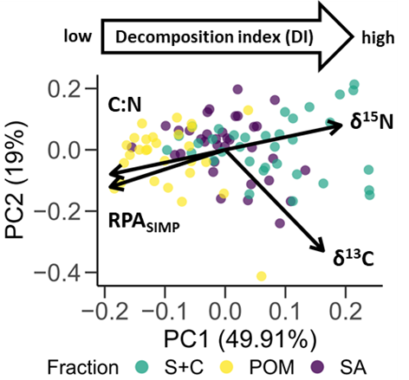

Figure S1. Results of a PCA based on fraction specific C:N ratio, relative peak area of RPA_{SIMP}, δ¹³C and δ¹⁵N. n = 96 (n_{SA} = 35, n_{S+C} = 34 ; n_{POM} = 28). PC1 explains 50 % of variation in the input variables and can be interpreted as a decomposition index (DI) as described in the methods section.

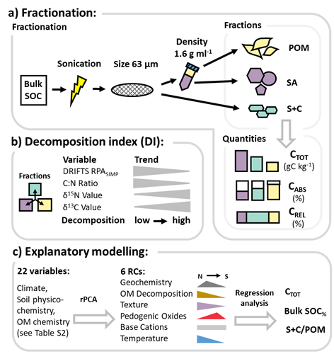
Figure S2. Schematic overview of quantitative and qualitative SOC characterization and data analysis. a) Isolation of three soil fractions; free particulate organic matter (POM), stable microaggregates > 63 μm (SA) and silt- and clay-sized particles (S+C). Quantification of the total amount of SOC per unit soil (C_{TOT}), fraction-specific C content (C_{ABS}) and relative contribution to bulk SOC (C_{REL}). b) To quantify the degree of microbial transformation of OM, a decomposition index (DI) was derived from principal component analysis (PCA) with fraction-specific measurements of decomposition indicators. c) Regression analysis to investigate controls of SOC fractions. We first applied rotated PCA (rPCA) to reduce 22 environmental variables (listed in Table S2) to six rotated components (RCs) for regression analysis.

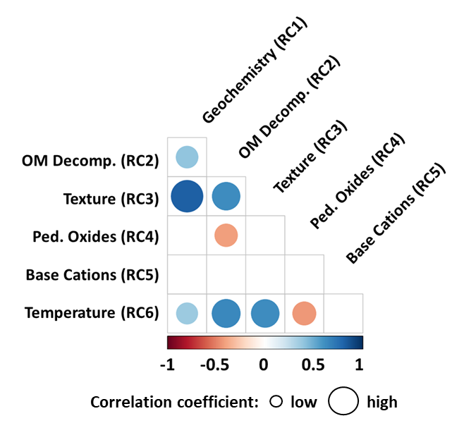
Figure S3. Correlation matrix of the six RCs retained after rPCA. Shown are significant correlations (Pearson correlation, p < 0.05).
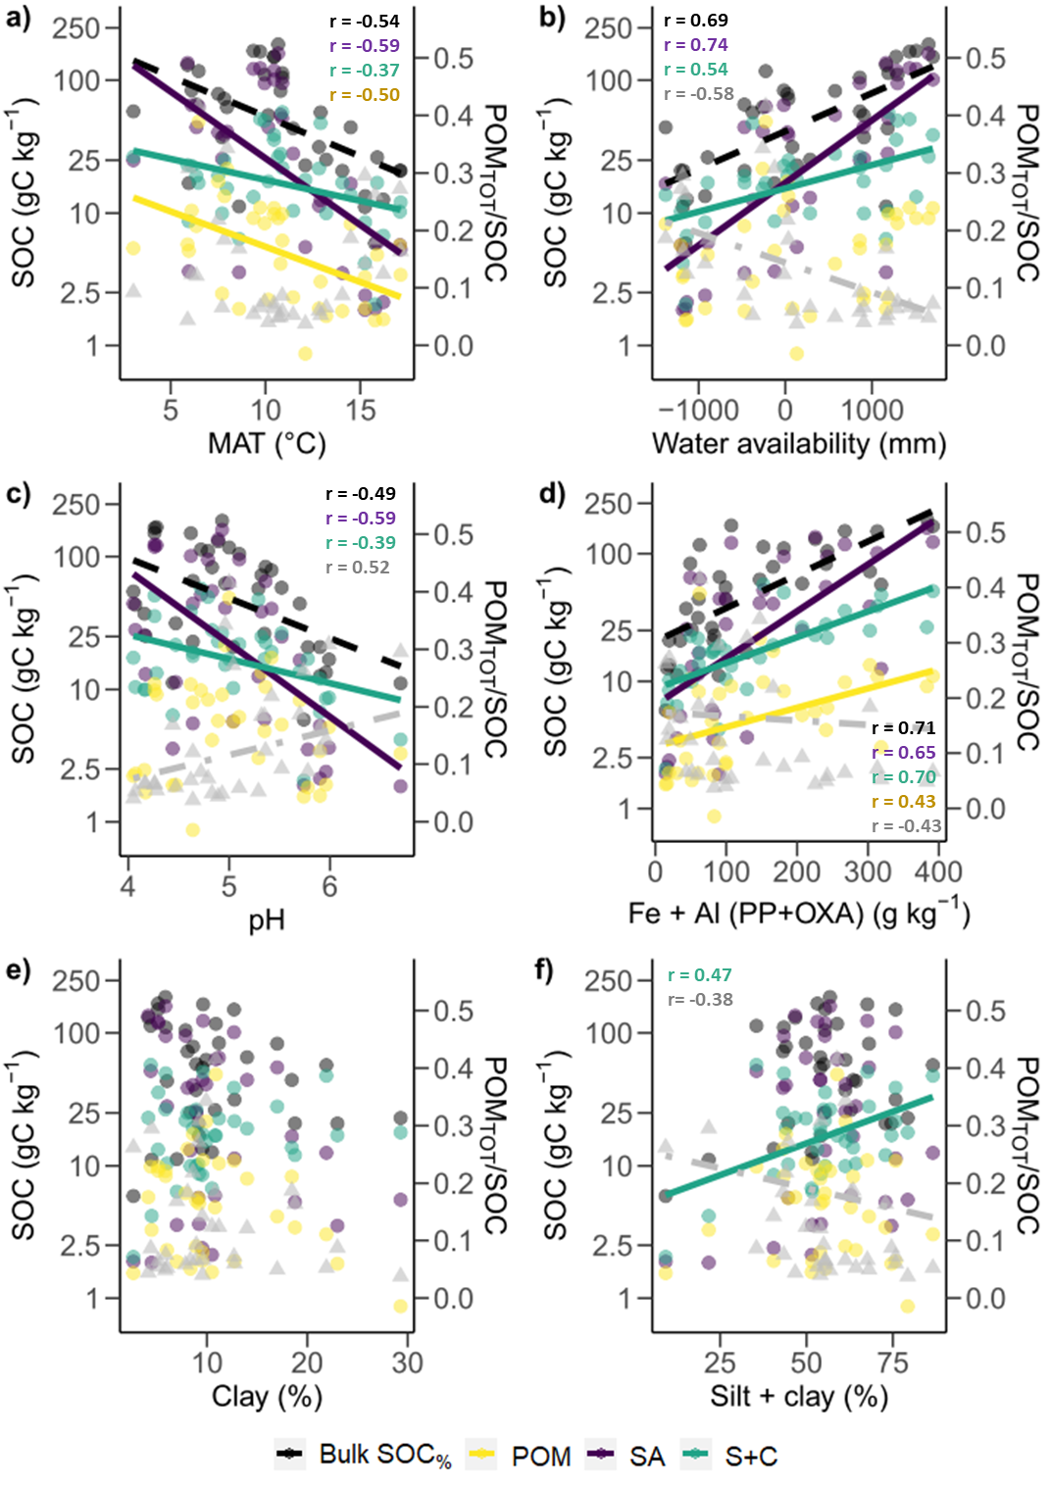
Figure S4. Correlations between bulk SOC% and C_{TOT} in SA, S+C and POM as well as POM_{TOT}/SOC with measured environmental variables. Shown are relationships with a) MAT, b) water availability (MAP – PET), c) pH value, d) the sum of Fe and Al sequentially extracted with pyrophosphate ammonium oxalate, e) primary clay content and f) the sum of primary clay and silt content. Dots indicate datapoints of SOC amounts, triangles datapoints of POM_{TOT}/SOC ratio, lines indicate slopes of significant (p-values < 0.05) Pearson correlations. All correlations of SOC amounts performed with log-transformed SOC quantities. Only in the case of pedogenic oxides (panel d) transformation led to small decreases in the strength of relationship for bulk SOC% and SA_{TOT}.

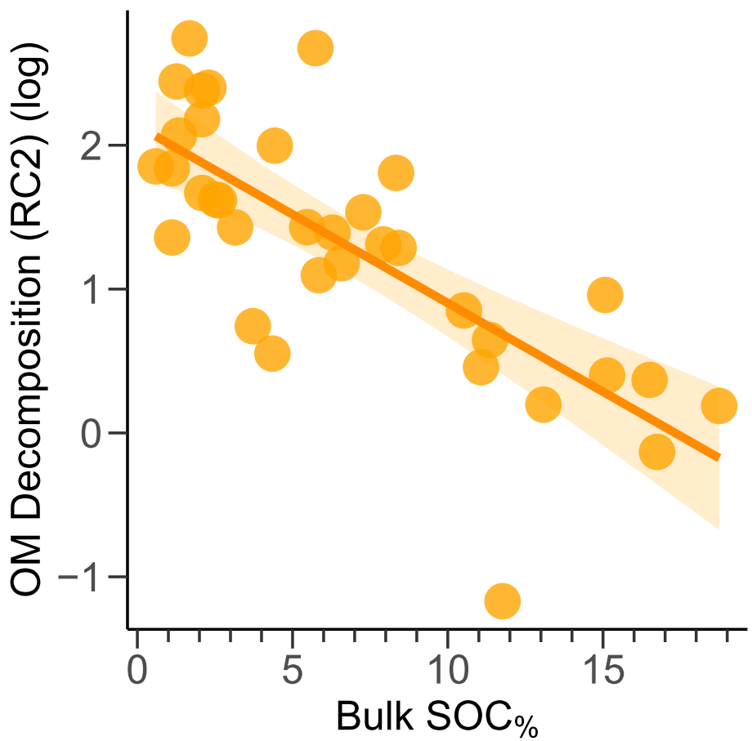

Figure S5. The degree of bulk organic matter decomposition decreases with bulk SOC content. As a measure for the degree of bulk organic matter decomposition, the rotated component RC2 “OM Decomposition” was used (decomposition index (DI) cannot be calculated for bulk soil), which strongly correlates with a decrease of aliphatic compounds (RPA_{SIMP}) relative to other compounds, and with a decrease of the Rock-Eval derived I-index (see Table S4). Log-transformed data points and fitted model with 95 % confidence intervals are shown. Because the rotated component had negative values (min. -4.69), log-transformation was done after adding + 5 to all data points. RMSE = 3.53, adj. R² = 0.55, p-value < 0.05, n = 35, df = 33.

Supplementary Tables
Table S1. Geomorphology and soil information of sampling sites. Site IDs refer to the numbers as used in Figure 1. Literature used for metadata is indexed with numbers from 1 – 11: 1 = Aburto F., Hernández C., Pfeiffer M., Casanova M., Luzio W. (2008). Soil: a work of art of nature. Northern field guide between 30S° and 33S° In: Casanova M., Luzio W. (Eds.) The international conference and field workshops on soil classification. University of Chile, Santiago-Ovalle, Chile; 2 = CIREN (1997). Soil survey, region V of Chile. Natural Resources Information Centre, Publication N° 116 Santiago (in Spanish); 3 = CIREN (1996). Soil survey of the Metropolitan region of Chile. Natural Resources Information Centre, Publication N° 115 Santiago (in Spanish); 4 = CIREN (1996). Soil survey, region VI of Chile. Natural Resources Information Centre, Publication N° 114 Santiago (in Spanish); 5 = CIREN (1997). Soil survey of the VII region of Chile. Natural Resources Information Centre, Publication N° 121 Santiago (in Spanish); 6 = CIREN (1999). Soil survey, region VIII of Chile. Natural Resources Information Centre, Publication N° 117 Santiago (in Spanish); 7 = CIREN (2002). Soil survey, region IX of Chile. Natural Resources Information Centre, Publication N° 122 Santiago (in Spanish); 8 = CIREN (2003). Soil survey, region X of Chile. Natural Resources Information Centre, Publication N° 123 Santiago (in Spanish); 9 = CIREN (2005). Soil survey, region XI of Chile. Natural Resources Information Centre, Publication N° 130 Santiago (in Spanish); 10 = INIA (2014). Taxonomic characterization of soils from valleys with agricultural interest from Aysen Region (Patagonia Occidental-Chile.). In: Stolpe N., Hepp C. (Eds.). Bulletin INIA (Instituto de Investigaciones Agropecuarias) N° 299. Coyhaique, Chile. (in Spanish); 11 = CNR (1997). Comprehensive study of irrigation and drainage of Magellan, XII Region, vol 2 (in Spanish).
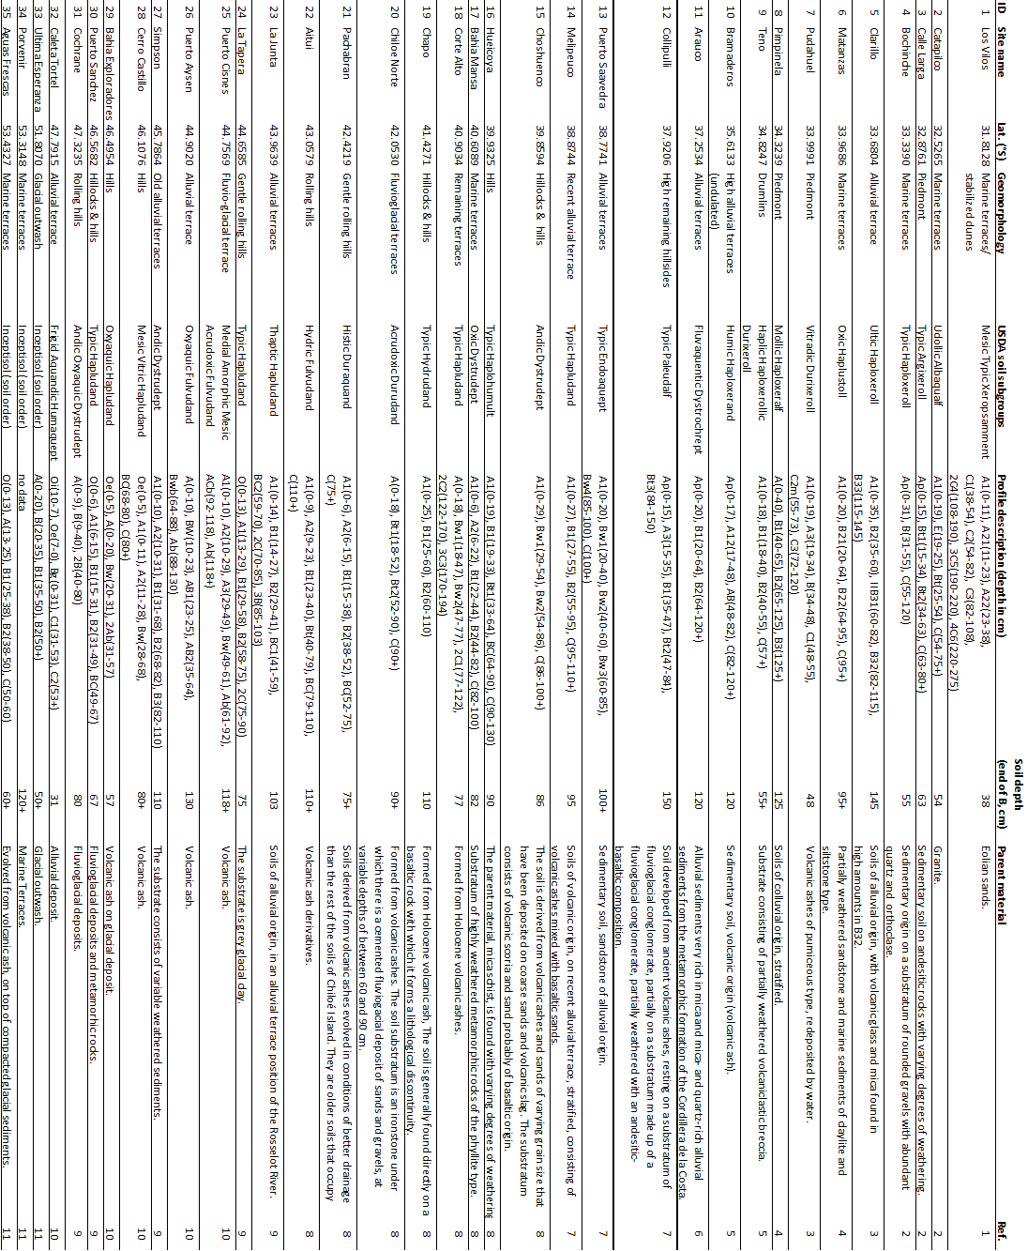

Table S2. Soil physicochemical and climatic variation along the gradient. Ranges of all soil physicochemical and climatic variables that were used for the rPCA for dimension reduction.
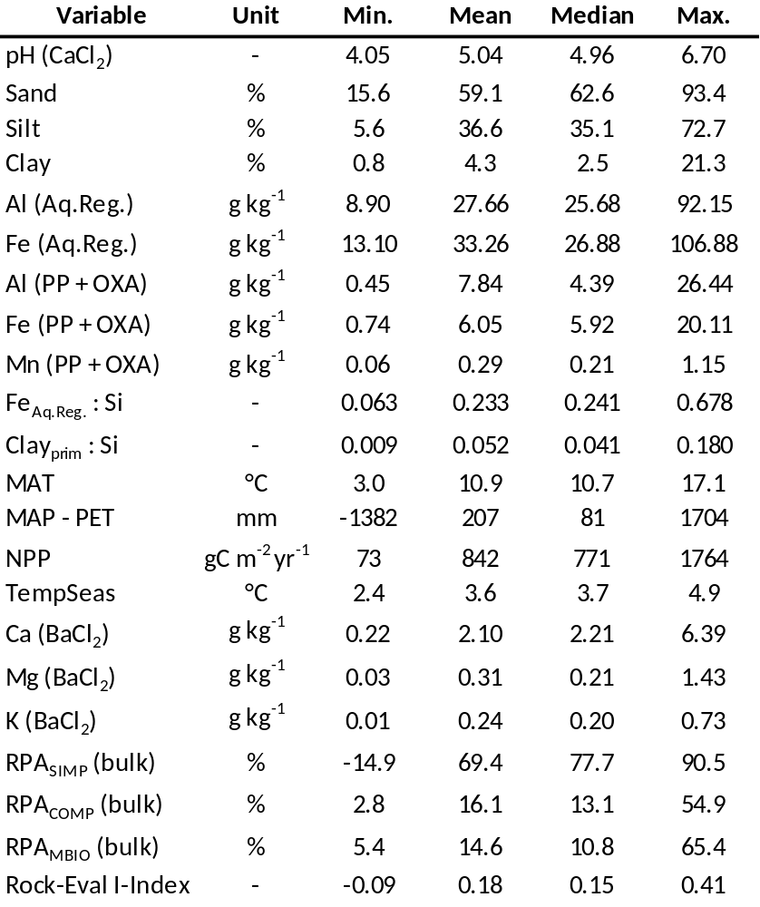

Table S3. Regression analysis of SOC quantities and qualities in the fractions with bulk SOC%. * BP-test not possible in models that have zero-intercept; **C_{TOT} of POM is forced through zero and has one outlier. Transf. = transformation of the dependent variable; BP = p-value of Breusch-Pagan test for homoscedasticity of model residuals; SW = p-value of Shapiro-Wilk test for homoscedasticity of model residuals.
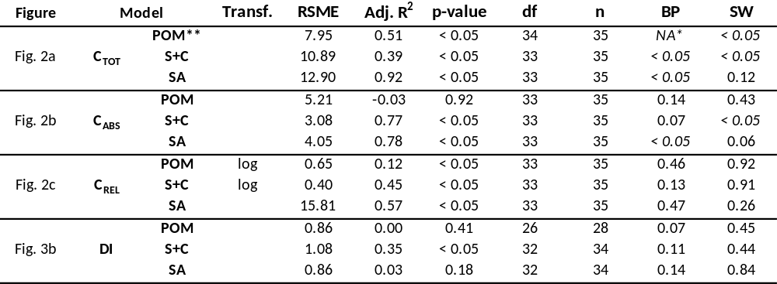

Table S4. Results of the rPCA for dimension reduction. The six retained rotated components (RCs) with Eigenvalue > 1 that resulted from this rPCA. The top shows Eigenvalues and individual as well as cumulative variability explained by the RCs. Loadings are shown for all 22 input variables. Interpretation and naming of the RCs was based on variables with loadings ≥ 0.5 (highlighted), and the assigned names for the RCs are given at the top. OM Decomp. = OM Decomposition; Ped. Oxides = Pedogenic Oxides.
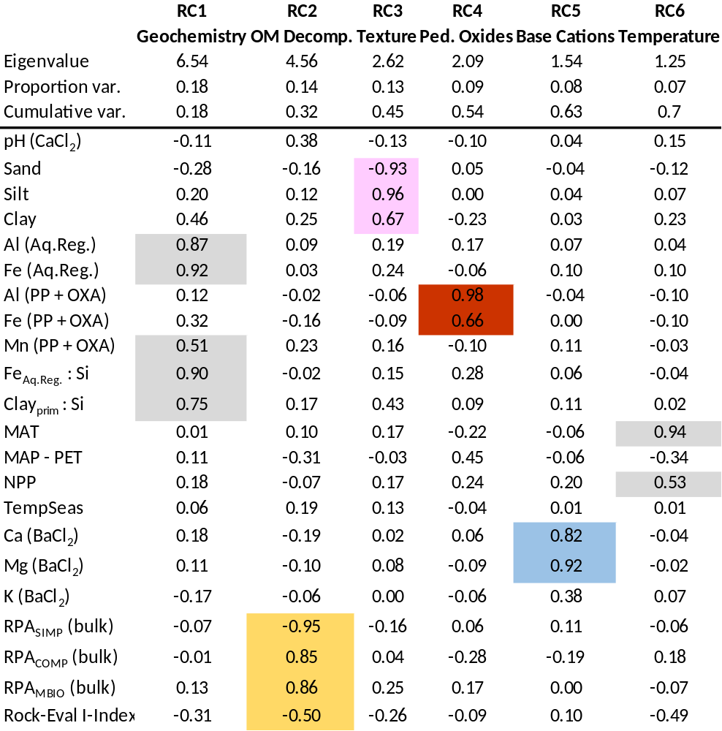

Table S5. Comparison of performances of the simple linear model (SLM), linear model allowing for interactions (ILM) and non-linear random forest model for each predicted SOC variable. The model with the best performance is highlighted in yellow. Transf. = transformation of the dependent variable; BP = p-value of Breusch-Pagan test for homoscedasticity of model residuals; SW = p-value of Shapiro-Wilk test for homoscedasticity of model residuals.
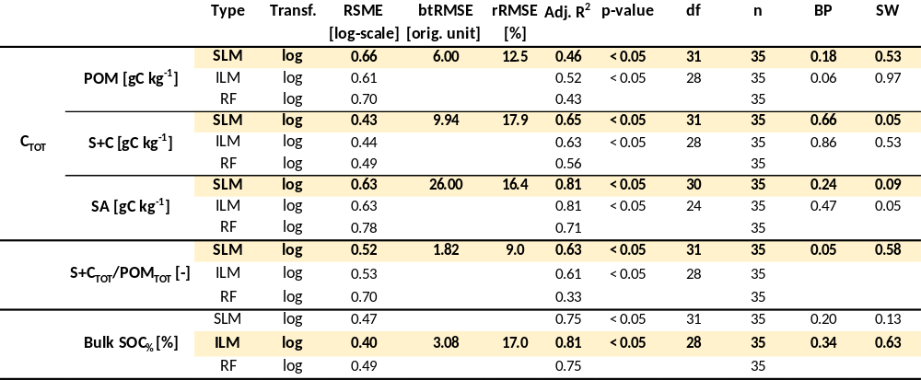

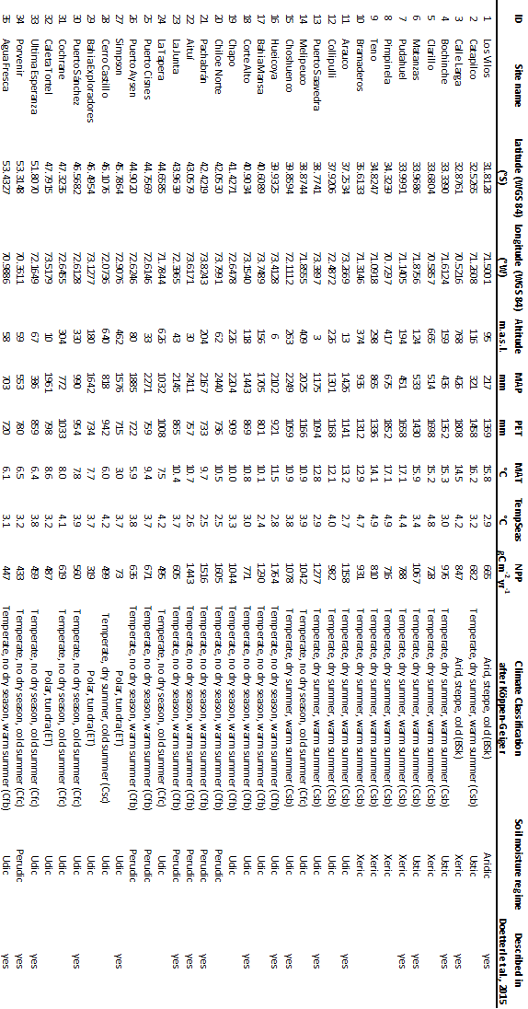
Table S6. General site information. Site IDs refer to the numbers as used in Figure 1.

Table S7. Vegetation information of sampling sites. Site IDs refer to the numbers as used in Figure 1. Literature used for metadata is indexed with numbers from 1 – 11 (see caption Table S1).
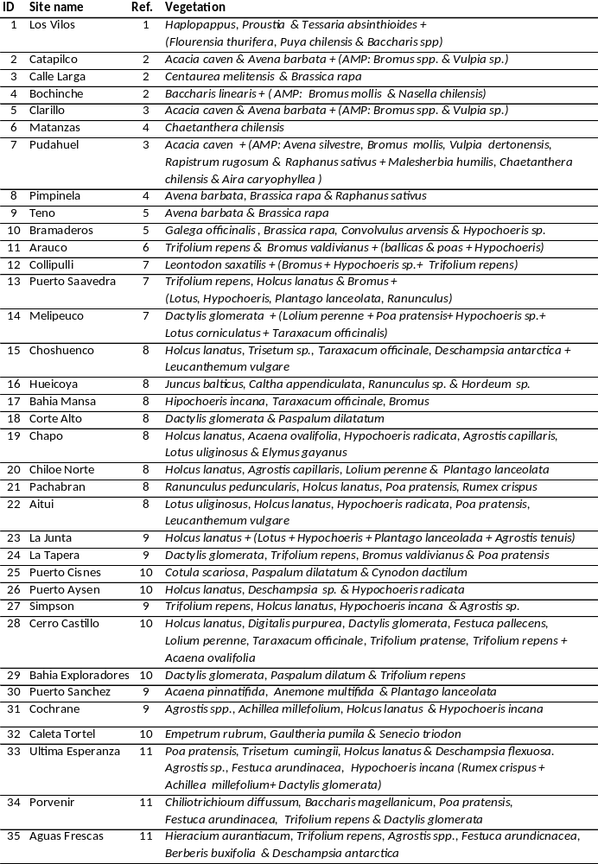

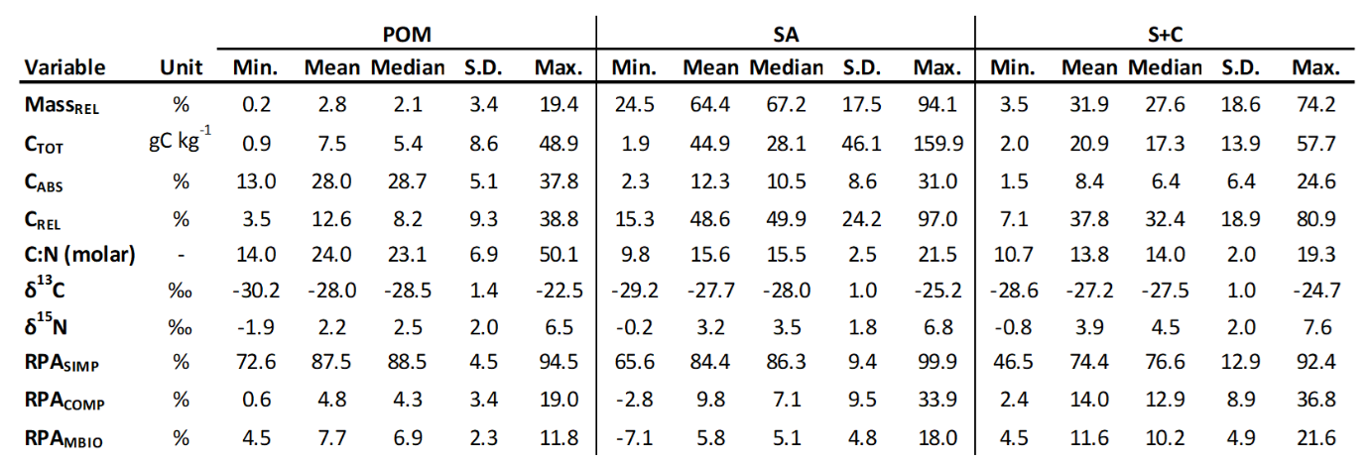
Table S8. Summary of quantitative and qualitative SOC data of the three isolated fractions. Shown without outliers, which were removed based on Cochran’s C test. Thus, DRIFTS-values n_{SA} = 35, n_{S+C} = 34, n_{POM} = 28; else n = 35.

