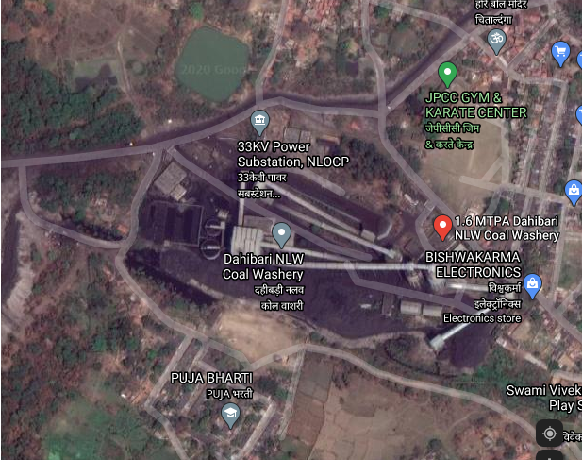

Thickener at Dahibari Washery

Figure 1: Satellite view of Dahibari coal washery

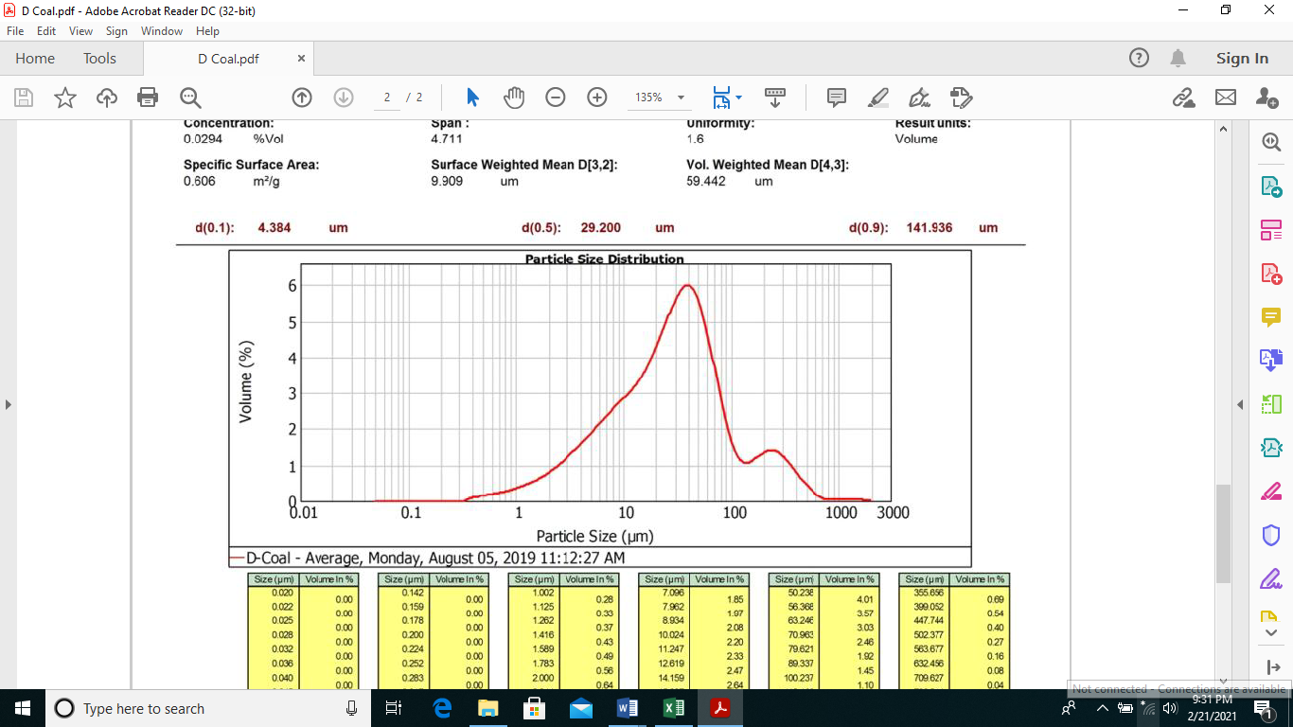
Fig: 2a
Figure 2b: Cumulative particle size distribution plot for Dahibari effluent coal
Figure 2a: Particle size distribution plot for Dahibari effluent coal (Using Malvern Particle Size Analyser)

Figure 3: Zeta Potential profile for Dahibari washery effluent

Fig: 4
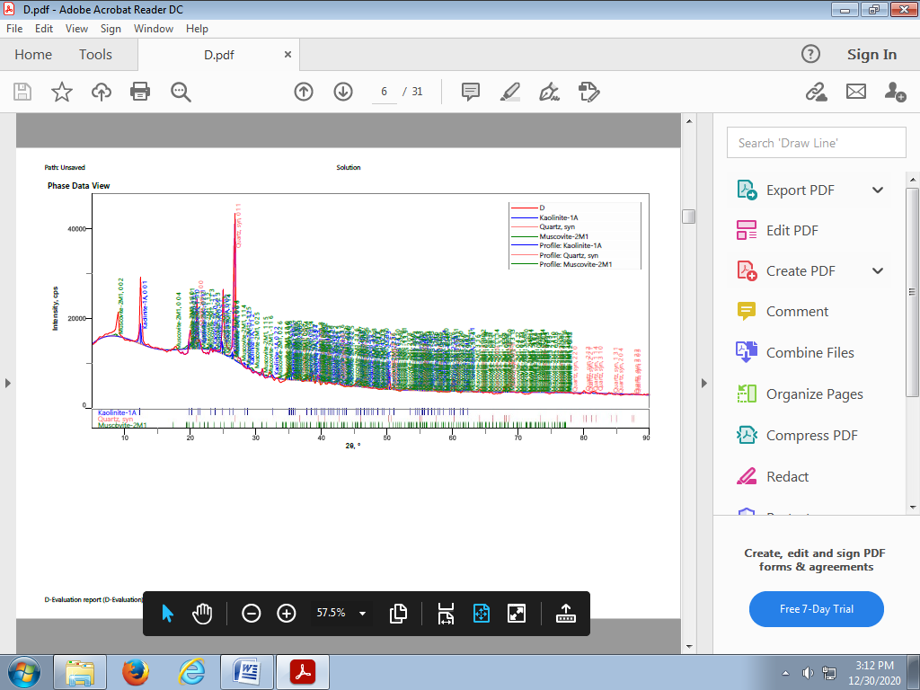

Figure 4: X-ray diffractogram (XRD) of Dahibari effluent coal

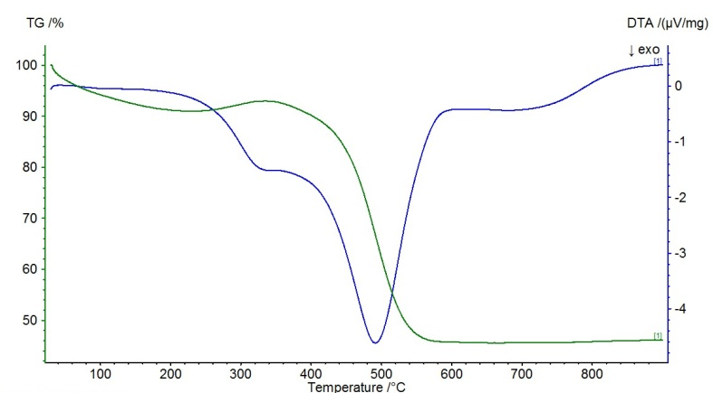
Fig: 5

Figure 5: TG-DTA plot of Dahibari effluent coal

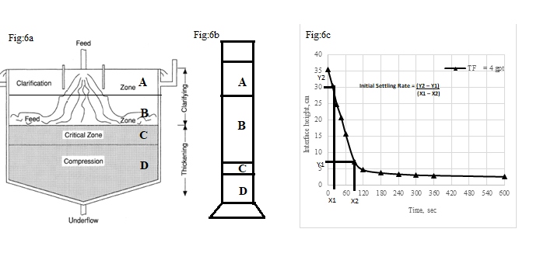
Figure 6: (a) Typical zones in thickener (Source: doi:10.1615/AtoZ.t.thickeners)
(b) Zone comparison in Jar test
(c) Plot showing settling curve and estimation of initial settling rate as a typical example at 4gpt with TF

Figure 7 (a to c): Effect of variables on settling rates (a) at natural pH of 8.72 (b) at acidic pH of 4.0 (c) at alkaline pH of 11.0

Figure 8 (a to c): Turbidity removal analogous to initial settling rate at natural pH = 8.72 for (a) Telfloc-3674F (b) Magna-1011 and (c) Nalco-83370⁺ flocculants
Figure 8 (d to f): Turbidity removal analogous to initial settling rate at acidic pH = 4.0 for (d) Telfloc-3674F (e) Magna-1011 and (f) Nalco-83370⁺ flocculants

Figure 8 (g to i): Turbidity removal analogous to initial settling rate at acidic pH = 11.0 for (g) Telfloc-3674F (h) Magna-1011 and (i) Nalco-83370⁺ flocculants

Figure 10 (a to c): The second order kinetic rate plots for (a) Telfloc-3674F dosage (TFD), (b) Magna-1011 dosage (MFD) and (c) Nalco-83370⁺ dosage (NFD)
Figure 9 (a to c): The settling curves for (a) Telfloc-3674F dosage (TFD), (b) Magna-1011 dosage (MFD) and (c) Nalco-83370⁺ dosage (NFD)
Figure 11 (a to c): The second order kinrtic rate plots

Figure 11g: Variation in settling rate constant (Slope K₂) with flocculants

Figure 12 (a & b): Comparative analysis of Particle size of Dahibari effluent coal & coal flocs (a) percent Volume peak (b) D10, D50 and D90 particle size

Figure 13: FTIR spectra of Dahibari effluent coal before and after polymer flocculation

