Saroja M completed B.sc computer science in sarah tucker college (Autonomous), Tirunelveli, Tamilnadu in 2021. She completed M.sc computer science in sarah tucker college (Autonomous), Tirunelveli, Tamilnadu in 2023. Her research interests include Machine learning and deep learning.

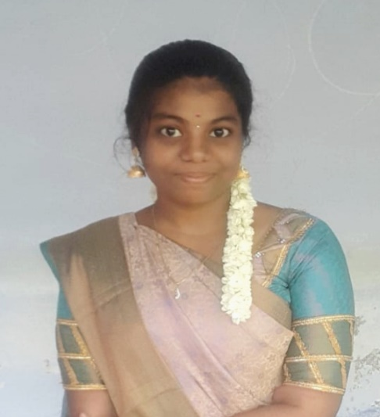

Dr. Ani Brown Mary N completed B.E Computer science and Engineering in Infant College of Engineering, Tuticorin, Tamilnadu in 2009. She completed M.E Computer science and Engineering in Regional Campus, Anna University, Chennai in 2013. She completed Ph.D in Information and Communication Engineering, Regional Campus, Anna University, Chennai. She has teaching experience of more than 8 years. Her research interests include IMAGE PROCESSING, cloud computing and DEEP LEARNING. She has published many papers in International Conferences and reputed journals. She also has published two chapters and a book. She has published an Indian patent.
