Table 1 Detail information of samples.

Table S1 Detail information of samples.
Samples | Classification | Number | Origin
Gastrodia elata | Cultivated | 51 | Deqin County, Diqing Prefecture, Yunnan Province
Gastrodia elata | Cultivated | 58 | Yiliang County, Zhaotong City, Yunnan Province
Gastrodia elata | Wild | 63 | Dongshan Town, Qilin District, Qujing City, Yunnan Province

Figure S1. Confusion matrix plots for PLS-DA models with 9 data sets.
Figure S2. Plots of training set hyperplane and test set classification results for SVM models with 9 data sets (A: RAW; B: first-order derivative (1D) ; C: second-order derivative (2D); D: standard normal variate transformation (SNV); E: multiplicative scattering correction (MSC); F: Savitzky-Golay; G: SNV+2D; H: MSC+2D; I: SG+2D).
Figure S3. Plots of R² and Q² relationships for the PLS-DA model after 200 permutation tests.
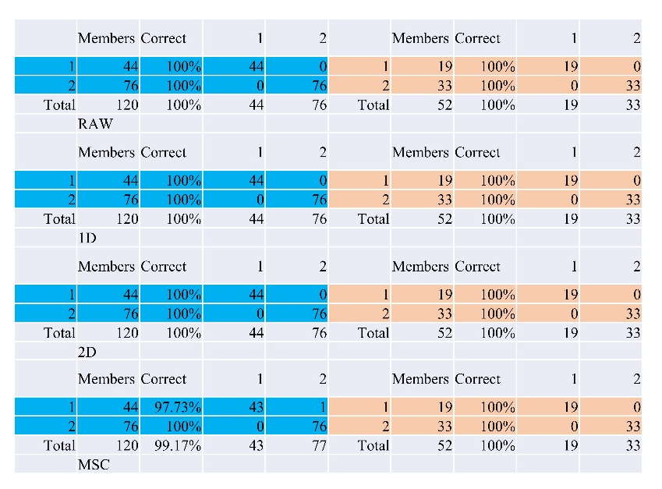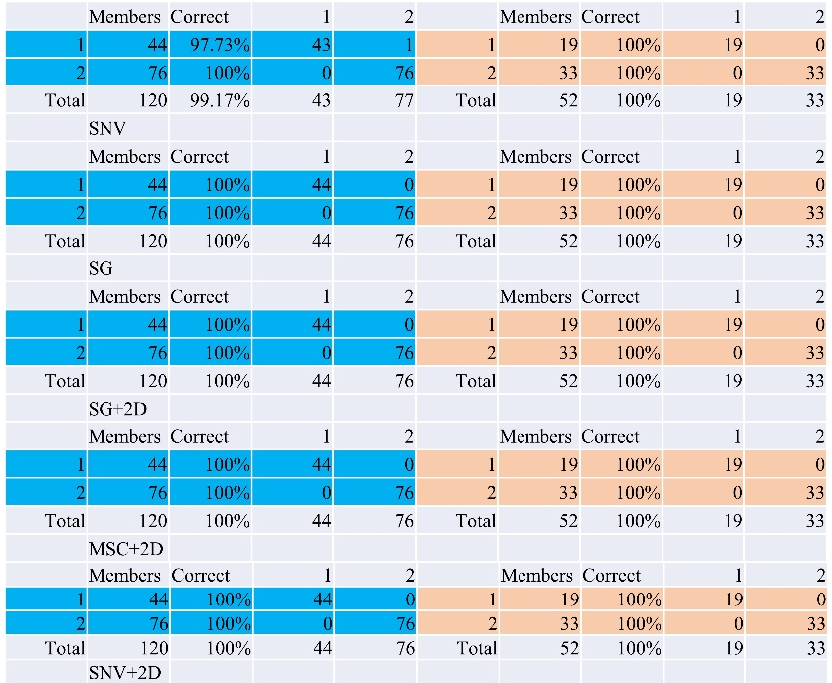
Figure S1. Confusion matrix plots for PLS-DA models with 9 data sets.
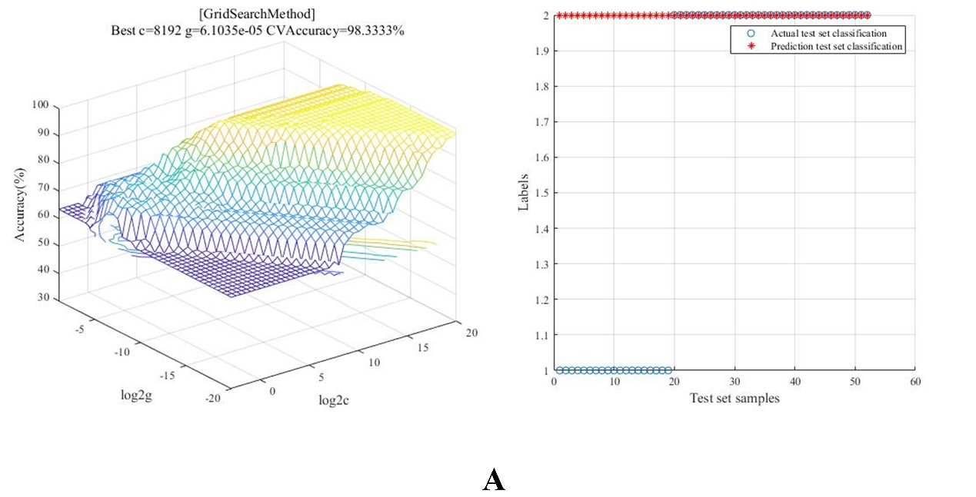
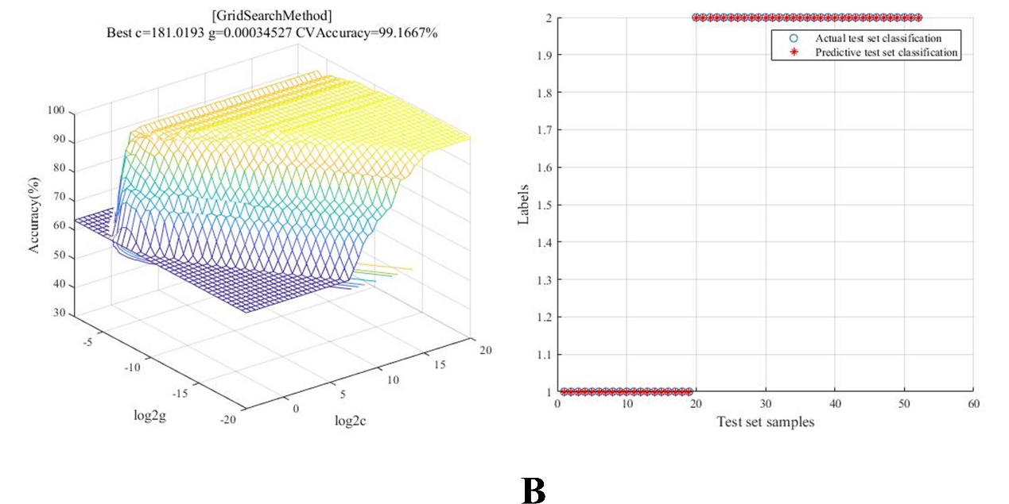
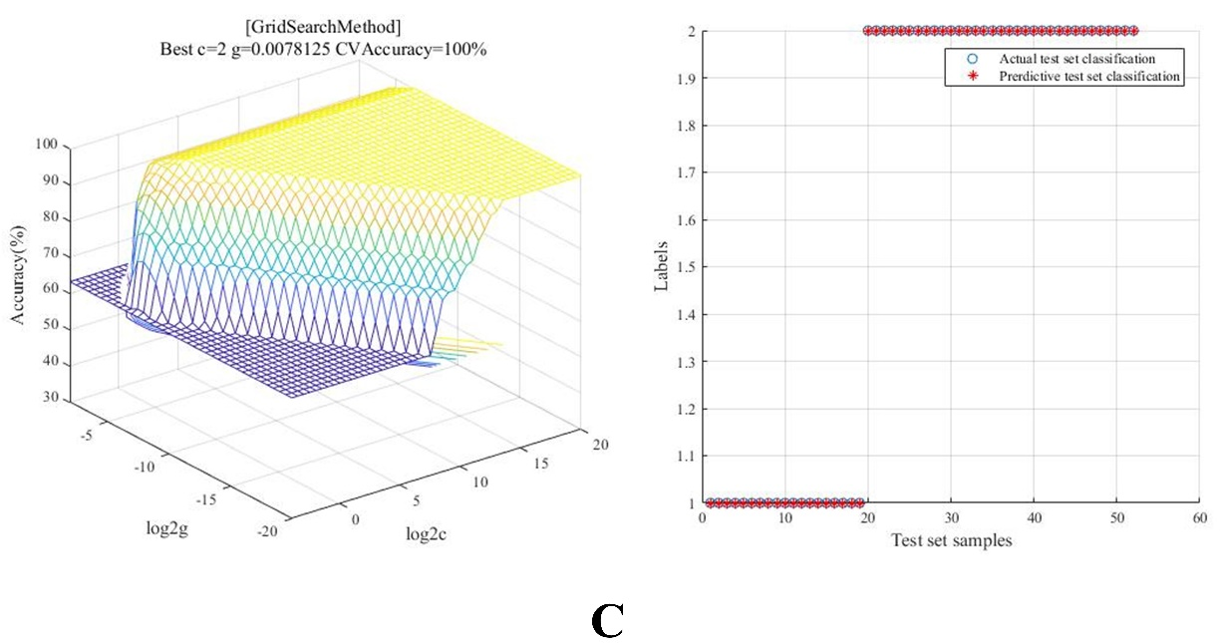
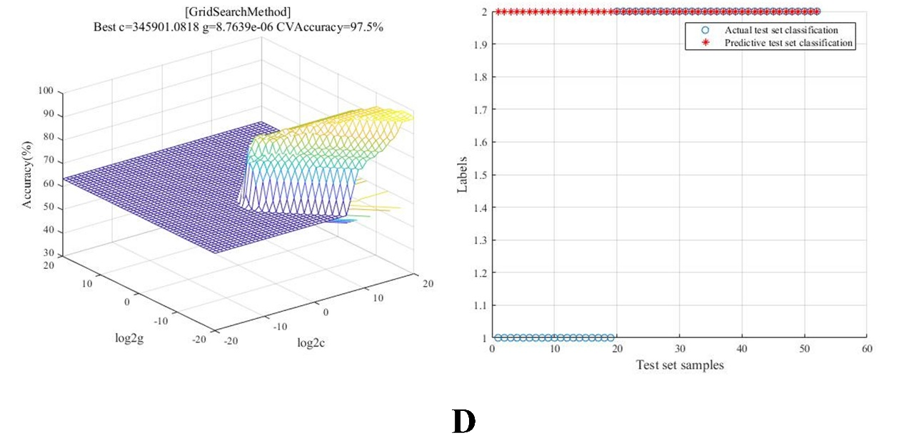
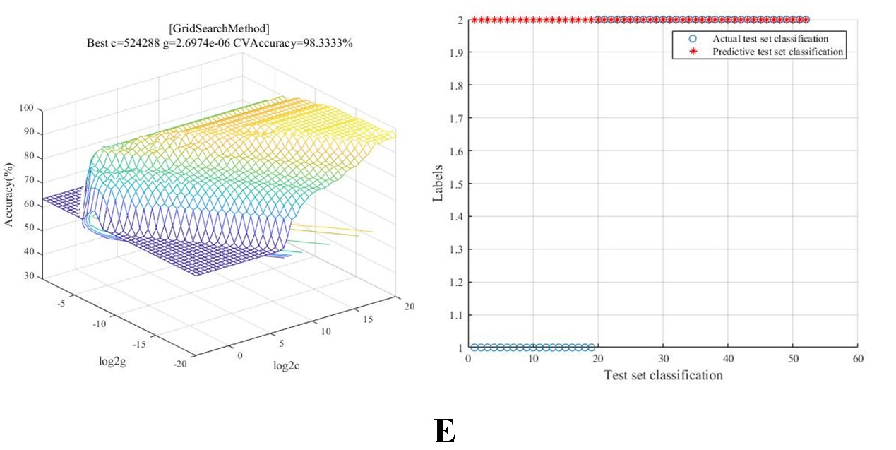
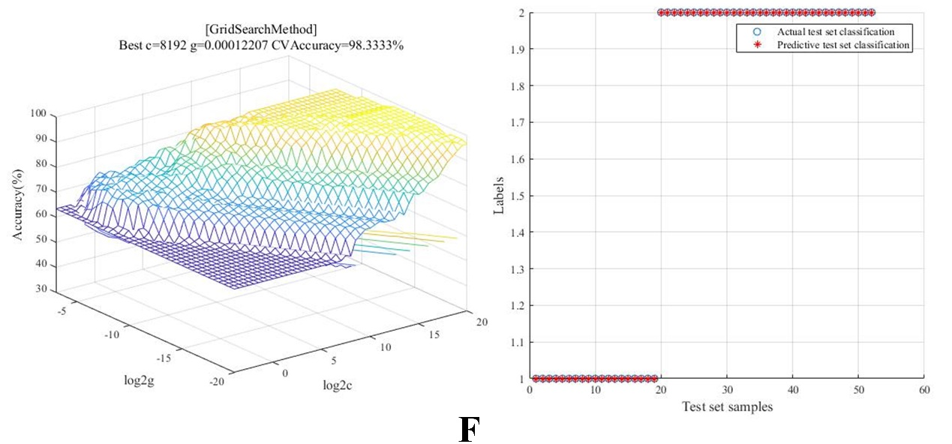
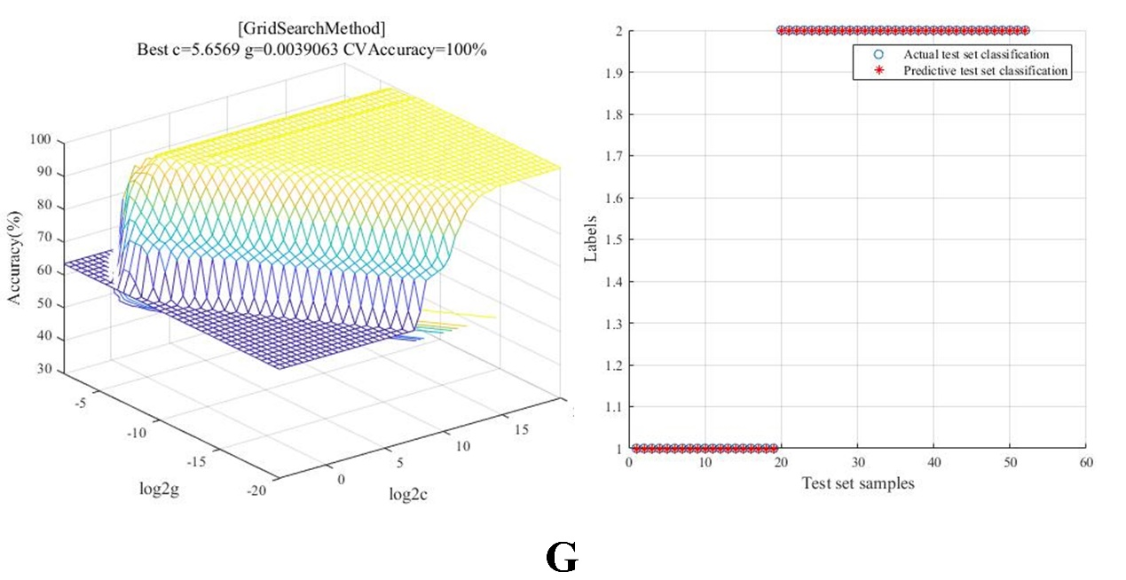
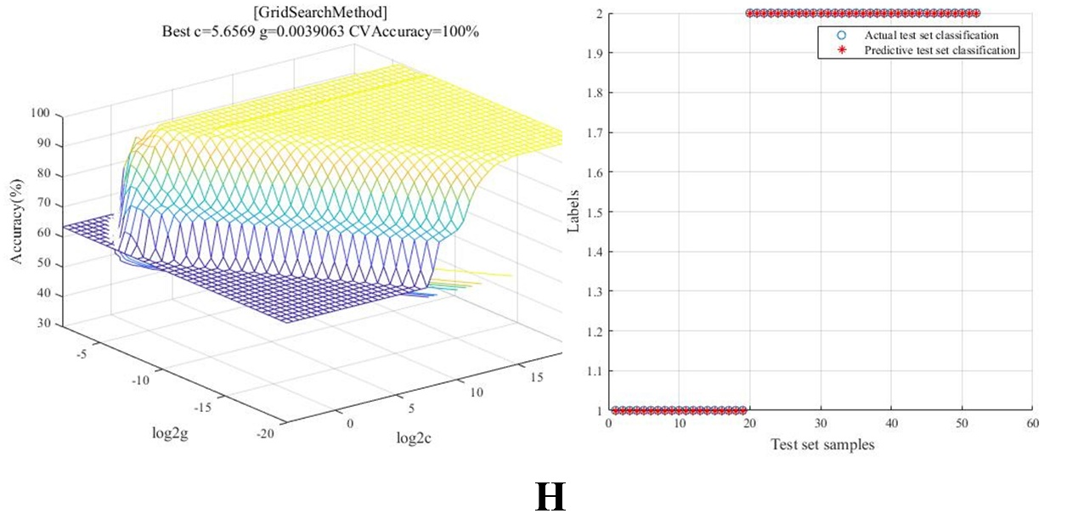
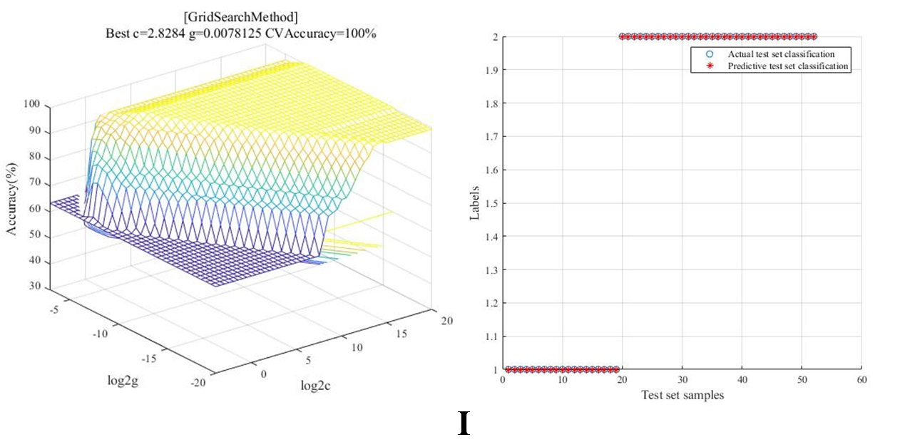
Figure S2. Plots of training set hyperplane and test set classification results for SVM models with 9 data sets (A: RAW; B: first-order derivative (1D) ; C: second-order derivative (2D); D: standard normal variate transformation (SNV); E: multiplicative scattering correction (MSC); F: Savitzky-Golay; G: SNV+2D; H: MSC+2D; I: SG+2D).
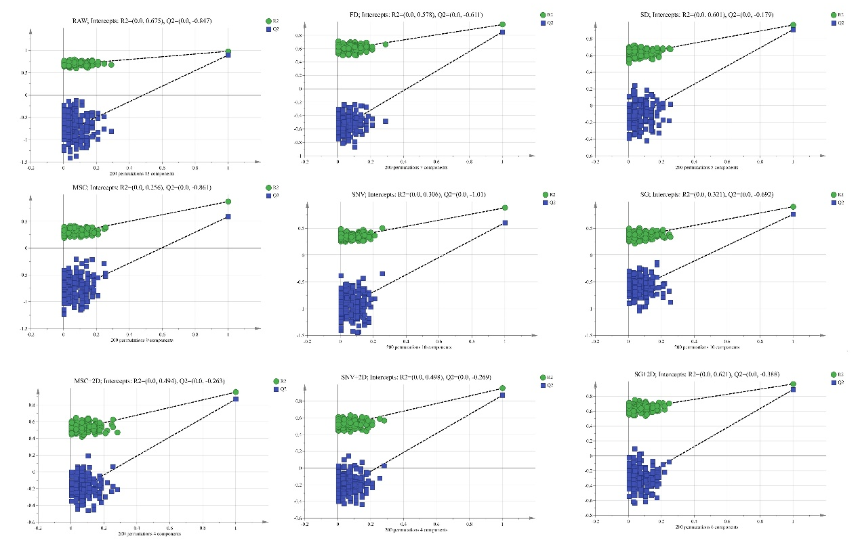
Figure S3. Plots of R² and Q² relationships for the PLS-DA model after 200 permutation tests

