Table S1. Primer sequences used RT-PCR

Gene Name | Forward primers | Reverse primers
PtrPPO9 | TCCCTCATCTTATAAAAAGGGCCTC | AGGACATCCCTTCTCGTGGA
PtrPPO11 | GCAGTGAAGGTGTGAGTGGC | TACGGGCGACTTCTAGTGGA
PtrPPO13 | CGAACTGACCTGACTGACCC | TGGCCTGGATTGTAGCCAAG
PtrPPO14 | CCTGTTGTCATCTCTGGCGTTA | ACATGTTGTTGCCCAATAATAGCA
PtrPPO15 | GCTTTGGTGCCCAGGTCTAA | AGGTGGACATTCACTCTTTAACAA

Table S2. Accession numbers of gene
Species | Name | Accession numbers
Aquilegia coerulea | AqcPPO1 | Aqcoe1G318200
Aquilegia coerulea | AqcPPO2 | Aqcoe1G318300
Aquilegia coerulea | AqcPPO3 | Aqcoe1G318400
Aquilegia coerulea | AqcPPO4 | Aqcoe2G240400
Ananas comosus | AcPPO1 | Aco014845
Ananas comosus | AcPPO2 | Aco014847
Ananas comosus | AcPPO3 | Aco014848
Ananas comosus | AcPPO4 | Aco014850
Amaranthus hypochondriacus | AhPPO1 | AHYPO_004163
Amaranthus hypochondriacus | AhPPO2 | AHYPO_004165
Amaranthus hypochondriacus | AhPPO3 | AHYPO_004166
Amaranthus hypochondriacus | AhPPO4 | AHYPO_008370
Amaranthus hypochondriacus | AhPPO5 | AHYPO_011354
Amaranthus hypochondriacus | AhPPO6 | AHYPO_019806
Carica papaya | CpPPO1 | evm.TU.supercontig_27.43
Carica papaya | CpPPO2 | evm.TU.supercontig_62.169
Cucumis sativus | CsPPO1 | Cucsa.126490
Eucalyptus grandis | EgPPO1 | Eucgr.D00657
Eucalyptus grandis | EgPPO2 | Eucgr.D00659
Eucalyptus grandis | EgPPO3 | Eucgr.L00689
Gossypium raimondii | GrPPO1 | Gorai.006G086400
Gossypium raimondii | GrPPO2 | Gorai.010G151800
Gossypium raimondii | GrPPO3 | Gorai.010G152000
Gossypium raimondii | GrPPO4 | Gorai.010G254900
Kalanchoe fedtschenkoi | KfPPO1 | Kaladp0010s0069
Kalanchoe fedtschenkoi | KfPPO2 | Kaladp1262s0012
Kalanchoe laxiflora | KlPPO1 | Kalax.0092s0048
Kalanchoe laxiflora | KlPPO2 | Kalax.0239s0002
Kalanchoe laxiflora | KlPPO3 | Kalax.0658s0017
Kalanchoe laxiflora | KlPPO4 | Kalax.0856s0002
Linum usitatissimum | LuPPO1 | Lus10038309.g
Musa acuminata | MaPPO1 | GSMUA_Achr7G03560_001
Musa acuminata | MaPPO2 | GSMUA_Achr8G34370_001
Musa acuminata | MaPPO3 | GSMUA_AchrUn_randomG22730_001
Musa acuminata | MaPPO4 | GSMUA_AchrUn_randomG22740_001
Musa acuminata | MaPPO5 | GSMUA_AchrUn_randomG25220_001
Malus domestica | MdPPO1 | MDP0000007676
Malus domestica | MdPPO2 | MDP0000007682
Malus domestica | MdPPO3 | MDP0000173059
Malus domestica | MdPPO4 | MDP0000207799
Malus domestica | MdPPO5 | MDP0000221498
Malus domestica | MdPPO6 | MDP0000234782
Malus domestica | MdPPO7 | MDP0000298729
Malus domestica | MdPPO8 | MDP0000317364
Malus domestica | MdPPO9 | MDP0000478750
Malus domestica | MdPPO10 | MDP0000500159
Malus domestica | MdPPO11 | MDP0000511406
Malus domestica | MdPPO12 | MDP0000609966
Malus domestica | MdPPO13 | MDP0000699845
Malus domestica | MdPPO14 | MDP0000709073
Malus domestica | MdPPO15 | MDP0000744636
Mimulus guttatus | MgPPO1 | Migut.M00642
Mimulus guttatus | MgPPO2 | Migut.M01175
Marchantia polymorpha | MpPPO1 | Mapoly0024s0005
Marchantia polymorpha | MpPPO2 | Mapoly0038s0001
Marchantia polymorpha | MpPPO3 | Mapoly0038s0002
Marchantia polymorpha | MpPPO4 | Mapoly0038s0003
Marchantia polymorpha | MpPPO5 | Mapoly0038s0004
Marchantia polymorpha | MpPPO6 | Mapoly0038s0112
Marchantia polymorpha | MpPPO7 | Mapoly0091s0043
Marchantia polymorpha | MpPPO8 | Mapoly0121s0018
Marchantia polymorpha | MpPPO9 | Mapoly0121s0019
Marchantia polymorpha | MpPPO10 | Mapoly0145s0006
Marchantia polymorpha | MpPPO11 | Mapoly0145s0008
Marchantia polymorpha | MpPPO12 | Mapoly0145s0009
Marchantia polymorpha | MpPPO13 | Mapoly0145s0011
Marchantia polymorpha | MpPPO14 | Mapoly0145s0012
Marchantia polymorpha | MpPPO15 | Mapoly0237s0004
Marchantia polymorpha | MpPPO16 | Mapoly0237s0005
Marchantia polymorpha | MpPPO17 | Mapoly0391s0001
Oryza sativa | OsPPO1 | LOC_Os01g58100
Oryza sativa | OsPPO2 | LOC_Os04g53250
Oryza sativa | OsPPO3 | LOC_Os04g53290
Oryza sativa | OsPPO4 | LOC_Os04g53300
Oropetium thomaeum | OtPPO1 | Oropetium_20150105_01740
Oropetium thomaeum | OtPPO2 | Oropetium_20150105_14050
Oropetium thomaeum | OtPPO3 | Oropetium_20150105_18562
Populus trichocarpa | PtrPPO1 | Potri.001G387900
Populus trichocarpa | PtrPPO2 | Potri.001G388000
Populus trichocarpa | PtrPPO3 | Potri.001G388100
Populus trichocarpa | PtrPPO4 | Potri.001G388200
Populus trichocarpa | PtrPPO5 | Potri.001G388300
Populus trichocarpa | PtrPPO6 | Potri.001G388400
Populus trichocarpa | PtrPPO7 | Potri.001G388600
Populus trichocarpa | PtrPPO8 | Potri.001G388800
Populus trichocarpa | PtrPPO9 | Potri.001G388900
Populus trichocarpa | PtrPPO10 | Potri.004G038500
Populus trichocarpa | PtrPPO11 | Potri.004G156500
Populus trichocarpa | PtrPPO12 | Potri.011G047200
Populus trichocarpa | PtrPPO13 | Potri.011G047300
Populus trichocarpa | PtrPPO14 | Potri.011G108200
Populus trichocarpa | PtrPPO15 | Potri.011G108300
Populus trichocarpa | PtrPPO16 | Potri.T061900
Populus trichocarpa | PtrPPO17 | Potri.T062100
Populus trichocarpa | PtrPPO18 | Potri.T062200
Panicum virgatum | PvPPO1 | Pavir.J28528
Panicum virgatum | PvPPO2 | Pavir.Fb00567
Ricinus communis | RcPPO1 | 29851.t000009
Sorghum bicolor | SbPPO1 | Sobic.003G310400
Sorghum bicolor | SbPPO2 | Sobic.006G181300
Sorghum bicolor | SbPPO3 | Sobic.007G068300
Sorghum bicolor | SbPPO4 | Sobic.007G068500
Sorghum bicolor | SbPPO5 | Sobic.007G068700
Sorghum bicolor | SbPPO6 | Sobic.010G192700
Sphagnum fallax | SfPPO1 | Sphfalx0022s0057
Sphagnum fallax | SfPPO2 | Sphfalx0048s0110
Sphagnum fallax | SfPPO3 | Sphfalx0310s0011
Sphagnum fallax | SfPPO4 | Sphfalx0213s0034
Solanum lycopersicum | SlPPO1 | Solyc02g078650.2
Solanum lycopersicum | SlPPO2 | Solyc08g074620.1
Solanum lycopersicum | SlPPO3 | Solyc08g074630.1
Solanum lycopersicum | SlPPO4 | Solyc08g074640.1
Solanum lycopersicum | SlPPO5 | Solyc08g074650.2
Solanum lycopersicum | SlPPO6 | Solyc08g074680.2
Solanum lycopersicum | SlPPO7 | Solyc08g074690.2
Spirodela polyrhiza | SpiPPO1 | Spipo0G0115000
Spirodela polyrhiza | SpiPPO2 | Spipo24G0018500
Spirodela polyrhiza | SpiPPO3 | Spipo24G0018800
Spirodela polyrhiza | SpiPPO4 | Spipo24G0019000
Spirodela polyrhiza | SpiPPO5 | Spipo25G0004100
Spirodela polyrhiza | SpiPPO6 | Spipo25G0004200
Salix purpurea | SpPPO1 | SapurV1A.0044s0470
Salix purpurea | SpPPO2 | SapurV1A.0064s0010
Salix purpurea | SpPPO3 | SapurV1A.0064s0020
Salix purpurea | SpPPO4 | SapurV1A.0064s0030
Salix purpurea | SpPPO5 | SapurV1A.0064s0040
Salix purpurea | SpPPO6 | SapurV1A.0064s0050
Salix purpurea | SpPPO7 | SapurV1A.0064s0060
Salix purpurea | SpPPO8 | SapurV1A.0299s0070
Salix purpurea | SpPPO9 | SapurV1A.0721s0060
Salix purpurea | SpPPO10 | SapurV1A.0737s0010
Solanum tuberosum | StPPO1 | PGSC0003DMG400018913
Solanum tuberosum | StPPO2 | PGSC0003DMG400018914
Solanum tuberosum | StPPO3 | PGSC0003DMG400018916
Solanum tuberosum | StPPO4 | PGSC0003DMG400018917
Solanum tuberosum | StPPO5 | PGSC0003DMG400018924
Solanum tuberosum | StPPO6 | PGSC0003DMG400018925
Solanum tuberosum | StPPO7 | PGSC0003DMG400029576

Table S3. Amino acid conserved domain

Gene ID | Pfam ID | From | To | Short name
Q#1 - >PtPPO1 | pfam12143 | 453 | 578 | PPO1_KFDV
Q#1 - >PtPPO1 | pfam00264 | 159 | 367 | Tyrosinase
Q#1 - >PtPPO1 | pfam12142 | 377 | 428 | PPO1_DWL
Q#2 - >PtPPO2 | pfam12142 | 47 | 97 | PPO1_DWL
Q#2 - >PtPPO2 | pfam12143 | 110 | 189 | PPO1_KFDV
Q#2 - >PtPPO2 | pfam00264 | 5 | 44 | Tyrosinase
Q#3 - >PtPPO3 | pfam12143 | 393 | 518 | PPO1_KFDV
Q#3 - >PtPPO3 | pfam00264 | 91 | 307 | Tyrosinase
Q#3 - >PtPPO3 | pfam12142 | 317 | 368 | PPO1_DWL
Q#4 - >PtPPO4 | pfam12143 | 453 | 578 | PPO1_KFDV
Q#4 - >PtPPO4 | pfam00264 | 159 | 367 | Tyrosinase
Q#4 - >PtPPO4 | pfam12142 | 377 | 428 | PPO1_DWL
Q#5 - >PtPPO5 | pfam12143 | 313 | 438 | PPO1_KFDV
Q#5 - >PtPPO5 | pfam12142 | 237 | 287 | PPO1_DWL
Q#5 - >PtPPO5 | pfam00264 | 74 | 227 | Tyrosinase
Q#6 - >PtPPO6 | pfam12143 | 453 | 578 | PPO1_KFDV
Q#6 - >PtPPO6 | pfam00264 | 159 | 367 | Tyrosinase
Q#6 - >PtPPO6 | pfam12142 | 377 | 428 | PPO1_DWL
Q#7 - >PtPPO7 | pfam12143 | 453 | 578 | PPO1_KFDV
Q#7 - >PtPPO7 | pfam00264 | 159 | 367 | Tyrosinase
Q#7 - >PtPPO7 | pfam12142 | 377 | 428 | PPO1_DWL
Q#8 - >PtPPO8 | pfam12143 | 453 | 578 | PPO1_KFDV
Q#8 - >PtPPO8 | pfam00264 | 159 | 367 | Tyrosinase
Q#8 - >PtPPO8 | pfam12142 | 377 | 428 | PPO1_DWL
Q#9 - >PtPPO9 | pfam12143 | 482 | 603 | PPO1_KFDV
Q#9 - >PtPPO9 | pfam00264 | 193 | 400 | Tyrosinase
Q#9 - >PtPPO9 | pfam12142 | 407 | 455 | PPO1_DWL
Q#10 - >PtPPO10 | pfam12143 | 118 | 244 | PPO1_KFDV
Q#11 - >PtPPO11 | pfam00264 | 140 | 357 | Tyrosinase
Q#11 - >PtPPO11 | pfam12143 | 453 | 585 | PPO1_KFDV
Q#11 - >PtPPO11 | pfam12142 | 363 | 413 | PPO1_DWL
Q#12 - >PtPPO12 | pfam12143 | 115 | 240 | PPO1_KFDV
Q#13 - >PtPPO13 | pfam12143 | 460 | 587 | PPO1_KFDV
Q#13 - >PtPPO13 | pfam00264 | 160 | 368 | Tyrosinase
Q#13 - >PtPPO13 | pfam12142 | 374 | 425 | PPO1_DWL
Q#14 - >PtPPO14 | pfam12143 | 430 | 522 | PPO1_KFDV
Q#14 - >PtPPO14 | pfam00264 | 184 | 348 | Tyrosinase
Q#14 - >PtPPO14 | pfam12142 | 358 | 408 | PPO1_DWL
Q#15 - >PtPPO15 | pfam12143 | 433 | 560 | PPO1_KFDV
Q#15 - >PtPPO15 | pfam00264 | 145 | 351 | Tyrosinase
Q#15 - >PtPPO15 | pfam12142 | 361 | 411 | PPO1_DWL
Q#16 - >PtPPO16 | pfam12143 | 453 | 578 | PPO1_KFDV
Q#16 - >PtPPO16 | pfam00264 | 159 | 367 | Tyrosinase
Q#16 - >PtPPO16 | pfam12142 | 377 | 428 | PPO1_DWL
Q#17 - >PtPPO17 | pfam12143 | 417 | 542 | PPO1_KFDV
Q#17 - >PtPPO17 | pfam00264 | 159 | 331 | Tyrosinase
Q#17 - >PtPPO17 | pfam12142 | 341 | 392 | PPO1_DWL
Q#18 - >PtPPO18 | pfam12143 | 453 | 578 | PPO1_KFDV
Q#18 - >PtPPO18 | pfam00264 | 159 | 367 | Tyrosinase
Q#18 - >PtPPO18 | pfam12142 | 377 | 428 | PPO1_DWL

Table S4. Amino acid sequence encode and SeqLogo of the Motif
Motif ID | Amino acid sequence encode | SeqLogo
Motif_1 | ENMGNFYSAGRDPIFYCHHSNVDRMW | 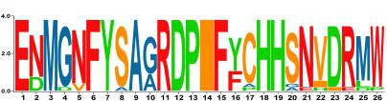
Motif_2 | LDKVISVEVSRPKKSRSATEKEDEDEVLVIEGIEYEENQLIKFDVLVNDE | 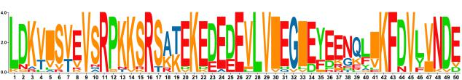
Motif_3 | QIHFSWLFFPWHRLYLYYFERILGKLIDDPTFALPFWNWDAPAGMQMPAI | 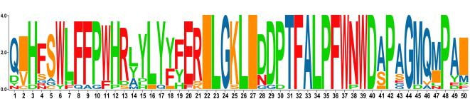
Motif_4 | DWLNSEFLFWDENKELVRVKVKDTLDTKKLRYGFQDVPIPWLKTRATPKL | 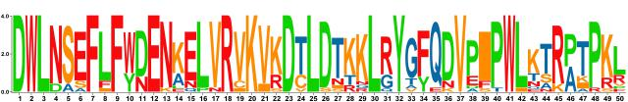
Motif_5 | MKSLPDDDPRSFKSQANVHCAYCDGAYHQ | 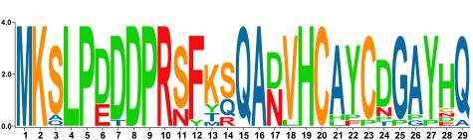
Motif_6 | DPSPGMGTIETTPHTQIHYWTGDPNQTNG | 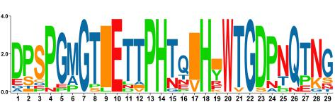
Motif_7 | YANPIAPPDITQCELVTLPTESDPSNCCPPTSTKIKNFEFPSASSPMRIR | 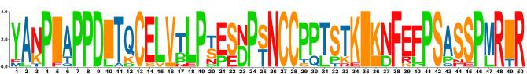
Motif_8 | ANPDPAKAEELYASNLNVMYRQMVSGATKPTLFFGKPYRAG | 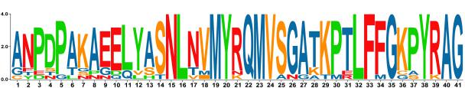
Motif_9 | AKKSKTTMVLGITGLLEDLEAEGDDTLVV | 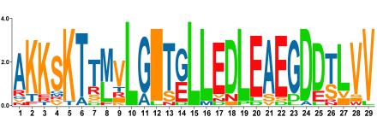
Motif_10 | KTHRVSRIKKPNRHNIPIVSCKSGKNDHEQNPATRRDLLIG | 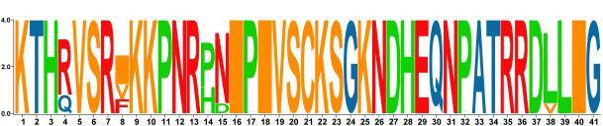

Table S5. Collinear genes among different species

Ptr-Sp | Ptr-Md | Ptr-Os | Ptr-At
PtPPO1(Potri.001G387900) | PtPPO10(Potri.004G038500)
PtPPO10(Potri.004G038500) | PtPPO12(Potri.011G047200)
PtPPO11(Potri.004G156500) | PtPPO13(Potri.011G047300)
PtPPO12(Potri.011G047200)
PtPPO14(Potri.011G108200)

Table S6. Information of functional elements in PPOs gene

GeneID | Element | Sequence | Description
PtrPPO1 | P-box | CCTTTTG | gibberellin-responsive element
PtrPPO1 | TC-rich repeats | ATTCTCTAAC | defense and stress responsiveness
PtrPPO1 | O2-site | GATGATGTGG | zein metabolism regulation
PtrPPO1 | CGTCA-motif | CGTCA | MeJA-responsiveness
PtrPPO1 | TCA-element | CCATCTTTTT | salicylic acid responsiveness
PtrPPO1 | ABRE | ACGTG | abscisic acid responsiveness
PtrPPO1 | TGACG-motif | TGACG | MeJA-responsiveness
PtrPPO2 | ABRE | ACGTG | abscisic acid responsiveness
PtrPPO2 | TGACG-motif | TGACG | MeJA-responsiveness
PtrPPO2 | CGTCA-motif | CGTCA | MeJA-responsiveness
PtrPPO2 | MBS | CAACTG | drought-inducibility
PtrPPO2 | MBS | CAACTG | drought-inducibility
PtrPPO2 | TC-rich repeats | ATTCTCTAAC | defense and stress responsiveness
PtrPPO2 | TC-rich repeats | ATTCTCTAAC | defense and stress responsiveness
PtrPPO2 | TATC-box | TATCCCA | gibberellin-responsiveness
PtrPPO3 | TCA-element | CCATCTTTTT | salicylic acid responsiveness
PtrPPO3 | ABRE | CGCACGTGTC | abscisic acid responsiveness
PtrPPO3 | ABRE | ACGTG | abscisic acid responsiveness
PtrPPO3 | ABRE | ACGTG | abscisic acid responsiveness
PtrPPO3 | TGACG-motif | TGACG | MeJA-responsiveness
PtrPPO3 | TGACG-motif | TGACG | MeJA-responsiveness
PtrPPO3 | LTR | CCGAAA | low-temperature responsiveness
PtrPPO3 | CGTCA-motif | CGTCA | MeJA-responsiveness
PtrPPO3 | CGTCA-motif | CGTCA | MeJA-responsiveness
PtrPPO4 | ABRE | CGCACGTGTC | abscisic acid responsiveness
PtrPPO4 | ABRE | ACGTG | abscisic acid responsiveness
PtrPPO4 | TCA-element | CCATCTTTTT | salicylic acid responsiveness
PtrPPO5 | TATC-box | TATCCCA | gibberellin-responsiveness
PtrPPO5 | TATC-box | TATCCCA | gibberellin-responsiveness
PtrPPO5 | P-box | CCTTTTG | gibberellin-responsive element
PtrPPO5 | MBS | CAACTG | drought-inducibility
PtrPPO5 | TC-rich repeats | GTTTTCTTAC | defense and stress responsiveness
PtrPPO5 | CGTCA-motif | CGTCA | MeJA-responsiveness
PtrPPO5 | CGTCA-motif | CGTCA | MeJA-responsiveness
PtrPPO5 | ABRE | ACGTG | abscisic acid responsiveness
PtrPPO5 | ABRE | ACGTG | abscisic acid responsiveness
PtrPPO5 | TGACG-motif | TGACG | MeJA-responsiveness
PtrPPO5 | TGACG-motif | TGACG | MeJA-responsiveness
PtrPPO5 | TCA-element | TCAGAAGAGG | salicylic acid responsiveness
PtrPPO5 | LTR | CCGAAA | low-temperature responsiveness
PtrPPO5 | RY-element | CATGCATG | seed-specific regulation
PtrPPO6 | ABRE | ACGTG | abscisic acid responsiveness
PtrPPO6 | TCA-element | CCATCTTTTT | salicylic acid responsiveness
PtrPPO6 | MSA-like | (T/C)C(T/C)AACGG(T/C)(T/C)A | cell cycle regulation
PtrPPO6 | GARE-motif | TCTGTTG | gibberellin-responsive element
PtrPPO7 | CGTCA-motif | CGTCA | MeJA-responsiveness
PtrPPO7 | TCA-element | CCATCTTTTT | salicylic acid responsiveness
PtrPPO7 | TGACG-motif | TGACG | MeJA-responsiveness
PtrPPO7 | ABRE | ACGTG | abscisic acid responsiveness
PtrPPO7 | ABRE | ACGTG | abscisic acid responsiveness
PtrPPO8 | P-box | CCTTTTG | gibberellin-responsive element
PtrPPO8 | MBSI | aaaAaaC(G/C)GTTA | flavonoid biosynthetic genes regulation
PtrPPO8 | O2-site | GATGACATGG | zein metabolism regulation
PtrPPO8 | TC-rich repeats | GTTTTCTTAC | defense and stress responsiveness
PtrPPO8 | CGTCA-motif | CGTCA | MeJA-responsiveness
PtrPPO8 | CGTCA-motif | CGTCA | MeJA-responsiveness
PtrPPO8 | TGACG-motif | TGACG | MeJA-responsiveness
PtrPPO8 | TGACG-motif | TGACG | MeJA-responsiveness
PtrPPO8 | ABRE | ACGTG | abscisic acid responsiveness
PtrPPO8 | TCA-element | CCATCTTTTT | salicylic acid responsiveness
PtrPPO8 | RY-element | CATGCATG | seed-specific regulation
PtrPPO8 | LTR | CCGAAA | low-temperature responsiveness
PtrPPO9 | P-box | CCTTTTG | gibberellin-responsive element
PtrPPO9 | P-box | CCTTTTG | gibberellin-responsive element
PtrPPO9 | TGA-element | AACGAC | auxin-responsive element
PtrPPO9 | ABRE | ACGTG | abscisic acid responsiveness
PtrPPO9 | ABRE | GACACGTGGC | abscisic acid responsiveness
PtrPPO9 | CAT-box | GCCACT | meristem expression
PtrPPO10 | GCN4_motif | TGAGTCA | endosperm expression
PtrPPO10 | CAT-box | GCCACT | meristem expression
PtrPPO10 | CAT-box | GCCACT | meristem expression
PtrPPO10 | CGTCA-motif | CGTCA | MeJA-responsiveness
PtrPPO10 | CGTCA-motif | CGTCA | MeJA-responsiveness
PtrPPO10 | TGACG-motif | TGACG | MeJA-responsiveness
PtrPPO10 | TGACG-motif | TGACG | MeJA-responsiveness
PtrPPO10 | ABRE | ACGTG | abscisic acid responsiveness
PtrPPO10 | RY-element | CATGCATG | seed-specific regulation
PtrPPO10 | P-box | CCTTTTG | gibberellin-responsive element
PtrPPO10 | P-box | CCTTTTG | gibberellin-responsive element
PtrPPO10 | MBS | CAACTG | drought-inducibility
PtrPPO10 | TC-rich repeats | GTTTTCTTAC | defense and stress responsiveness
PtrPPO11 | TC-rich repeats | ATTCTCTAAC | defense and stress responsiveness
PtrPPO11 | O2-site | GTTGACGTGA | zein metabolism regulation
PtrPPO11 | TCA-element | CCATCTTTTT | salicylic acid responsiveness
PtrPPO11 | TGACG-motif | TGACG | MeJA-responsiveness
PtrPPO11 | TGACG-motif | TGACG | MeJA-responsiveness
PtrPPO11 | ABRE | ACGTG | abscisic acid responsiveness
PtrPPO11 | ABRE | AACCCGG | abscisic acid responsiveness
PtrPPO11 | ABRE | GCCGCGTGGC | abscisic acid responsiveness
PtrPPO11 | CGTCA-motif | CGTCA | MeJA-responsiveness
PtrPPO11 | CGTCA-motif | CGTCA | MeJA-responsiveness
PtrPPO12 | TCA-element | CCATCTTTTT | salicylic acid responsiveness
PtrPPO12 | ABRE | ACGTG | abscisic acid responsiveness
PtrPPO12 | ABRE | ACGTG | abscisic acid responsiveness
PtrPPO12 | ABRE | ACGTG | abscisic acid responsiveness
PtrPPO12 | LTR | CCGAAA | low-temperature responsiveness
PtrPPO13 | TCA-element | CCATCTTTTT | salicylic acid responsiveness
PtrPPO13 | ABRE | AACCCGG | abscisic acid responsiveness
PtrPPO13 | ABRE | CACGTG | abscisic acid responsiveness
PtrPPO13 | ABRE | ACGTG | abscisic acid responsiveness
PtrPPO13 | ABRE | ACGTG | abscisic acid responsiveness
PtrPPO13 | TGACG-motif | TGACG | MeJA-responsiveness
PtrPPO13 | CAT-box | GCCACT | meristem expression
PtrPPO13 | CAT-box | GCCACT | meristem expression
PtrPPO13 | CGTCA-motif | CGTCA | MeJA-responsiveness
PtrPPO13 | TGA-element | AACGAC | auxin-responsive element
PtrPPO13 | P-box | CCTTTTG | gibberellin-responsive element
PtrPPO13 | P-box | CCTTTTG | gibberellin-responsive element
PtrPPO13 | TC-rich repeats | GTTTTCTTAC | defense and stress responsiveness
PtrPPO13 | TC-rich repeats | GTTTTCTTAC | defense and stress responsiveness
PtrPPO13 | GC-motif | CCCCCG | anoxic specific inducibility
PtrPPO14 | TGACG-motif | TGACG | MeJA-responsiveness
PtrPPO14 | TGACG-motif | TGACG | MeJA-responsiveness
PtrPPO14 | TGACG-motif | TGACG | MeJA-responsiveness
PtrPPO14 | CGTCA-motif | CGTCA | MeJA-responsiveness
PtrPPO14 | CGTCA-motif | CGTCA | MeJA-responsiveness
PtrPPO14 | CGTCA-motif | CGTCA | MeJA-responsiveness
PtrPPO14 | GCN4_motif | TGAGTCA | endosperm expression
PtrPPO14 | CAT-box | GCCACT | meristem expression
PtrPPO14 | O2-site | GATGACATGG | zein metabolism regulation
PtrPPO14 | MBS | CAACTG | drought-inducibility
PtrPPO14 | MBS | CAACTG | drought-inducibility
PtrPPO14 | P-box | CCTTTTG | gibberellin-responsive element
PtrPPO15 | O2-site | GTTGACGTGA | zein metabolism regulation
PtrPPO15 | O2-site | GATGA(C/T)(A/G)TG(A/G) | zein metabolism regulation
PtrPPO15 | CGTCA-motif | CGTCA | MeJA-responsiveness
PtrPPO15 | CGTCA-motif | CGTCA | MeJA-responsiveness
PtrPPO15 | HD-Zip 1 | CAAT(A/T)ATTG | palisade mesophyll cells differentiation
PtrPPO15 | ABRE | ACGTG | abscisic acid responsiveness
PtrPPO15 | ABRE | ACGTG | abscisic acid responsiveness
PtrPPO15 | TGACG-motif | TGACG | MeJA-responsiveness
PtrPPO15 | TGACG-motif | TGACG | MeJA-responsiveness
PtrPPO16 | O2-site | GATGACATGG | zein metabolism regulation
PtrPPO16 | TC-rich repeats | GTTTTCTTAC | defense and stress responsiveness
PtrPPO16 | P-box | CCTTTTG | gibberellin-responsive element
PtrPPO16 | LTR | CCGAAA | low-temperature responsiveness
PtrPPO16 | ABRE | ACGTG | abscisic acid responsiveness
PtrPPO16 | TGACG-motif | TGACG | MeJA-responsiveness
PtrPPO16 | TGACG-motif | TGACG | MeJA-responsiveness
PtrPPO16 | TCA-element | CCATCTTTTT | salicylic acid responsiveness
PtrPPO16 | CGTCA-motif | CGTCA | MeJA-responsiveness
PtrPPO16 | CGTCA-motif | CGTCA | MeJA-responsiveness
PtrPPO17 | CGTCA-motif | CGTCA | MeJA-responsiveness
PtrPPO17 | ABRE | ACGTG | abscisic acid responsiveness
PtrPPO17 | ABRE | ACGTG | abscisic acid responsiveness
PtrPPO17 | TGACG-motif | TGACG | MeJA-responsiveness
PtrPPO17 | TCA-element | CCATCTTTTT | salicylic acid responsiveness
PtrPPO18 | ABRE | ACGTG | abscisic acid responsiveness
PtrPPO18 | TCA-element | CCATCTTTTT | salicylic acid responsiveness
PtrPPO18 | CAT-box | GCCACT | meristem expression

Table S7. The number of functional elements in PPOs gene
Gene ID | MeJA-responsiveness | salicylic acid responsiveness | abscisic acid responsiveness | drought-inducibility | defense and stress responsiveness | low-temperature responsiveness | zein metabolism regulation | flavonoid biosynthetic genes regulation | gibberellin responsiveness | auxin-responsive | cell cycle regulation | meristem expression | seed-specific regulation | anoxic specific inducibility | endosperm expression | palisade mesophyll cells differentiation
PtrPPO1 | 2 | 1 | 1 | / | 1 | / | 1 | / | 1 | / | / | / | / | / | / | /
PtrPPO2 | 2 | / | 1 | 2 | 2 | / | / | / | 1 | / | / | / | / | / | / | /
PtrPPO3 | 4 | 1 | 3 | / | / | 1 | / | / | / | / | / | / | / | / | / | /
PtrPPO4 | / | 1 | 2 | / | / | / | / | / | / | / | / | / | / | / | / | /
PtrPPO5 | 4 | 1 | 2 | 1 | 1 | 1 | / | / | 3 | / | / | / | 1 | / | / | /
PtrPPO6 | / | 1 | 1 | / | / | / | / | / | 1 | / | 1 | / | / | / | / | /
PtrPPO7 | 2 | 1 | 2 | / | / | / | / | / | / | / | / | / | / | / | / | /
PtrPPO8 | 4 | 1 | 1 | / | 1 | 1 | 1 | 1 | 1 | / | / | / | 1 | / | / | /
PtrPPO9 | / | / | 2 | / | / | / | / | / | 2 | 1 | / | 1 | / | / | / | /
PtrPPO10 | 4 | / | 1 | 1 | 1 | / | / | / | 2 | / | 1 | 2 | / | / | 1 | /
PtrPPO11 | 4 | 1 | 3 | / | 1 | / | 1 | / | / | / | / | / | / | / | / | /
PtrPPO12 | / | 1 | 3 | / | / | 1 | / | / | / | / | / | / | / | / | / | /
PtrPPO13 | 2 | 1 | 4 | / | 2 | / | / | / | 2 | 1 | / | 2 | / | 1 | / | /
PtrPPO14 | 6 | / | / | 2 | / | / | 1 | / | 1 | / | / | 1 | / | / | 1 | /
PtrPPO15 | 4 | / | 2 | / | / | / | 2 | / | / | / | / | / | / | / | / | 1
PtrPPO16 | 4 | 1 | 1 | / | 1 | 1 | 1 | / | 1 | / | / | / | / | / | / | /
PtrPPO17 | 2 | 1 | 2 | / | / | / | / | / | / | / | / | / | / | / | / | /
PtrPPO18 | / | 1 | 1 | / | / | / | / | / | / | / | / | 1 | / | / | / | /

Table S8. Expression of PPOs gene in different plant tissues
GeneID | Twigs-Non-Girdled | Flowers-Dormant | Flowers-Expanded | Leaves-Mature | Flowers-Expanding | Suckers-Whole-Sucker | Petiole-Mature | Buds-Prechilling | Buds-Dormant | Leaves-Freshly-Expanded | Leaves-Non-Girdled | Leaves-Girdled | Seeds-Mature | Leaves-Young-Expanding | Cambium-Phloem-Dormant
PtrPPO1 | -0.77 | 1.29 | 0.29 | -0.12 | 0.37 | 0.75 | -0.69 | -0.68 | -0.46 | 2.00 | 0.18 | 0.12 | 0.85 | 2.14 | -0.96
PtrPPO2 | 0.00 | 0.00 | 0.00 | 0.00 | 0.00 | 0.00 | 0.00 | 0.00 | 0.00 | 0.00 | 0.00 | 0.00 | 0.00 | 0.00 | 0.00
PtrPPO3 | 0.88 | 2.85 | 0.85 | -0.99 | -0.15 | 1.12 | -0.99 | 3.83 | 4.17 | 1.53 | 0.36 | -0.99 | 0.36 | 3.81 | -0.99
PtrPPO4 | -0.63 | 1.66 | -1.45 | -1.60 | -0.18 | 1.53 | -1.16 | 2.51 | 2.83 | 1.90 | -0.73 | -1.73 | 0.54 | 3.69 | -2.24
PtrPPO5 | 0.18 | 1.97 | -1.08 | -1.75 | -0.03 | 1.38 | -1.13 | 2.97 | 3.20 | 1.88 | -0.54 | -0.87 | 0.66 | 3.80 | -2.04
PtrPPO6 | -0.08 | 1.14 | -0.89 | 0.05 | 0.91 | 0.24 | -0.08 | 0.53 | 1.51 | 0.93 | -0.89 | 0.71 | 1.15 | 2.10 | -0.89
PtrPPO7 | 1.56 | 1.88 | 0.00 | 0.00 | 1.18 | 1.12 | 0.00 | 3.13 | 3.40 | 0.00 | 0.00 | 0.00 | 0.00 | 2.81 | 0.00
PtrPPO8 | 0.06 | -0.75 | -0.75 | -0.75 | 0.43 | 0.37 | -0.75 | 0.96 | 0.18 | -0.75 | -0.06 | 0.58 | -0.75 | 1.45 | -0.75
PtrPPO9 | -1.23 | 0.00 | 1.79 | -3.52 | 0.63 | 0.97 | -3.10 | 0.48 | -1.84 | 0.92 | -3.74 | -2.04 | 3.18 | 0.00 | -6.44
PtrPPO10 | 0.08 | -1.16 | 0.89 | 0.33 | -0.08 | -0.37 | -0.08 | -0.29 | -1.73 | -1.25 | -0.31 | 0.57 | 0.72 | -2.04 | -0.89
PtrPPO11 | -1.68 | 2.09 | 0.40 | -0.49 | 1.29 | 1.61 | -2.10 | 1.49 | 1.72 | 2.31 | 1.33 | 0.65 | 0.27 | 0.09 | -3.19
PtrPPO12 | -1.65 | -0.55 | 0.74 | 1.45 | -0.69 | -0.12 | -0.38 | 0.16 | -1.82 | -1.64 | 1.65 | 0.12 | 1.24 | -3.20 | -4.65
PtrPPO13 | 0.88 | 2.50 | 1.82 | -1.60 | 0.70 | 0.64 | -0.13 | 2.39 | -2.62 | -1.89 | -0.08 | -0.95 | 2.23 | -3.82 | -6.39
PtrPPO14 | 0.04 | 0.34 | -1.83 | -0.52 | 0.25 | 4.70 | -1.03 | -1.83 | -0.27 | 6.26 | -1.14 | -0.88 | -0.48 | 4.68 | -0.59
PtrPPO15 | 0.26 | 1.27 | -1.51 | -1.04 | 1.11 | 5.62 | -2.62 | -1.19 | -0.49 | 7.15 | -1.43 | -0.79 | -0.26 | 5.43 | -0.72
PtrPPO16 | 0.01 | 1.06 | -0.01 | -1.55 | 0.08 | 1.11 | -1.55 | 1.39 | 1.44 | 1.26 | -0.57 | -1.55 | -1.55 | 2.57 | -1.55
PtrPPO17 | 0.00 | 0.89 | 0.00 | 0.00 | 0.00 | 0.80 | 0.00 | 1.02 | 1.30 | 0.00 | 0.00 | 0.00 | 0.00 | 1.49 | 0.00
PtrPPO18 | 1.02 | 2.85 | -0.55 | -2.09 | -0.46 | 1.82 | -2.09 | 4.37 | 4.33 | 2.32 | -1.39 | -1.14 | -0.05 | 5.39 | -2.09

GeneID | Leaves-Beetle-  Damaged | Leaves-Mechanical-  Damage | Leaves-  Drought | Roots-  Drought
PtrPPO1 | 1.27 | 1.23 | -0.61 | -1.25
PtrPPO2 | 0.00 | 0.00 | 0.00 | 0.00
PtrPPO3 | -0.08 | 0.94 | -0.05 | -0.85
PtrPPO4 | 0.05 | 0.51 | 0.01 | -1.56
PtrPPO5 | -0.39 | 0.22 | -0.30 | -1.35
PtrPPO6 | 0.84 | 1.22 | 0.00 | 0.00
PtrPPO7 | -0.91 | 0.56 | -0.91 | 0.00
PtrPPO8 | 0.84 | 1.22 | 0.00 | -1.44
PtrPPO9 | -0.09 | 0.30 | 4.32 | 0.02
PtrPPO10 | -0.07 | 0.27 | -0.17 | 0.30
PtrPPO11 | -2.27 | -1.86 | -0.65 | -0.61
PtrPPO12 | 0.81 | 0.57 | -0.29 | -1.25
PtrPPO13 | 3.15 | 3.68 | 4.11 | 1.06
PtrPPO14 | -3.14 | -2.99 | -1.26 | -0.66
PtrPPO15 | -3.19 | -3.26 | -1.47 | -1.96
PtrPPO16 | 0.08 | 0.73 | 1.12 | -0.85
PtrPPO17 | 0.84 | 0.00 | 0.00 | 0.00
PtrPPO18 | 0.83 | 1.24 | 0.50 | -1.64

Table S9. Expression of PPOs gene in different treatments

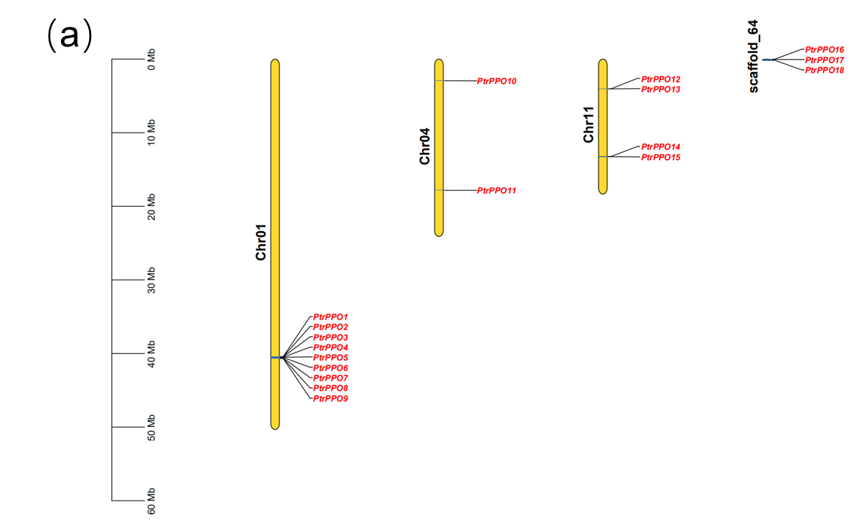

Figure S1 Chromosomal locations of Populus PPO family members. The chromosomal locations of the PPO genes were mapped with MapDraw program.

