Supporting Information for

Superior Activation of Persulfate to Degrade Acetaminophen by MgO incorporated CuO/TiO₂: Pivotal Roles of non-redox MgO in the Regulation of Performance, Surface Properties and Nonradical Mechanism
Wang Jiang,ª Jawad Ali,^{b} Fang Luo,ª Siqi Wang,ª Jia Wang,ª Zhuwei Liao^{*c} and Zhuqi Chen^{*a}
Affiliation:
ª Key Laboratory of Material Chemistry for Energy Conversion and Storage, Ministry of Education; Hubei Key Laboratory of Material Chemistry and Service Failure, School of Chemistry and Chemical Engineering, Huazhong University of Science and Technology, Wuhan 430074, China.
^{b} Wuhan Technology and Business University, School of Environment and Biological Engineering, Wuhan 430065, China.
^{c} Urban Construction Engineering Division, Wenhua College, Wuhan 430074, China.

*Corresponding author:
E-mail address: zqchen@hust.edu.cn (Zhuqi Chen), liaozhuwei@outlook.com (Zhuwei Liao)

List of Tables and Figures

Table S1. EDS spectra data of CuOMgO/TiO₂.
Table S2. Changes in solution pH before and after reaction and metal leaching.
Table S3. Metal leaching of different Cu modified catalysts.
Table S4. LC-MS data for ACT and transformation products (TPs).
Figure S1. Element mapping of CuOMgO/TiO₂. (a) Cu, (b) Mg, (c) O and (d) Ti.
Figure S2. Pores size distribution curves of CuO/TiO₂ and CuOMgO/TiO₂.
Figure S3. Optimization of catalyst preparation conditions. (a, b) Mg²⁺ ion loading, (c, d) calcination temperature.
Figure S4. The pH_{zpc} of CuOMgO/TiO₂.
Figure S5. XPS spectra of CuOMgO/TiO₂ before and after reaction.
Figure S6. Reusability of CuOMgO/TiO₂. (a) ACT degradation over five consecutive runs in CuOMgO/TiO₂/PS, (b) XRD spectra of CuOMgO/TiO₂ before and after reaction.
Figure S7. Influence of DMSO on the degradation of ACT in CuOMgO/TiO₂/PS.
Figure S8. ACT degradation in H₂O and D₂O.
Figure S9. Influence of K₂CrO₄ on the degradation of ACT in CuOMgO/TiO₂/PS.
Figure S10. Solid EPR spectra of CuO, CuOMgO and CuOMgO/TiO₂.

Table S1. EDS spectra data of CuOMgO/TiO_{2.}
Element | Weight (%) | Atomic (%)
Cu | 3.71 | 1.01
Mg | 8.05 | 5.73
O | 41.7 | 45.0
Ti | 10.6 | 3.84

Table S2. Changes in solution pH before and after reaction and metal leaching.
Initial pH | pH after reaction | Cu²⁺ leaching (mg/L) | ACT removal efficiency (%)
3.0 | 4.68 | 1.9 |  | 17.0
5.0 | 7.24 | 0.26 |  | 76.3
7.0 | 7.75 | 0.10 |  | 87.0
8.44 (unadjusted pH) | 7.58 | 0.34 |  | 93.5
9.0 | 7.70 | 0.17 |  | 90.8
10.0 | 8.64 | 0.029 |  | 85.6
11.0 | 10.47 | 0.030 |  | 25.5

Table S3. Metal leaching of different Cu modified catalysts.
Catalyst | ACT removal efficiency (%) | Cu²⁺ leaching (mg/L)
CuO | 1.51 | 0.47
CuOMgO | 55.1 | 0.0060
CuO/TiO₂ | 33.1 | 2.5
CuOMgO/TiO₂ | 93.5 | 0.34
CuOMgO/Kaolin | 91.2 | 0.090
CuOMgO/SBA-15 | 13.1 | 0.020
CuOMgO/ZnO | 52.5 | 0.050
CuOMgO/Al₂O₃ | 80.3 | 0.040
CuOMgO/SiO₂ | 89.3 | 0.080
CuOMgO/MnO₂ | 88.9 | 0.060
CuOMgO/Fe₃O₄ | 82.8 | 0.23

Table S4. LC-MS data for ACT and transformation products (TPs).
Product | Chemical name |  | Molecular structure | Retention time (min) | Experimental mass (m/z)
 | Acetaminophen | 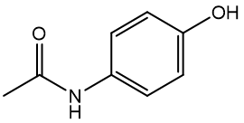 |  | 5.27 | 152.07
TP-59 | Acetamide | 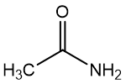 |  | 1.86 | 59.05
TP-111 | Hydroquinone | 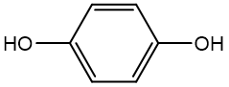 |  | 0.800 | 111.08
TP-101 | N-acetylacetamide |  | 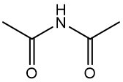 | 7.15 | 101.13
TP-300 | N,N-(5,6-dihydroxy-[1,1'-biphenyl]-2,3'-diyl)diacetamide |  | 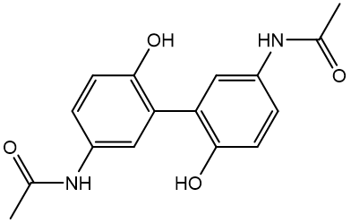 | 9.90 | 300.14
TP-118 | Succinic acid | 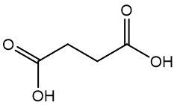 |  | 1.34 | 118.02
TP-110 | 4-aminophenol | 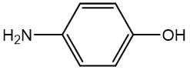 |  | 7.70 | 110.05
TP-60 | Acetic acid | 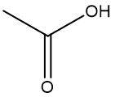 |  | 2.36 | 60.05
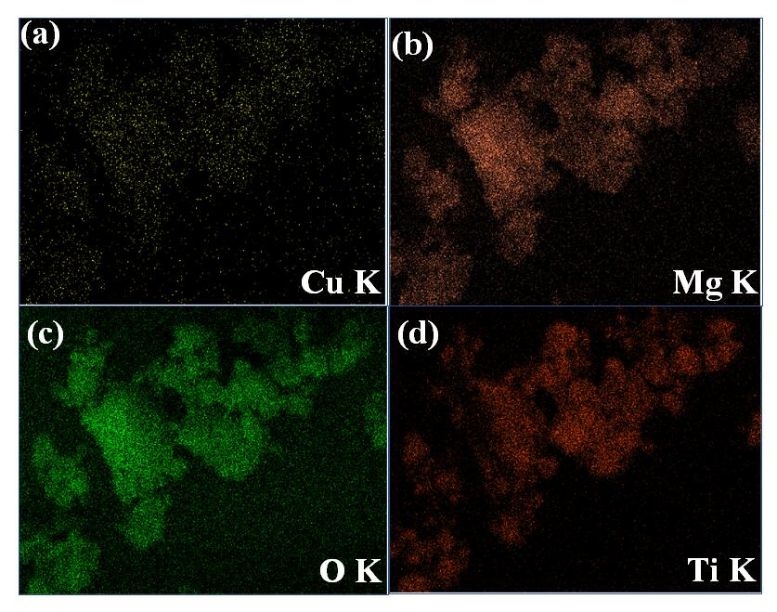

Figure S1. Element mapping of CuOMgO/TiO₂: (a) Cu, (b) Mg, (c) O and (d) Ti.

Figure S2. Pores size distribution curves of CuO/TiO₂ and CuOMgO/TiO₂.

Figure S3. Optimization of catalyst preparation conditions. (a, b) Mg²⁺ ion loading, (c, d) calcination temperature.
Reaction conditions: PS 0.4 mM, catalyst 0.04g/L, ACT 20 mg/L, reaction temperature 30 °C.

Figure S4. The pH_{zpc} of CuOMgO/TiO₂.

Figure S5. XPS spectra of CuOMgO/TiO₂ before and after reaction.

Figure S6. Reusability of CuOMgO/TiO₂. (a) ACT degradation over five consecutive runs in CuOMgO/TiO₂/PS, (b) XRD spectra of CuOMgO/TiO₂ before and after reaction.
Reaction conditions: PS 0.4 mM, catalyst 0.04g/L, ACT 20 mg/L, reaction temperature 30 °C.

Figure S7. Influence of DMSO on the degradation of ACT in CuOMgO/TiO₂/PS.
Reaction conditions: PS 0.4 mM, catalyst 0.04g/L, ACT 20 mg/L, reaction temperature 30 °C.

Figure S8. ACT degradation in H₂O and D₂O,
Reaction conditions: PS 0.4 mM, catalyst 0.04g/L, ACT 20 mg/L, reaction temperature 30 °C.

Figure S9. Influence of K₂CrO₄ on the degradation of ACT in CuOMgO/TiO₂/PS.
Reaction conditions: PS 0.4 mM, catalyst 0.04g/L, ACT 20 mg/L, reaction temperature 30 °C.

Figure S10. Solid EPR spectra of CuO, CuOMgO and CuOMgO/TiO₂.

