Supplementary information

3D model of bronchial epithelial barrier to study xenobiotic repeated exposure: application to silver nanoparticles

Chloé Chivé¹*, Claire Mac-Cord¹*, Daniel Sanchez-Guzman¹, Oliver Brookes¹, Prinitha Joseph¹, René Lai Kuen², Guillaume Phan³, Armelle Baeza-Squiban^{1§}, Stéphanie Devineau^{1#}, Sonja Boland^{1#}

Detailed methods
- Calu-3 cell culture
- Oxidative potential of AgNPs
- Exposure of Calu-3 cells to AgNO₃
- Characterisation of the insert porosity by Raman microscopy
- Epithelial barrier integrity and cell viability
- ELISA and ELLA assays
- RT-qPCR

List of figures
Figure S1. Effect of pseudo-ALI conditions on TEER of the Calu-3 barrier
Figure S2. Effect of 5 repeated exposures to 1 µg/cm² AgNPs on Calu-3 viability and epithelial barrier integrity
Figure S3. Analysis of the porosity of Transwell and Millicell inserts
Figure S4. TEM observations of control Calu-3 cultures at ALI at D11 after 5 repeated exposure to HBSS
Figure S5. Silver concentration in the apical and basal medium measured by ICP-MS
Figure S6. Constitute secretion of IL-6 and IL-8 by Calu-3 cells
Figure S7. Interaction of AgNPs with IL-6
Figure S8. Effect of 5 repeated exposures to 10 µg/cm² AgNPs on MUC5AC expression
Figure S9. Oxidative potential of AgNPs and copper nanoparticles
Figure S10. Effect of AgNO₃ on Calu-3 viability, epithelial barrier integrity and gene expression
Figure S11. Quantitative analysis of the apical secretome of Calu-3 cells after single and repeated exposure to AgNPs

List of tables
Table S1. Sequences of the primers used for RT-qPCR
Table S2. Silver concentration and translocation measured by ICP-MS

Associated files
The complete list of proteins identified in the apical secretome of Calu-3 cells following repeated exposure to AgNPs or HBSS is available in the Excel file WS1.
Detailed Methods
Calu-3 cell culture
Calu-3, human adenocarcinoma epithelial cells, (ATCC® HTB-55TM, LGC standard, Molsheim, France) were used from passage 27 to 34 according to (Sanchez-Guzman et al. 2021). Briefly, Calu-3 cells were grown in Eagle’s Minimum Essential Medium (MEM, Gibco, Thermo Fisher Scientific, Courtaboeuf, France) supplemented with 10% v/v fetal bovine serum (FBS, Sigma-Aldrich), 1% non-essential amino acids (NEAA, Gibco), 1% sodium pyruvate (Gibco), 1% glutamax (Gibco), 1% penicillin streptomycin (Gibco), and 1% HEPES buffer (Gibco). Cell cultures were maintained in 25 or 75 cm² culture flasks (Corning®, Dominique Dutscher, Bernolsheim, France) at 37°C and 5% CO₂. The culture medium was changed every 2-3 days and cells were passaged weekly, before confluence. To obtain an epithelial barrier, Calu-3 cells were seeded either on Millicell® (Millipore, Sigma-Aldrich) or Transwell® (Corning®) inserts with a polyethylene terephthalate (PET) membrane with 3 µm pore diameter and 1.1 cm² surface area. When cultures exhibited TEER > 700 Ω.cm², an air-liquid interface (ALI) was created and the percentage of serum in the basolateral compartment was reduced to 4% FBS one day after ALI.

Oxidative potential of AgNPs
The oxidative potential of AgNPs was determined by measuring the depletion of antioxidants (uric acid (UA), ascorbic acid (AA), and reduced glutathione GSH) following incubation of AgNPs in a simplified synthetic respiratory tract lining fluid (sRTLF) at 37°C for 4 h according to (Crobeddu et al. 2020). Briefly, 1, 5, 10 µg/mL AgNPs were mixed for 4 h at 37°C with sRTLF (200 µM UA, 200 µM AA and 200 µM GSH in 9 g/L NaCl solution pH 7.4). Then the solutions were centrifuged on SpinX 0.2 µm cellulose acetate filters at 12,000 g to remove AgNPs. The antioxidant (UA, AA, GSH) and oxidized glutathione (GSSG) concentrations were analyzed by reverse-phase HPLC on a Kromasil 100-5C18 column using 25 mM sodium phosphate and 0.5 mM octane sulfonic acid for the mobile phase A, and acetonitrile for the mobile phase B. The absorbance of UA, AA, GSH, and GSSG were measured at 280 nm, 243 nm, and 210 nm respectively. The depletion in GSH was confirmed by the formation of oxidized glutathione (GSSG). A sample containing sRTLF only was used as a reference. The depletion in antioxidant was expressed as the ratio between the antioxidant concentration difference between the reference and the sample, divided by the antioxidant concentration of the reference. Copper nanoparticles (CuNP) (Sigma 774111) were used as a positive control.

Exposure of Calu-3 cells to AgNO₃
20 µL of AgNO₃ (Merck Millipore) at 790 µg/mL was used for exposure of Calu-3 cells to obtain a concentration of Ag equivalent to that in 10 µg AgNPs/cm². Cells were exposed twice on D0 and D2. Biological effects were assessed from D0 to D4.

Analysis of the insert porosity by Raman microscopy
The porosity of 3-µm inserts of the different providers (Transwell, Millicell) was characterized by Raman microscopy using an alpha300 R confocal microscope (WITec, Oxford Instruments). The Raman spectra were measured using an excitation wavelength of 532 nm and a grating of 600 g/mm with a 100x objective. The data were analysed using Project 5 Plus software for cosmic ray removal, baseline subtraction, and spectral analysis. Analysis of the Raman spectra shows that both inserts have the same chemical composition (PET). The average pore diameter was automatically analyzed on the Raman images using Fiji software assuming spherical shape. A minimum of 100 pores were analyzed for each insert. The data are presented as mean ± standard deviation. The percentage of single pores and fused pores was determined for each insert.

Epithelial barrier integrity and cell viability

Trans-Epithelial Electrical Resistance (TEER).
TEER was measured with an EVOM2 ohmmeter (World Precision Instruments, Sarasota, USA) and STX2 electrode. HBSS^{Ca2+/Mg2+} at 37°C was added to the basal (1.5 mL) and apical (0.5 mL) compartments. TEER was also measured in a cell-free insert (blank) and its value was subtracted from values measured in cell-seeded inserts. Calu-3 cells form a tight epithelium if TEER > 300 Ω.cm² (Sanchez-Guzman et al. 2021).

Lucifer yellow permeability assay
The Lucifer Yellow (LY) paracellular permeability assay (Sigma-Aldrich) was done according to the manufacturer. Briefly, LY (0.1 mg/mL in HBSS^{Ca2+/Mg2+}) was added to the apical (0.5 mL) compartment and the basal compartment was filled with 1 mL HBSS^{Ca2+/Mg2+}. After 1h incubation, 0.1 mL of the apical and basal solutions were transferred to a 96-well clear bottom microplate (µClear®, Greiner Bio-One, Germany) for fluorescence measurement on a FlexStation 3 multi-mode microplate reader (Molecular Devices, San Jose, California) with excitation and emission wavelengths set at 485 nm and 538 nm. The permeability was calculated according to (Sanchez-Guzman et al. 2021). Calu-3 cells form a tight epithelium if LY permeability <2 %.

Alamar Blue™ assay
1 mL of 10% v/v AlamarBlue™ (AB, Thermo Fisher Scientific) diluted in HBSS^{Ca2+/Mg2+} was added to the basal compartment of control and treated cultures. After 2 h incubation, 150 µL of basal medium were transferred to a 96-well clear bottom microplate (µClear®, Greiner Bio-One, Dominique Dutscher). Fluorescence measurements were carried out on a FlexStation 3 multi-mode microplate reader with 545 nm excitation and 590 nm emission wavelengths.

Lactate Dehydrogenase (LDH) assay
The CytoTox 96® Non-Radioactive Cytotoxicity Assay (Promega, Charbonnières les Bains, France) was used to measure the concentration of lactate dehydrogenase (LDH) in the basal culture medium. Basal media of control and treated cultures were collected and stored at -80 ºC. Samples were analyzed according to the manufacturer’s protocol. Optical density at 490 nm was measured on a UV-vis plate reader (UV-vis Spectrometer reader Bioteck EL808, Bioblock scientific, Illkirch, France) to determine the LDH concentration.
ELISA and ELLA

ELISA
Basal media and apical washes were stored at –80°C to quantify the release of pro-inflammatory cytokines (IL-6 and IL-8) by ELISA assay (DuoSet ELISA kit DY206 and DY208, R&D systems, Bio-Techne, Noyal Chatillon sur Seiche, France) according to the manufacturer’s instructions. Optical density at 450 nm and 595 nm were measured on a plate reader. To check whether AgNPs interfere with the ELISA assay, we mixed a standard solution of 400 pg/mL IL-6 with 10 µg AgNPs in HBSS^{Ca2+/Mg2+} at 37°C for 1h. The solutions were centrifuged at 14,000 g at 4°C for 20 min. The concentration of IL-6 was measured in the supernatant by ELISA and compared to the concentration of the solution without AgNPs.

Enzyme-linked lectin assay (ELLA)
The glycoprotein concentration in the apical secretome was measured by the enzyme-linked lectin assay (ELLA) according to (Sanchez-Guzman et al. 2021). Briefly, 96-well high binding plates were coated with lectin from Triticum vulgaris (Sigma-Aldrich) and washed with 0.5 M NaCl and 0.1% Tween 20 in PBS. Calibration curve was established with Porcine stomach mucin (Sigma-Aldrich). Standards and samples were incubated for 1h at 37°C. Lectin detection was performed with Glycine max peroxidase conjugate (Sigma-Aldrich) by 1h incubation at 37°C. Tetramethylbenzidine (TMB) substrate reagent (R&D systems, Bio-Techne) was added for 20 min and the enzymatic reaction was stopped with 2N H₂SO_{4.} The absorbance was measured at 490 nm on a UV-vis plate reader.
Gene | Forward | Reverse
HO-1 | CGTTCCTGGTCAACATCC | CTGTCGCCACCAGAAAG
IL-6 | TGGTCTTTTGGAGTTTGAGG | CGCAGAATGAGATGAGTTGTC
IL-8 | AGACAGCAGAGCACACAAGC | ATGGTTCCTTCCGGTGGT
MUC5AC | AACTACTCCCAGCCC | GTAGAGGCAGGGGTT
RPL19 | GGCTCGCCTCTAGTGTCCTC | CAAGGTGTTTTTCCGGCATC
MT1X | ACT CCT GCT TCT CCT TGC CTC | TGC ACT TGT CGT ACG TCC CTT
MT2A | TCC TGC AAA TGC AAA GAG TGC | AAA ATC CAG GTT TGT GGA AGT CG
Table S1. Sequences of the primers used for RT-qPCR

RT-qPCR
Cell lysis and RNA collection from control and treated cultures were done using the Nucleospin RNA/Protein Mini kit (Macherey-Nagel, Hoerdt, France) according to manufacturer's instructions. Cells were lysed in situ by addition of 350 µL of the lysis buffer supplemented with 0.5 M dithiothreitol (Sigma-Aldrich) and gentle scraping with the pipette tip to ensure complete dissociation of the cells from the insert membrane. Reverse transcription of the mRNA was performed using multiscribe High-cDNA Capacity RT kits (Applied Biosystems, ThermoFisher Scientific) according to the manufacturer’s instructions. RT-qPCR was done using LightCycler SYBR Green master mix (Roche Diagnostics, Meylan, France) with primers from Eurofins Genomics (Ebersberg, Germany) (Table S1). Reactions were carried out in sealed 384-well plates in a LightCycler 480 thermocycler (Roche Diagnostics). Gene expression was quantified using 2^{-∆∆Ct} method to yield Log₂ fold change of a gene relative to RPL19 as housekeeping gene and normalized to the control at each timepoint.
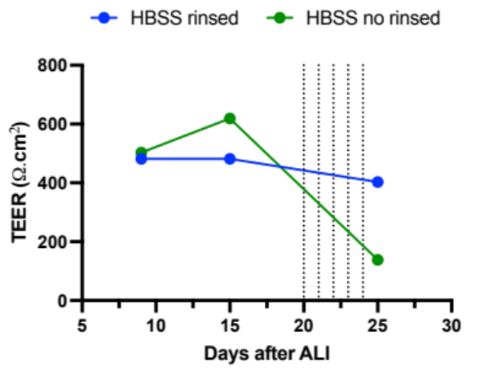
Figure S1. Effect of pseudo-ALI conditions on TEER of the Calu-3 barrier. Control Calu-3 cultures were exposed 5 times to 20 µL HBSS ^{Ca2+/Mg2+} at ALI during 5 days. In one culture (blue), HBSS ^{Ca2+/Mg2+} was removed before each new treatment, as done in the study of control and treated cells. In a second culture (green), HBSS ^{Ca2+/Mg2+} was not collected before the next treatment, leading to a total added volume of 100 µL on the apical side.
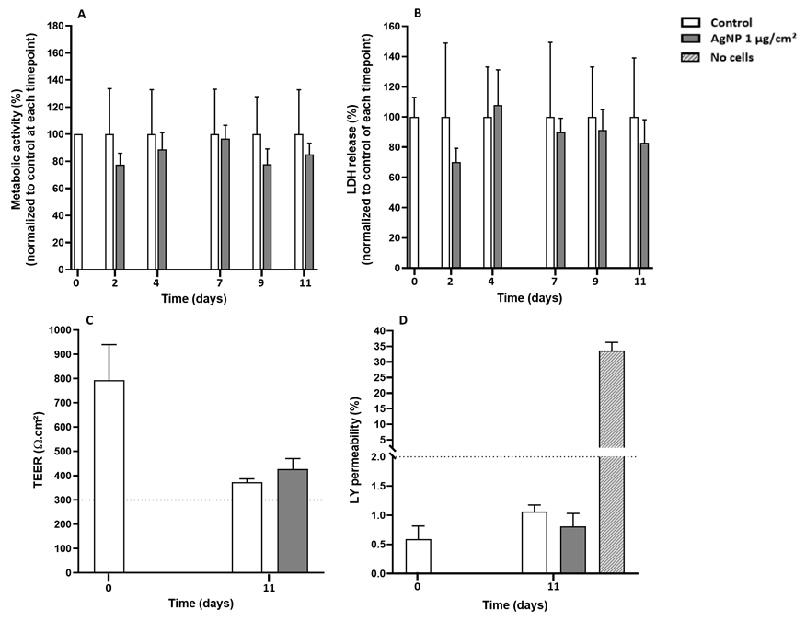
Figure S2. Effect of 5 repeated exposures to 1 µg/cm² AgNPs on Calu-3 viability and epithelial barrier integrity. Calu-3 epithelial barrier was exposed to HBSS (control, white) or 1 µg/cm² AgNPs (treated, black) from D0 to D9. The different endpoints were measured from D0 to D11. (A) Metabolic activity measured by the AlamarBlue assay (N=4). Dotted lines represent the metabolic activity of the control culture during 12 days. (B) Cell membrane integrity measured by LDH release (N=4). (C) Trans-epithelial electric resistance (TEER) (N=3). Minimal value for a tight barrier is indicated by a dotted line (TEER > 300 Ω.cm²). (D) Lucifer Yellow (LY) permeability (N=3) of controls (white), treated cells (dark grey), and empty insert (hatched). Maximal value for a tight barrier is indicated by a dotted line (LY < 2%).

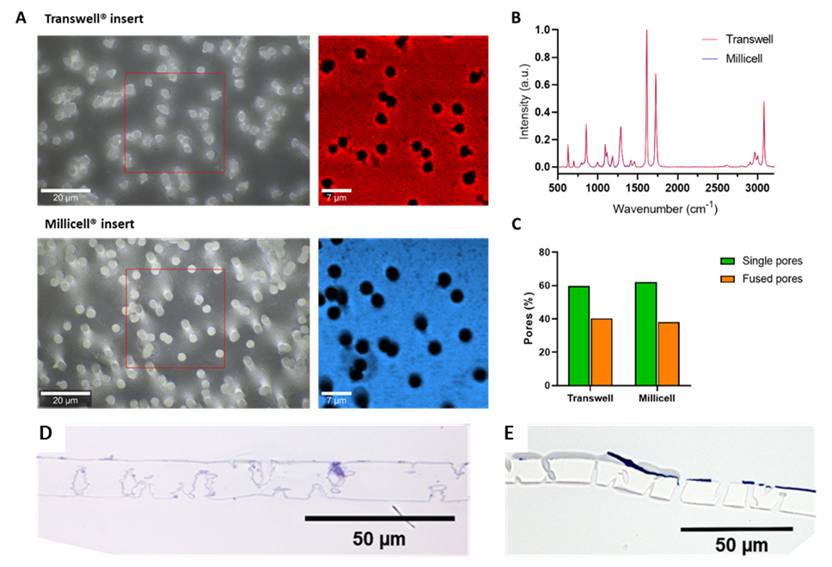
Figure S3. Analysis of the porosity of Transwell and Millicell inserts. (A) Bright field (left) and Raman (right) images of Transwell and Millicell inserts. (B) Raman spectra of Transwell (red) and Millicell (blue) inserts. (C) Percentage of single pores and fused pores for each insert. (D-E) Semi-thin sections of Calu-3 cultures on Transwell® (D) and Millicell® (E) inserts stained with toluidine blue showing differences in the morphology of the pore wall.
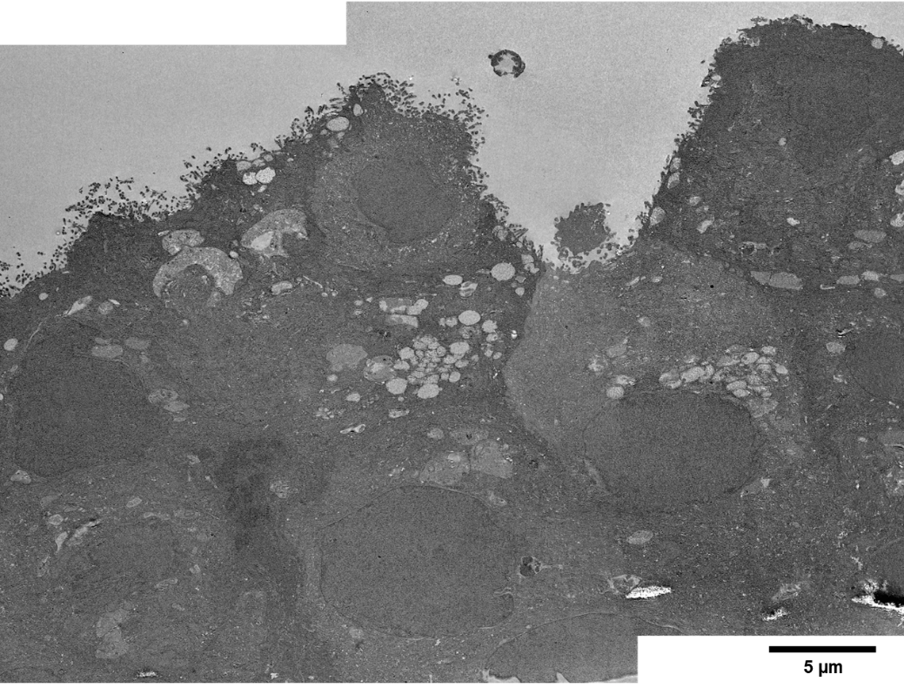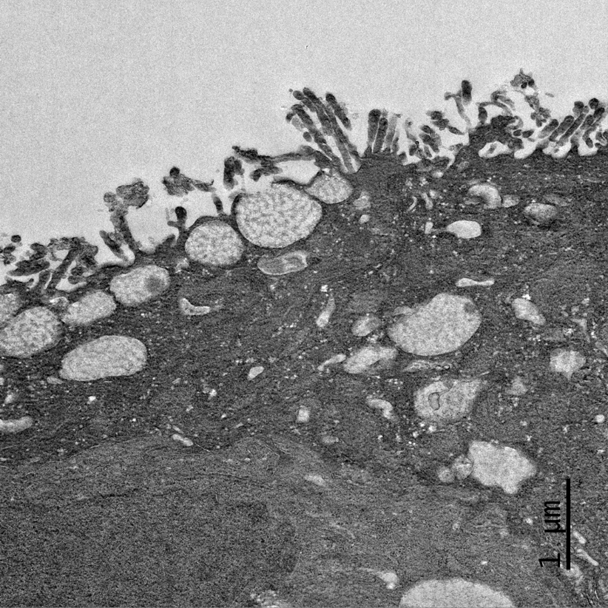
Figure S4. TEM images of control Calu-3 cultures at D11 after 5 repeated exposure to HBSS at ALI. Scale bar 5 µm (top) and 1 µm (bottom). Mucus secretory granules and microvilli are visible on the apical side of the Calu-3 cells on the bottom image.
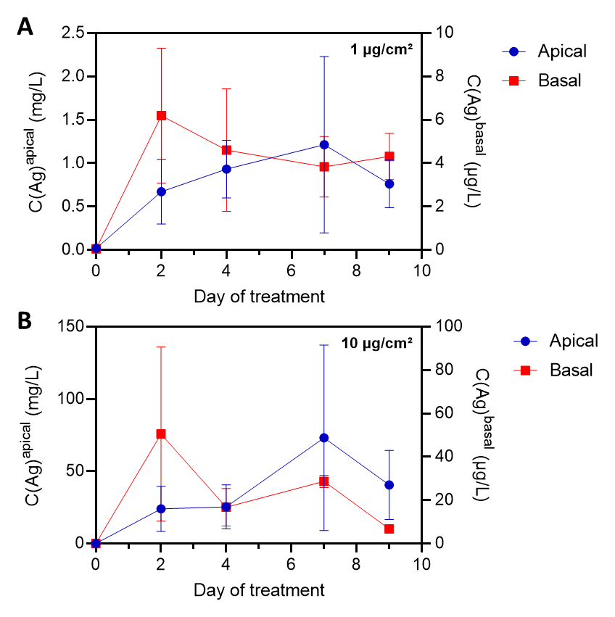
Figure S5. Silver concentration in the apical and basal medium measured by ICP-MS. (A) Calu-3 epithelial barrier exposed 5 times to 1 µg/cm² from D0 to D9. (B) Calu-3 epithelial barrier exposed 5 times to 10 µg/cm² from D0 to D9. Silver concentration is expressed in mg/L in the apical medium (left axis) and in µg/L in the basal medium (right axis). (N=3)

Table S2. Silver concentration and translocation measured by ICP-MS after 5 repeated exposure to 1 and 10 µg/cm² AgNPs. Data not available for the basal media after 5 treatments
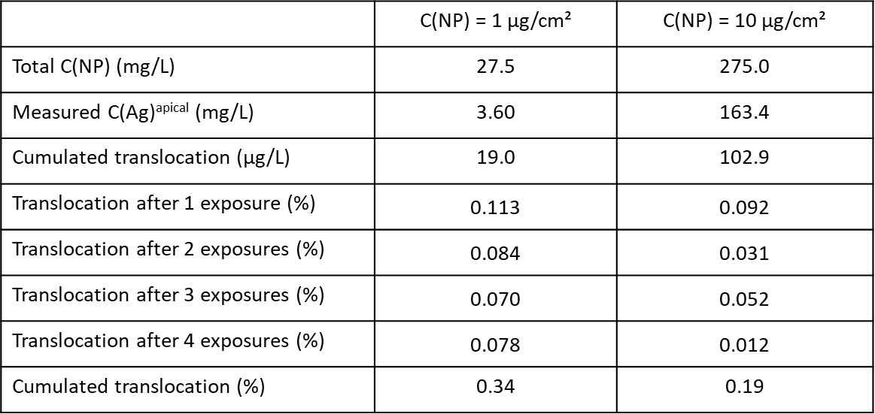

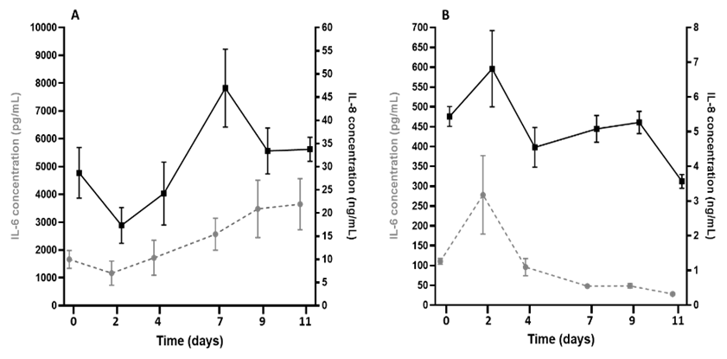
Figure S6. Constitute secretion of IL-6 and IL-8 cytokines by Calu-3 cells. The apical and the basolateral secretomes were recovered from D0 to D11 and the two cytokines IL-6 and IL-8 were quantified by ELISA. IL-6 (dotted grey line, pg/mL) and IL-8 (black line, ng/mL) concentrations in the apical (A) and in the basolateral (B) secretomes (N=3). Apical concentrations represent the accumulation of the secreted cytokines during 48 h between collection of the secretome, except at D7 where cytokines could accumulate during 72 h, which may explain the higher concentration measured for IL-8.
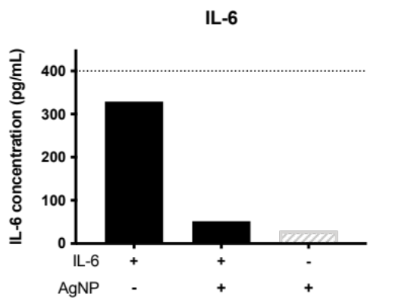
Figure S7. Interactions of AgNPs with IL-6. A known concentration of IL-6 (400 pg/ml) was added to 10 µg/mL AgNP in HBSS^{Ca2+/Mg2+} at 37°C for 1h. Two control samples were prepared without AgNPs, with AgNPs without IL-6. The concentration of IL-6 was measured after centrifugation in the supernantant by ELISA to estimate the loss of IL-6 due to adsorption on AgNPs and the possible interference of AgNPs with the ELISA test.
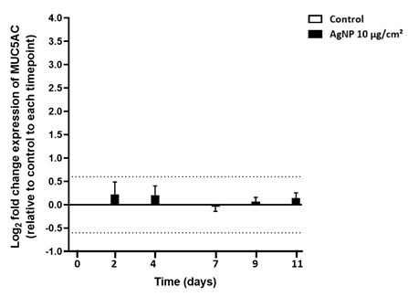
Figure S8. Effect of 5 repeated exposures to 10 µg/cm² AgNPs on MUC5AC expression . Calu-3 epithelial barrier was repeatedly exposed to HBSS ^{Ca2+/Mg2+} or 10 µg/cm² AgNPs from D0 to D9. The mRNA expression of MUC5AC was measured in control and treated cells 48 to 72 h after each treatment. The dotted lines indicate significant fold change. (N=3)

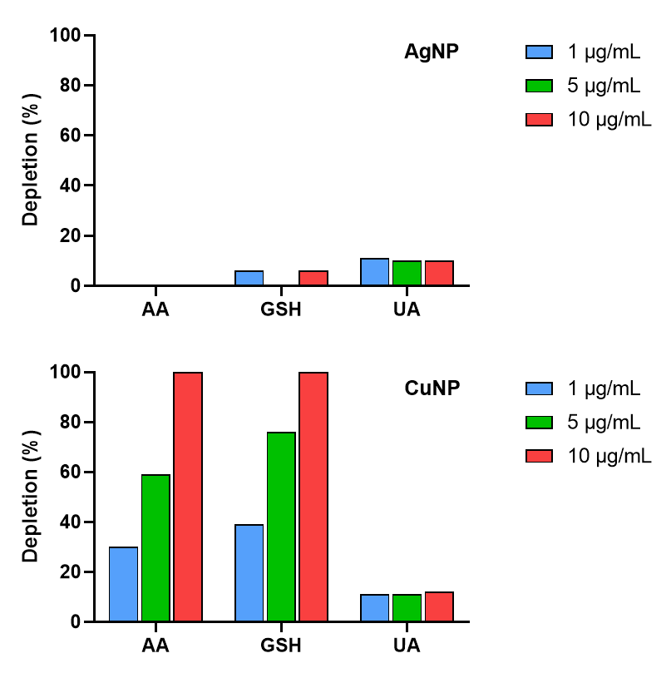
Figure S9. Oxidative potential of AgNPs and copper nanoparticles. Oxidative potential of AgNPs and copper nanoparticles (CuNP) measured by the depletion of antioxidants (%) in synthetic lung lining fluid at 37°C for NP concentrations of 1, 5, 10 µg/mL. AA: ascorbic acid. UA: uric acid. GSH: reduced glutathione.
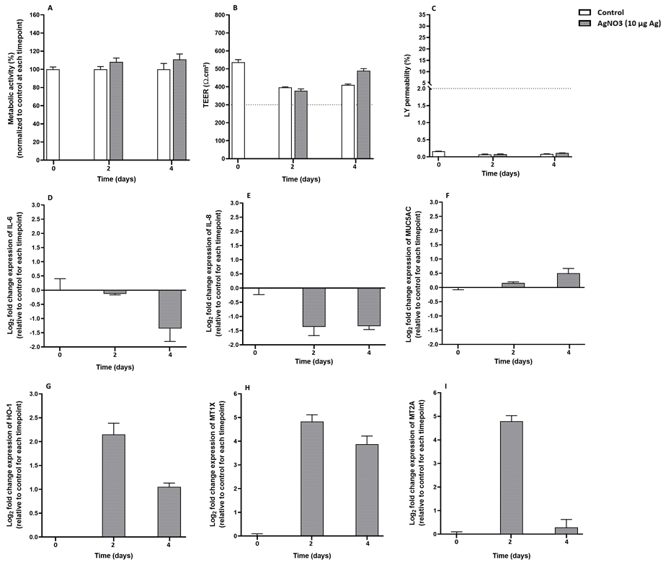
Figure S10. Effect of AgNO3 on Calu-3 viability, epithelial barrier integrity and gene expression. Calu-3 epithelial barrier was exposed to HBSS ^{Ca2+/Mg2+} or AgNO₃ at a concentration equivalent to 10 µg/cm² Ag from D0 to D2. The different endpoints were measured from D0 to D4. (A) Metabolic activity measured by the AlamarBlue assay, (B) TEER. (C) LY permeability. (D-I) mRNA were extracted at D2 and D4 to measure (D) IL-6, (E) IL-8, (F) MUC5AC, (G) HO-1, (H) MT1X and (I) MT2A gene expression. (N = 1)
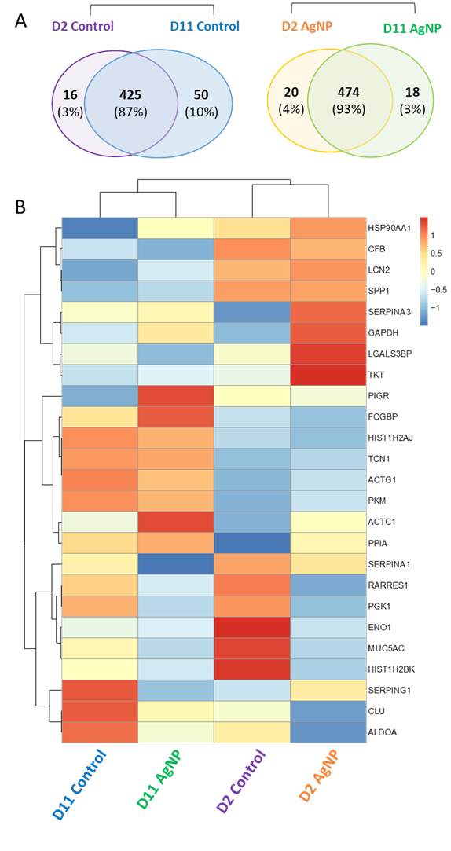
Figure S11. Quantitative analysis of the secretome of Calu-3 cells after single or repeated exposure to AgNPs. (A) Venn diagram of the secretome composition after single exposure (D2) and repeated exposure (D11) to HBSS ^{Ca2+/Mg2+} or 10 µg/cm² AgNPs for control and treated cells respectively. (B) Heat map of the 20 most abundant extracellular proteins identified in the secretome of control and treated cells at D2 and D11. The colours reflect the quantitative enrichment (red) or depletion (blue) of a secreted protein.

References
Sanchez-Guzman D, Boland S, Brookes O, Mc Cord C, Lai Kuen R, Sirri V, et al. Long-term evolution of the epithelial cell secretome in preclinical 3D models of the human bronchial epithelium. Sci Rep. 2021 Dec;11(1):6621.

