SUPPLEMENTARY INFORMATION
Figure S.1. A) Experimental apparatus used for analysis of droplet size and velocity measurement by the PDPA technique; B) Measurement of the sizes and velocity of the emulsion droplets atomized in the air in real time; C) Two Channel Nozzle atomizer of the spray dryer used in the tests.
A)
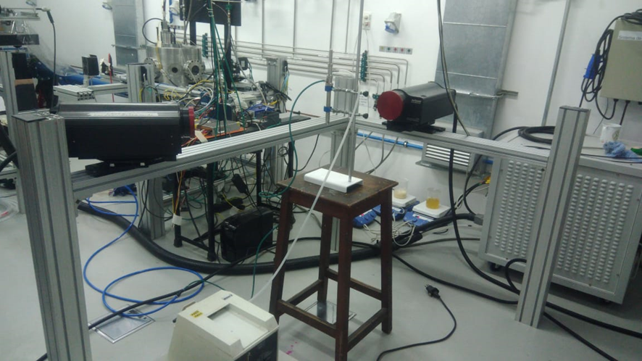
B)
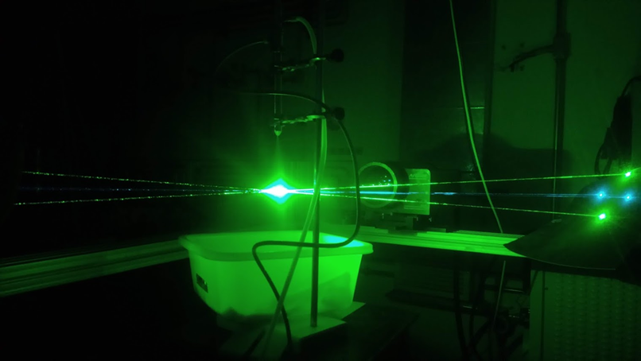

C)
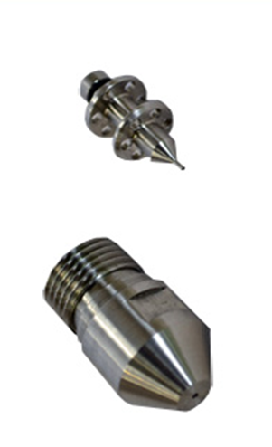

Table S.1. Comparison of mode (μm) and volume (%) for initial and reconstituted emulsion.
Formulation | Initial Emulsion |  |  | Reconstituted Emulsion
Formulation | Mode (µm) | Volume (%) |  | Mode (µm) | Volume (%)
C10 | 2.76 ± 0.21^{bAB} | 6.07 ± 0.25^{cE} |  | 1.59 ± 0.12^{abBC} | 8.96 ± 0.36^{bcBC}
C20 | 1.00 ± 0.08^{cC} | 7.14 ± 0.21^{bD} |  | 1.26 ± 0.00^{bC} | 11.28 ± 0.34^{aA}
C30 | 0.95 ± 0.00^{cC} | 7.08 ± 0.13^{bD} |  | 1.26 ± 0.00^{bC} | 9.66 ± 0.24^{bB}
O40 – 1 | 3.31 ± 0.00^{abA} | 9.28 ± 0.50^{aB} |  | 1.10 ± 0.00^{bC} | 8.30 ± 0.14^{cC}
O50 – 1 | 3.83 ± 0.53^{aA} | 9.26 ± 0.37^{aB} |  | 1.10 ± 0.00^{bC} | 8.85 ± 0.12^{cBC}
O50 – 2 | 0.95 ± 0.00^{cC} | 9.49 ± 0.34^{aB} |  | 3.14 ± 1.65^{aA} | 4.56 ± 0.25^{dF}
Values are expressed as mean ± standard deviation. Lower case and capital different letters correspond to statistically different values (p < 0.05) to each column and line, respectively.

