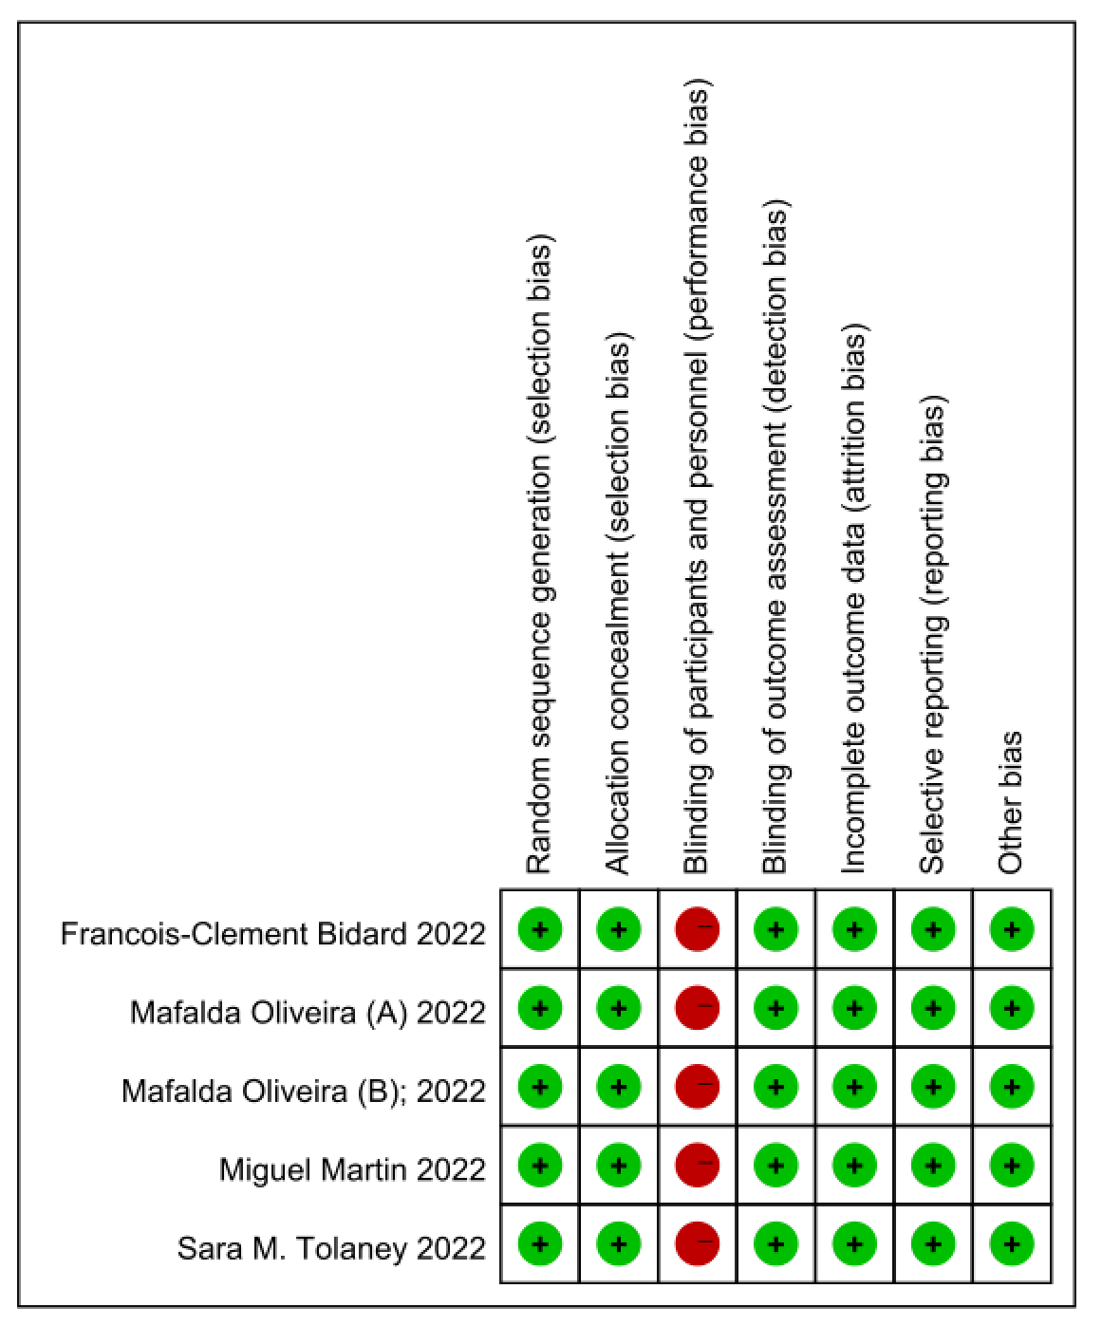

Supplementary Figure 1. Risk of bias summary of included studies

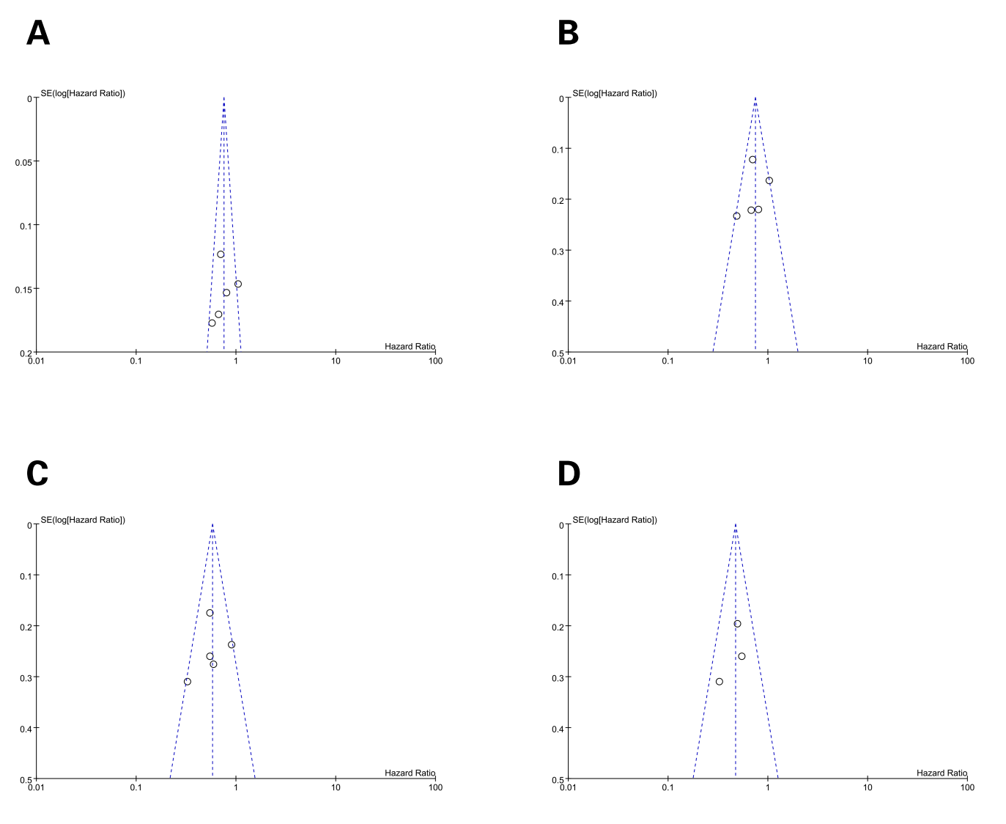

Supplementary Figure 2. The funnel plot PFS for patients with HR+/HER2- advanced breast cancer after progression on ≥ 1 line of endocrine treatment: (A) The funnel plot PFS for overall patients; (B) The funnel plot PFS for patients with previous use of CDK4/6 inhibitors; (C) The funnel plot PFS for patients with ESR1m; (D) The funnel plot PFS for comparing oral SERDS with fulvestrant in patients with ESR1m subgroup. Note: PFS, progression-free survival; CI, confifidence interval; HR, hazard ratio; HR+/HER2-, hormone receptor-positive and human epidermal growth factor receptor 2-negative; SERDS, selective estrogen receptor degrader; ESR1m, estrogen receptor 1 mutations.

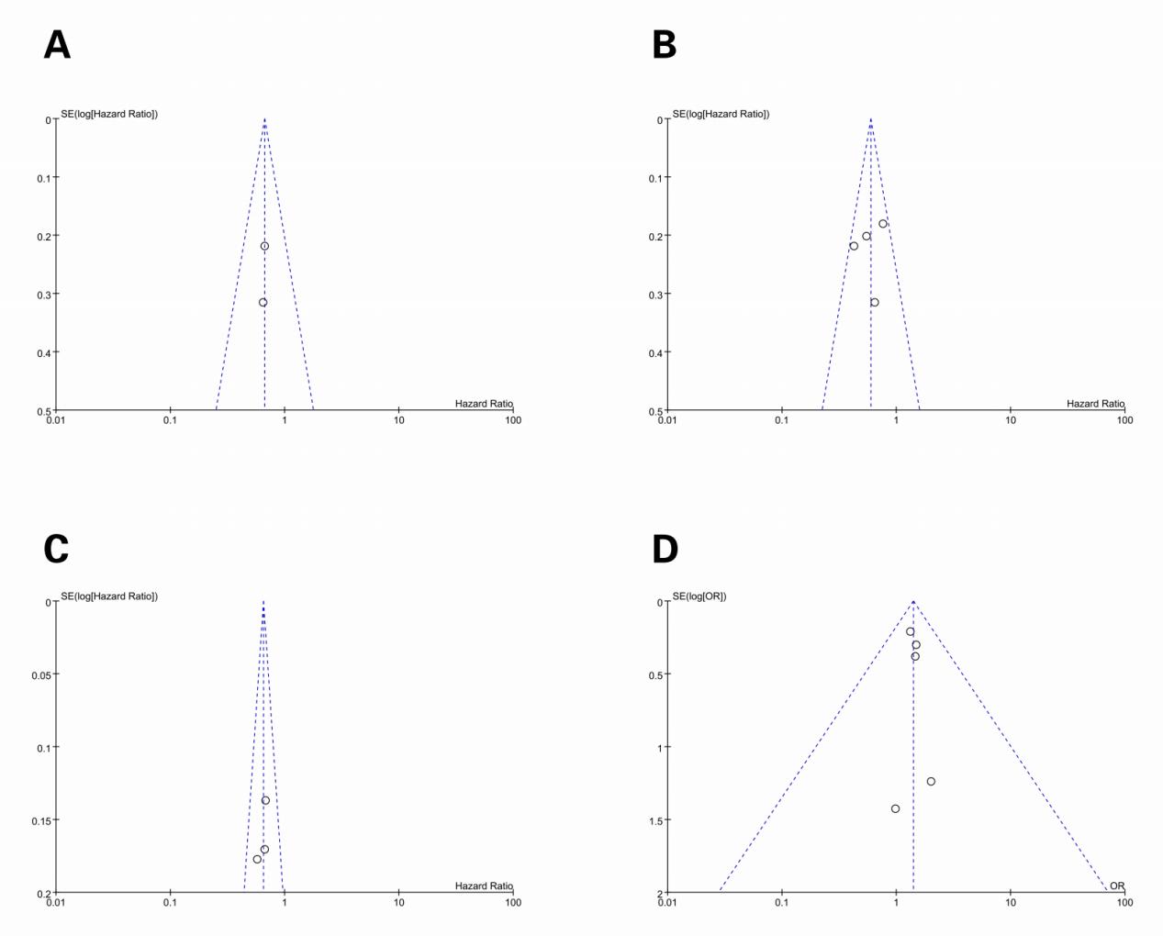

Supplementary Figure 3. The funnel plot PFS for patients with (A) previous use of fulvestrant; (B) visceral metastasis; (C) funnel plot for PFS comparing oral SERDS with fulvestrant. (D) The funnel plot for AE ≥ Grade 3 for patients with HR+/HER2- advanced breast cancer after progression on ≥ 1 line of ET.
Note: PFS, progression-free survival; CI, confifidence interval; HR, hazard ratio; HR+/HER2-, hormone receptor-positive and human epidermal growth factor receptor 2-negative; SERDS, selective estrogen receptor degrader; AE, adverse event.

