Supporting Information

Sulfonated Litchi Exocarp Carbon as Solid Acid Catalyst to Produce Dihydropyrimidinones via Biginelli Reaction
Qiang Hu,^{a‡} Shang Wu,ª*‡ Penghui Zhang,ª Shuaishuai Fu,ª Jiajia Wang,ª Chaoyang Liu,ª Hong Zhang,ª* Yuzhi Sun,ª Quanlu Yang^{b}*
ª Key Laboratory for Utility of Environmental Friendly Composite Materials and Biomass in the University of Gansu Province, Key Laboratory of Environment Friendly Composites of the State Ethnic Affairs Commission, Gansu Provincial Biomass Function Composites Engineering Research Center, College of Chemical Engineering, Northwest Minzu University, Lanzhou, Gansu 730030, China.
^{b} College of Chemical Engineering, Lanzhou University of Arts and Science, Beimiantan 400, Lanzhou, Gansu 730000, China.
‡These authors contributed equally to this work. They should thus be considered co-first authors.
*Corresponding authors: chwush84@163.com (Shang Wu), 171941425@xbmu.edu.cn (Hong Zhang), yangquanlu2002@163.com (Quanlu Yang).
3490706355@qq.com (Qiang Hu), 1851574307@qq.com (Penghui Zhang), 2363702209@qq.com (Shuaishuai Fu), 2292833149@qq.com (Jiajia Wang), 964986926@qq.com (Chaoyang Liu), 136026667@qq.com (Yuzhi Sun).

The Table of Contents Entry
1. Characterization of SO₃H-CL catalyst | S2-S3
2. ¹H NMR and ¹³C NMR Spectral data of synthesized compounds | S4-S19

1. Characterization of SO₃H-CL catalyst
Fig. S1 The XRD patterns of SO₃H-CL

Table S1 Comparison of the Biginelli reaction using different catalysts for the production of DHPMs
Catalyst | Amount | Time | Temp. | Yield | Ref.
CRH | 0.07 g | 1 h | 130 °C | 92 % | 26
Polypropylene fiber-SO₃H | 0.25 g | 18 h | 80 °C | 81 % | 35
IL-HSO₄@MCM-41@Cu | 0.50 g | 2 h | 80 °C | 90 % | 36
WSi/A15 | 0.05 g | 4.5 h | 95 °C | 88 % | 37
Fe-PANI | 0.20 g | 24 h | 81 °C | 83 % | 38
Montmorillonite K10-H₃PW₁₂O₄₀ | 0.40 g | 4.5 h | 82 °C | 90 % | 39
SO₃H-CL | 0.03 g | 3.5 h | 80 °C | 95 % | This work

2. ¹H NMR and ¹³C NMR Spectral data of synthesized compounds for Scheme 2
Methyl 6-methyl-2-oxo-4-phenyl-1,2,3,4-tetrahydropyrimidine-5-carboxylate (4a). 95% yield, ¹H NMR (600 MHz, DMSO-d₆) δ 9.21 (s, 1H), 7.75 (s, 1H), 7.34 – 7.30 (m, 2H), 7.26 – 7.22 (m, 3H), 5.15 (d, J = 3.4 Hz, 1H), 3.53 (s, 3H), 2.25 (s, 3H). ¹³C NMR (151 MHz, DMSO-d₆) δ 165.83 , 152.17 , 148.65 , 144.67 , 128.45 , 127.28 , 126.16 , 99.02 , 53.81 , 50.78 , 17.84 .
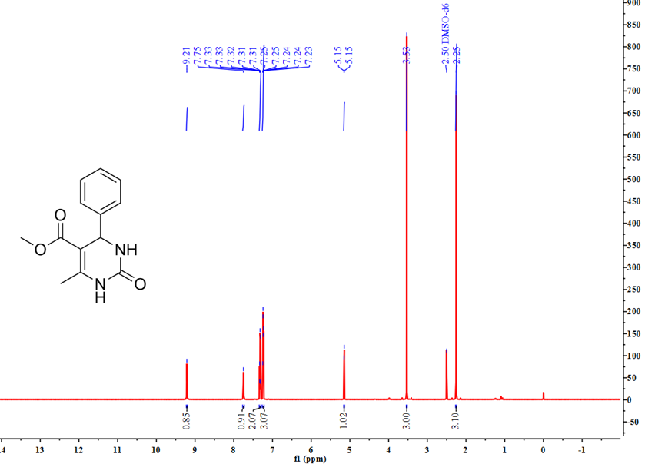
Fig. S2 ¹H NMR spectra of 4a in DMSO‒d₆ (600 MHz, 298K)
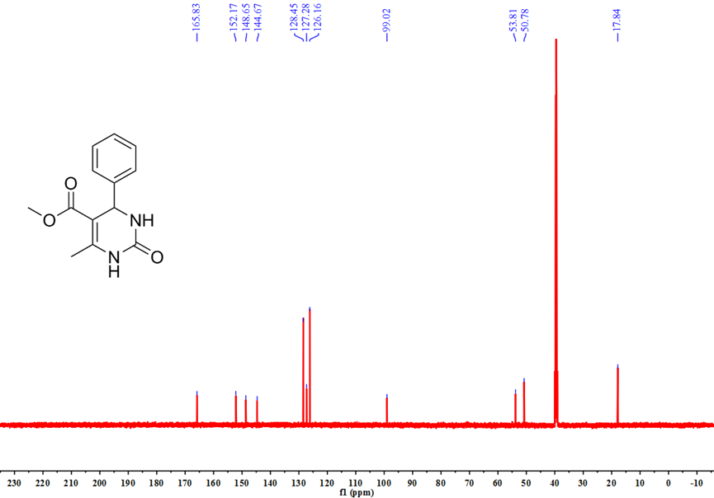
Fig. S3 ¹³C NMR spectra of 4a in DMSO‒d₆ (151 MHz, 298K)
methyl 6-methyl-4-(4-nitrophenyl)-2-oxo-1,2,3,4-tetrahydropyrimidine-5-carboxylate (4b). 96% yield, ¹H NMR (600 MHz, DMSO-d₆) δ 9.37 (s, 1H), 8.21 (d, J = 8.7 Hz, 2H), 7.90 (s, 1H), 7.51 (d, J = 8.7 Hz, 2H), 5.28 (d, J = 3.4 Hz, 1H), 3.54 (s, 3H), 2.27 (s, 3H). ¹³C NMR (151 MHz, DMSO-d₆) δ 165.56 , 151.80 , 149.62 , 146.74 , 127.58 , 123.86 , 98.00 , 53.54 , 50.91 , 17.92 .
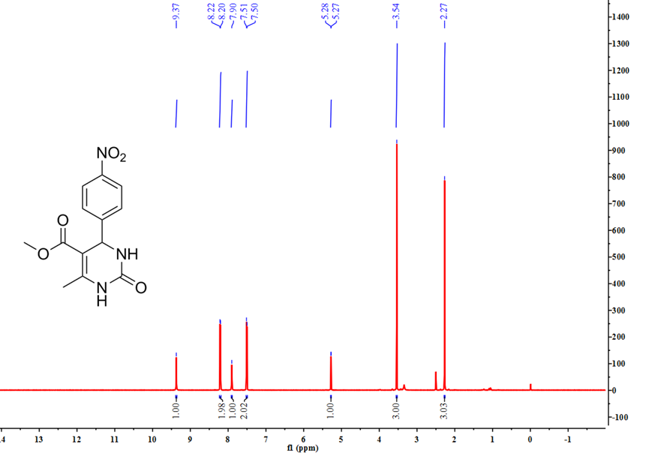
Fig. S4 ¹H NMR spectra of 4b in DMSO‒d₆ (600 MHz, 298K)
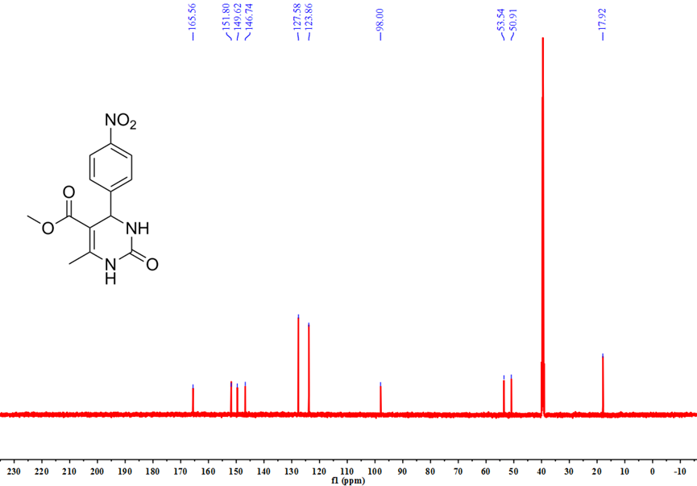
Fig. S5 ¹³C NMR spectra of 4b in DMSO‒d₆ (151 MHz, 298K)
methyl 4-(4-hydroxyphenyl)-6-methyl-2-oxo-1,2,3,4-tetrahydropyrimidine-5-carboxylate (4c). 93% yield, ¹H NMR (600 MHz, DMSO-d₆) δ 9.32 (s, 1H), 9.13 (s, 1H), 7.63 (d, J = 2.1 Hz, 1H), 7.02 (d, J = 8.5 Hz, 2H), 6.70 – 6.67 (m, 2H), 5.04 (d, J = 3.3 Hz, 1H), 3.52 (s, 3H), 2.23 (s, 3H). ¹³C NMR (151 MHz, DMSO-d₆) δ 165.91 , 156.57 , 152.20 , 148.09 , 135.23 , 127.33 , 115.05 , 99.47 , 53.28 , 50.73 , 17.81 .
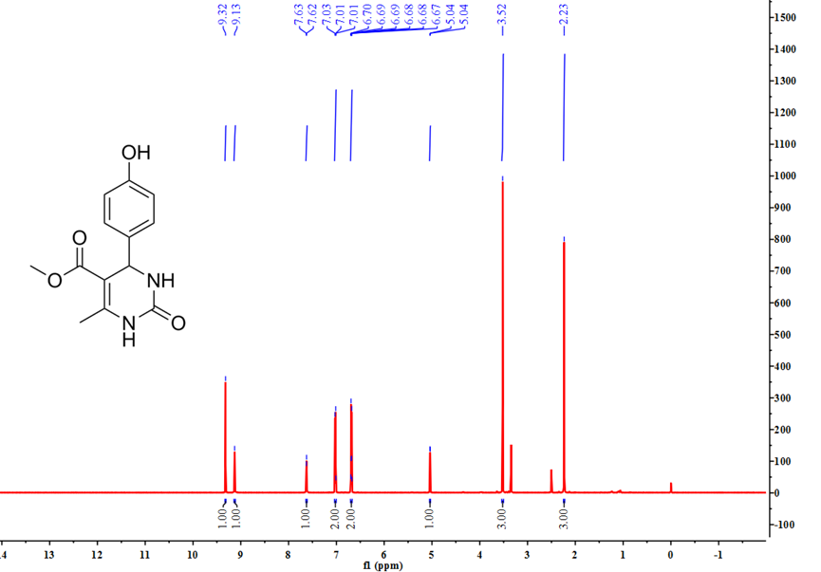
Fig. S6 ¹H NMR spectra of 4c in DMSO‒d₆ (600 MHz, 298K)
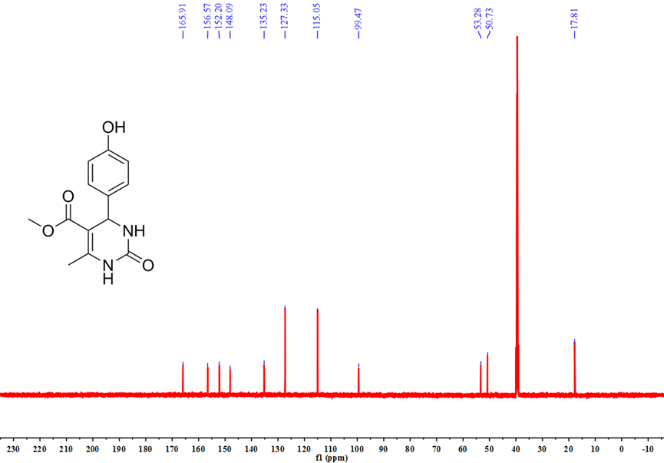
Fig. S7 ¹³C NMR spectra of 4c in DMSO‒d₆ (151 MHz, 298K)
methyl 4-(3-methoxyphenyl)-6-methyl-2-oxo-1,2,3,4-tetrahydropyrimidine-5-carboxylate (4d). 84% yield, ¹H NMR (600 MHz, DMSO-d₆) δ 9.21 (s, 1H), 7.74 (s, 1H), 7.24 (t, J = 7.9 Hz, 1H), 6.84 – 6.79 (m, 2H), 6.79 – 6.77 (m, 1H), 5.12 (d, J = 3.3 Hz, 1H), 3.72 (s, 3H), 3.54 (s, 3H), 2.25 (s, 3H). ¹³C NMR (151 MHz, DMSO-d₆) δ 165.83 , 159.25 , 152.21 , 148.74 , 146.13 , 129.59 , 118.15 , 112.35 , 112.14 , 98.85 , 54.96 , 53.60 , 50.80 , 17.81 .
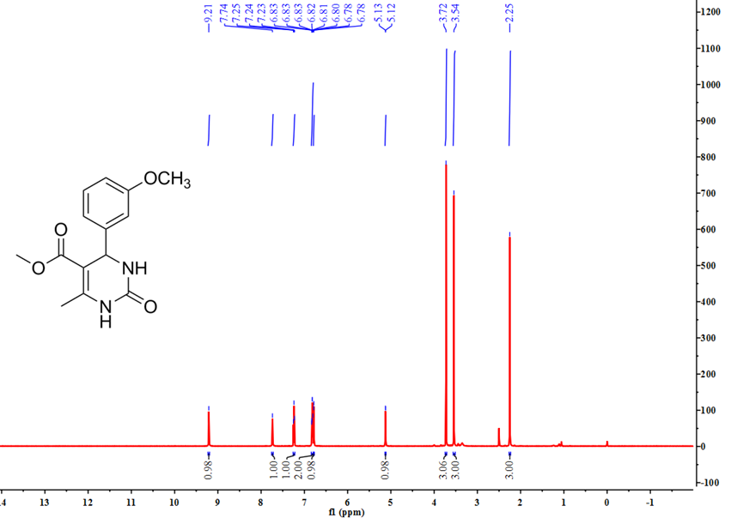
Fig. S8 ¹H NMR spectra of 4d in DMSO‒d₆ (600 MHz, 298K)
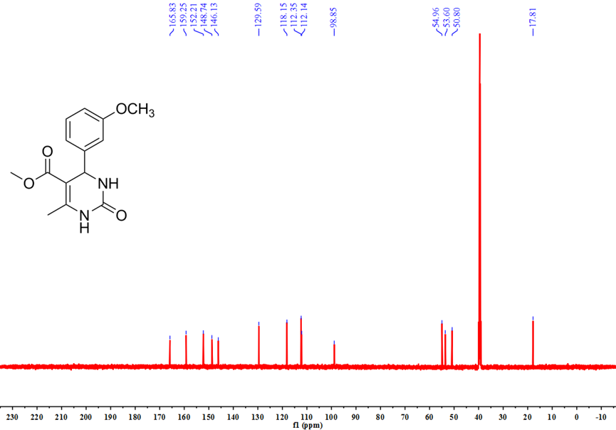
Fig. S9 ¹³C NMR spectra of 4d in DMSO‒d₆ (151 MHz, 298K)
methyl 4-(2-bromophenyl)-6-methyl-2-oxo-1,2,3,4-tetrahydropyrimidine-5-carboxylate (4e). 86% yield, ¹H NMR (600 MHz, DMSO-d₆) δ 9.30 (s, 1H), 7.69 (s, 1H), 7.57 -7.18 (m, 4H), 5.59 (d, J = 2.9 Hz, 1H), 3.45 (s, 3H), 2.30 (s, 3H). ¹³C NMR (151 MHz, DMSO-d₆) δ 165.46 , 151.30 , 149.38 , 143.31 , 132.69 , 129.41 , 128.71 , 128.47 , 122.17 , 98.14 , 53.89 , 50.71 , 17.72 .
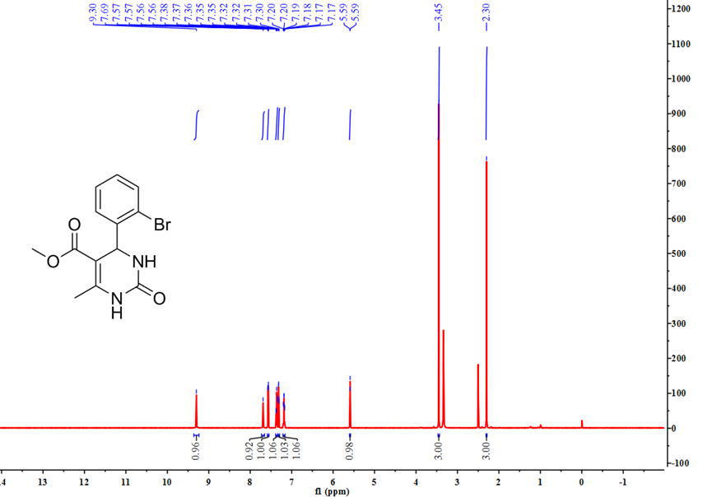
Fig. S10 ¹H NMR spectra of 4e in DMSO‒d₆ (600 MHz, 298K)
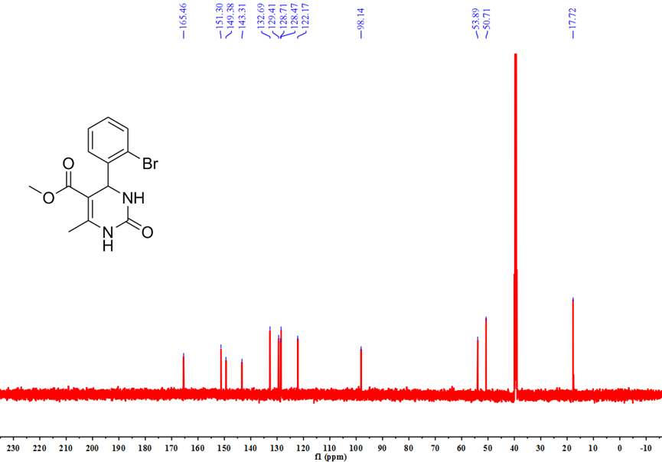
Fig. S11 ¹³C NMR spectra of 4e in DMSO‒d₆ (151 MHz, 298K)
methyl 4-(3-bromophenyl)-6-methyl-2-oxo-1,2,3,4-tetrahydropyrimidine-5-carboxylate (4f). 89% yield, ¹H NMR (600 MHz, DMSO-d₆) δ 9.29 (s, 1H), 7.80 (s, 1H), 7.45 (d, J = 7.9 Hz, 1H), 7.39 (s, 1H), 7.30 (t, J = 7.8 Hz, 1H), 7.23 (d, J = 7.7 Hz, 1H), 5.15 (d, J = 3.2 Hz, 1H), 3.54 (s, 3H), 2.26 (s, 3H). ¹³C NMR (151 MHz, DMSO-d₆) δ 165.69 , 151.93 , 149.25 , 147.24 , 130.84 , 130.21 , 129.02 , 125.21 , 121.65 , 98.35 , 53.40 , 50.89 , 17.90 .
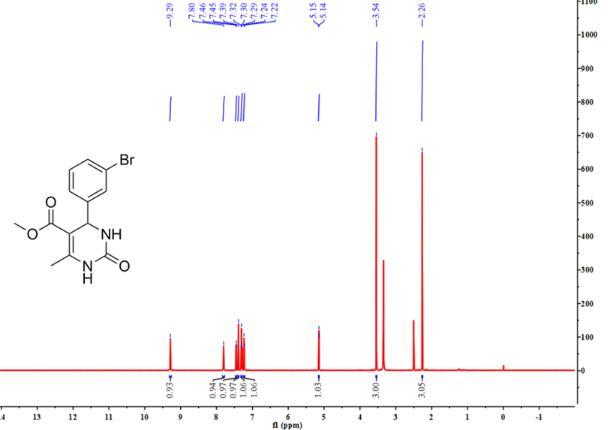
Fig. 12 ¹H NMR spectra of 4f in DMSO‒d₆ (600 MHz, 298K)
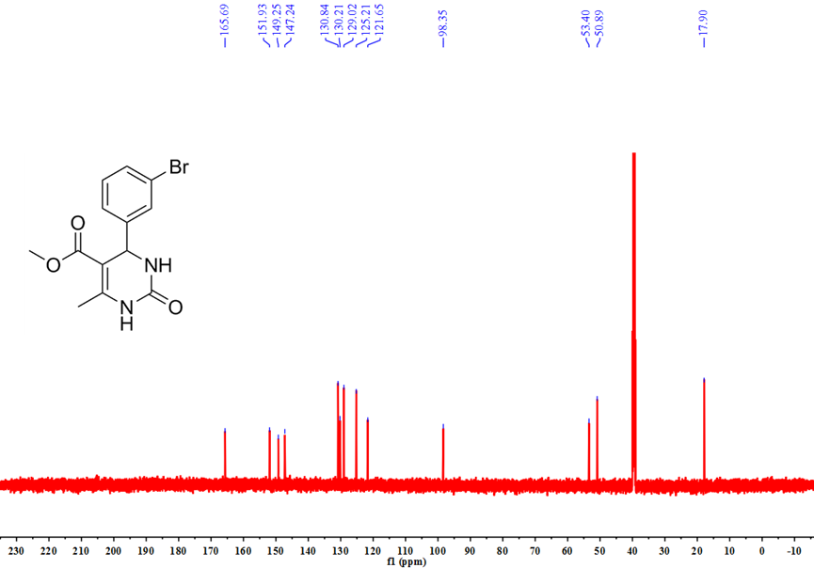
Fig. S13 ¹³C NMR spectra of 4f in DMSO‒d₆ (151 MHz, 298K)
methyl 4-(4-bromophenyl)-6-methyl-2-oxo-1,2,3,4-tetrahydropyrimidine-5-carboxylate (4g). 90% yield, ¹H NMR (600 MHz, DMSO-d₆) δ 9.26 (s, 1H), 7.79 – 7.77 (m, 1H), 7.54 – 7.51 (m, 2H), 7.20 – 7.17 (m, 2H), 5.13 (d, J = 3.4 Hz, 1H), 3.53 (s, 3H), 2.25 (s, 3H). ¹³C NMR (151 MHz, DMSO-d₆) δ 165.68 , 151.94 , 149.00 , 144.00 , 131.36 , 128.47 , 120.34 , 98.52 , 53.33 , 50.82 , 17.85 .
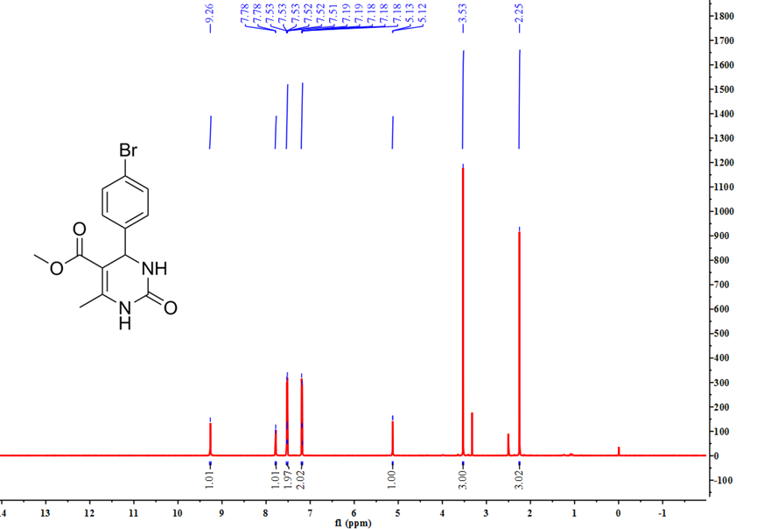
Fig. S14 ¹H NMR spectra of 4g in DMSO‒d₆ (600 MHz, 298K)
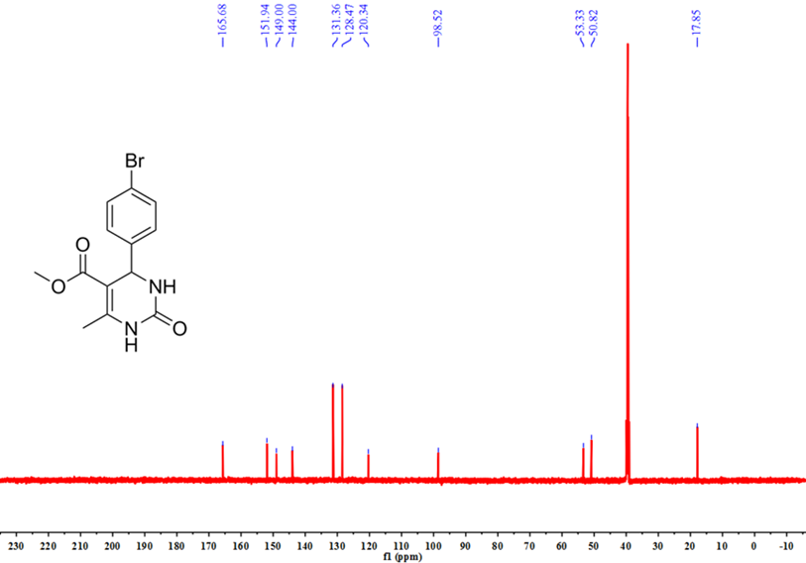
Fig. S15 ¹³C NMR spectra of 4g in DMSO‒d₆ (151 MHz, 298K)
methyl 4-(4-chlorophenyl)-6-methyl-2-oxo-1,2,3,4-tetrahydropyrimidine-5-carboxylate (4h). 88% yield, ¹H NMR (600 MHz, DMSO-d₆) δ 9.26 (s, 1H), 7.78 (s, 1H), 7.39 (d, J = 8.4 Hz, 2H), 7.25 (d, J = 8.4 Hz, 2H), 5.14 (d, J = 3.3 Hz, 1H), 3.53 (s, 3H), 2.25 (s, 3H). ¹³C NMR (151 MHz, DMSO-d₆) δ 165.70 , 151.96 , 148.99 , 143.60 , 131.82 , 128.45 , 128.11 , 98.60 , 53.27 , 50.83 , 17.86 .
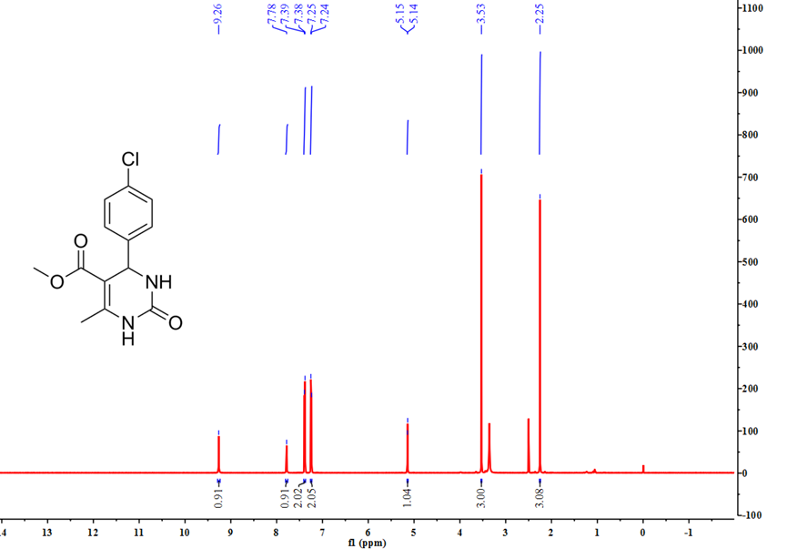
Fig. S16 ¹H NMR spectra of 4h in DMSO‒d₆ (600 MHz, 298K)
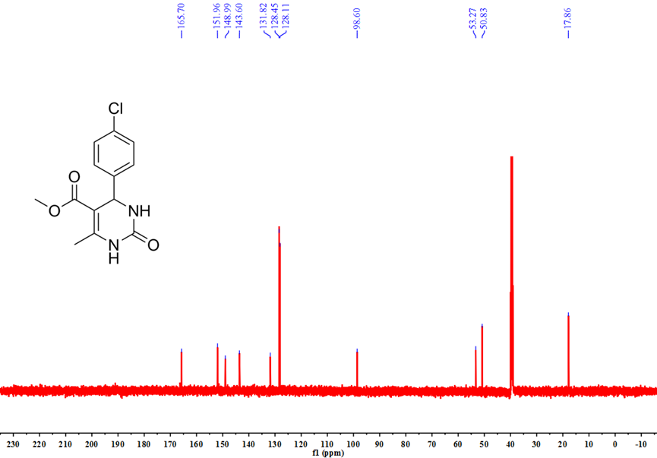
Fig. S17 ¹³C NMR spectra of 4h in DMSO‒d₆ (151 MHz, 298K)

Ethyl 6-methyl-2-oxo-4-phenyl-1,2,3,4-tetrahydropyrimidine-5-carboxylate (4i). 93% yield, ¹H NMR (600 MHz, DMSO-d₆) δ 9.19 (s, 1H), 7.74 (s, 1H), 7.35 – 7.29 (m, 2H), 7.24 (d, J = 6.4 Hz, 3H), 5.15 (s, 1H), 3.98 (q, J = 7.1 Hz, 2H), 2.25 (s, 3H), 1.09 (t, J = 7.1 Hz, 3H). ¹³C NMR (151 MHz, DMSO-d₆) δ 165.76 , 152.56 , 148.78 , 145.29 , 128.81 , 127.68 , 126.67 , 99.68 , 59.61 , 54.40 , 18.22 , 14.51 .
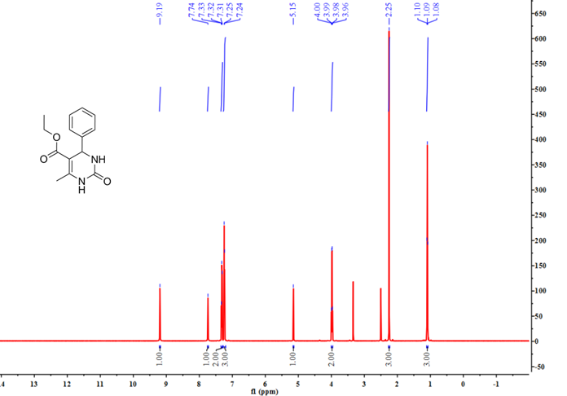
Fig. S18 ¹H NMR spectra of 4i in DMSO‒d₆ (600 MHz, 298K)
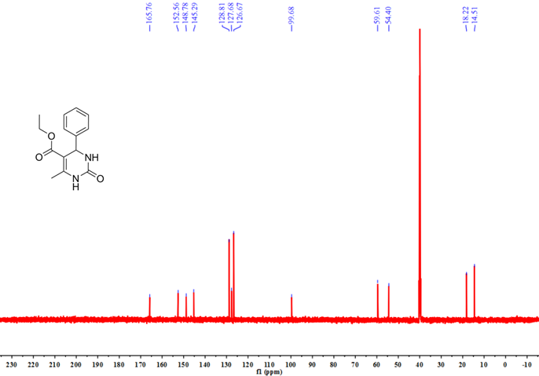
Fig. S19 ¹³C NMR spectra of 4i in DMSO‒d₆ (151 MHz, 298K)

Ethyl 6-methyl-2-oxo-4-(p-tolyl)-1,2,3,4-tetrahydropyrimidine-5-carboxylate (4j). 80% yield, ¹H NMR (600 MHz, DMSO-d₆) δ 9.14 (s, 1H), 7.67 (d, J = 3.2 Hz, 1H), 7.12 (s, 4H), 5.11 (d, J = 3.4 Hz, 1H), 3.98 (q, J = 7.1 Hz, 2H), 2.26 (s, 3H), 2.24 (s, 3H), 1.10 (t, J = 7.1 Hz, 3H). ¹³C NMR (151 MHz, DMSO-d₆) δ 165.35 , 152.17, 148.13 , 141.95 , 136.35 , 128.87 , 126.14 , 99.42 , 59.15 , 53.63 , 20.64 , 17.76 , 14.09 .
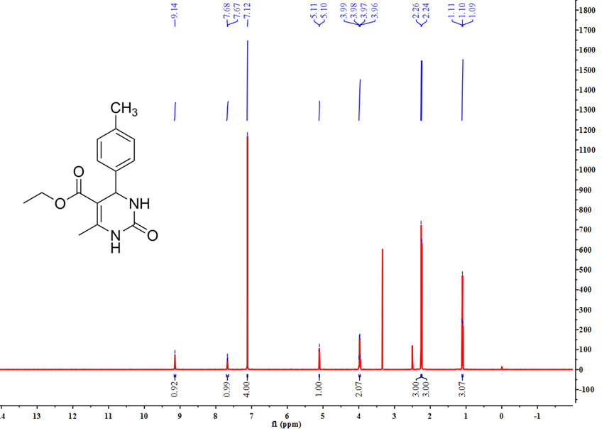
Fig. S20 ¹H NMR spectra of 4j in DMSO‒d₆ (600 MHz, 298K)
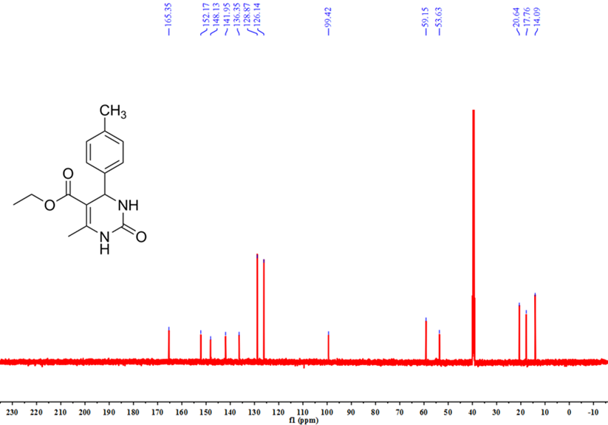
Fig. S21 ¹³C NMR spectra of 4j in DMSO‒d₆ (151 MHz, 298K)

Ethyl 6-methyl-4-(4-nitrophenyl)-2-oxo-1,2,3,4-tetrahydropyrimidine-5-carboxylate (4k). 91% yield, ¹H NMR (600 MHz, DMSO-d₆) δ 9.34 (s, 1H), 8.23 – 8.20 (m, 2H), 7.88 (d, J = 3.0 Hz, 1H), 7.53 – 7.48 (m, 2H), 5.28 (d, J = 3.3 Hz, 1H), 3.99 (q, J = 7.1 Hz, 2H), 2.27 (s, 3H), 1.09 (t, J = 7.1 Hz, 3H). ¹³C NMR (151 MHz, DMSO-d₆) δ 165.05 , 151.99 , 151.74 , 149.38 , 146.71 , 127.65 , 123.82 , 98.18 , 59.39 , 53.69 , 17.87 , 14.05 .
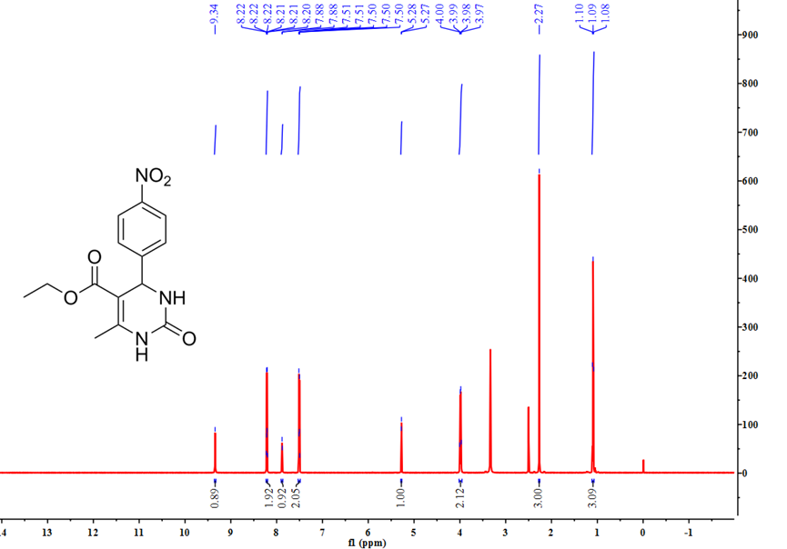
Fig. S22 ¹H NMR spectra of 4k in DMSO‒d₆ (600 MHz, 298K)
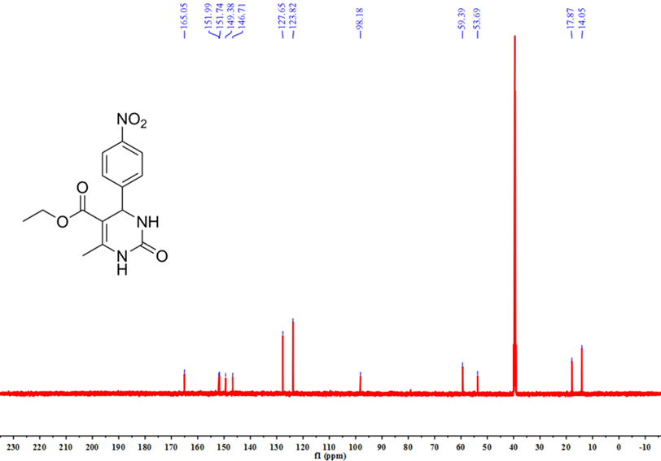
Fig. S23 ¹³C NMR spectra of 4k in DMSO‒d₆ (151 MHz, 298K)

Ethyl 6-methyl-4-phenyl-2-thioxo-1,2,3,4-tetrahydropyrimidine-5-carboxylate (4l). 79% yield, ¹H NMR (600 MHz, DMSO-d₆) δ 10.32 (s, 1H), 9.64 (s, 1H), 7.35 (t, J = 7.5 Hz, 2H), 7.29 – 7.26 (m, 1H), 7.23 – 7.20 (m, 2H), 5.17 (s, 1H), 4.01 (q, J = 7.1 Hz, 2H), 2.29 (s, 3H), 1.10 (t, J = 7.1 Hz, 3H). ¹³C NMR (151 MHz, Chloroform-d) δ 174.54 , 165.13 , 142.55 , 142.27 , 128.82 , 128.33 , 126.71 , 102.90 , 60.37 , 56.20 , 18.30 , 14.02 .
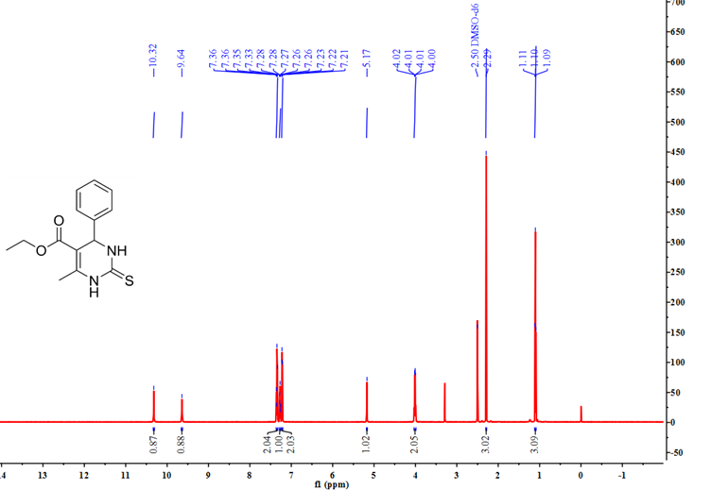
Fig. S24 ¹H NMR spectra of 4l in DMSO‒d₆ (600 MHz, 298K)
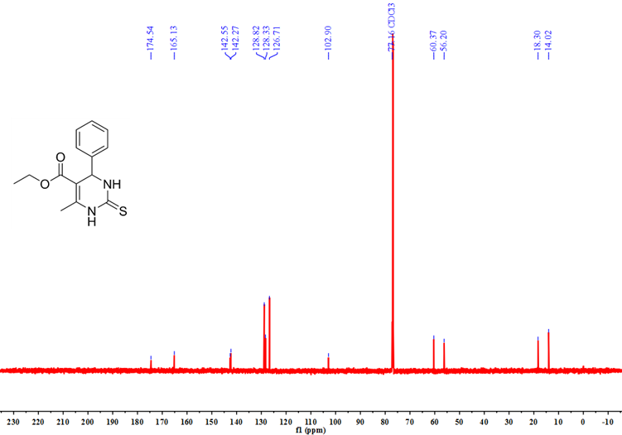
Fig. S25 ¹³C NMR spectra of 4l in CDCl₃ (151 MHz, 298K)

