Table 1. The binding energy of top-scoring ligands targeting AKT 1
S/N | Chemical Structure | PubChem ID | Compound name | Binding affinity (kcal/mol)
1 | 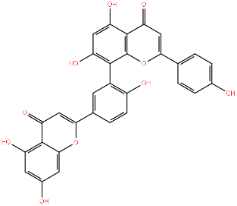 | 5281600 | Amentoflavone | -11
2 | 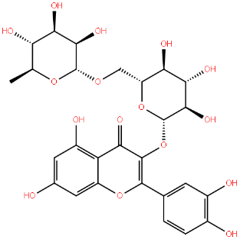 | 5280805 | Rutin | -10
3 | 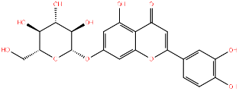 | 5280637 | Cynaroside | -9.9
4 | 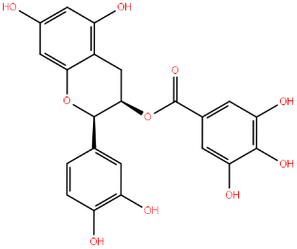 | 107905 | Epicatechin gallate | -9.9
5 | 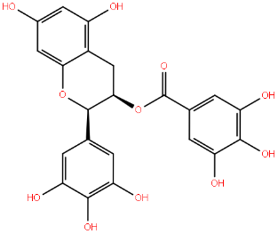 | 65064 | Epigallocatechin gallate | -9.9
6 | 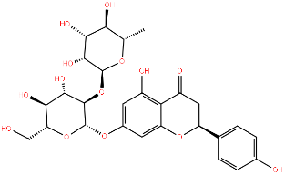 | 442428 | Naringin | -9.8
7 | 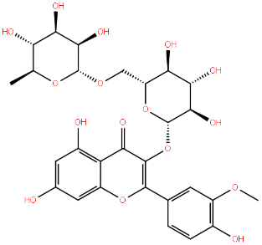 | 5481663 | Isoharmnetin-3-o-rutinoside | -9.7
8 |  | 25227436 | Capivasertib  (reference drug) | -9.5

Table 2. The binding energy of top-scoring ligands targeting AKT 2
S/N | Chemical Structure | PubChem ID | Compound name | Binding affinity (kcal/mol)
1 |  | 5281600 | Amentoflavone | -12.5
2 |  | 5280637 | Cynaroside | -10.2
3 |  | 107905 | Epicatechin gallate | -10.2
4 |  | 442428 | Naringin | -10
5 |  | 65064 | Epigallocatechin gallate | -9.9
6 | 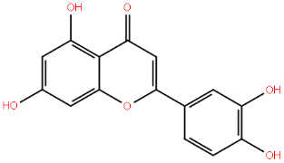 | 5280445 | Luteolin | -9.7
7 | 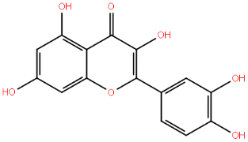 | 5280343 | Quercetin | -9.7
8 | 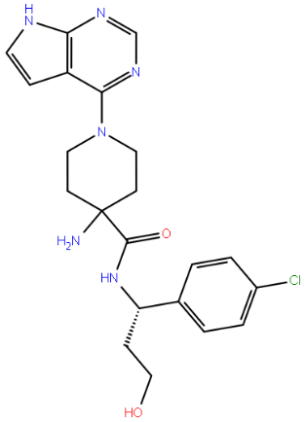 | 25227436 | Capivasertib  (reference drug) | -8.4

