Integrated Supercritical CO₂ and subcritical water extraction of high-value compounds to valorize brown macroalgae (Padina tetrastromatica and Turbinaria conoides) harvested from Indian coastline
Nidhi Hans^{1*}, Anushree Malik², Satyanarayan Naik^{1, *}
¹Supercritical Fluid Extraction Lab, Centre for Rural Development and Technology, IIT Delhi 110016
²Applied Microbiology Laboratory, Centre for Rural Development and Technology, IIT Delhi 110016

Email address:
nidhihans015@gmail.com (N. Hans)
anushree@rdat.iitd.ac.in (A. Malik)
snn@rdat.iitd.ac.in (S. N. Naik) - *Corresponding author

Postal address:
Room no 390, Block III
Centre for Rural Development and Technology
IIT Delhi
Hauz Khas, Delhi-110016
India
Tel: +91 11 2659 6356

FIGURES
(a) GC-MS chromatogram of lipids obtained from Padina Tetrastromatica by conventional method
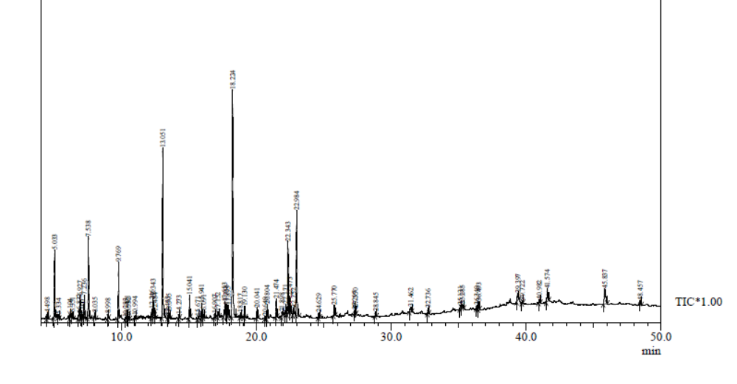
(b) GC-MS chromatogram of lipids obtained from Turbinaria Conoides by conventional method
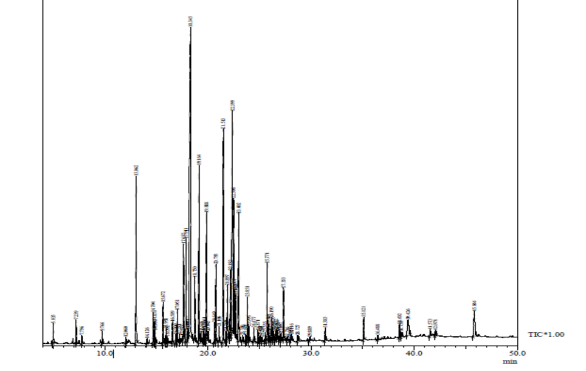
(c) GC-MS chromatogram of lipids obtained from Padina Tetrastromatica by supercritical CO₂ extraction
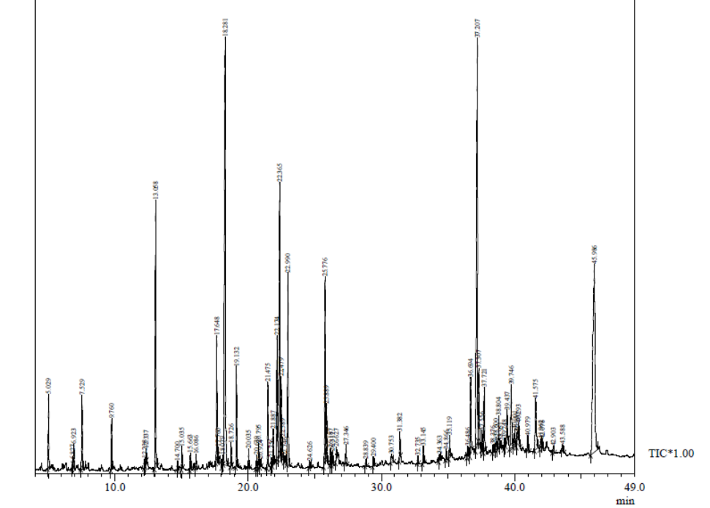
(d) GC-MS chromatogram of lipids obtained from Turbinaria Conoides by supercritical CO₂ extraction
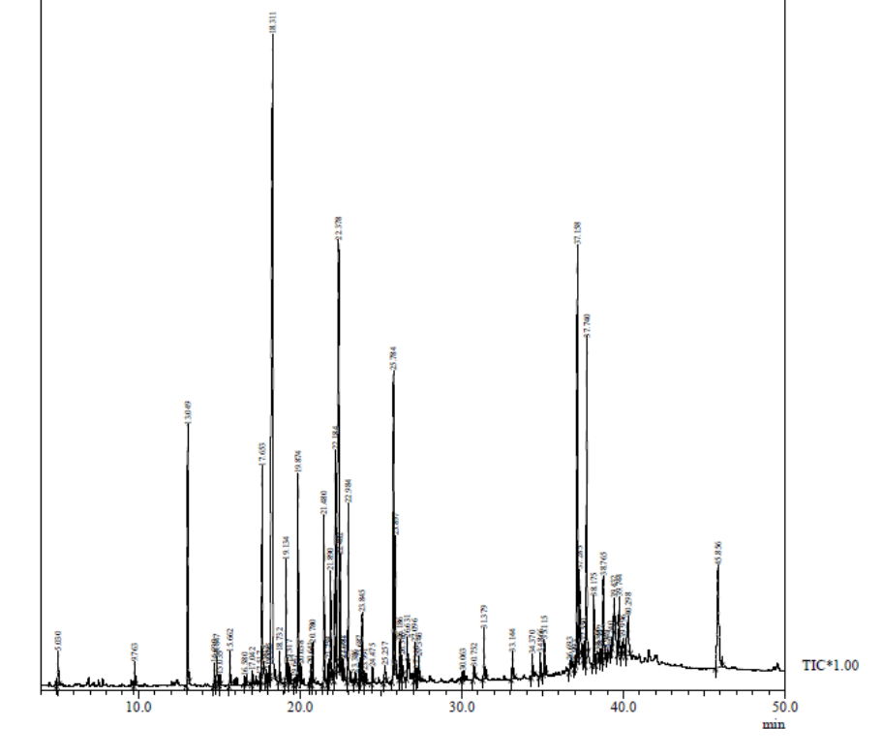
Figure S1: GC-MS chromatograms of lipid from Padina tetrastromatica and Turbinaria conoides obtained after conventional soxhlet extraction (a, c) and supercritical CO₂ extraction (b, d), respectively
(a)
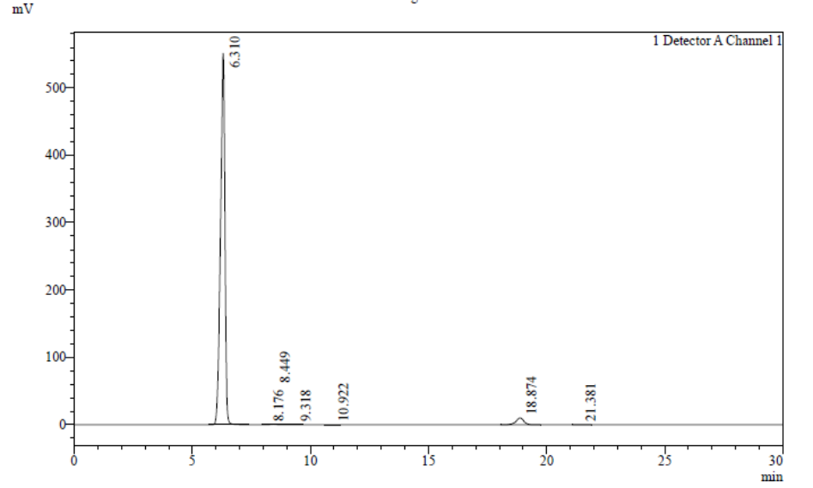
(b)
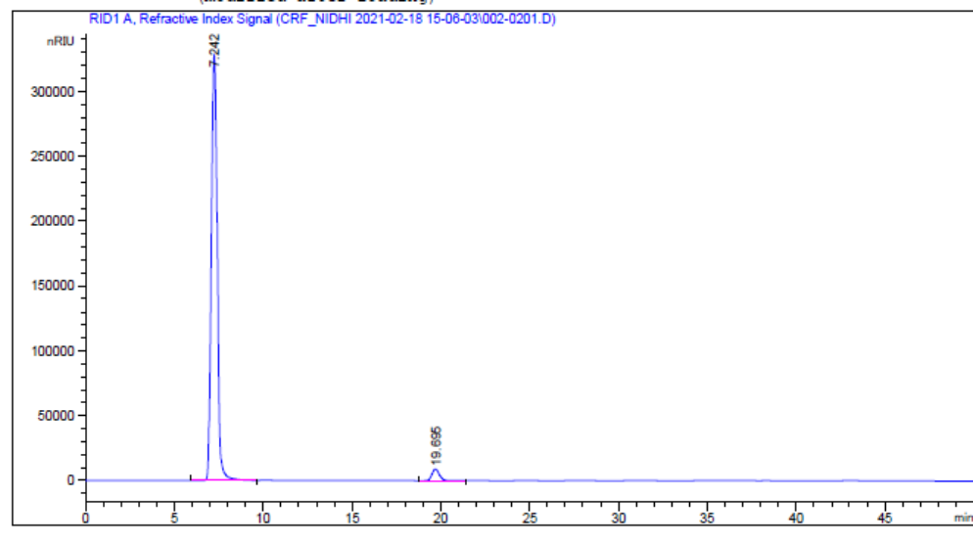
(c)
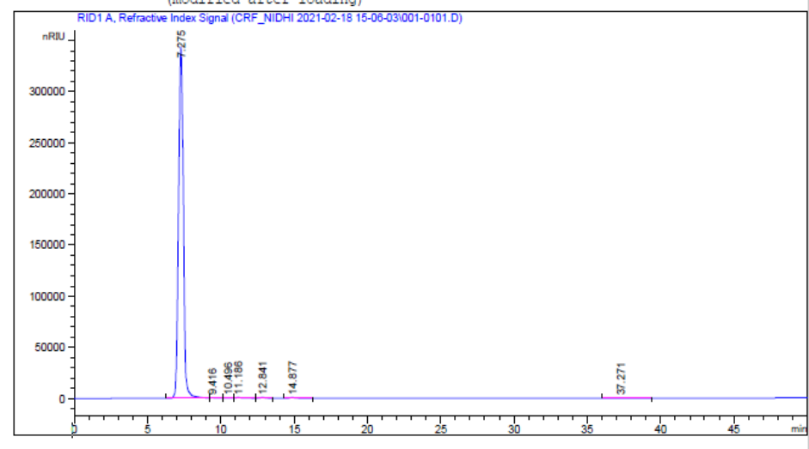
(d)
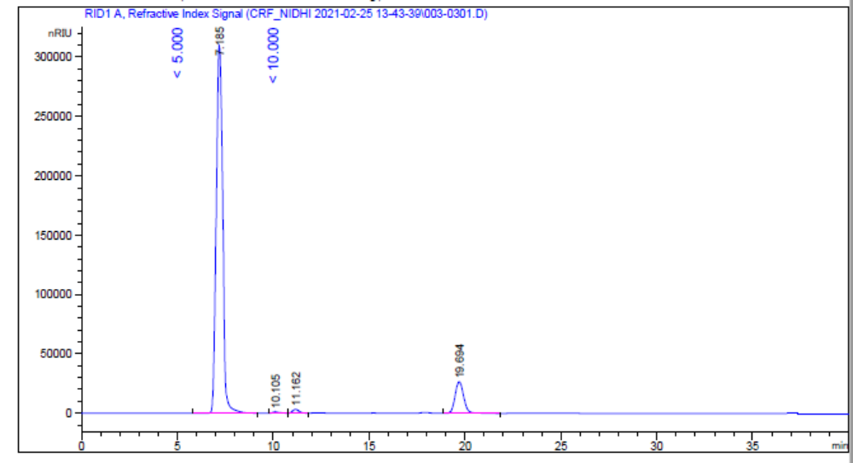
(e)
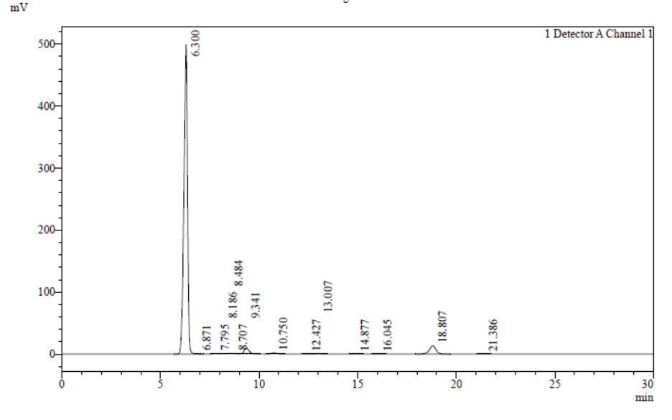
(f)
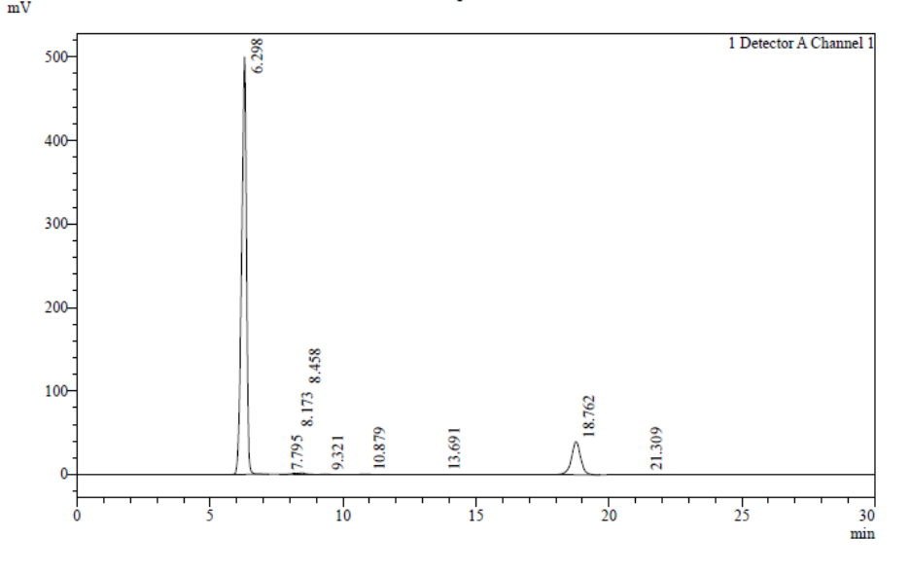
(g)
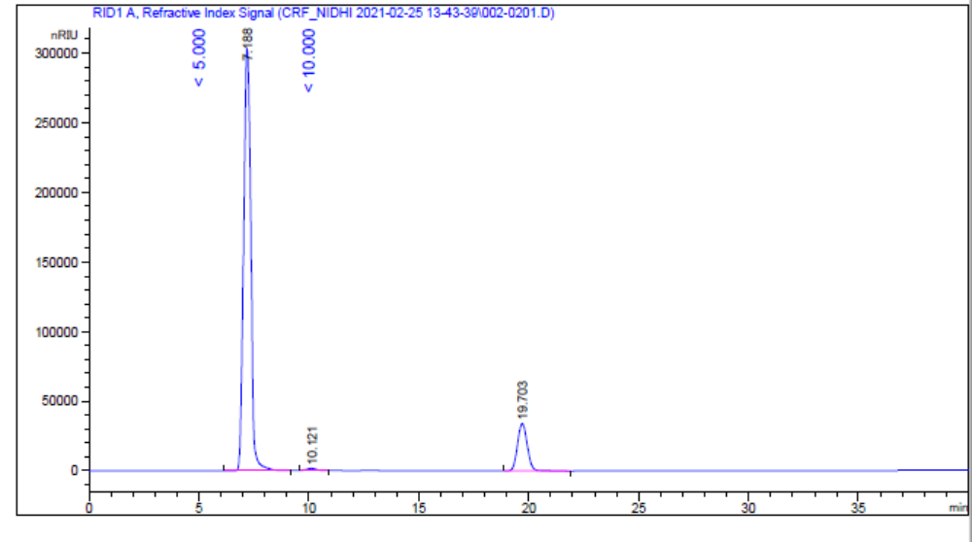
(h)
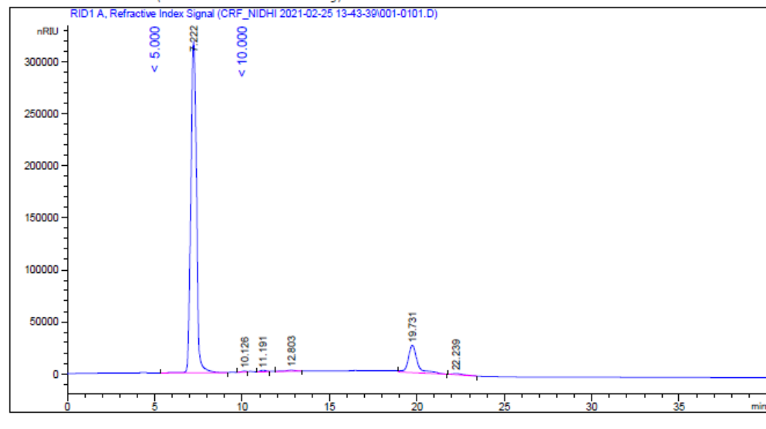
(i)
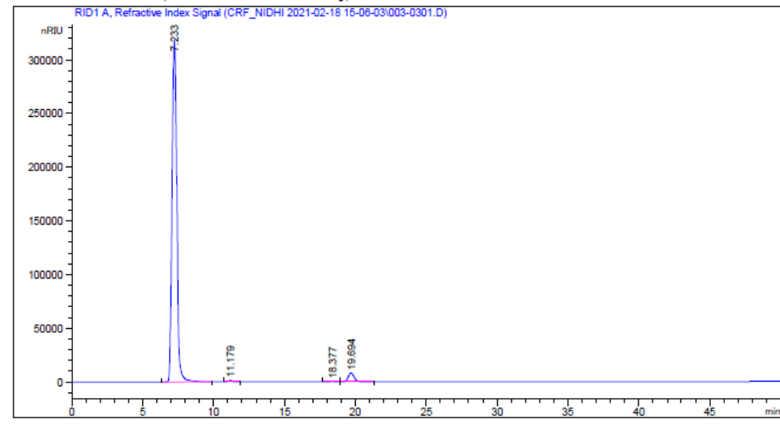
(j)
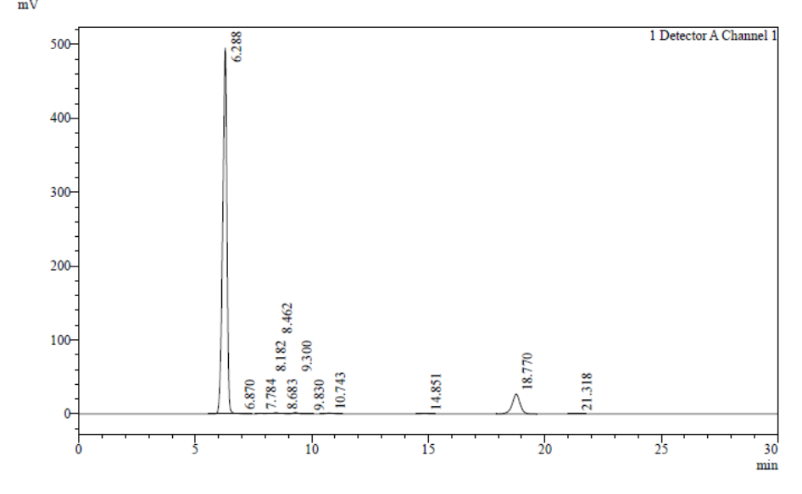

Figure S2: HPLC chromatogram of Padina tetrastromatica monosaccharides obtained by (a) aqueous (w/o treatment) (b) chemical method (c) UAE (d) EAE (e) ScW method and Turbinaria conoides obtained after (f) aqueous (w/o treatment) (g) chemical method (h) UAE (i) EAE (j) ScW method

