SUPPORTING INFORMATION (SI) for
Novel agonists of benzodiazepine receptors: Design, synthesis, binding assay and pharmacological evaluation of diphenyl-1,2,4-triazole derivatives
Hossein Fasihi^{a,b}, Elham Rezaeeª, Mojdeh Safari^{c}, Motahareh Sabagh^{c}, Soraya Shahhosseini^{a,d}, Mehrdad Faizi^{c}, Mona Khoramjouy^{e}, and Sayyed Abbas Tabatabaiª*
ª Department of Pharmaceutical Chemistry, School of Pharmacy, Shahid Beheshti University
of Medical Sciences, Tehran, Iran.
^{b} Biomaterial and Medicinal Chemistry Research Center, AJA University of Medical Science, Tehran, Iran
^{c} Department of Pharmacology and Toxicology, School of Pharmacy, Shahid Beheshti University of
Medical Sciences, Tehran, Iran
^{d} Protein Technology Research Center, Shahid Beheshti University of Medical Sciences, Tehran, Iran.
^{e} Phytochemistry Research Center, Shahid Beheshti University of Medical Sciences, Tehran, Iran
*Corresponding author. Tel: +982188200093; fax: +98 2188665341; E-mail address: sa_tabatabai@sbmu.ac.ir (Sayyed Abbas Tabatabai).
Contents:
1. Synthetic procedures
2. Spectroscopic data

1. Synthetic procedures
General methods:
Scheme 1: General synthetic methods. Reagents and conditions: (a) Hydrazine hydrate, hydrazine sulfate, ethylene glycol, 130°C, 3-5 h, reflux; (b) Chloroacethyl chloride, Na₂CO₃,KI, 90°C,1h, microwave; (c) Proper amine, methanol, K₂CO₃, KI, 100°C, 24-72h, reflux

A mixture of benzonitrile (48 mmol), hydrazine sulphate (48 mmol) and hydrazine hydrate (145 mmol) in ethylene glycol was heated at 130°C with stirring under argon for 3 hours. After cooling, the reaction mixture was diluted with water (200 ml). The obtained precipitate was filtered, washed with water and n-hexan, dried and recrystallized from ethyl acetate to give 9g (80%) of compound 2.
Next step 500 mg (2 mmol) of 2 and 480 mg(4 mmol) sodium carbonate were dissolved in chloroacetyle chloride and heated on microwave oven at 90°C for 40 min. the residue washed with ethyl acetate and water. The precipitate was dried and recrystallized from absolute ethanol to give 470 mg (75%) of 3.
General procedure for the synthesis of compounds 4a–4m
500 mg (1.6 mmol) of 3, 330 mg potassium carbonate (2.5 mmol) and 3.2 mmol of substituted amine were dissolved in methanol and were refluxed for 24-72 hours. The solvent was evaporated and residue washed with ethyl acetate to give 4a-4m compounds.

2. Spectroscopic data
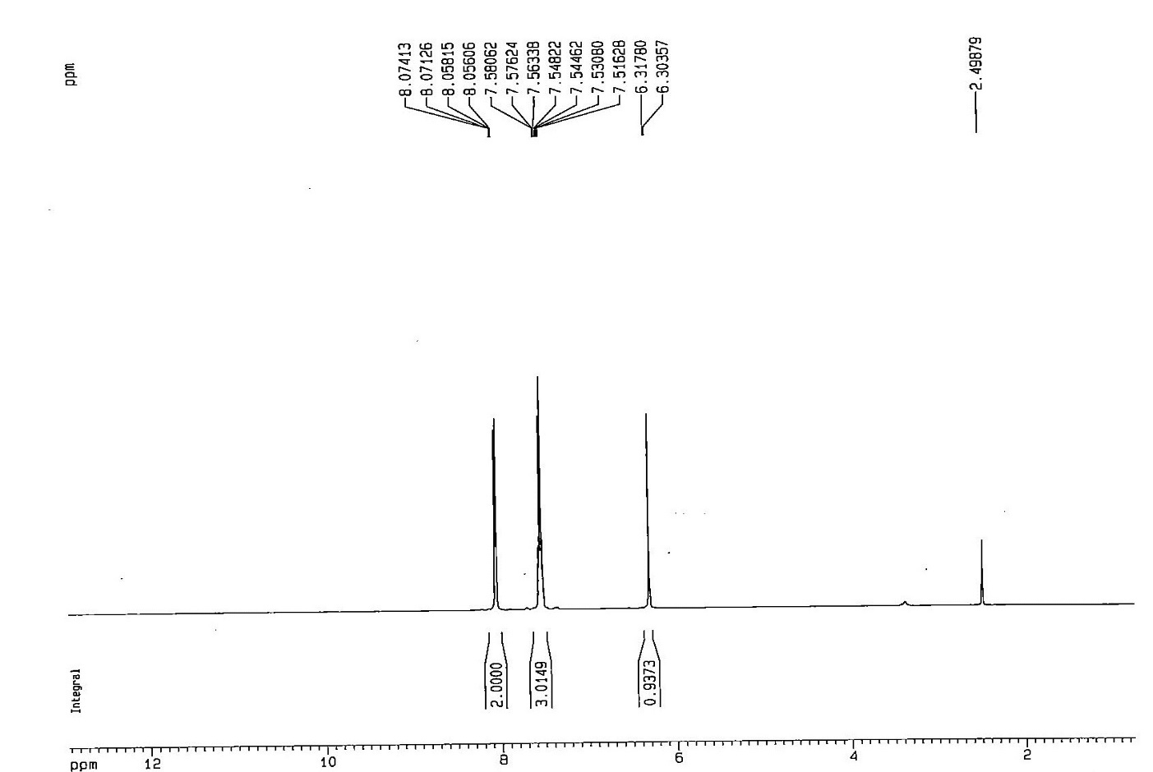
2.1 ¹H NMR spectrum 3,5-diphenyl-4H-1,2,4-triazol-4-amine

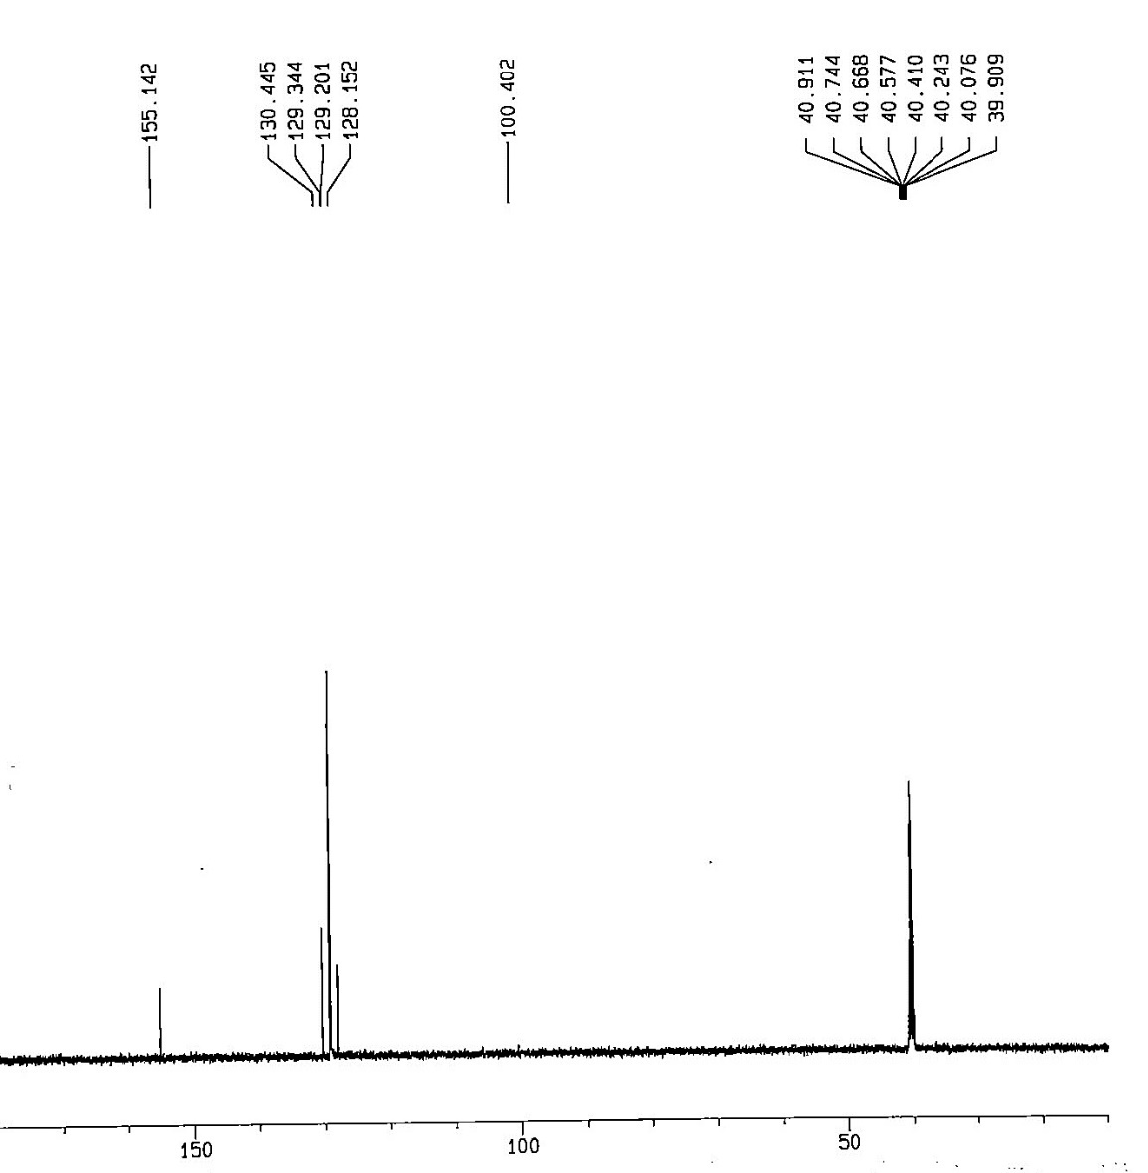
2.2 ¹³C NMR spectrum 3,5-diphenyl-4H-1,2,4-triazol-4-amine

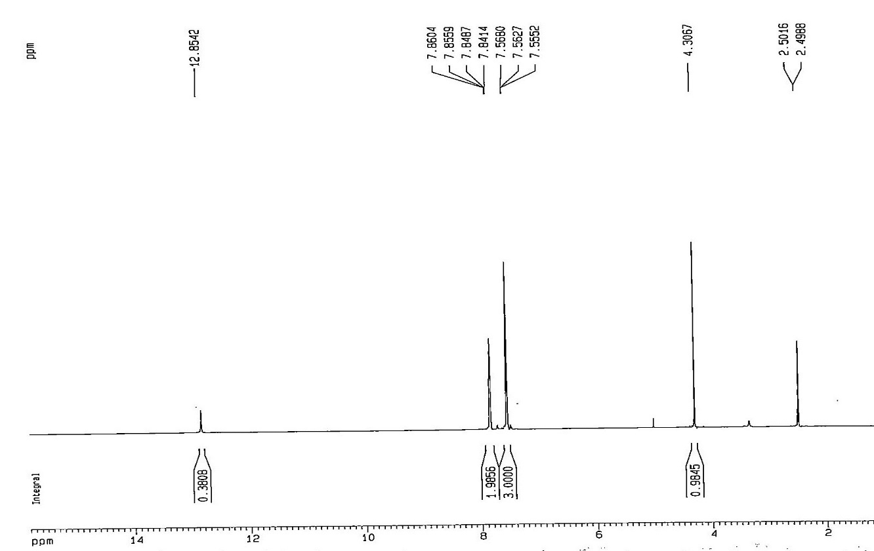
2.3 ¹H NMR spectrum of 2-chloro-N-(3,5-diphenyl-4H-1,2,4-triazol-4-yl)acetamide(3)

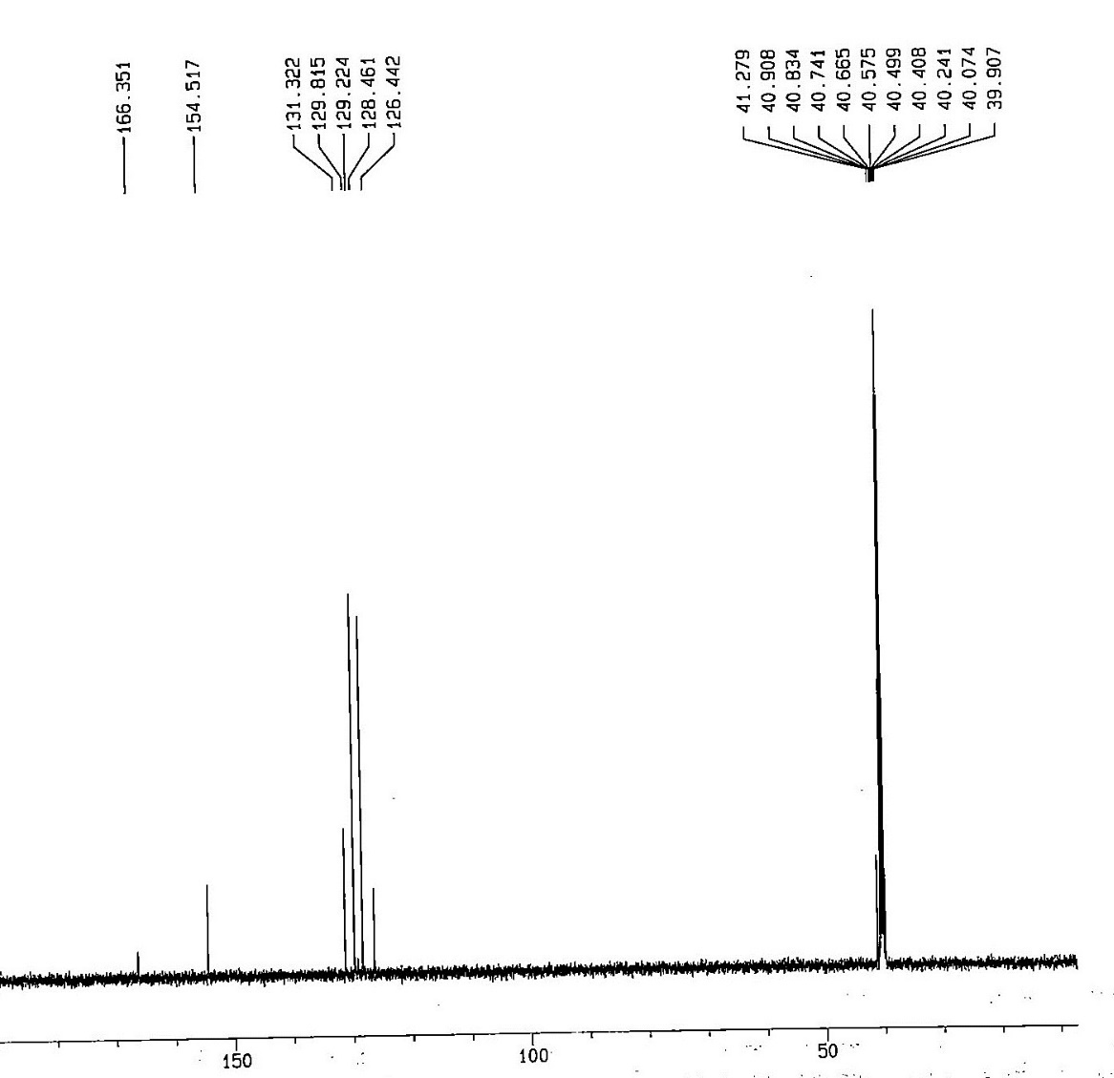
2.4 ¹³C NMR spectrum of 2-chloro-N-(3,5-diphenyl-4H-1,2,4-triazol-4-yl)acetamide
2.5 ¹H NMR spectrum of 2-(cyclohexylamino)-N-(3,5-diphenyl-4H-1,2,4-triazol-4-yl)acetamide (4a)

2.2 ¹³C NMR spectrum of 2-(cyclohexylamino)-N-(3,5-diphenyl-4H-1,2,4-triazol-4-yl)acetamide (4a)

2.7 ¹H NMR spectrum of N-(3,5-diphenyl-4H-1,2,4-triazol-4-yl)-2-(pyrrolidin-1-yl)acetamide (4b)

2.8 ¹³C NMR spectrum of N-(3,5-diphenyl-4H-1,2,4-triazol-4-yl)-2-(pyrrolidin-1-yl)acetamide (4b)

2.9 ¹H NMR spectrum of 2-(butylamino)-N-(3,5-diphenyl-4H-1,2,4-triazol-4-yl)acetamide (4c)

2.10 ¹³C NMR spectrum of 2-(butylamino)-N-(3,5-diphenyl-4H-1,2,4-triazol-4-yl)acetamide (4c)

2.11¹H NMR spectrum of N-(3,5-diphenyl-4H-1,2,4-triazol-4-yl)-2-(morpholinoamino)acetamid (4d)

2.12 ¹³C NMR spectrum of N-(3,5-diphenyl-4H-1,2,4-triazol-4-yl)-2-(morpholinoamino)acetamid (4d)

2.13 ¹H NMR spectrum of 2-(diethylamino)-N-(3,5-diphenyl-4H-1,2,4-triazol-4-yl)acetamide (4e)
2.14 ¹³C NMR spectrum of 2-(diethylamino)-N-(3,5-diphenyl-4H-1,2,4-triazol-4-yl)acetamide(4e)

2.15 ¹H NMR spectrum of N-(3,5-diphenyl-4H-1,2,4-triazol-4-yl)-2-(phenylamino)acetamide (4f)

2.16 ¹³C NMR spectrum of N-(3,5-diphenyl-4H-1,2,4-triazol-4-yl)-2-(phenylamino)acetamide (4f)

2.17 ¹H NMR spectrum of N-(3,5-diphenyl-4H-1,2,4-triazol-4-yl)-2-((4-fluorophenyl)amino)acetamide (4g)

2.18 ¹³C NMR spectrum of N-(3,5-diphenyl-4H-1,2,4-triazol-4-yl)-2-((4-fluorophenyl)amino)acetamide (4g)

2.19 ¹H NMR spectrum of N-(3,5-diphenyl-4H-1,2,4-triazol-4-yl)-2-(p-tolylamino)acetamide (4h)

2.20 ¹³C NMR spectrum of N-(3,5-diphenyl-4H-1,2,4-triazol-4-yl)-2-(p-tolylamino)acetamide (4h)
2.21 ¹H NMR spectrum of 2-(benzylamino)-N-(3,5-diphenyl-4H-1,2,4-triazol-4-yl)acetamide (4i)

2.21. ¹³C NMR spectrum of 2-(benzylamino)-N-(3,5-diphenyl-4H-1,2,4-triazol-4-yl)acetamide (4i)

2.22 ¹H NMR spectrum of N-(3,5-diphenyl-4H-1,2,4-triazol-4-yl)-2-((4-fluorobenzyl)amino)acetamide (4j)

2.23 ¹³C NMR spectrum of N-(3,5-diphenyl-4H-1,2,4-triazol-4-yl)-2-((4-fluorobenzyl)amino)acetamide (4j)
2.24 ¹H NMR spectrum of N-(3,5-diphenyl-4H-1,2,4-triazol-4-yl)-2-((4-methoxybenzyl)amino)acetamide (4k)

2.25¹³C NMR spectrum of N-(3,5-diphenyl-4H-1,2,4-triazol-4-yl)-2-((4-methoxybenzyl)amino)acetamide (4k)

2.26 ¹H NMR spectrum of N-(3,5-diphenyl-4H-1,2,4-triazol-4-yl)-2-((4-methylbenzyl)amino)acetamide (4l)

2.27 ¹³C NMR spectrum of N-(3,5-diphenyl-4H-1,2,4-triazol-4-yl)-2-((4-methylbenzyl)amino)acetamide (4l)

2.28 ¹H NMR spectrum of 2-((3,4-dichlorobenzyl)amino)-N-(3,5-diphenyl-4H-1,2,4-triazol-4-yl)acetamide (4m)

2.29 ¹³C NMR spectrum of 2-((3,4-dichlorobenzyl)amino)-N-(3,5-diphenyl-4H-1,2,4-triazol-4-yl)acetamide (4m)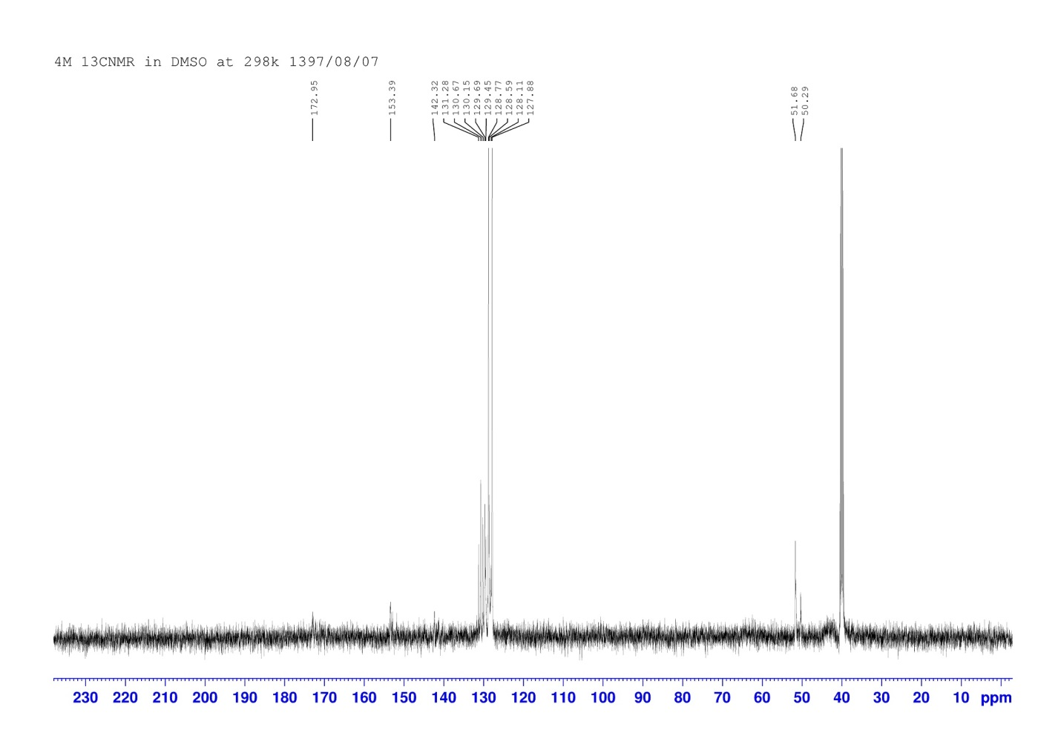

2.30 radioligand binding assay

Determining the time to reach the steady state. All data are reported in triplicate (n=3) and based on the mean ± standard deviation from the mean (Mean ± SEM)

Incubation time  (min) | TB  (cpm) | NSB  (cpm) | SB  (cpm)
0 | 0 | 0 | 0
10 | 456.6±60.2 | 90.3±2.8 | 367±59.3
20 | 516±9.8 | 104±1 | 412±10.58
25 | 537±32.5 | 104.3±2.08 | 433.6±20.6
30 | 577.6±79.8 | 102.3±9.86 | 455.3±70.4
40 | 577.6±47.3 | 99.6±9.29 | 458±50.06

Percent of total binding based on increasing amount of tissue. All data are presented as triplicates and based on the mean ± standard deviation of the mean. (Mean ± SEM)
Protein concentration  (μg) | TB  (cpm) | TA  (cpm) | (TB×100)/TA
0 | 0 | 0 | 0
50 | 194.3±12.5 | 3974 | 4.85±0.27
100 | 316±61.7 | 3974 | 7.9±1.56
150 | 457.6±46.7 | 3974 | 11.48±1.14
200 | 517.6±14.04 | 3974 | 12.98±0.35
250 | 551.3±105.02 | 3974 | 13.83±2.6
300 | 580±12.28 | 3974 | 14.55±0.3

Determination of specific binding against different concentrations of labeled flumazenil. All data are reported in triplicate (n=3) and based on the mean ± standard deviation from the mean (Mean ± SEM).
³H-flumazenil  (nM) | TB  (cpm) | NSB  (cpm) | SB  (cpm)
0.97 | 2129.67±11.2 | 153.5.3±5.3 | 1976.7±7.7
0.86 | 2056.6±37.1 | 149.67±3.53 | 1907±33.65
0.63 | 1836±107.3 | 141.33±3.48 | 1695±110.6
0.4 | 1358.33±6.39 | 118.33±9.83 | 1240.3±3.93
0.28 | 776.3±61.9 | 113.3±8.46 | 663±69.6
0.17 | 429±67.1 | 101.67±5.5 | 327.36±4.9
0.05 | 240±16.09 | 86.67±5.79 | 153.33±21.4

Effect of concentration of compounds on the binding interval of tritiated [3H]flumazenil. All data are reported in triplicate (n=3) and based on the mean ± standard deviation from the mean

 | log l (µM) | Specific binding  (cpm)
Compound 4a | -6.3  -5.3  -3.3  -1.3  0.6  1.6  2.6  3.6 | 70.37 ± 1.64  64.12 ± 2.94  49.36 ± 1.63  40.32 ± 3.74  33.90 ± 1.69  27.68 ± 2.50  25.87 ± 0.62  15.11 ± 2.78

 | log l (µM) | Specific binding  (cpm)
Compound 4b | -6.3  -5.3  -3.3  -1.3  -0.3  0.6  1.6  2.6 | 57.03 ± 0.81  51.11 ± 4.08  42.32 ± 3.26  36.82 ± 4.89  25.64 ± 3.29  24.23 ± 0.81  23.06 ± 0.81  22.15 ± 0.39

 | log l (µM) | Specific binding  (cpm)
Compound 4c | -6.3  -5.3  -3.3  -1.3  -0.3  0.6  1.6  2.6  3.6 | 70.04 ± 2.40  59.12 ± 6.54  48.36 ± 2.44  37.99 ± 6.12  33.51 ± 4.08  31.23 ± 1.63  27.01 ± 3.27  16.42 ± 5.66  11.11 ± 2.94

 | log l (µM) | Specific binding  (cpm)
Compound 4d | -3.3  -1.3  -0.3  0.6  1.6  2.6 | 54.15 ± 2.82  33.86 ± 6.22  29.45 ± 4.49  33.52 ± 1.88  31.98 ± 1.66  16.90 ± 4.50

 | log l (µM) | Specific binding  (cpm)
Compound 4e | -6.3  -5.3  -3.3  -1.3  -0.3  0.6  1.6 | 97.38 ± 0.81  95.55 ± 1.63  89.75 ± 3.26  84.71 ± 3.26  76.53 ± 2.44  73.22 ± 3.26  70.20 ± 2.44

 | log l (µM) | Specific binding  (cpm)
Compound 4f | -6.3  -5.3  -4.3  -3.3  -2.3  -1.3  -0.3  0.6 | 37.21 ± 4.08  36.43 ± 2.44  32.97 ± 2.44  31.18 ± 2.44  25.50 ± 2.44  21.14 ± 1.63  19.11 ± 3.26  8.39 ± 4.08

 | log l (µM) | Specific binding  (cpm)
Compound 4g | -6.3  -5.3  -3.3  -1.3  -0.3  0.6  1.6  2.6 | 75.02 ± 1.63  65.94 ± 6.12  58.30 ± 5.59  53.15 ± 4.11  49.38 ± 2.62  41.16 ± 6.52  38.50 ± 2.69  36.63 ± 1.92

 | log l (µM) | Specific binding  (cpm)
Compound 4h | -5.3  -4.3  -3.3  -2.3  -1.3  0.3  1.3 | 43.47 ± 2.49  35.64 ± 1.24  29.02 ± 1.69  26.97 ± 2.16  19.09 ± 0.81  10.50 ± 1.87  9.49 ± 0.99

 | log l (µM) | Specific binding  (cpm)
Compound 4i | -5.3  -4.3  -3.3  -2.3  -1.3  0.3  1.3 | 40.86 ± 3.22  35.97 ± 0.81  28.35 ± 2.44  25.30 ± 3.68  18.09 ± 1.63  10.00 ± 2.44  7.96 ± 1.43

 | log l (µM) | Specific binding  (cpm)
Compound 4j | -6.3  -5.3  -4.3  -3.3  -2.3  -1.3  0.3 | 47.52 ± 2.86  45.73 ± 1.63  40.98 ± 4.08  33.47 ± 5.71  29.56 ± 3.26  18.19 ± 5.63  8.83 ± 2.24

 | log l (µM) | Specific binding  (cpm)
Compound 4k | -5.3  -3.3  -1.3  -0.3  0.6  1.6  2.6 | 94.66 ± 2.44  77.31 ± 0.81  72.43 ± 4.08  71.53 ± 0.81  62.93 ± 5.31  59.29 ± 2.33  54.80 ± 4.28

 | log l (µM) | Specific binding  (cpm)
Compound 4l | -6.3  -5.3  -3.3  -1.3  -0.3  0.6  1.6 | 63.38 ± 2.05  53.81 ± 3.85  34.19 ± 6.54  28.45 ± 3.85  32.18 ± 3.26  30.29 ± 4.02  19.56 ± 0.81

 | log l (µM) | Specific binding  (cpm)
Compound 4m | -6.3  -5.3  -3.3  -1.3  -0.3  0.6  1.6  2.6 | 75.02 ± 2.44  63.94 ± 10.27  60.96 ± 2.07  53.81 ± 3.40  51.04 ± 1.22  44.49 ± 3.96  40.16 ± 1.46  37.32 ± 1.62

 | log l (µM) | Specific binding  (cpm)
Zolpidem | -5.3  -3.3  -1.3  -0.3  0.6  1.6  2.6 | 53.75 ± 1.63  45.64 ± 0.81  29.65 ± 2.44  16.59 ± 4.08  14.56 ± 1.63  11.56 ± 2.44  6.15 ± 0.81

Ki and IC50 values of different ligands as inhibitors of specific binding of labeled flumazenil in vitro using rat brain cortex membrane (Mean ± SEM)
Compound | IC₅₀ (95% CI) (nM) | Ki (nM)
4a | 32.65  (9.80 to 108.7) | 13.89  (4.17 to 46.25)
4b | 49.09  (19.13 to 126.0) | 20.88  (8.14 to 53.61)
4c | 45.88  (12.30 to 171.1) | 19.51  (5.23 to 72.80)
4d | 15.43  (1.85 to 128.4) | 6.56  (0.78 to 54.63)
4e | 75.28  (29.84 to 189.9) | 32.01  (12.69 to 80.80)
4f | 7.66  (2.0 to 28.0) | 3.25  (0.85 to 11.91)
4g | 76.39  (18.97 to 307.6) | 32.49  (8.03 to 130.33)
4h | 9.54  (3.43 to 26.56) | 4.01  (1.44 to 11.20)
4i | 8.05  (2.90 to 22.0) | 3.39  (1.22 to 9.28)
4j | 6.10  (2.13 to 17.51) | 2.56  (0.89 to 7.35)
4k | 95.44  (18.24 to 499.3) | 40.19  (7.69 to 210.67)
4l | 9.46  (1.35 to 66.02) | 3.98  (0.56 to 27.85)
4m | 75.54  (17.72 to 322.1) | 31.39  (7.38 to 134.2)
Zolpidem | 48.93  (27.57 to 86.86) | 20.61  (11.63 to 36.64)

The percentage of specific binding against increasing concentrations of compounds was plotted using graphpad Prism software and non-linear regression analysis.

2.31 Raw data of sleeping time (minute) in pentobarbital-induced sleep test. One-way ANOVA with Tukey’s HSD posthoc test was used (n=10).

 | 5 mg/kg | 10 mg/kg | 20 mg/kg | 40 mg/kg
Compound 4a | 25  23  21  22  23  23  25  20  27  25 | 25  32  30  30  26  26  25  30  31  32 | 44  30  35  35  32  30  40  44  40  41 | 54  52  56  46  48  52  52  60  58  45

 | 5 mg/kg | 10 mg/kg | 20 mg/kg | 40 mg/kg
Compound 4b | 21  25  28  26  25  26  27  19  23  21 | 24  28  20  28  28  27  25  23  24  22 | 38  52  44  39  48  37  40  36  32  33 | 53  53  37  64  56  60  63  44  58  40

 | 5 mg/kg | 10 mg/kg | 20 mg/kg | 40 mg/kg
Compound 4c | 22  26  27  18  28  21  19  18  20  22 | 33  36  27  37  32  36  35  34  32  26 | 64  70  60  57  68  48  48  52  54  50 | 70  74  68  66  56  58  68  60  65  70

 | 5 mg/kg | 10 mg/kg | 20 mg/kg | 40 mg/kg
Compound 4d | 49  38  48  36  40  49  36  45  41  45 | 55  55  62  53  39  36  45  42  45  72 | 53  79  69  55  53  73  70  53  80  63 | 80  80  69  80  70  79  69  70  65  70

 | 5 mg/kg | 10 mg/kg | 20 mg/kg | 40 mg/kg
Compound 4e | 25  23  24  20  26  21  21  26  28  26 | 30  27  25  23  24  22  24  29  27  28 | 36  37  40  38  34  33  38  48  44  39 | 50  60  65  47  58  44  49  53  44  64

 | 5 mg/kg | 10 mg/kg | 20 mg/kg | 40 mg/kg
Compound 4f | 22  28  25  20  20  22  20  16  16  20 | 16  38  23  25  16  22  28  16  21  28 | 32  35  29  25  41  28  40  35  48  33 | 45  25  40  20  33  44  47  38  49  50

 | 5 mg/kg | 10 mg/kg | 20 mg/kg | 40 mg/kg
Compound 4g | 40  21  39  30  31  16  20  16  17  17 | 43  52  21  20  21  16  20  16  29  16 | 30  29  21  37  42  39  34  18  32  46 | 35  39  51  51  30  29  51  37  40  50

 | 5 mg/kg | 10 mg/kg | 20 mg/kg | 40 mg/kg
Compound 4h | 38  35  50  27  38  40  34  32  32  32 | 48  55  34  47  39  35  45  42  43  42 | 44  79  69  40  33  73  43  53  44  50 | 49  79  65  64  70  60  69  60  65  62

 | 5 mg/kg | 10 mg/kg | 20 mg/kg | 40 mg/kg
Compound 4i | 16  32  21  16  29  20  20  28  20  16 | 20  16  25  39  19  36  47  40  36  46 | 29  20  26  18  55  40  43  22  42  43 | 33  38  33  28  36  58  26  50  26  50

 | 5 mg/kg | 10 mg/kg | 20 mg/kg | 40 mg/kg
Compound 4j | 20  16  20  20  27  35  22  17  20  20 | 16  24  19  28  28  27  32  30  24  24 | 37  33  30  39  16  32  23  40  35  37 | 40  33  30  46  29  34  50  33  51  46

 | 5 mg/kg | 10 mg/kg | 20 mg/kg | 40 mg/kg
Compound 4k | 29  29  30  20  25  16  32  25  23  16 | 45  45  38  58  58  56  37  37  40  40 | 37  55  78  65  47  49  36  80  54  47 | 57  64  79  80  50  80  75  55  60  65

 | 5 mg/kg | 10 mg/kg | 20 mg/kg | 40 mg/kg
Compound 4l | 20  26  28  20  32  20  16  40  20  22 | 33  20  27  28  32  30  28  34  47  26 | 64  54  50  57  68  48  57  36  54  50 | 80  80  80  66  56  58  80  60  65  70

 | 5 mg/kg | 10 mg/kg | 20 mg/kg | 40 mg/kg
Compound 4m | 24  32  46  22  38  44  28  34  16  27 | 39  46  39  27  21  26  20  47  40  45 | 53  79  62  39  48  62  66  44  48  80 | 67  80  63  56  59  80  71  79  80  80

2.32 Raw data of total distance movement (cm) in open field test. One-way ANOVA with Tukey’s HSD posthoc test was used (n=10).

 | 5 mg/kg | 10 mg/kg | 20 mg/kg | 40 mg/kg
Compound 4a | 4200.0  4120.0  3440.0  3600.0  2160.0  3600.0  4400.0  3260.9  3920.0  3132.6 | 3840.0  3040.0  3547.3  3273.4  3160.0  3680.0  3320.0  3188.4  3960.0  3119.7 | 2164.1  2120.0  1680.0  1912.9  2000.0  2720.0  2599.0  2176.2  2400.0  2560.0 | 1800.0  1479.4  1200.0  1720.0  2200.0  2040.0  1672.0  1746.3  2396.1  1840.0

 | 5 mg/kg | 10 mg/kg | 20 mg/kg | 40 mg/kg
Compound 4b | 4180.0  4128.0  3500.0  3906.8  3060.0  3902.4  4358.8  3260.9  3920.0  4000.0 | 3914.8  3027.2  3547.3  2538.0  2307.2  3424.0  3471.6  3188.4  3989.2  3955.6 | 1871.2  1928.0  1775.2  1474.4  1685.2  2172.8  2138.0  1649.2  2538.8  3506.8 | 1341.6  1230.4  1342.4  1262.4  1575.6  1306.8  1194.8  1258.4  1302.4  1328.4

 | 5 mg/kg | 10 mg/kg | 20 mg/kg | 40 mg/kg
Compound 4c | 2658.0  2794.8  2792.3  2849.2  2986.8  2938.4  2679.2  2453.6  3064.3  2941.9 | 2129.2  2006.0  2485.2  2218.4  2182.4  2173.6  2591.9  2634.8  2715.6  2848.8 | 1609.6  1794.8  1736.0  1951.6  1250.4  2094.0  1471.2  1993.2  1805.8  2244.9 | 845.2  750.4  1115.6  885.6  982.4  986.8  1102.4  671.2  1478.7  844.8

 | 5 mg/kg | 10 mg/kg | 20 mg/kg | 40 mg/kg
Compound 4d | 2404.8  2538.0  2227.2  2177.8  2210.3  2315.6  1991.2  3510.2  2271.2  3062.4 | 2195.6  2274.8  1729.6  2569.9  2138.0  2929.6  2853.0  2649.7  2093.6  1782.4 | 2174.8  2218.8  2039.2  1914.8  1950.8  1351.2  1694.4  1386.8  2106.8  2715.6 | 1329.6  794.8  906.8  1551.6  1290.8  891.6  1120.0  874.8  942.4  991.6

 | 5 mg/kg | 10 mg/kg | 20 mg/kg | 40 mg/kg
Compound 4e | 4049.2  3591.2  3951.2  3862.4  3293.6  3898.0  3946.8  3418.4  3906.8  3822.4 | 3506.8  2938.4  3374.4  2794.8  2307.2  3146.8  3818.0  2619.2  3463.6  3613.6 | 1631.2  1879.2  1550.4  1871.2  1694.4  2578.8  2026.8  1751.2  1591.2  1915.6 | 1338.0  1290.0  982.4  1115.6  1253.6  1071.2  1431.2  1235.6  843.6  1475.6

 | 5 mg/kg | 10 mg/kg | 20 mg/kg | 40 mg/kg
Compound 4f | 5000.0  4480.1  5000.0  4915.8  3665.3  4900.0  4950.0  4900.0  5250.0  3750.8 | 5000.0  4074.3  3677.4  4183.5  3343.8  5000.0  5050.0  4900.0  4276.7  4305.1 | 3812.6  2587.7  4092.0  3955.6  2882.5  3685.9  3961.1  3362.6  4037.0  4835.9 | 2280.5  2358.8  3605.3  3189.8  3625.2  2285.0  2500.0  3050.0  3075.6  2250.0

 | 5 mg/kg | 10 mg/kg | 20 mg/kg | 40 mg/kg
Compound 4g | 5000.0  5000.0  4250.0  3915.8  2785.3  4500.0  5500.0  4076.1  4900.0  3915.8 | 4720.2  3345.5  4434.2  4091.7  3646.0  4600.0  3917.5  3985.5  5000.0  3899.7 | 2705.2  1560.9  2635.7  2391.1  2995.1  4435.5  3248.7  2720.3  3464.4  1745.1 | 2059.5  1849.2  1915.8  4150.0  3250.0  3058.5  2090.0  2182.9  2995.1  1831.7

 | 5 mg/kg | 10 mg/kg | 20 mg/kg | 40 mg/kg
Compound 4h | 3289.4  3000.0  2596.4  1686.3  2762.8  2762.2  2344.4  4387.8  2762.2  4000.0 | 3717.9  2242.4  2020.7  3212.3  2465.1  3715.9  3566.3  3312.1  2020.7  712.3 | 2470.3  1297.3  2650.4  3380.7  2438.6  1457.2  2000.0  1537.6  3066.4  3503.9 | 2124.2  1500.0  2153.8  1703.0  1696.4  1283.6  1400.0  2150.0  2197.2  1239.5

 | 5 mg/kg | 10 mg/kg | 20 mg/kg | 40 mg/kg
Compound 4i | 5000.0  4328.6  4286.1  4589.8  3008.2  3911.5  3250.0  4717.0  4511.7  4039.0 | 4554.5  3575.6  3778.8  5000.0  4290.7  3593.4  4786.2  4650.0  3492.0  5000.0 | 3345.5  2580.9  3823.0  2706.2  4047.7  5000.0  3366.0  4078.6  2718.0  2525.7 | 1918.2  2488.1  3021.3  2954.9  2193.6  1823.3  2760.8  2121.3  1769.5  2000.0

 | 5 mg/kg | 10 mg/kg | 20 mg/kg | 40 mg/kg
Compound 4j | 3646.5  5000.0  5200.0  4800.0  4735.0  5000.0  2234.4  2275.0  2951.5  3339.1 | 2254.8  3347.4  2951.5  5000.0  4464.8  2972.0  5000.0  3877.2  2954.4  5000.0 | 2275.3  2275.6  5000.0  2627.2  4500.0  2261.1  2800.0  2000.0  2447.7  2927.0 | 1570.9  1141.4  1451.1  2951.8  2098.0  3347.6  2488.7  3646.3  2847.6  3999.9

 | 5 mg/kg | 10 mg/kg | 20 mg/kg | 40 mg/kg
Compound 4k | 3460.6  3479.6  4000.0  3500.0  3500.0  3000.0  3250.0  2934.4  4402.5  2885.5 | 2500.0  2440.2  2559.1  3977.2  2684.7  1680.3  3840.8  3250.0  3297.4  3235.4 | 1850.4  2039.6  2559.6  2561.1  1524.5  2000.0  2250.0  2021.6  2562.3  2256.3 | 1250.0  1518.3  1835.5  1500.0  1250.0  750.0  1363.0  1600.5  600.0  1363.0

 | 5 mg/kg | 10 mg/kg | 20 mg/kg | 40 mg/kg
Compound 4l | 3250.0  3288.1  3079.1  3500.0  3844.4  2866.8  2111.8  3717.3  4111.8  3642.3 | 2868.5  3000.0  3000.0  3779.0  1779.0  3376.4  3378.1  1778.1  3029.0  3250.0 | 2747.4  2042.6  2742.2  3162.0  3132.9  2107.0  2161.5  2742.1  2500.0  2992.1 | 1346.9  1750.0  1661.9  1500.0  2067.1  1000.0  1660.2  1100.0  1865.8  1367.0

 | 5 mg/kg | 10 mg/kg | 20 mg/kg | 40 mg/kg
Compound 4m | 3000.0  3491.1  3490.3  3504.4  3885.6  3500.0  1884.8  3000.0  3830.4  3677.4 | 3250.0  2592.8  3255.6  2832.1  3250.0  878.6  3239.9  3118.9  3337.1  3561.1 | 1501.6  2509.0  2170.0  2304.2  2598.4  2680.5  2770.3  2306.2  2257.2  2806.1 | 1884.2  1500.0  1408.3  1464.3  1565.0  1250.0  1500.0  750.0  1848.4  500.0

2.33 Raw data of latency (s) on anterograde memory in passive avoidance test. One-way ANOVA with Tukey’s HSD posthoc test was used (n=10).

Control | 4h  (10 mg/kg) | 4d  (10 mg/kg) | Zolpidem
420  420  420  420  420  420  420  420 | 420  420  320  420  400  420  420  420 | 40  140  420  420  90  420  320  420 | 30  75  120  25  50  100  20  32

