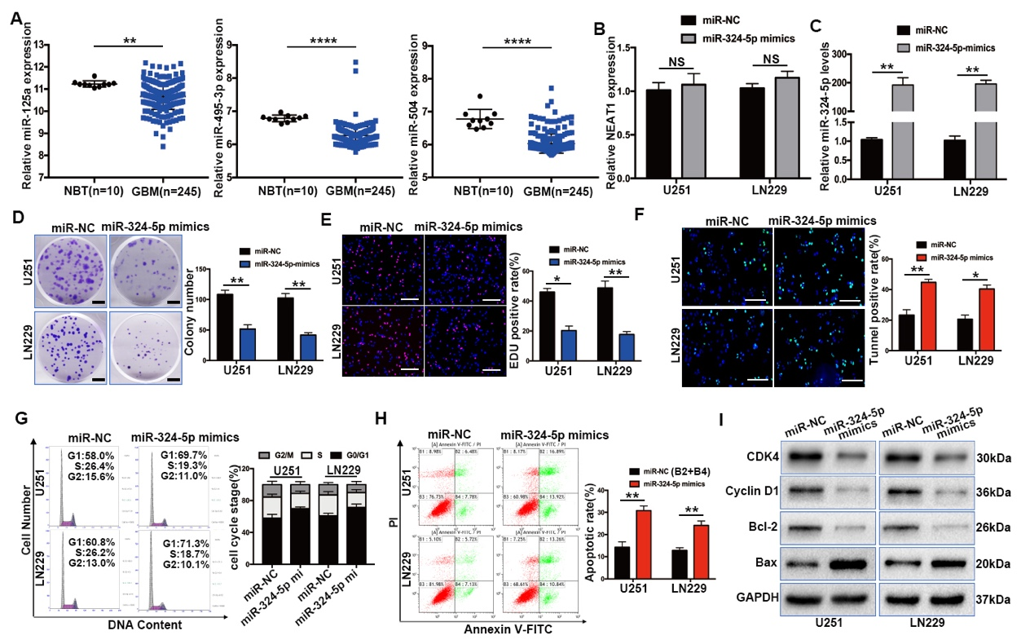
Figure S1. MiR-324-5p inhibits proliferation and promotes apoptosis in glioma. A. The expression of miR-125a, miR-495-3p and miR-504 was analyzed in control brain tissues and glioma tissues of the TCGA database. B. NEAT1 expression was monitored using qRT-PCR in U251 and LN229 after transfection with miR-324-5p mimics or miR-NC. C. qRT-PCR analysis of the expression of miR-324-5p in in U251 and LN229 cells transfected with miR-324-5p mimics or negative controls. D-E. Colony formation and EdU assays were used to determine the U251 and LN229 cells growth after transfection miR-324-5p mimics or Scrambled. scale bar=100μm F. TUNEL positive rates were analyzed in U251 and LN229 cells after transduced with miR-NC or miR-324-5p mimics. scale bar=100μm G. The percentage of cells in different phases of the cell cycle was determined by flow cytometry analysis in above cells. H. After U251 and LN229 cells were transfected with miR-324-5p mimics or NC, the apoptosis rate of the cells was detected by FACS experiments. I. Western blot analysis of CDK4, Cyclin D1, Bcl-2, and Bax in the indicated cells. GAPDH was used as the loading control. *P < 0.05, **P < 0.01, ****P < 0.0001

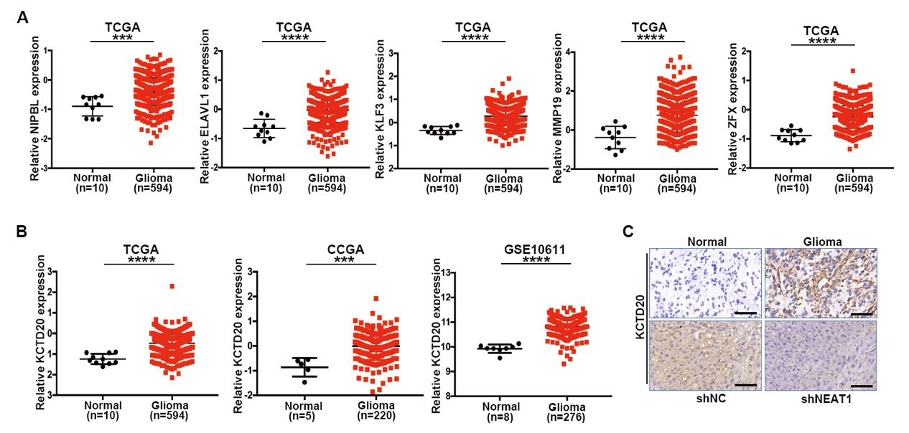

Figure S2. KCTD20 expression was significantly increased in glioma tissues. A. The TCGA database was used to analyze the expression of 5 potential target genes (NIPBL, ELAVL1, KLF3, MMP19, ZFX). B. KCTD20 expression was evaluated in TCGA，CGGA and GSE10611 database. C. upper: The expression of KCTD20 is tested in adjacent normal brain tissues and glioma tissues by Immunohistochemistry; Lower: Immunohistochemical analyses of KCTD20 expression in orthotopic xenograft tumours after stably transfected with vehicle or shNEAT1 treatment. scale bar=100μm. ***P < 0.001, ****P < 0.0001

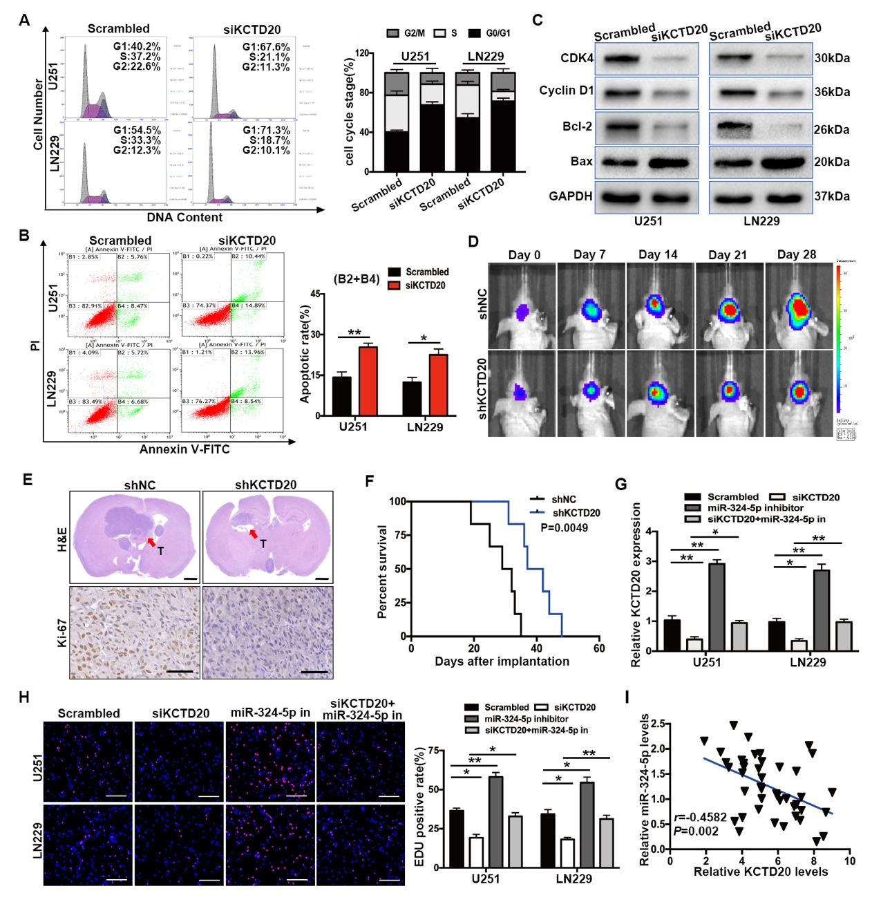Figure S3. KCTD20 is involved in miR-324-5p-induced tumor-suppressive effects. A. The cell cycle distribution of U251 and LN229 cells transfected with siKCTD20 or Scrambled. B. The apoptotic rates of flow cytometry assay using LN229 and U251 cells with vector or siKCTD20. C. Western blot analysis of CDK4, Cyclin D1, Bcl-2 and Bax in U251 and LN229 cells transduced with siKCTD20 or control siRNA. GAPDH served as the loading control. D. Tumor formation was assessed by bioluminescence imaging after U251 cells stably transfected with shKCTD20 or shNC. E. Representative H&E staining for tumor cytostructure and histological analysis to detect Ki-67 expression in tumors originated from shNC and shKCTD20-infected U251 cells. scale bar=1mm (upper panels), 100μm (lower panels) F. Survival curve of shNC or shKCTD20-transduced U251 cells-derived intracranial xenografts. G. After transfected with Vector, siKCTD20 or siKCTD20 combined with miR-324-5p inhibitor, the mRNA level of KCTD20 in U251 and LN229 cells was examined by qRT-PCR. H. The efficiency of EdU experiments was detected in KCTD20 silencing U251 and LN229 cells by introducing miR-324-5p inhibitor. scale bar=100μm I. Spearman’s correlation analysis of the relative expression levels of miR-324-5p and KCTD20 (r=-0.4582, P=0.002). Values are shown as the mean ± standard errors of the mean based on three independent experiments. *P < 0.05, **P < 0.01

