Supplementary Material

Macrophage-derived extracellular DNA initiates heterotopic ossification
Xiaoxiao Han^{1,2†}, Changhe Gao^{1,3†}, Weicheng Lu^{1†}, Jianfei Yan¹, Haoqing Xu^{1,2}, Zhenxing Guo¹, Wenpin Qin¹, Naining Lu⁴, Jialu Gao¹, Weiwei Zhu^{1,2}, Yutong Fu^{1,2}, Kai Jiao^{1,5*}
† These authors contributed equally to this work
¹State Key Laboratory of Military Stomatology & National Clinical Research Center for Oral Diseases & Shaanxi Key Laboratory of Stomatology, School of Stomatology, The Fourth Military Medical University, Xi'an, Shaanxi, China.
²The college of life science, Northwest University, Xi’an, Shaanxi, China.
³ The Third Affiliated Hospital of Xinxiang Medical University, Xinxiang, China.
⁴ Department of Neurobiology, The Fourth Military Medical University, Xi'an, Shaanxi, China.
⁵Department of Stomatology, Tang Du Hospital, Fourth Military Medical University, Xi'an, Shaanxi, China
* Correspondence: Kai Jiao: kjiao1@163.com

Supplementary Figures and Tables

Supplementary Figures
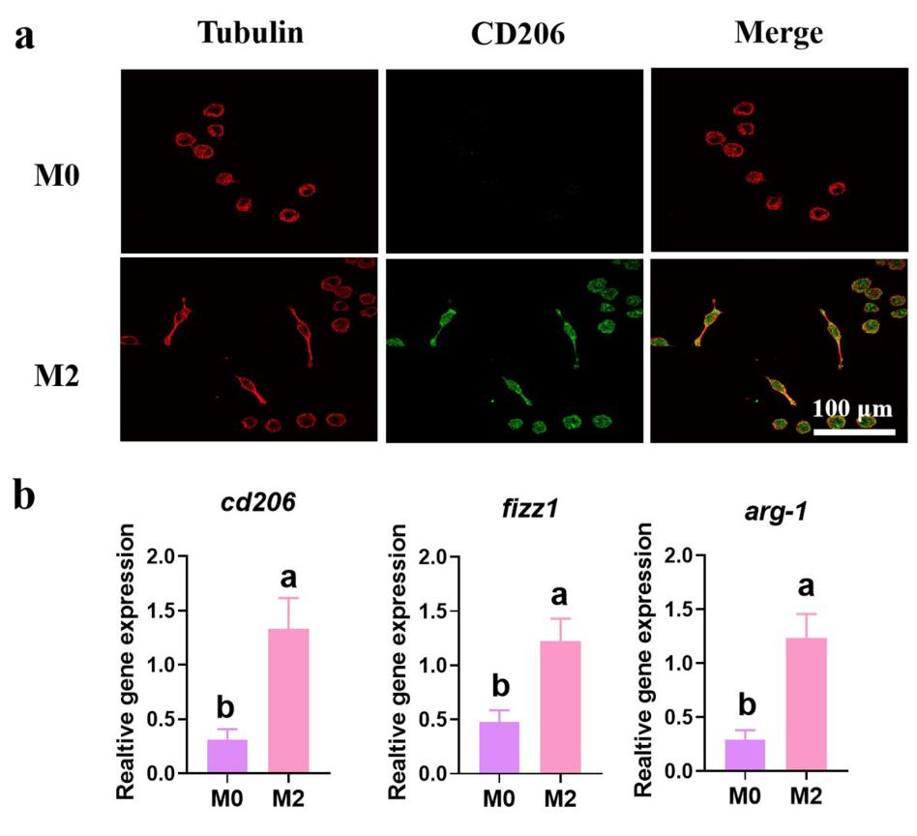
Supplementary Figure 1. (a) Representative images of immunofluorescence image of M0 and M2 macrophages. In all images, the cells were counterstained with tubulin antibody (red). (b) qRT-PCR was performed using primers targeting M2 macrphages expression.

Supplementary Table
Gene name | Forward/ Reverse | Sequence （5’-3’）
iNOS | Forward | CAAGCTGAACTTGAGCGAGGA
iNOS | Reverse | TTTACTCAGTGCCAGAAGCTGGA
IL-1β | Forward | TCCAGGATGAGGACATGAGCAC
IL-1β | Reverse | GAACGTCACACACCAGCAGGTTA
TNF-α | Forward | ACTCCAGGCGGTGCCTATGT
TNF-α | Reverse | GTGAGGGTCTGGGCCATAGAA
CD206 | Forward | AGCTTCATCTTCGGGCCTTTG
CD206 | Reverse | GGTGACCACTCCTGCTGCTTTAG
FIZZ1 | Forward | CAGCTGATGGTCCCAGTGAA
FIZZ1 | Reverse | CAAGCACACCCAGTAGCAGTC
Arg-1 | Forward | AGCTCTGGGAATCTGCATGG
Arg-1 | Reverse | ATGTACACGATGTCTTTGGCAGATA
Supplementary Table 1. Primer sequences used for RT-PCR in the present study.

