Appendix - Transcriptome analysis of knockout mutants from SpARR11 and SpMYB84

Transcriptome sequencing
The mutant sparr11-ko line 1, sparr11-ko line 2, spmyb84-ko line 1, spmyb84-ko line 2 and wild type S. plumbizincicola were selected as materials, no biological duplication. After 10 days of one-quarter MS nutrient solution culture, roots were respectively taken and placed in liquid nitrogen for transcriptome sequencing (BioMarker, Beijing, China).
Transcriptome analysis
The mutant transcriptome was analyzed without reference. Log2(Fold Change) ≥2 and FDR<0.01 were used as screening criteria for differentially expressed genes
Genes knockout mutants transcriptome differential gene analysis
GO analysis was performed on the common differentially expressed genes (wild type and spmyb84-ko line1 vs wild type and spmyb84-ko line2). The differentially expressed genes in root about the molecular functional module, with significant differences in “transporter activity” and “antioxidant activity”. The differential genes of antioxidant activity pathway were extracted, and most peroxidase related genes were down-regulated. There were significant differences in the “transporter activity” pathway, some of which were annotated as “metal ion transport”, more downregulation. In addition, MapMan was used to obtain the differential transporter genes. Through analysis, it was found that ABC transporter, NAC transporter and P-type ATPase transporter were significantly different between the wild type and myb84-ko.
GO analysis was performed on the common differentially expressed genes (wild type and sparr11-ko line1 VS wild type and sparr11-ko line2). In the molecular functional module, the “transporter activity” was significantly different. MapMan was used to modulated differentially transporter genes, and it was found that ABC transporter, ZIP transporter and P-type ATPase transporter were significantly different between wild type and sparr11-ko.
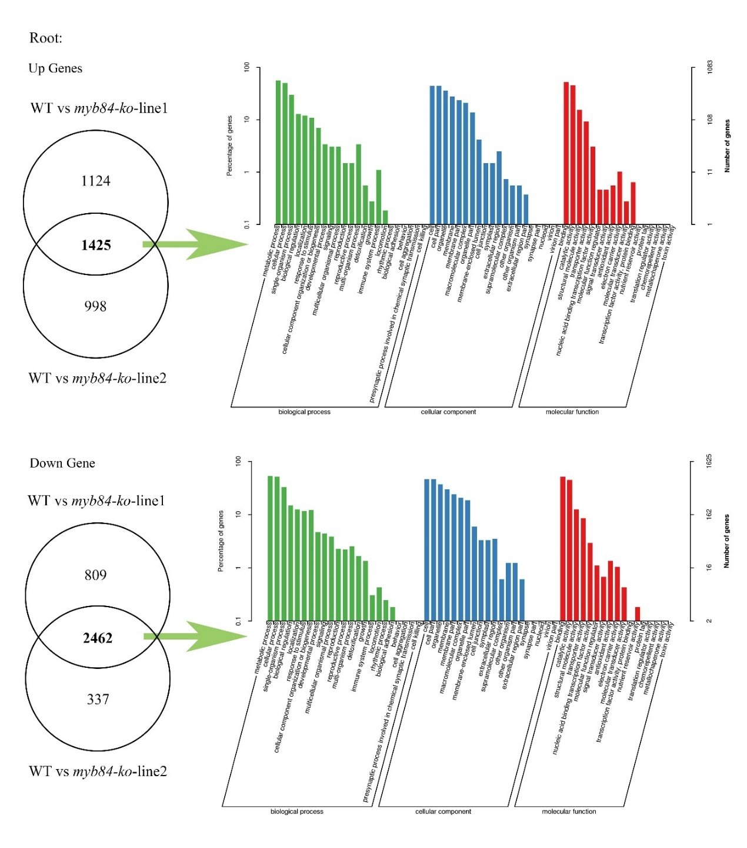
Appendix Fig. S5 Differentially expressed genes analysis between SpMYB84 knockout strain and wild type. The Venn diagram shows the number of different genes, and the bar chart shows the results of GO analysis.
Appendix Fig. S6 Differentially expressed gene heat maps of key enrichment pathways between SpMYB84 knockout strain and wild type. Heat map of partial differential transporter (a). Heat map of differential genes in antioxidant activity pathways (b).
Note: R1a: sparr11-ko line1; R1b: sparr11-ko line2; R21a: spmyb84-ko line1; R21b: spmyb84-ko line2
Appendix Fig. S7 Differentially expressed gene analysis between SpARR11 knockout strain and wild type. The Venn diagram shows the number of different genes, and the bar chart shows the results of GO analysis.

Appendix Fig. S8 Heat map of partial differential transporter between SpARR11 knockout strains and wild types
Note: R1a: sparr11-ko line1; R1b: sparr11-ko line2; R21a: spmyb84-ko line1; R21b: spmyb84-ko line2

