Supporting Information

Title:
Litter isopod mouthpart traits respond to a tropical forest recovery gradient

Running title:
Isopod trait–environment interaction

Authors:
Shawn B. H. Ang^{1†}, Weng Ngai Lam^{1†}, G. Kenny Png¹, Sylvia K. B. Tan¹, Benjamin P. Y-H. Lee², Max Khoo³, Matthew S. Luskin⁴, David A. Wardle¹ and Eleanor M. Slade¹
† Authors contributed equally

Affiliations:
¹ The Asian School of the Environment, Nanyang Technological University, 50 Nanyang Avenue, Singapore 639798, Republic of Singapore.
² Singapore Botanic Gardens, National Parks Board 1 Cluny Road, Singapore 259569, Republic of Singapore
³ Wildlife Management Division, National Parks Board, 1 Cluny Road, Singapore 259569, Republic of Singapore
⁴ School of Biological Sciences, The University of Queensland, St. Lucia, QLD, Australia

Corresponding author:
† Weng Ngai Lam. Email: wengngai@u.nus.edu. ORCID: 0000-0002-1188-1363

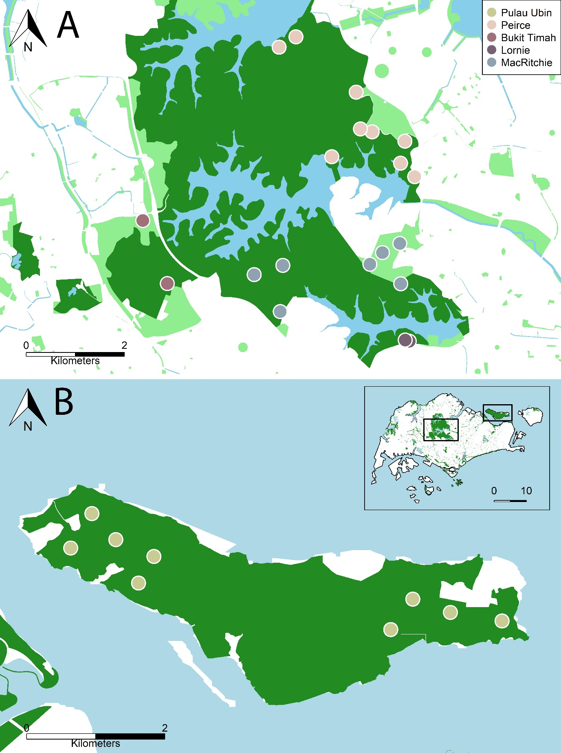
Fig. S1. Plot locations (circles) on the Singapore mainland (A) and Pulau Ubin island (B). Each circle denotes a pair of plots.

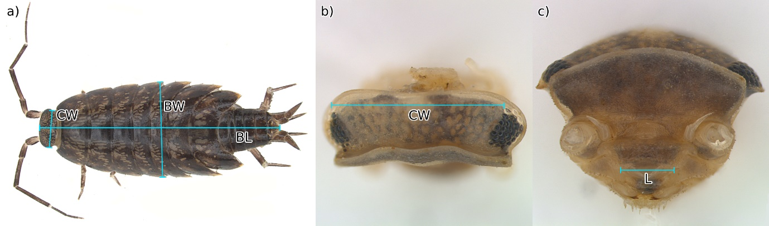Fig. S2. Measurements taken for scaling traits; BL, body length (a); BW, body width (a); CW, cephalon width taken from cephalon still attached to body for runners (a) and after being removed from body for rollers (b) since cephalon in an upright position is otherwise obscured when still attached to the body in rollers; L, labrum width (c).
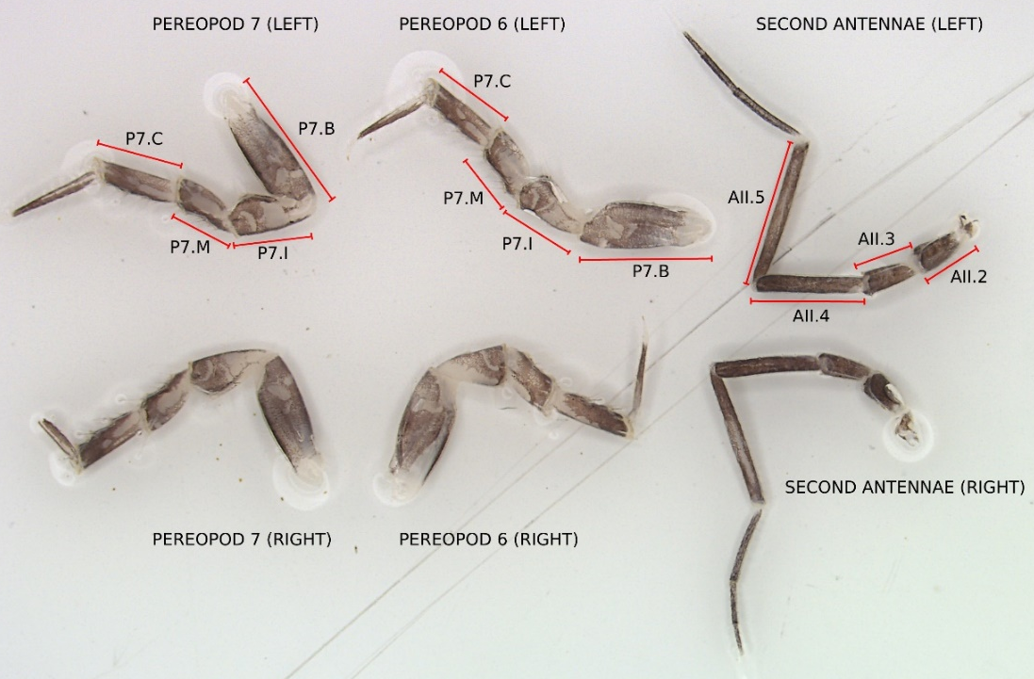
Fig. S3. Measurements taken for locomotory traits from laid out, dissected pereopods 6 and 7 and second antennae from an individual of Burmoniscus sp. 1 (Philosciidae). The measured segments are annotated in the appendages in the top row. B = basis, I = ischium, M = merus, C = carpus.

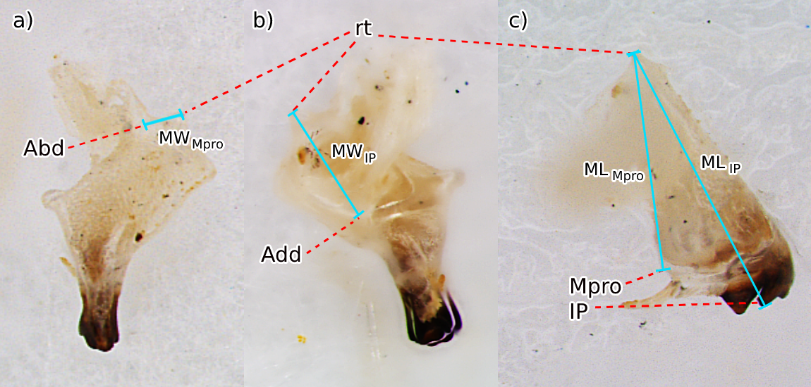Fig. S4. Measurements taken to calculate mechanical consumptive trait proxies from multiple angles, with red dotted lines indicating key features on the mandible (left mandible of Armadillidae sp.); rt, rotation point of mandible; Abd, insertion point of abductor muscle; Add, insertion point of adductor muscle; Mpro, molar process; IP, incisor process. Lengths highlighted in blue indicate measurements taken; MW_{Mpro}, basal width of the mandible from the insertion point of the abductor muscle (a); MW_{IP}, basal width of the mandible from the insertion point of the adductor muscle (b); ML_{Mpro}, length from the end of the mandible base to the molar process (c); ML_{IP}, length from the end of the mandible base to the incisor process (c). Images have been sharpened and contrast increased for better discernability of the translucent mandible features.

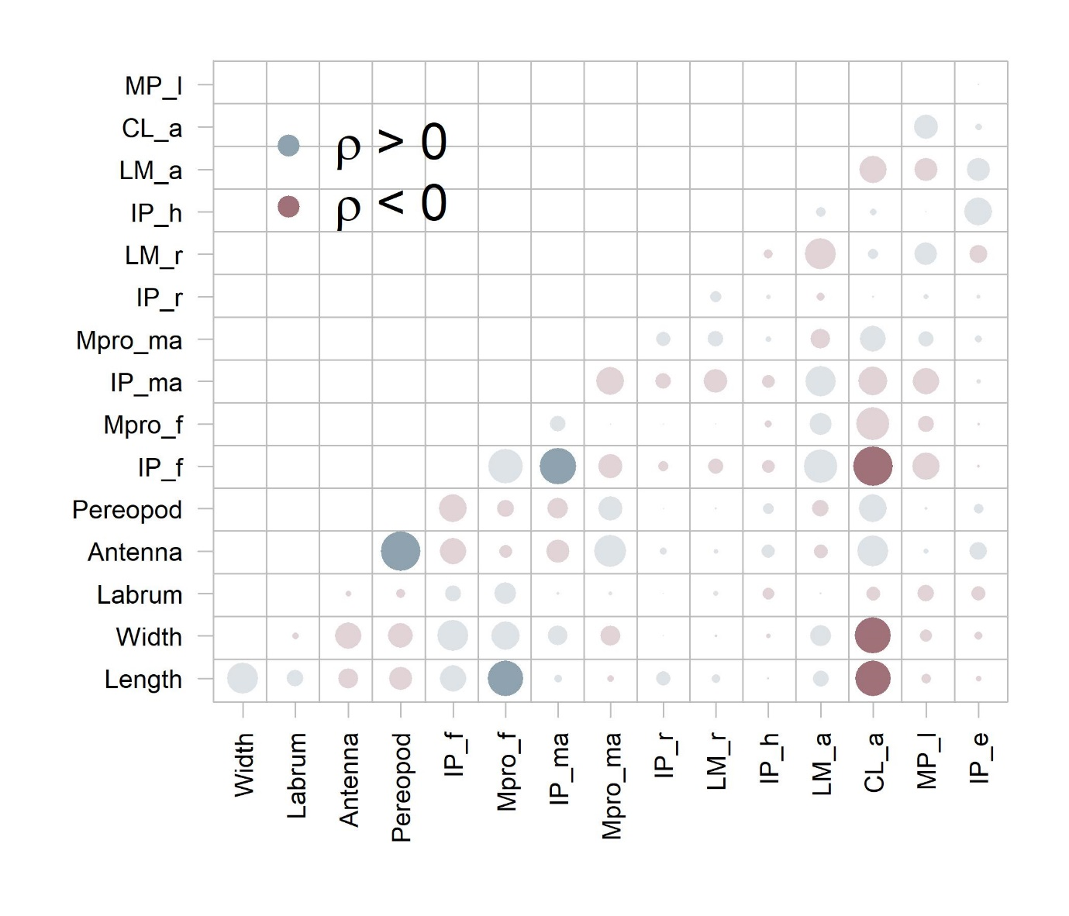
Fig. S5. Correlogram showing pairwise correlations between the traits measured in this study. Positive correlations (correlation coefficient, $ρ$ > 0) are colored blue, and negative correlations, red; significant correlations (false discovery rate-corrected p-value < 0.05) are opaquely colored, while non-significant ones are translucently coloured. Point sizes are scaled according to the absolute magnitude of the correlation coefficient, $ρ$. IP_f = incisor process biting force; IP_ma = incisor process mechanical advantage; Mpro_f = molar process biting force; CL_a = side profile area of ciliated lobe.

Appendix S1: Evaluating the potential effect of interspecific interactions on results
To check for the potential effect of interspecific interactions on these results, a Bayesian generalized linear latent variable model (GLLVM) was fitted to the data, with almost identical specifications to the best GLMM model, as described in the main text. Latent variables are used in GLLVMs to account for interspecific interactions and joint responses to unmeasured environmental variables in ecological models (Hui, 2016), and are increasingly being used in community ecology (Warton et al. 2015).
$$\begin{aligned}Y_{ipqr} \sim NegBinom\left(μ_{ipqr},θ \right) \#\left(Equation S1\right)\end{aligned}$$
$$\begin{aligned}\ln{μ_{ipqr}}=β_{0,i}+β_{0,qr}+β_{1,i}X_{pqr}+β_{2}Z_{i}X_{pqr} +\sum_{l=1}^{2}{λ_{l,i}L_{l,p}}\#\left(Equation S2\right)\end{aligned}$$
where $Y$ is abundance, $μ$ is the linear predictor, $θ$ is the dispersion parameter, $β_{0,i}$ is the species-specific random intercept, $β_{0,qr}$ is the plot pair–forest patch nested random intercept, $X_{pqr}$ is the environmental variables PCoA1, $β_{1,i}$ is the species-specific response to the environment (random slope), $Z_{i}$ is the first principal component of morphological mouthpart traits (morphPC1), $β_{2}$ is the trait–environment interaction coefficient, and $λ_{l,p}$ are species-specific latent responses to latent plot variables $L_{l,p}$. Notice that the only difference between Equation S2 and Equation 2 in the main text is the latent variable term, $\sum_{l=1}^{2}{λ_{l,i}L_{l,p}}$.
The $PCoA1×morphPC1$ interaction coefficient, $β_{2}$, estimated by this model, was 3.44 (95% highest posterior density = [−0.49, 7.54]), which was close to that estimated by the model described in the main text ($β_{2}$ = 3.27, 95% confidence interval = [1.27, 5.28]).

