Stoichiometric characteristics drive the soil aggregate stability rather than microbial community characteristics and soil nutrients after 5 years of vegetation restoration in China
Haiming Kan¹, Hengkang Xu¹, Guofang Zhang¹, Chao Chen¹, Zhuo Pang¹, Xifeng Fan¹ and Juying Wu¹
¹Institute of Grassland, Flowers and Landscape Ecology, Beijing Academy of Agriculture and Forestry Sciences (BAAFS), Beijing, China, No. 9 Shuguang Garden Middle Road, Haidian District;
Correspondence: wujuying@grass-env.com

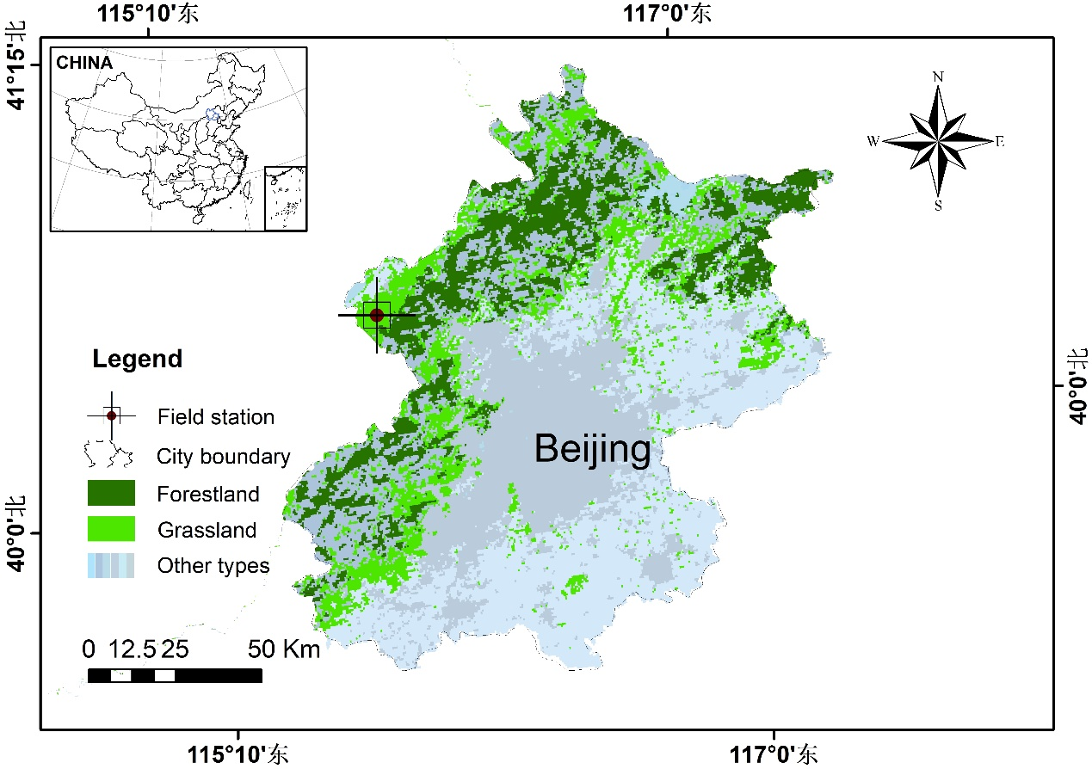

Figure S1 Research area.

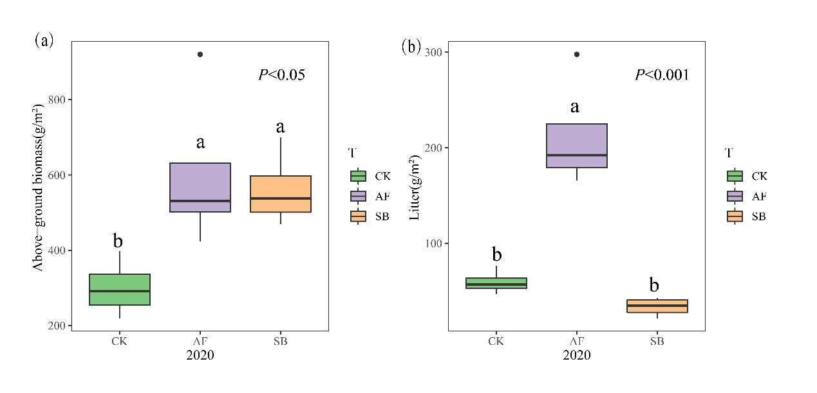
Figure S2 Effects of different restoration methods on aboveground biomass (a) and litter weight (b). CK, natural recovery; AF, Medicago sativa L sowing; and SB, Bromus inermis Leyss sowing.

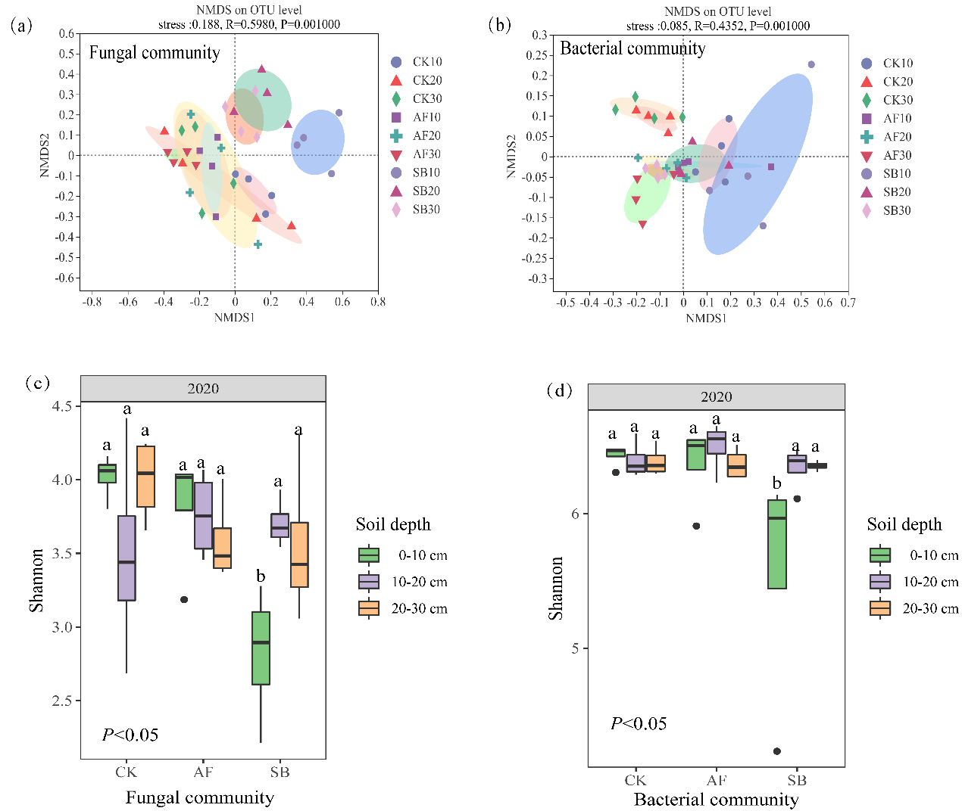

Figure S3 Effects of different vegetation restoration methods on fungal community structure (a) and diversity (c) and bacterial community structure (b) and diversity (d). CK, natural recovery; AF, Medicago sativa L sowing; and SB, Bromus inermis Leyss sowing.

